Owner ’s
Manual

YACHTBUILDERS
T A S H I N G
T O * T H E * W O R L D

* PREFACE * *

The purpose of this manual is to acquaint you with the safe operation of your yacht and to familiarize you with its instruments, equipment, etc.

This manual also provides essential information for the proper service and maintenance. Including various sketches. carefully read the manual from cover to cover and understand how all instruments and equipment function. Adhere to all instructions in this manual to avoid damage to your yacht and to make sure you and your passengers are safe.

However, any time a conflict is evident between the equipment manufacturer’s instructions and this manual, follow the equipment manufacturer’s instructions.

Make sure that all things are kept in excellent condition and are ready for sailing. Ta Shing wishes you happy sailing.

Notice: Ta Shing Yacht Building CO., LTD. Reserves the right to update its products and information within this manual regarding the yacht. This manual should be used as a general operation and maintenance guide and not as a specification catalog.

-—July,12,1986.—-

DEALER LISTINGS :

** Jack Kelly Yachts
955 harbor Island Drive Suite 150 San Diego
CA 92101
TEL (619)543-1316
FAX (619)223-3592
ATT. Mr. Robert L. Phillips

** Tatoosh Marine
1120 Brickyard Cove Road Point Richmond
CA 94801
TEL (415)232-7778
FAX (415)232-0201
ATT Mr. Bill Stennis

** Tatoosh Marine Suite #150
809 Fairview Place N. Seattle, WA 98109
TEL | (206)625-1580 | P. O. Box 203 Destin
FAX | (206)584-2102 | FL 32541

** Willis Marine Center INC.
P. O. Box 579
Huntington, NY 11743
TEL (516)421-3400
FAX (516)549-7134
℅ Exhibit Marketing Services ATT Mr. Jeffrey W. Willis

** The Annapolis Sailyard, LTD.
326 FIRST STREET
ANNAPOLIS, MD 21403
TEL (301)268-4100
FAX (301)268-2974
TLX 386630 SAIL YARD LTD ATT MR. MICHAEL P. GRIFFIN

** Royal Sailboat CO.
13 Crooked Tree Trail Ormond Beach, FL 32074 tel (904)672-7795
FAX (904)673-4556
ATT Mr. George C. Mynchenberg

** Friendship Charter Sailing

TLX 9104442014
ATT Mr. Bob Berg

** Alibi Yacht Sales 14701 Pioneer Trail Eden Prairie
MN 55344
TEL (612)941-0226
FAX (612)941-0229
TLX 857899
ATT Mr. Roger D. Eide

** Alibi Yacht Sales 24535 Jefferson St. Clair Shores MI 48080
TEL (313)778-8480

** Bass Harbor Marine Bass Harbor
Maine 04653
TEL (207)244-5066
FAX (207)244-7535
TL 5101002968 Hinckley Yacht ATT Mr. Bob Pooler
TEL (904)837-2694
FAX (904)837-7097
ATT Mr. Kenneth A. MacPike

** Yachts Incorporated 2511B, NASA RD One
Suite 108, Seabrook, TX 77586
TEL (713)326-1538
FAX (713)326-2333
ATT Mr. Dennis Lawrence

** Tsunefuji & CO., LTD.
5-2 Yanagibashi-1 Taito-Ku, Tokyo TEL 862-1501
FAX 866-7358
TLX 2657048 TSUNEF-J
ATT Mr. Y. Tsunefuji

** Simpson Marine LTD.
Unit 6 G/F Aberdeen Marina Tower 8, Shum Wan Road, Aberdeen
honG Kong TEL 5-558377
FAX 5-8734024
ATT Mr. Mike Simpson

ii

** TA SHING USA:

Ta Shing Yacht Service CO.,(USA) 1208 Walnut Grove AVE #C RoseMead, CA 91770
TEL & FAX (818)307-5037
ATT Mr. Palmer Lai

** INTERIOR DESIGNER:

Plachter Interior Design 1600 S.E. 17TH Street
FT. Lauderdale, FL 33316 TEL (305)524-9070
ATT MS. Jane V. Plachter

iii

Contents

- * Preface * * i
Dealer Listings ii
** Ta Shing USA: iii
** Interior Designer: iii
- Construction Details 1
  - Hull 1
  - Deck to Hull Joint 2
  - Bulkheads 3
  - Ballast 4
  - Rudder 4
  - Mast Step 4
  - Engine Bed 5
  - Deck Hardware Installation 6
- Engine 8
  - Before Starting The Engine 8
  - Starting Procedure 8
  - After Starting The Engine 9
  - Stopping The Engine 10
  - Engine Cooling and Exhaust System 10
- Power Transmission 12
  - Shaft Alignment procedure 12
  - Dripless Shaft Seal 13
- Fuel System 14
  - Fuel Tank 14
  - Deck Fill Plate 14
  - Fuel Tank Vent 14
  - Shut Off Valve 14
i
  - Fuel Filter 15
- Fresh Water System 16
  - Water Tanks 16
  - Water Vent 16
  - Shut Off Valve 16
  - Pressure Water System 16
  - Accumulator Tank 17
  - Water Heater 17
- Toilet system 18
  - Operating Toilet 18
  - To Empty Holding Tank 19
  - Clogged Discharge Line 20
  - Marine Head Anti-siphon Valve 20
- Bilge Pump 21
  - Manual Bilge Pump 21
  - Electric Bilge Pump 21
  - Bilge Pump MAINTENANCE 22
- Drains and Seacocks 23
  - Hoses And Clamps 23
  - Check Valves 23
  - Ball Valves And ThrOUGH-Hulls 23
  - Ice Box Drains 25
  - Shower Drains 25
- Steering System 26
  - maintenance and inspection 26
  - use of emergency tiller 27
  - Rudder 28
- Electric System and Switch Panel 29
  - 12V D.C. System 29
  - 110V A.C. System 30
  - Bonding System 31
- Battery 33
  - Operation of The D.C. Voltmeter 33
  - Battery Maintenance 33
- Antifouling 35
  - Preparation 35
  - selecting a coating system 35
  - application 36
- Fiberglass Maintenance 37
- Winterizing 39
  - Hauling 39
  - Hull Bottom 39
  - Zincs 39
  - Freshwater System 40
  - Head and Holding Tank 40
  - Engine 41
  - Fuel System 41
  - Batteries 41
  - Seacocks 41
  - Bilge 42
  - Ice Box 42
  - Stove 42
  - covering the Boat 42
  - Mast 42
- Sails 44
  - Sail Care 44
  - Sail Storage 45
  - How to Clean Sails and Remove Unwanted Stains 46
  - Ultra-Violet (U.V.) Degradation of Sails 46

CONSTRUCTION DETAILS

Ta Shing Yacht Building Co., LTD. uses highest quality materials and construction methods in the production of the Tashiba yachts. The engineering department at the yard keeps the factory abreast of the latest materials and construction methods.
The following is a brief description of the construction of the basic components of the yacht.

HULL

The hull is build according to the architect’s specifications. The lamination schedule can be seen in Figure 1.

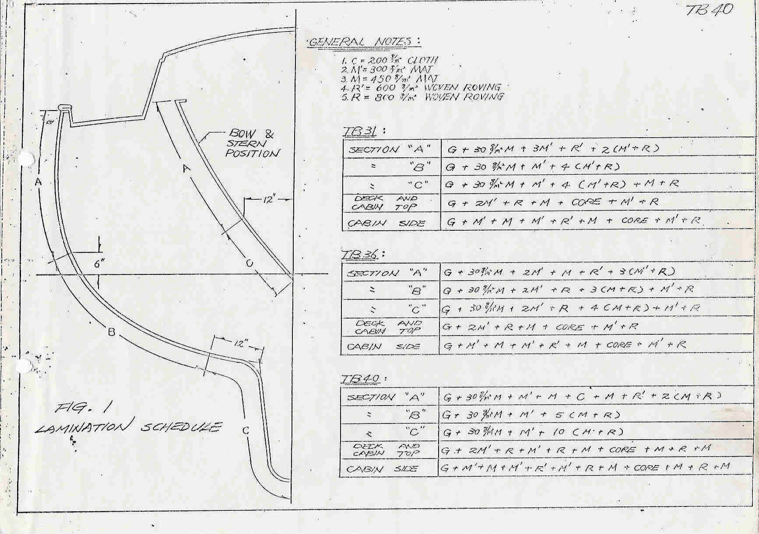

FIGURE 1. FIBERGLASS LAYUP SCHEDULE

It is built as a one piece fiberglass moulding with the strips of material allowed to overlap along the boot top and waterline area for additional strength. Two extra pairs of mat and roving are applied on the bow to reinforce the bow areas. The sheer hull/deck joint area is also specially reinforced.
Top quality U.S. made gelcoat is used (of the isophthalic type) which has the best water and chemical resistance.

1.2 Deck

The deck is constructed of the same gelcoat and FRP materials as the hull. All deck surfaces are cored with a high strength end grain light wood core while the more vertical surfaces are cored with end grain balsa for light weight and “print” resistance.
In areas where is bolted through the deck, marine plywood is used as the core for higher compressive strength.
The deck lamination schedule is called out in Figure 1.

DECK TO HULL JOINT

The hull flange is specially reinforced to strengthen the joint by extra fiberglass layers. The deck is installed on a layer of 3M-EC 5200 for highest strength and water-tightness. It is screwed in place with 5mm SS self tapping screws on 8” centers. Then a teak cap rail is installed and the entire joint is bolted together with 1/4” SS bolts on 8” centers.
Details of the joint may be seen in Figure 2.

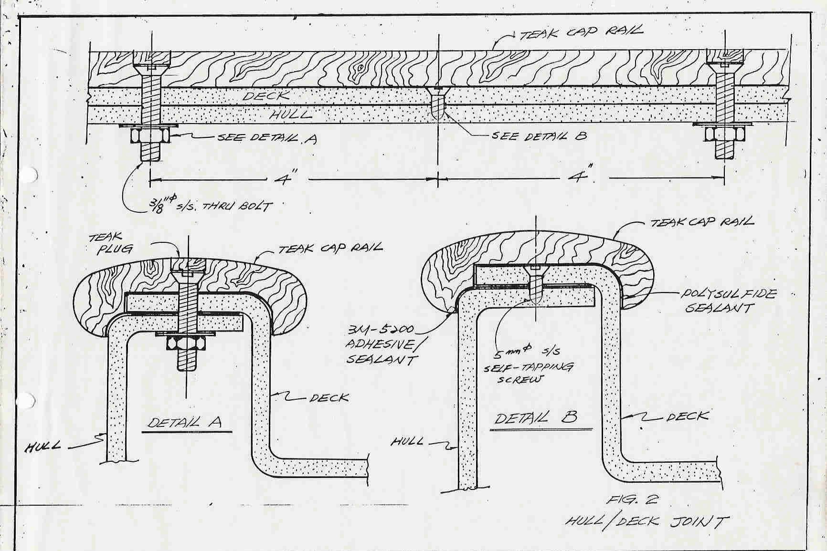

FIGURE 2. HULL TO DECK JOINT

BULKHEADS

The bulkheads are cut from marine grade plywood to precise contours. A PVC foam fillet strip is applied to the edges and the bulkheads are installed in the hull in their exact locations. They are then fiberglassed in place while the hull is still in the mold so that the design hull shape is locked in. As the bulkheads are glassed in place, an especially strong bulkhead to hull connection is made by lacing fiberglass roving strands through holes in the bulkhead and into the hull on each side. The PVC foam fillet strips pad the bulkheads to the hull connection to prevent “hard spots” from showing on the hull.

BALLAST

The cast iron ballast is to a pattern which is a snug fit in the hull cavity. After the ballast is lowered into place, a mixture of polyester resin and sand sized bits of iron is poured around the ballast to fill any spaces between the ballast and the hull.
The ballast is then solidly glassed in place along its top surface.

RUDDER

The rudder back bone consists of the rudder stock and a stainless plate slightly smaller than the rudder profile. The plate is welded to the stock and stiffeners are welded to the plate and stock on each side. The rudder shell is made of FRP in two halves. The rudder stock assembly is glassed into place in one shell and then the other shell is pressed into place into wet FRP. All voids are filled with P.U. foam.
Details of the rudder may be seen in Figure 3.

MAST STEP

The Tashiba 31 has a deck stepped mast. The mast step fitting is through bolted to the top plate of a heavy stainless steel tubular compression post. The compression post base stands on a heavy by 1/2” self tapping screw, which is solidly glasses in place on ballast keel.
The Tashiba 36 and 40 has a keel stepped mast. Through a mast deck collar which is bolted to the cabin top. The mast step stands on a heavy hardwood by 1/2” self tapping screw which is solidly glassed in place on ballast keel.
Details of the mast step may be seen in Figure 4. (for TB31 only)

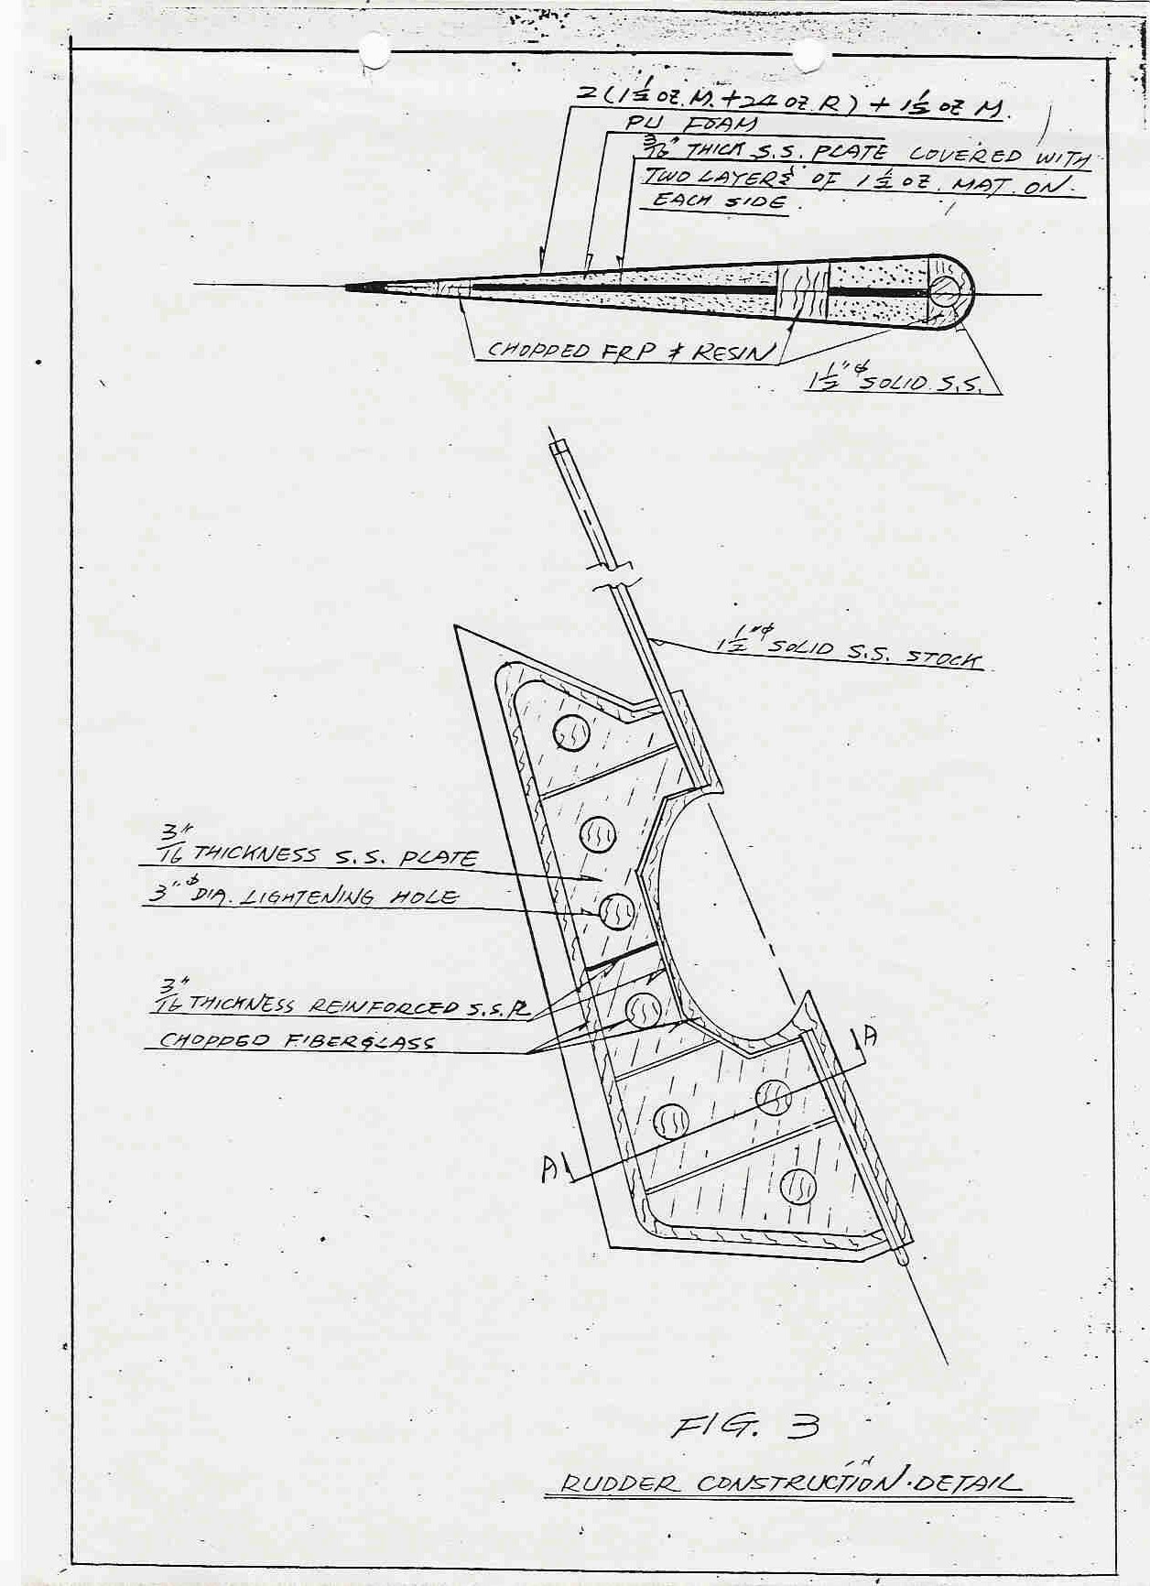

FIGURE 3 CONSTRUCTION DETAIL

ENGINE BED

The engine beds are molded in a special mold to substantial thicknesses. The tops of the beds have 1/2” mild steel plates embedded in the fiberglass. These plates are later drilled and tapped to accept the engine mount bolts.
The engine bed molding is accurately located in the hull and heavily glassed in place.
See Figure 5 for details.

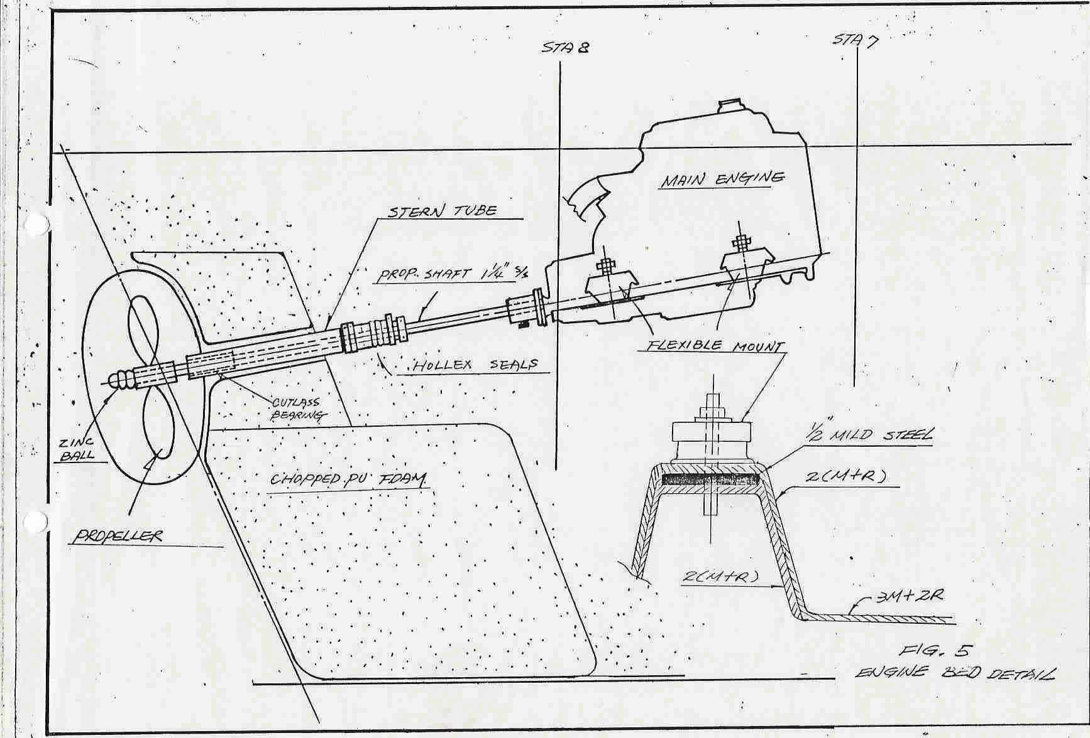

FIGURE 5. ENGINE BED

DECK HARDWARE INSTALLATION

All deck hardware is through bolted into position. The deck core is replaced with marine plywood in the areas where fittings are attached. In addition, Stainless Steel backing plates are used to spread the loads.
Permanently flexible type bedding compounds are used when the fittings are installed.
See Figure 6 for details.

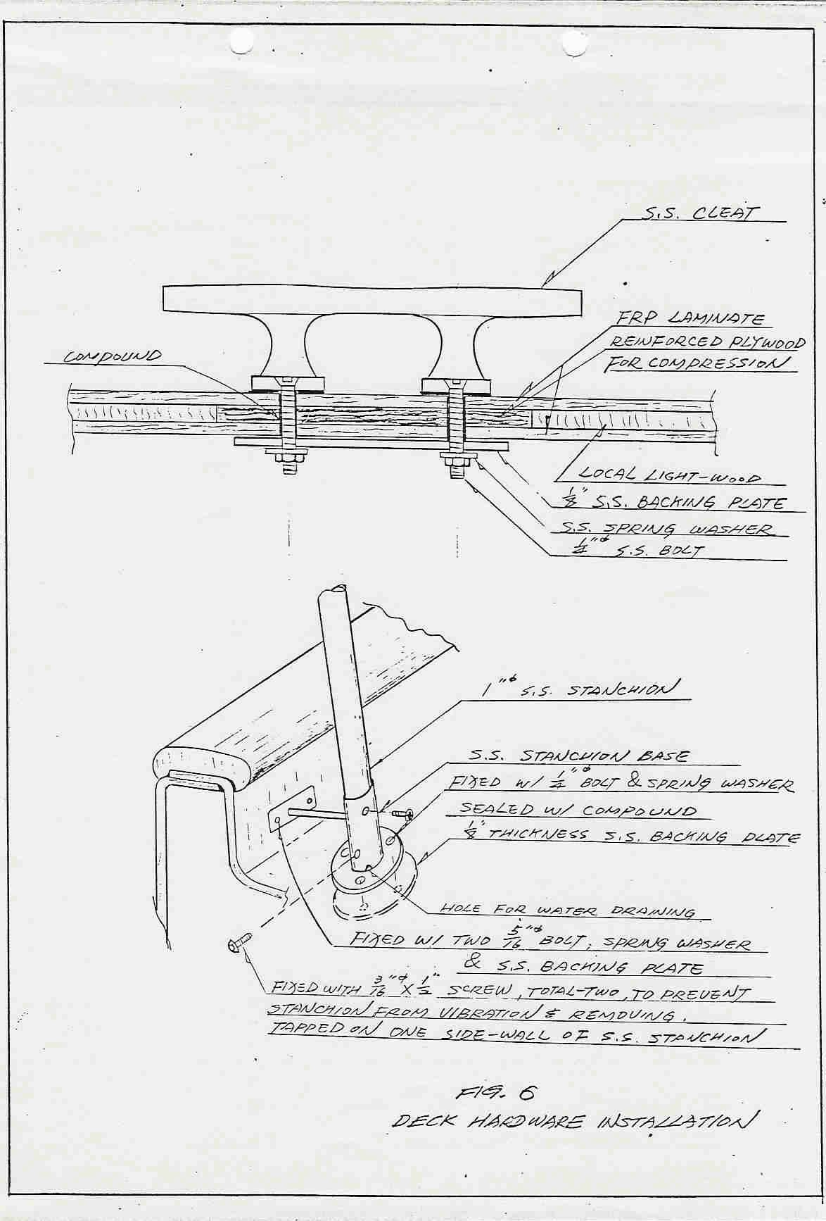

FIGURE 6. DECK HARDWARE

ENGINE

An engine owner’s manual has been supplied with your boat and should be read carefully before operating the engine. The single most important factor affecting engine life is the attention paid to routine preventive maintenance.

BEFORE STARTING THE ENGINE

Each time before starting the engine it is necessary to do the following:

- Check the seawater strainer for debris or foreign material, and clean it if necessary, then secure the top.
- Open the sea water seacock.

- Check the cooling water level on engines with fresh water cooling.

Check owner’s manual for instructions.

- Check the transmission and engine oil levels. If a white froth is noted on the engine oil dipstick, do not operate the engine since this may mean water contamination, and serious damage may occur. Contact your engine dealer.
- Check the fuel level in the tank and open the fuel valve.

- Check the instrument panel alarm system, according to the owner’s manual instructions, to ensure that all the alarms are functioning correctly.

STARTING PROCEDURE

- Put the clutch control lever in the neutral position.

- place the throttle control lever slightly advanced.

- be sure the fuel valve and sea water intake valves are opened, and the battery switch is “on”.
- Be sure the stop-knob is back to the “operating” position.

- Place the starter key in the “on” position.

- Press the start-button to start the engine.

Note: The alarm device will sound from turning the key “on” until Pushing the

start-button or turning the key off.

if the engine can’t be started in cold weather, please refer to the owner’s manual.

AFTER STARTING THE ENGINE

- Check for normal oil pressure. Shut down the engine if normal oil pressure is not present within 15 seconds of starting.
- Check immediately for sea water flow through the exhaust outlet.

- Operate the engine around 890-900 R.P.M. for at least five minutes to allow the engine to warm up. do not run at high speed during warm up period.
- If warning lamps light up or the alarm device sounds, it may be an indication that there is some trouble in the engine. Alternatively there may be a problem with the warning system. Please contact the engine dealer.
Caution: Never shut off the battery switch while the engine is running as

serious alternator damage may result.

STOPPING THE ENGINE

Place the Clutch control in the neutral position and run the engine at a low speed for five minutes to cool it down. Then use the stop control with the engine idling and return the key to the “off” position. Always close the intake seacock when the engine is not in use.

ENGINE COOLING AND EXHAUST SYSTEM

    - THE RAW WATER SYSTEM

Raw water is drawn through the seacock and through a raw water filter before being pumped through the engine heat exchanger. After the heat exchanger, the water passes over a high vented loop and then is injected into the exhaust line. The vented loop prevents possible siphon action which might fill the exhaust system and ultimately engine cylinders causing serious damage.
The exhaust hoses should be periodically checked for condition and security, and the clamps for tightness.

    - FRESH WATER COOLING SYSTEM

The coolant from the heat exchanger is forced by the fresh water pump on the engine through the cylinder block and cylinder head cooling passages and then back to the heat exchanger for cooling. A thermostat makes the coolant by pass the heat exchanger until operating temperatures are reached.
Some of the heated coolant is routed through the heat exchanger tubes in the hot water heater.
Maintenance involves using the correct coolant for your area, checking for leaks, and keeping the system topped up with coolant.

    - EXHAUST SYSTEM

After the raw water leaves the heat exchanger it is injected into the exhaust system at the exhaust elbow. The water cools and silences the exhaust gas and allows special rubber hose to be used for the exhaust run. The mixture is lifted high enough to exit the boat at the transom by the hydraulic action of the water lift muffler. See the exhaust system drawing, Figure 7, for details.
It is important to note that the water lift system does not function unless driven by the exhaust gas from the running engine. Therefore, the

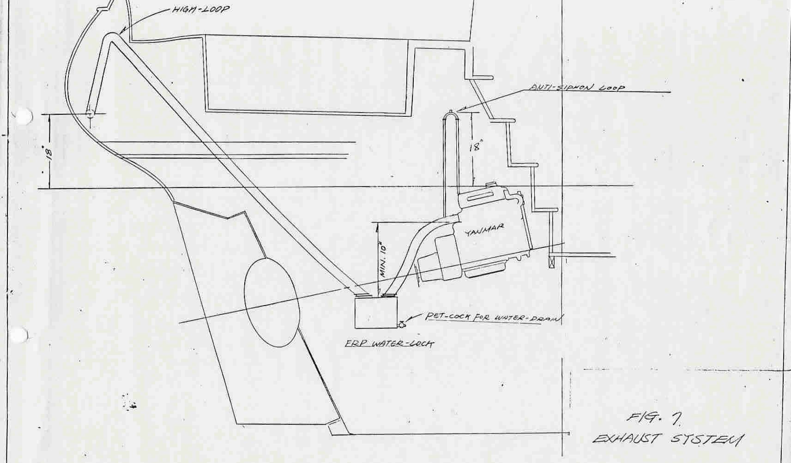

FIGURE 7. EXAUST SYSTEM

muffler must be drained whenever the engine is cranked more than 10 seconds without starting. This will prevent a back up of water into the engine which might cause serious damage.
The exhaust hoses should be periodically checked for condition and security, and the clamps for tightness.

POWER TRANSMISSION

It is most important that the shaft alignment is checked by the dealer during commissioning. Alignments are carefully checked at the factory, but shipping stresses and slight hull shape changes due to the differences of hull support by the cradle and the water will cause some misalignment.
The alignment should be checked 24-48 hours after launching and again at

100 hours, or whenever vibration is noted.

SHAFT ALIGNMENT PROCEDURE

    - Remove the coupling bolts and holding the flanges together insert feeler gauges to find the maximum gap between the faces at any point. Check radially all around the coupling. The face alignment is acceptable if it is within .1 mm or .004”.
if necessary, adjust the engine mounts tp achieve this tolerance. Retighten any loosened engine mount bolts and recheck alignment.When Alignment is achieved,
    - Rotate the propeller shaft 180 degrees relative to the transmission coupling and recheck alignment.
    - If it does not remain within .1 mm or .004” the shaft or coupling flanges are bent and must be repaired.
When reinstalling the coupling bolts, use “lock tire” or similar thread locking compound for boat security.

DRIPLESS SHAFT SEAL

A DripLess shaft seal is used in place of the conventional stuffing box. The system has a heavy rubber bellows clamped to the stern tube with a special plastic ring at its forward end. A stainless collar, sealed with an “o” ring to the shaft, is clamped to the shaft at a point where it puts pressure against the plastic ring on the flexible bellows. As the S.S. collar turns with the shaft, it bears against the plastic bellows end ring, and allows no water into the boat.
The advantages of this system include the fact that there is no stuffing material to clean and replace, and that the gland requires no adjustment. Also note that there is no shaft wear or noise transmission.
The s.s. ring should compress the bellows by 4 mm when set in the correct position.

FUEL SYSTEM

FUEL TANK

The Black iron fuel tank is located under the cabin sole forward of the companionway ladder, with a dipstick and inspection plate on top of the tank.
It is recommended that the fuel tank be periodically checked for water condensation by inserting a small hose to the lowest point through the dipstick hole. The water will settle to the lowest point and can be easily sucked out with a general purpose pump and should be done every six months. The fuel tank can be sounded with the dipstick or with the optional fuel gauge.

DECK FILL PLATE

The deck fill plate and cover are mounted flush with the deck. Use only the special wrench provided to remove or install the cover.

FUEL TANK VENT

The fuel tank is vented through a flexible hose that runs to the cabin side with a S.S. Cap to prevent sea water from entering the tank.

SHUT OFF VALVE

A fuel shut-off valve is located on the top of the fuel tank. the handle is inline when open and at 90 degrees when closed. Keep this valve closed at all times when the engine is not in use.

FUEL FILTER

Presence of water or dust in the fuel may cause failure of the engine and rapid wear of the fuel injection equipment. A Racor fuel filter/separator is installed between fuel tank and the engine fuel feed pump which separates water from the fuel through centrifugal and gravity forces. The clear bowl on the bottom has to be inspected periodically for water and large solids. Replace the filter element at least annually.
Water in the bowl is a distinctive, light color which can be drained by the pet-cock on the bottom when noted.
A secondary fuel filter is fitted on the engine, between the lift pump and the injection pump. it also contains a filter element which should be replaced after the first 50 hours of operation or long term storage. After that, replace the element every 250 hours of operation.
See the fuel system drawing on Figure 8.

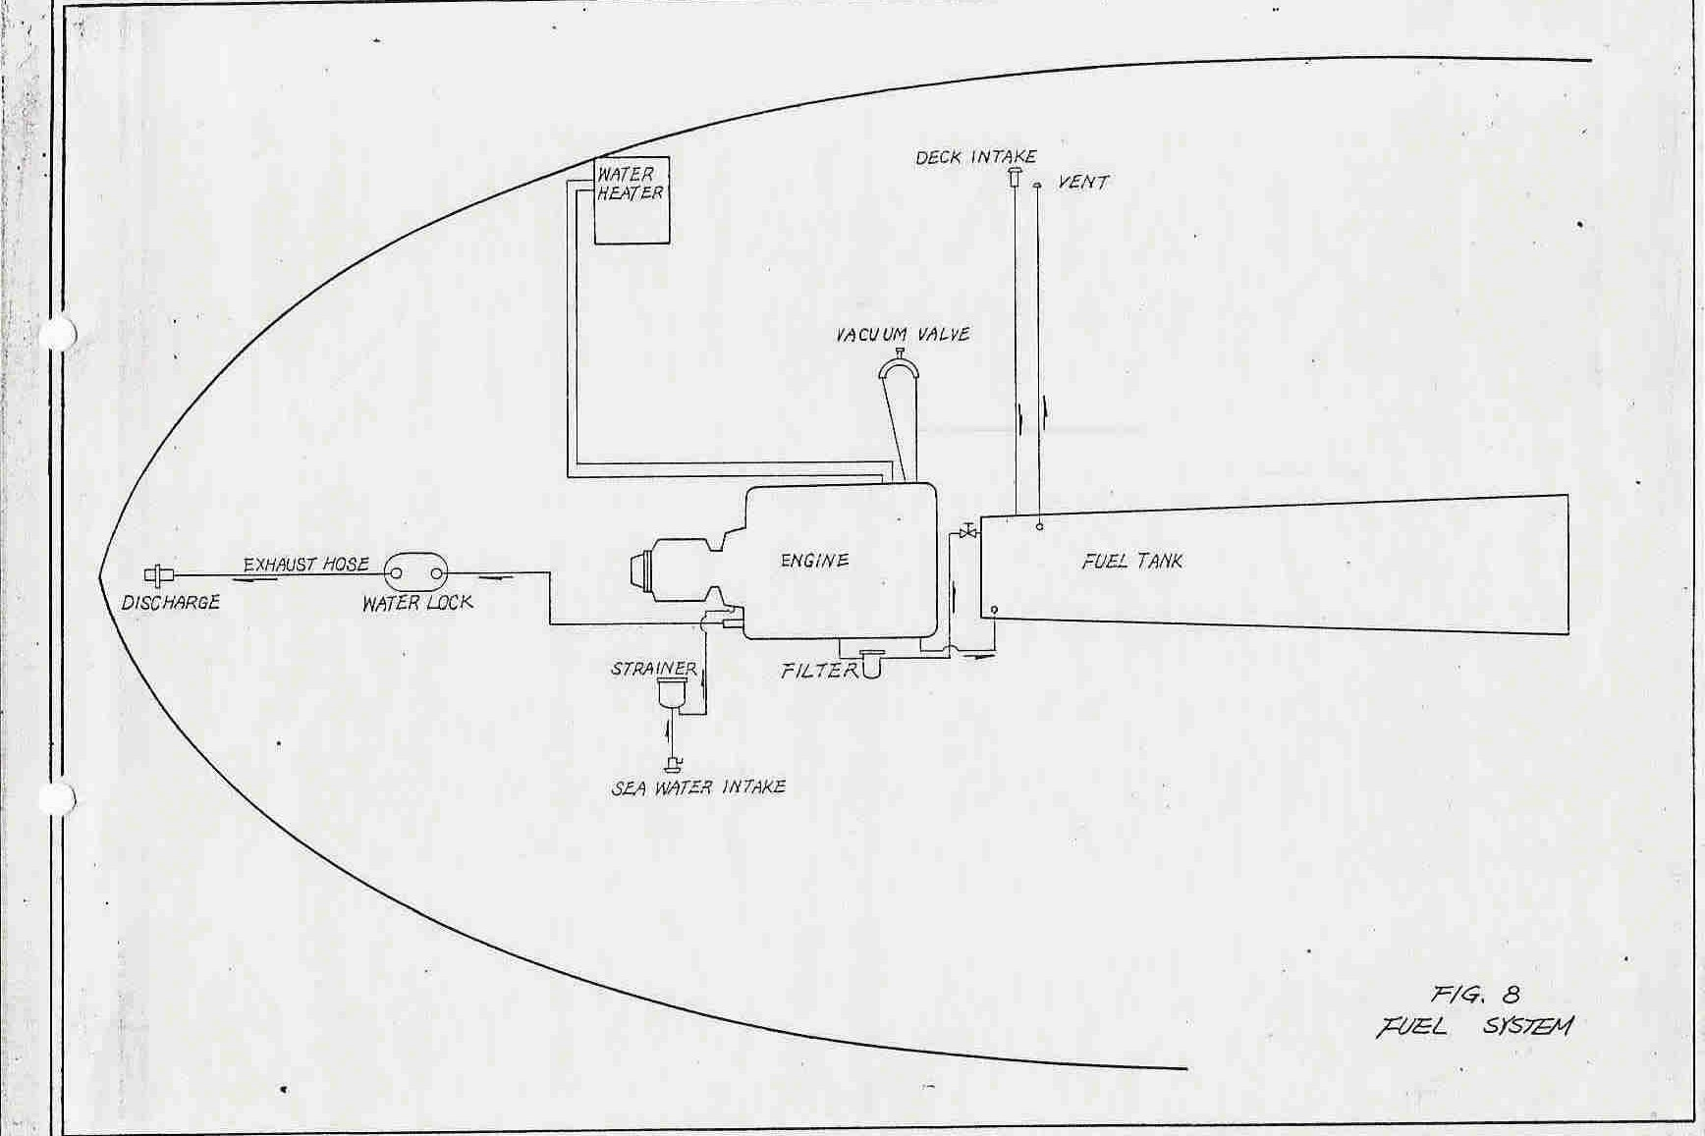

FIGURE 8. FUEL SYSTEM

FRESH WATER SYSTEM

There are two water tanks (stainless steel). One is under the port side settee and the other is under the starboard side settee.

WATER TANKS

Each water tank has a flush mounted deck fill plate. To remove or install the cover always use the special wrench provided.
A removable inspection plate and a dip-stick are installed on each tank for periodical cleaning and checking.
Water left in a tank for a long time will become stale. The tank must be pumped out if this occurs and cleaned with a baking soda and water solution followed by rinsing with fresh water.

WATER VENT

The water tank ins vented through a flexible hose that runs to the cabin side with a S.S. Cap to prevent sea water from entering the water tank.

SHUT OFF VALVE

A s.s. manifold with two shut-off valves is provided for tank use selection.

PRESSURE WATER SYSTEM

A tank valve should be open when the pump is used, or damage to the pump may occur. If air is present in the system, the pump may run indefinitely, and will overheat and damage parts of the pump. for this reason always turn off the pump when out of water.

ACCUMULATOR TANK

A Accumulator tank is mounted in line after the pressure pump. This tank reduces the water system pulsation and prevents rapid on/off pump cycling. It also acts to cushion sudden surges of water pressure which assures a smooth flow to all fixtures.

WATER HEATER

A water heater is installed, which utilizes either 110 V.A.C. or heat exchange from the engine cooling water.
Caution:

- The heater coils will be permanently damaged if the 110V heater is energized without water in the tank. This means that air must be purged from the hot water system by opening a hot water tap whenever air enters the system from an empty tank. The hot water tap must be left on until the water flows free of air to ensure a full tank.
- A leak in the heat exchanger or its connection line from the engine cooling water could cause loss of coolant and subsequent engine failure. We recommend that the user make frequent inspections of the connection line and the heater to ensure that a leak has not developed.
- It should also be noted that the engine while idling may not generate enough heat to warm the water in the water heater significantly. Increasing RPM with the engine under load will increase heat output.
See fresh water system on Figure 9.

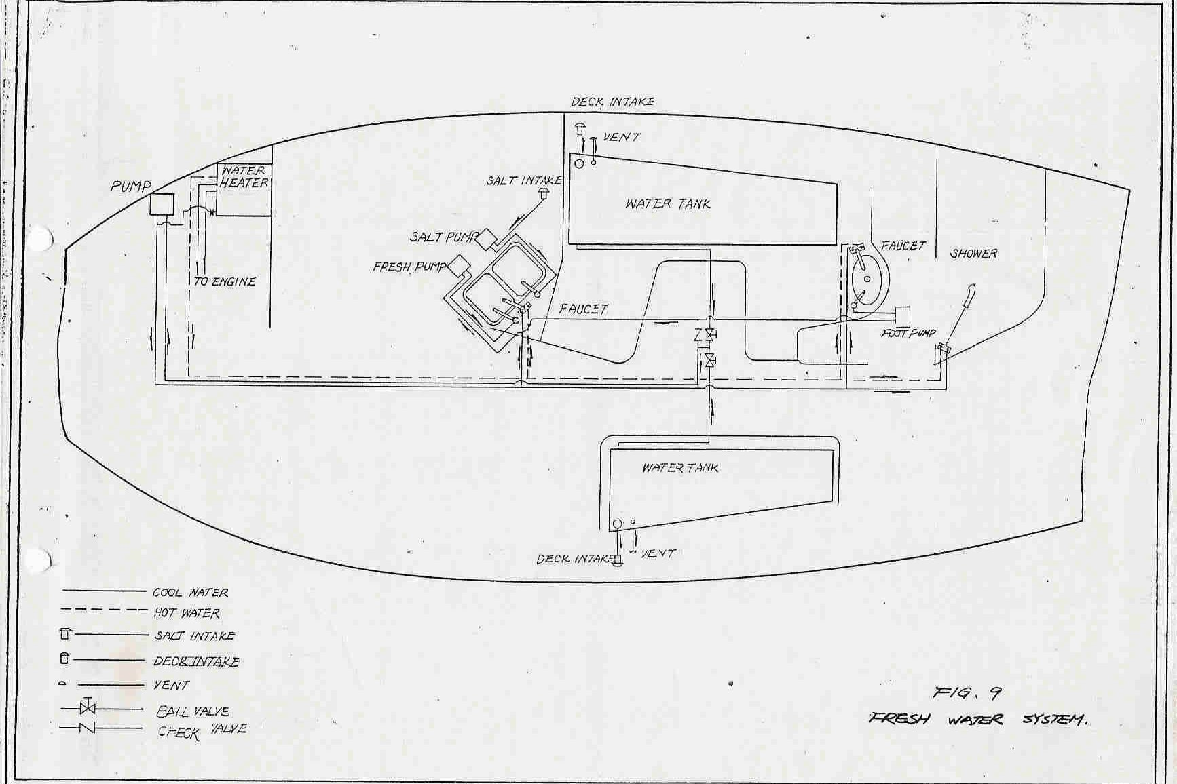

FIGURE 9. FRESHWATER SYSTEM

TOILET SYSTEM

All Tashiba yachts come equipped with a marine head and holding tank as standard equipment. the marine head is provided with a “y” valve which allows the operator to divert waste into the holding tank or directly overboard.
For toilet system see Figure 10.

OPERATING TOILET

Make sure the inlet and discharge seacocks are open. Move the valve lever to the “flush” position and operate pump. Return the valve lever in the “dryBowl” position and pump the bowl empty. Leave the valve in the “dry-bowl”

position when the toilet is not in use, and close the sea-cocks when the boat is unattended.

TO EMPTY HOLDING TANK

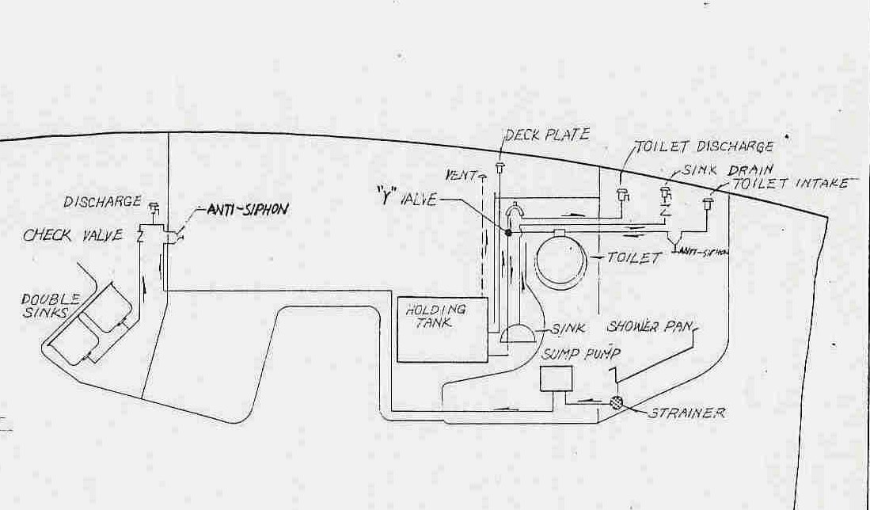An optional discharge pump can be ordered or, pump out by the standard deck fitting is possible if access to a dock side pumping unit is available. The optional pump should be pumped until liquid is totally removed and air is

FIGURE 10. TOILET SYSTEM

heard flowing through the pump. It is recommended that after emptying the holding tank of waste, a disinfectant and deodorant be pumped through the head and into the holding tank along with sufficient raw water to fill the holding tank. After pumping chemical and water into the tank, re-empty it a described.

CLOGGED DISCHARGE LINE

- Check the siphon break for clogging by loosening hose clamps and removing the hose. Check the head side of the siphon break.
- Check the inlet of the “y” Valve by removing the hose.

Note: Never try to flush hard items as this will damage the marine toilet. As a safeguard against a spoiled vacation, it is mandatory for every owner to understand his marine toilet system, cary spare parts (see head manual), And thoroughly brief his guests on the units proper use.

MARINE HEAD ANTI-SIPHON VALVE

The marine head is fitted with an anti-siphon valve which must be periodically checked to ensure that there are no problems in the venting action which could cause sticking and possible flooding through siphon action. Disassembly, Cleaning and inspection every six months is necessary.

BILGE PUMP

The Tashiba Yachts come equipped with a manual bilge pump and an electric pump as standard equipment.

MANUAL BILGE PUMP

The pump is equipped with a bilge strainer and installed on the cockpit seat back-rest for easy operation.

ELECTRIC BILGE PUMP

The electric pump is operated by using the switch on the d.c. panel. The suggested optional automatic float switch will automatically turn on the pump
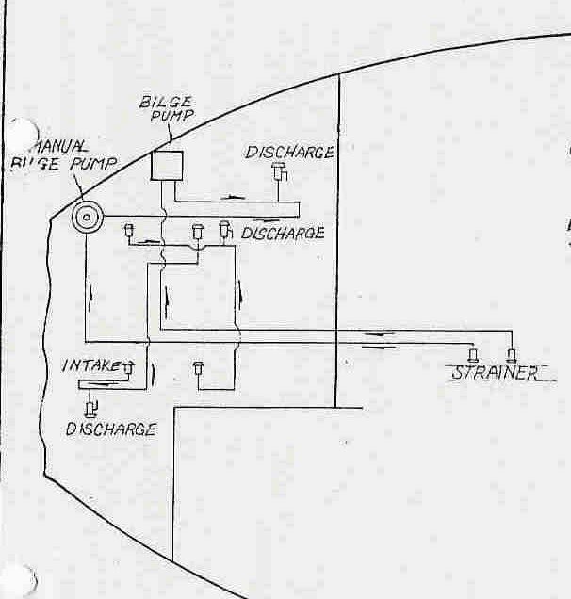

FIGURE 11. BILGE PUMP SYSTEM

whenever excess water enters the bilge. this pump also has an anti-siphon loop in the discharge line.

BILGE PUMP MAINTENANCE

Maintenance of the system involves keeping the intake screens clear of debris, and regular checks of the anti-siphon valve function.
For bilge pumping system see Figure 11.

DRAINS AND SEACOCKS

Rubber or reinforced PVC hose is used for all intake and drain lines. These connect via hose barbs and clamps to the bronze ball valves and through-hulls. all pumps, except the manual bilge pump, have anti-siphon discharge loops.
Maintenance and inspection of these items is essential to the safety of the boat. the following points in particular should be noted:

HOSES AND CLAMPS

Check all hoses for condition and clamps for tightness on a regular basis. Replace any that show determination. Never use commercial drain cleaner to free a hose as the caustic agent may damage the hose.

CHECK VALVES

Check valves are maintenance free. however, they sometimes clog with debris. A sharp rap on the side of the valve may free it; otherwise it will have to be disassembled and cleaned.

BALL VALVES AND THROUGH-HULLS

The seacocks used in the Tashiba yachts consist of quick-acting ball valves connected to through-hulls. These items are made of corrosion resistant bronze. In addition, each through hull is connected to the bonding system which incorporates sacrificial zinc anodes. These anodes will corrode as time passes protecting the through-hulls. Nevertheless, the through-hulls should be checked for corrosion and replaced should any be found.

The valves should be operated regularly to prevent seizing, whenever the boat is hauled out, any sticky valves or valves with marine growth inside should be disassembled and cleaned. Ball valves are open when the handles are inline and closed when at 90 degrees.
Sea-cock detail see figure 12.

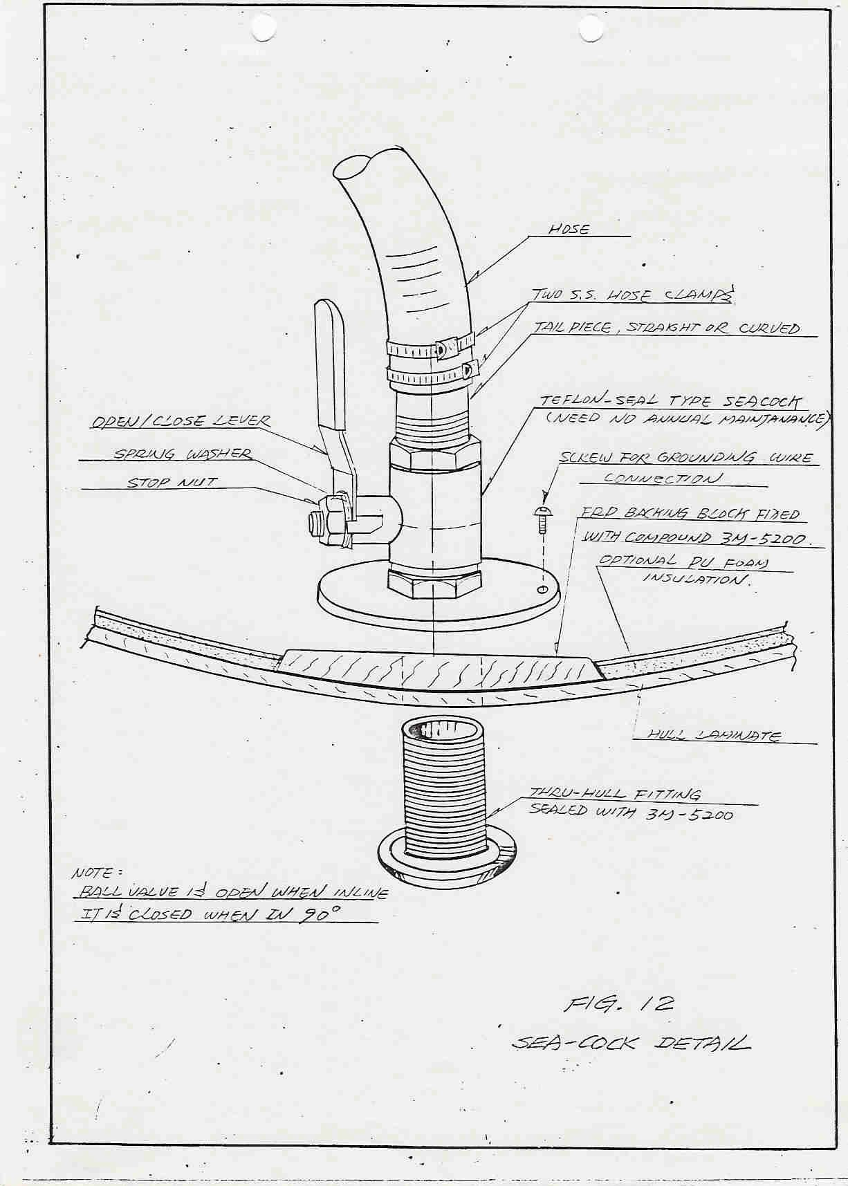

FIGURE 12. SEACOCK DETAIL

ICE BOX DRAINS

The icebox is insulated with 4” of PU foam and should retain low temperatures over extended periods of time.
The ice box drainage refer to fig. 9 fresh water system.

SHOWER DRAINS

The shower water is drained to the bilge pump, then discharged overboard by the bilge pump. If an optional shower sump pump is installed, then it will pump directly overboard via a vented discharge loop and a sink drain through hull. (sump pump is standard item for Tashiba 36 and 40).
The strainer of the shower pump must be cleaned periodically, and the anti-siphon loop valve on the sump pump discharge must be checked for function.

STEERING SYSTEM

The Tashiba yachts are fitted with a stainless steel pedestal operating steering system. Cables are driven by a chain over sprocket on the steering wheel shaft. The stainless steel cables are spiced to the chain ends and run via sheaves to the quadrant at the rudder post.
The Tashiba ph model has an indoor steering station in addition to the pedestal steering on the cockpit area. The maintenance and inspection of the system is essential to the safety of the vessel.

MAINTENANCE AND INSPECTION

The steering cable tension can be adjusted at the quadrant by turning the nuts on the wire take-up eyes after loosening the lock nuts. The same number of turns should be made on both sides to maintain the steering chain at the center position. Only enough cable tension is required to eliminate any loose feel in the steering, and to prevent the cables from jumping out of the grooves in the quadrant or sheaves. Excessive tension will quickly cause excessive wear on parts of the system.
Annual lubrication of the system is very important. The sheaves must be carefully greased with teflon grease. The wheel shaft should be oiled. the pedestal chain and all exposed cable should be lightly rubbed with an oiled cloth. This will also detect any broken cable strands indicating that the cables must be replaced.
Check that the sheaves and quadrant have proper alignment to the cables and adjust as necessary.

Finally, recheck your steering center mark, if any, and adjust as necessary.
Note that steering cable should be replaced every five years even if wear is not evident. The old cable can be retained as a spare.

USE OF EMERGENCY TILLER

If a failure of the steering system occurs, the emergency tiller can be used
The rudder shaft is machined to accommodate the socket at the base of the tiller shaft.
It is recommended that a small cable cutter be carried aboard allowing the owner to cut away a tangled cable quickly and regain steering control.
For steering system see figure 13 and 14.

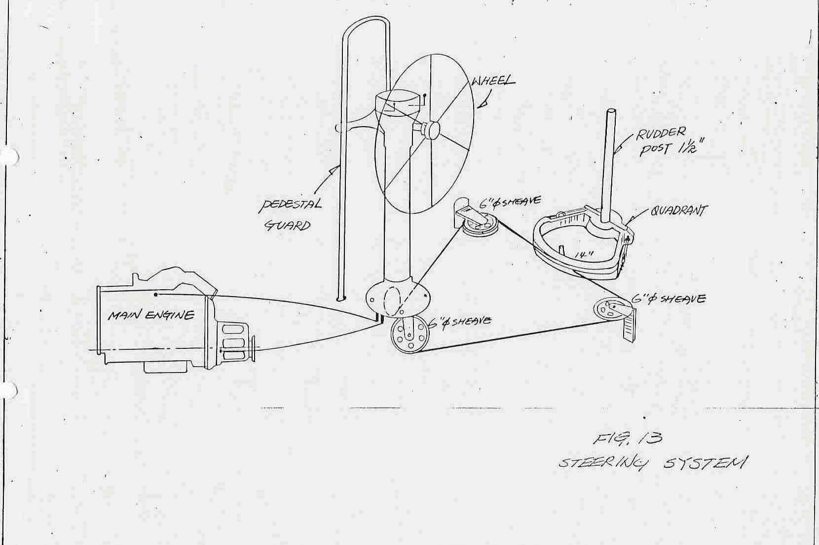

FIGURE 13. STEERING SYSTEM

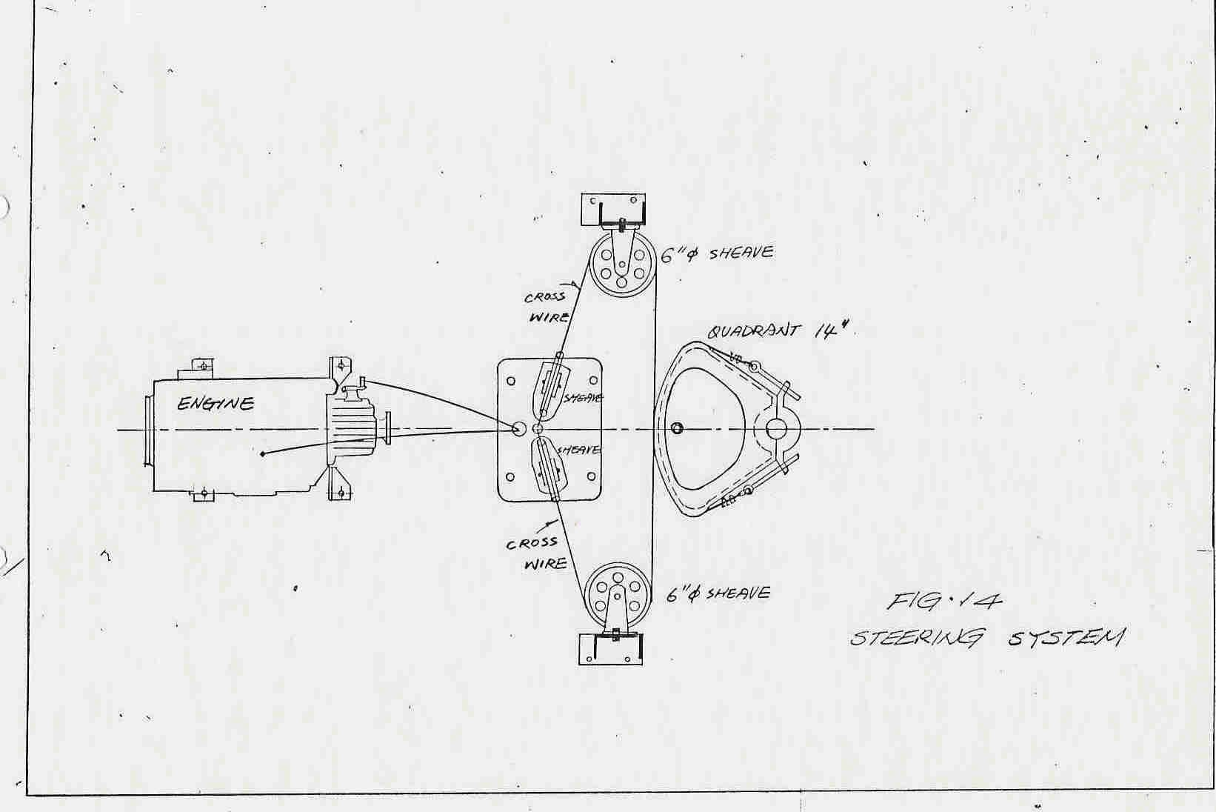

FIGURE 14. STEERING SYSTEM

RUDDER

ELECTRIC SYSTEM AND SWITCH PANEL

Tashiba Yacht has a combination electric panel for the 12V D.C. and 110V

A.C. system.

All circuit breakers used on this panel are of a “trip free” design and can not be manually held on to override the current-interrupting mechanism when in an overload condition.

12V D.C. SYSTEM

The 12V D.C. wiring diagram appears later in this owner manual and also see section 11 for battery information and use. The panel incorporates a voltmeter and ammeter to monitor battery condition and current draw.
Wiring for the 12 volt system has been run in accordance with industry standards and quality wire and connectors have been used throughout. A salt air environment and continual boat vibration require that the wires and terminals be checked routinely for corrosion or wear.
Power is supplied either by the single standard battery or by the alternator when the engine is operating. A master battery switch is located at the chart table area which also selects the power from one or both batteries if an optional second battery is installed in this case, one battery should always be kept in reserve for engine starting.
Caution:

Do not shut off the battery switch while the engine is running or serious alternator damage may result.

110V A.C. SYSTEM

The 110V Ac Standard system is powered by dock side supply. The electric panel incorporates an A.C. voltmeter and ammeter for checking the power supply voltage and current.
Polarity:

Appliances requiring a continuous ground or proper polarity rely on the correctness of the wiring of the shore power connection you make. Improper wiring of the shore outlet can result in equipment damage and is potentially dangerous to all passengers.

The polarity indicator will light when the polarity is reversed.Use a shore power cord and a suitable pigtail if necessary, to adapt to the dockside outlet.
Important:

To minimize shock and fire hazards:

    - Turn off the boat’s shore power switch before connecting or disconnecting the shore power cable.
    - Connect the shore power cable at the boat first.

    - If the polarity warning light on the panel is activated, immediately disconnect the cable and have the fault corrected by a qualified electrician.
    - Disconnect the shore power cable at the shore outlet first.

    - When using pigtail adaptors, make sure the outlet being used is 110 volts with ground. 12V & 110V electric systems see figure 15 .

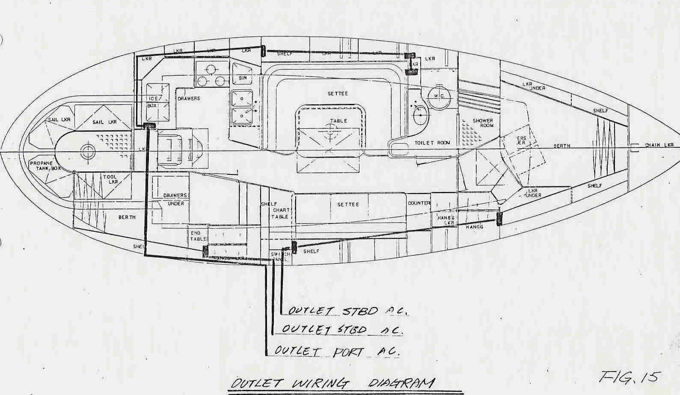

FIGURE 15. AC OUTLETS

BONDING SYSTEM

The Tashiba Yachts are fitted with a low resistance common ground or bonding system. This system connects all large metallic masses, all equipment grounds (AC & DC), and all underwater metal fittings, electrically together. This is to ensure that the grounds are all at the same potential to reduce the risk of electric shock. At the same time, the possibility of stray current corrosion is reduced.
In addition, the system is connected to the ship’s zincs. These zincs are intended to protect the underwater metals by corroding galvanically first. They will continue to protect the other fittings as long as they are electrically connected to them and immersed in the same body of water. It is therefore very important to renew the zincs regularly and before they are reduced below one-half their original size. When replacing zincs, do not

paint them or their will be eliminated. Their mounting details are shown in Figure 16.
If the boat is in a marina where stray currents from other boats or shore power ground problems cause rapid zinc loss, this procedure may be followed. Purchase a large zinc at your chandlery and a length of 8 gauge wire. Bolt the wire to the zinc making a good electrical connection. Suspend the zinc in the water and connect it to any bonded metal on the boat, such as the backstay. It will then begin to corrode, slowing the zinc loss on the regular ship’s zincs, and protecting the underwater fittings.
Figure 17 shows the ship’s bonding and ground system. remember that the bonding system must never be used to carry current such as a 12 volt negative return from an accessory. It is intended only as a ground system; any impressed currents may damage the ship’s fittings.

BATTERY

The Tashiba 31 is fitted with one 100A battery and selector switch which is used for extra batteries if needed. Many owner’s do considerable cruising and “living aboard” so that a second battery may be added to meet these requirements and keep one battery only for the use of engine starting. (Tashiba 36 or 40 is fitted with two 100A batteries as standard).

OPERATION OF THE D.C. VOLTMETER

Turn the selector switch to “off” or “BATT. 1” or “BATT. 2”. Then select Battery #1 or Battery #2 (optional) on the Battery test switch. It’s Voltage will be indicated on the dc voltmeter.
It is important to keep the batteries fully charged at all times, Low batteries may effect the function of s radio, depth sounder or other electronics. A no-load reading of approximately 12.8 volts indicates a full state of charge.

BATTERY MAINTENANCE

Correct battery use and maintenance will prolong their life. These points should be followed:
- Severe over-discharging may harm the battery plates. Damage will be reduced if the batteries are promptly recharged.
- The batteries must not be allowed to remain below full charge for an extended period, or damage will occur.
- The battery tops should be kept clean and dry to avoid trickle discharging. a baking soda solution may be used to clean the tops,

but do not allow it to enter the cells. the solution should be rinsed off and the tops carefully dried.
- The cable terminals and battery post must be kept clean and corrosion free. A stainless wire brush or sand paper may be used. A light coating of petroleum jelly should then be applied to retard corrosion.
The cell electrolyte level must be maintained. fill the cells with distilled water only to the indicator. Distilled water should be always be used unless you know the local water is low in chlorine and iron.
CAUTION:

Battery electrolyte is a dangerous acid. Gloves and goggles should be worn when working with batteries. If electrolyte is splashed on skin or clothing, flush with plenty of water. If it is splashed in the eyes, flush immediately with running water for 15 minutes and call a physician.
Batteries produce explosive hydrogen gas. When charging ensure that battery compartments have ventilation and keep fire, flame, and cigarettes away from batteries. To reduce the risk of explosion due to sparks.
Follow these steps the connecting and disconnecting batteries:

- Turn off the battery selector switch.

- Disconnect the ground cable first.

- When reconnecting, always check the polarity carefully, then connect the positive cable first
In addition, use caution when working around batteries with metal tools. A short circuit caused by touching the positive terminal and a grounded metal part could cause personal injury.

ANTIFOULING

The following is general introduction, follow paint manufacturer’s instructions in preference to these suggestions.

PREPARATION

The preparation of the hull bottom to receive coatings is critical to the performance of the coatings. Most coating failures are due to poor preparation.
The new boat has a waxy slick surface which must be broken to give coatings a good substrate. use 280 or 320 grade sand paper on a sanding block. Coarser paper will scratch the gelcoat too deeply and impair its performance as a water barrier. the surface must be sanded until water evenly wets it with no beading. It should appear evenly dull with no gloss when dry. If after sanding, Water still beads, wipe down the surface with an epoxy thinner to remove wax traces. Allow to thoroughly dry.

SELECTING A COATING SYSTEM

An epoxy barrier coat system is highly recommended to increase the trouble-free life of the hull by preventing water passage into the gelcoat and laminate.
The epoxy barrier coatings and the antifouling paint must be compatible and applied according to the manufacturer’s instructions.
Different antifouling paints are suitable for different usages and the type of paint decision should be made by discussing the advantages of each with the paint supplier and your dealer.

APPLICATION

Application of coatings is dependent on their type. follow the manufacturer’s instructions carefully.
Note especially the warning and cautions given by the manufacturer’s. Antifouling paints are toxic, and epoxies are highly sensitizing. proper breathing equipment, gloves and clothing must be used.

FIBERGLASS MAINTENANCE

Although FRP boat looks smooth and shiny, FRP is actually a fairly porous material and as it ages, the pores in the gelcoat surface will become more pronounced. Sunlight and salt water will attack the gelcoat, turning shiny surfaces dull and chalky, stains will become permanent, colors will fade, and refurbishing work will take on large proportions.
Although a new boat comes with the natural gloss of the fresh gelcoat combined with the waxed and release agents used in the moulding process, the sheen will begin to fade immediately unless steps are taken to preserve it. The best thing you can do for a new boat is to put a good coat of wax on it immediately.
As the boat begins to look used, the following steps may be followed:

Starting with a thorough washing with warm fresh water, liquid detergent and soft-bristled brush, the entire boat entire boat should be scrubbed down to remove dirt, dried salt, and any residues. No abrasive powders should be used that might scratch the delicate gelcoat surface. Paint thinner helps to remove oil and exhaust stains and stubborn stains can usually be removed with a cautious application of acetone, but remember that too much can damage the gelcoat. Use acetone or paint thinner only in well ventilated areas away from fire or electrical appliances. Wear rubber gloves and eye protection and avoid breathing vapors.
Once the hull is clean, a large automotive-style buffer should be used on the topsides and the cabin sides. Start with a mild polishing compound following the instructions on the container. scuffs and stains are erased by the compound, which also removes any oxidation that may have started to form

on the gelcoat. Dupont’s white polishing compound or similar types may be used. (The red is too abrasive.)
The most common mistakes that owners make is to simply apply the wax when they finish using the rubbing compound. It is important to completely rewash the surface, using plenty of water and a sponge to sluice off the residue of the rubbing compound.
Once clean again, the hull and smooth deck areas should receive a coat of paste wax. Depending on the type of wax used, it may be applied while the hull is still damp or when it has fully dried, but be sure to follow the directions carefully. Use only a marine paste wax since automotive waxes won’t fill the pores in the fiberglass as well and many auto waxes will turn white and chalky when exposed to salt water. Once the wax has turned to a dry haze, a clean buffing pad should be used to burnish it to a high sheen.
Molded in non-skid decks attract dirt, but a good marine cleaner and a stiff brush will generally clean out the pattern. Leaving non-skid areas unwaxed will maintain the non-skid effect.

WINTERIZING

The end of the season is a good time for complete inspection of all the boat’s systems. Taking the time to put the boat away in good order will expedite an early launch in the spring.

HAULING

The lifting slings is to be placed at a location to avoid damage to the propeller shaft and to ensure that the center of gravity of the boat is between the slings. If a knot meter impeller is in these areas it should be withdrawn per manufacturer’s instructions to avoid damage.
The boat must be well supported on a cradle with most of the weight on the keel. The supporting pads for the hull should be smooth and shaped to the hull if possible. The ideal locations for the support pads are in line with the bulkheads in the boat.

HULL BOTTOM

Scrape and scrub the hull bottom to remove all growth as soon as the boat is hauled. Bottom painting should wait until spring for best results. See Section 12.

ZINCS

Replace the zinc plates after bottom painting in the spring. The zincs must not be painted. See Section 10.3.

FRESHWATER SYSTEM

Winterize the fresh water system with one of the commercially available non-toxic antifreezes designed for potable water systems. Follow the instructions carefully.
Turn off the pressure water pump. Then, the hot water heater should be turned off and allowed to cool. The pressure relieve valve lever should be opened to relieve pressure and then disconnect the hot and cold hose connections. do not disconnect the heat exchanger hoses from the engine. Use a short length of 1/2” diameter tubing to connect the hot and cold lines together to by-pass the heater.
Pump the water system and both tanks dry by turning on the pressure water system and all taps. pump out first one tank then the other and remember to pump out the foot pump system as well if installed.
Mix the antifreeze solution per the instructions to the correct concentration for your area’s temperatures. 1 1/2 to 2 gallons are required for each water tank.
After the solution is in the tanks, open both tank valves and energize the pressure water pump. open each fixture in turn, both hot and cold, until the antifreeze solution comes out. Also operate the foot pump(s) if installed.

HEAD AND HOLDING TANK

Several days before completing the haul-out procedure, fresh water should be allowed to stand in the head unit to dissolve any salt accumulation in the hoses and pump. special lubricants for the pump’s internal mechanism are available and my be required. Check with your marine supplies dealer.

Pump out all waste and pour in a cleansing, deodorizing solution. Allow this to sit in the tank overnight if possible, then completely pump out and drain the entire system.

ENGINE

Refer to the engine manual for the details.

FUEL SYSTEM

Shut-off the fuel valve and drain the fuel filter. Clean the filter bowl and replace the fuel element filter in the spring before launching. The fuel tank should be kept full for winter storage with about 5% expansion room left at the top since empty fuel tanks encourage the formation of condensation.

BATTERIES

Clean battery terminals and cable ends thoroughly of any corrosion with a baking soda and water solution. Apply a light protective layer of petroleum jelly and store in a warm, dry place. Batteries should be fully charged before storage and the fluid level should be at the indicator. Check the charge with a hydrometer monthly and recharge as necessary. Discharged batteries become permanently damaged.

SEACOCKS

Open and drain all seacocks after haul-out. All seacocks are the teflon seal type which do not require lubrication. Any valves which leak or are difficult to operate should be replaced.
Seacocks used for drainage of the cockpit, Anchor Locker or cockpit lockers must be left open to drain these areas.

BILGE

Completely pump the bilge free of any water and clean out any debris present. Bilge pumps should be pumped dry and hoses disconnected if necessary to ensure that no water is left in the system.

ICE BOX

Remove any remaining food from the ice box and wash down thoroughly with a warm water and detergent solution. Odors can be removed with a baking soda and water solution. Completely drain out any water from the bottom of the ice box. Then leave the icebox lid open during the storage to allow ventilation.

STOVE

Clean the stove thoroughly. For CNG and LPG stoves, remove the tanks containing as and store them in a warm dry area.

COVERING THE BOAT

Cover the boat adequately during storage to prevent excessive weathering, Note: Black polyethylene film can cause excessive fading in colored gelcoat if in direct contact with fiberglass surfaces. This is caused by a chemical reaction between the polyethylene and the gelcoat. The boat cover should be of breathable fabric or be designed to allow good ventilation.

MAST

The aluminum mast requires a minimum of care and maintenance. At the end of each season if should be washed with a mild detergent and water solution, followed by a complete rinsing with fresh water, Tie off all halyards and

lifts and inspect the mast completely for scratches through the finish. Paint or clear lacquer should be applied to any scratches found to prevent corrosion.
Check all hardware on the mast carefully for signs of corrosion and check the tightness of the fastenings. Masthead sheaves should show no signs of wear and should move freely Lubricate if necessary.

SAILS

SAIL CARE

At present, the vast majority of sails are made from polyester and nylon. Although these synthetic materials need far less attention than cotton sails of old, they will last considerably longer if they are taken care of correctly.
You should check your sails regularly both the set aloft and when folding them after use. If you look at the sails carefully you will nearly always notice signs of damage starting, a small hole, an area of chafe, a few broken stitches. These small problems should be rectified as soon as possible, not put off to a later date. Remember the old saying ‘ A stitch in time saves 9.’ in the case of sails it usually means ‘saves 9,000’.
When you find one of these problems on your sail, try to find the cause of it. If you don’t rectify the object which is causing the problem, it will only happen again.
Some common “sail killers” are listed below followed by suggestions on how they can be avoided.
- Rigging split pins

These should always be taped up.

- Spreader ends

These should either be taped up or be bound with soft leather.

- Life line stations

These can catch and chafe sails during tacking.

Once you have established exactly where your sails chafe against speakers and stanchions it is a good idea to get your local sailmaker to sew patches over these areas to protect the sail from further chafe.
- Thread Chafe

When sails tear, other than when they have caught something sharp, It is nearly always a seam failure, and it nearly always starts from the leech. What usually happens is that the leech line chafes the stitching on the seam where the cloth is turned over on itself to form the tabling up the leech.
You should regularly check the stitching on each seam where it is folded over at the leech. If a couple of stitches have worn through here , have the sail attended to by your sailmaker without delay. A few broken stitches in the middle of the sail is not a serious problem, but right at the leech is likely to be the beginnings of serious and major damage.
Some sailmakers sew a continuous tape down the leech to avoid chafe by the leech line, Some put small patches under the tabling at each seam to protect the stitching, but many do not do anything the seams from leech line chafe.

SAIL STORAGE

When ever possible, sails should be rinsed in fresh water and than dried prior to bagging, particularly colored sails like spinnakers, as the colors from darker panels may run and stain the lighter panels.
When drying sails ,do not hoist them on your rig and let them flap, particularly if there is much more than a gentle breeze. Prolonged flapping will seriously reduce the strength of the sailcloth, and thus the life of the sail.
Sails covered with salt tend to attract moisture from the atmosphere. Damp sails stored in compact confines of a sail bag are prone to mildew.

HOW TO CLEAN SAILS AND REMOVE UNWANTED STAINS

Dirty Sails - Use mild detergent with cold or lukewarm water and a scrubbing

brush.

Oil Stains - On woven polyester sails use solvents such as White Spirit.

Rust Stains - use a 5% oxalic acid solution which will bleach the cloth.

Blood stains - These can be removed by using a mild ammonia solutions.

Mildew - Use dilute Chlorine bleach.

Please ensure that you rinse the treated area of the sails after using any of the above agents.
It is not advisable to use any of the these chemicals on mylar sails. In these sails the polyester film (mylar) is laminated to a substrate to enhance its strength characteristics and tear strength. These chemicals may well attack the bonding agent used which could lead to delimitation.

ULTRA-VIOLET (U.V.) DEGRADATION OF SAILS

U.V. light is one of the worst enemies of sails.

The molecular structure of polyester and nylon is rapidly broken down by

U.V. light, thus the longer a sail is left out in the sun the weaker it becomes.
If you leave your mainsail on the boom, or your headsail furled on the forestay, make sure these sails are covered by U.V. Resistant materials.
If you follow these suggestions and guidelines you will be rewarded with fewer major repair bills, and sails that will provide a considerably longer useful life.

We wish you smooth sailing.

