Chapter I

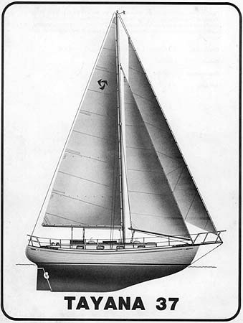

OPERATIONS AND MAINTENANCE MANUAL

Chapter 1

TAYANA 37

OPERATIONS
AND MAINTENANCE
MANUAL

Originally prepared by Southern Offshore Yachts.
Converted to digital format by Harvey J. Karten August 1998. Current update: 1/10/02 Many thanks to Ed Potter, Tom Beard and Mauro Migliorelli

TABLE OF CONTENTS

- INTRODUCTION .

- SPECIFICATIONS
II-A. General Design Specifications II-B. Serial Numbers
II-C. Materials
II-D. Construction
II-E. Importer's Documents
II-F. Procedures & Data For Documentation .

- COMMISSIONING AND DECOMMISSIONING
III-A. Initial Commissioning III-B. Owner Commissioning
III-C. Decommissioning for Storage III-D. Recommissioning After Lay-Up

- OPERATING PROCEDURES
IV-A. Sailing The Tayana 37 Cutter IV-B. Sailing The Tayana 37 Ketch IV-C. Tuning The Spars And Rigging IV-D. Tuning Under Sail
IV-E. Handling Under Power IV-F. Fuel System
IV-G. Electrical Systems
IV-H. The Plumbing Systems

- MAINTENANCE & MAINTENANCE PROCEDURES
V-A. The Hull
V-B. The Deck And Cabin Top V-C. Interior Woodwork
V-D. Spars, Rigging, And Sails
V-E. Auxiliary Engines & Related Systems V-F. Electrical Systems
V-G. Plumbing and Sanitation Systems

LIST OF ILLUSTRATIONS AND TABLES

Drawing

Tayana 37 Cutter Sail Plan Tayana 37 Ketch Sail Plan Tayana 37 Deck Plan

Tables

ELECTRICAL SYSTEMS/The Energy Audit System (Table IV.-1)

ELECTRICAL SYSTEMS/The 12 Volt System (Electric Wire Number & color Codes-Table V.-1.)

Figure

CONSTRUCTION. Thiokol Joints (Figure II.-l.) FUEL SYSTEM - (Figure IV.-1.)
FRESH HOT AND COLD WATER SYSTEM - (Figure IV.-2.)

AUXILIARY ENGINES/Installation
Exhaust And Engine Mounting -(Figure V.-1.)

ELECTRICAL SYSTEMS/The 12 Volt D.C. System
(Figure V.-2.)

PLUMBING AND SANITATION SYSTEMS/Bilge Pumping
Systems - (Figure V.3.)

ANNEX I ............................................................................................... Winch Assemblies
ANNEX II .............................................................................................. Warranty
ANNEX III ............................................................................................ Miscellaneous Info
PHRF Rating
Rigging (P, I, J and E Values) of Cutter Fuel Tank Depth vs. Volume

INTRODUCTION

You are to be congratulated on your selection of the TAYANA 37 cruising yacht. There is no better yacht in her size range on the market. With care and proper maintenance she will not only prove to be an excellent investment, she will take you cruising anywhere in the world safely and comfortably. This is being proven almost daily. Ocean crossings by TAYANA 37's are routine. Circumnavigations have been reported. By the same token, over 100 of these yachts are the primary homes of their owners.

The object of this handbook is to help you to know your yacht and to guide you in providing proper care and maintenance. And really, it isn't very hard- in fact, it can be a lot of fun. Your TAYANA 37 has been designed and built with maintenance in mind. Machinery, pumps, glands, seacocks, etc. have been installed to insure full and easy access. Where simplicity and adequate function do not conflict, the simpler equipment has been chosen. In a few cases, custom interiors have complicated some equipment installations, but you will find that adequate access and straight-forward installation have alleviated the potential for problems.

In the various sections which follow, you will find discussions of materials and construction, hull maintenance, rigging and sails, machinery-electrical systems and plumbing. But remember, this is a TAYANA 37 manual. It is not a general maintenance manual. It is not designed to take the place of your manufacturer's equipment manuals. In fact, should you find conflicts between this manual and that published by the manufacturer of any piece of equipment, the manufacturer's recommendations should be followed.

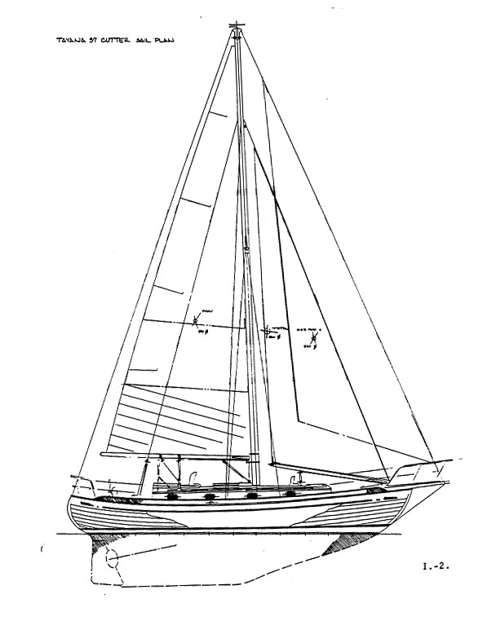

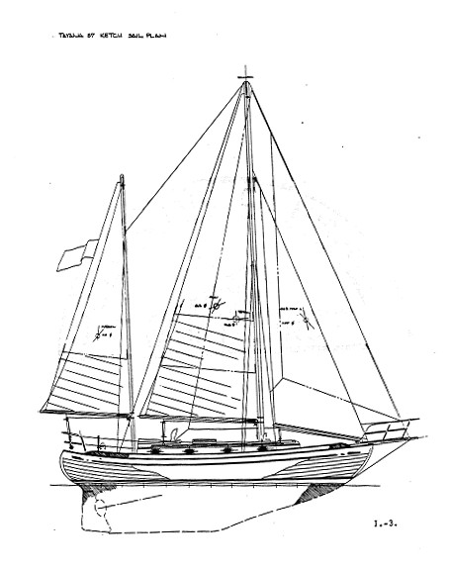

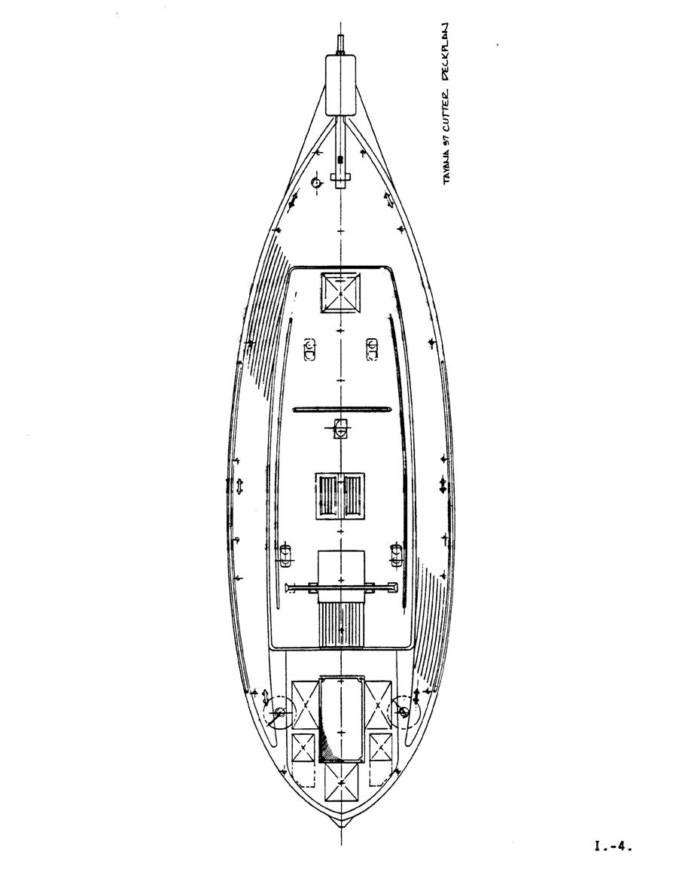

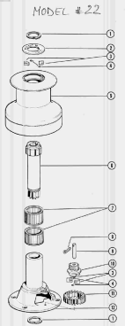

BARIENT WINCH #22 WINCH ASSEMBLY

Volume in Fuel Tank in Bow of older Tayana 37 as a function of height of fuel in tank. As the tank is shaped in the form of a polyhedron, the exact relationship of fuel level to total volume is non-linear and difficult to assess. Based on data provided by Tom Beard in TOG News.

Fuel Tayana 37 BowTank

25

20

15
Depth

10

5

0
0 10 20 30 40 50 60 70 80 90 100
Gallons

Chapter II SPECIFICATIONS ...............................................................................................II-1
A. General Design Specifications ......................................................................................II-1
B. Serial Numbers...............................................................................................................II-2
C. MATERIALS ................................................................................................................II-4
D. CONSTRUCTION........................................................................................................II-5
E. IMPORTER’S DOCUMENTS (No information provided in manual) ..........................II-8 F. PROCEDURES AND DATA FOR DOCUMENTATION...........................................II-8 Procedure ........................................................................................................................II-8

Chapter II SPECIFICATIONS

General Design Specifications

Length Overall 42' 2"
Length on Deck 36' 8"
Length Waterline 30' 10"
Beam 11' 6"
Draft 5' 8"
Displacement 22,500 lbs. (dry)
Ballast (Internal) 7,340 lbs.
D/L (Displacement/Length) 337
SA/D (Sail Area/Displacement) for Cutter 17.3
B/D (Ballast/Displacement) 33%
Sail Area
Cutter 864 square feet (total)
Main | 342 sq. ft.
Jib | 292 sq. ft
Staysail | 230 sq. ft
Rigging Values:.
I = 51.0 (Length from top of mast to deck) – May vary – confirm on your boat. J = 19.25 (Length from Forestay to mast )
P = 44.0 (Length of Luff of Mainsail) E = 15.25 (Length of Boom)
Calculated length of forestay based on I and J values = 54.5' Approx. area of 110% Genoa = 470 Square Feet
Source of Data: DESIGNER'S SAILPLAN – obtained from SailRite Webpage PHRF Rating of Tayana 37, Cutter Rig = 180
Ketch 786 square feet (total)
Main | 263 sq. ft
Jib | 209 sq. ft.
Staysail | 156 sq. ft.
Mizzen | 140 sq. ft.

Standard Engine Depending upon year of construction and original owner’s choice: Perkins 4-108 Diesel or YANMAR 3QM30 Diesel
Fuel Tankage may vary 100 gallons (U.S.) Water Tankage may vary 100 gallons (U.S.)
Vertical Clearance 55 feet (Verify on your particular vessel)

Non-Dimensional Values:
Hull Speed | 7.46
Comfort Index | 40.78
Capsize Ratio | 1.63
Pounds/Inch | 1,274
(Pounds per Inch Immersion: The weight required to sink the yacht one inch.
If the boat is in fresh water multiply the result by 0.975. If you know the beam at the waterline (BWL) multipy the result by BWL/Beam. )

Serial Numbers

Hull Number (Coast Guard) Engine Serial Number
Hot Water Heater Serial Number Stove Serial Number
Battery Charger Serial Number Stereo Serial Number

Polars for Tayana37 Cutter

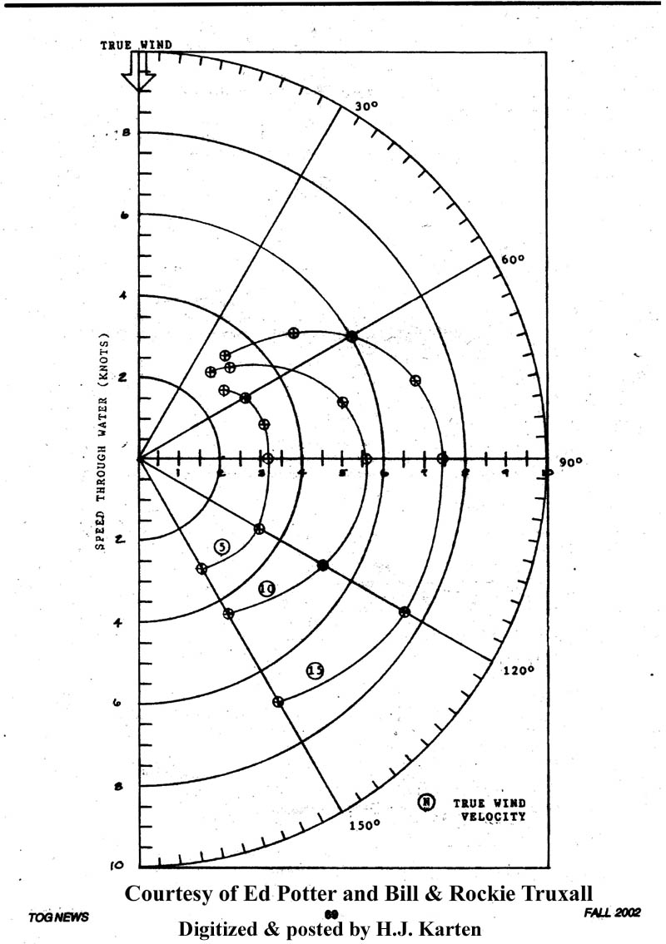

MATERIALS

A few words about materials are called for because of the many questions people ask about the quality of the metals, woods, and plastics used in Far East built yachts.

Resins. The resins used in the construction of TAYANA yachts are polyesters purchased in the United States or Japan. Their quality equals or exceeds that of the resins used in nearly any U.S. or European building yard. They are not of the fire retardant type, however. Yachts built from late 1985 use isophthalic gel coats to resist blistering.

Fiberglass: Fiberglass is generally purchased from the United States although some Japanese and European glass is used. The primary glass structures are made from 1.5 ounce mat and 24 ounce woven roving.

Core materials. Various core materials are used. If a cored hull has been ordered the core material is Airex (TM). This plastic material is light and highly resistant to moisture. It also is an excellent insulator. The decks of TaYang yachts are generally cored with wood blocks cut into two inch squares and formed into core "mats" much as Balsa is used. It is heavier than either Balsa or Airex, but it is cheaper than either and tolerates fastenings better. Where there is to be a heavy installation of some type, such as a winch or windlass, the core material is usually a solid plywood sheet covered on both sides by a heavy fiberglass laminate.

Teak. Teak is obtained from several sources. The most common, at this writing, appears to be Indonesia. The demand for Teak is sufficiently high that properly cured Teak is virtually impossible to find. It has been reported to us that the Teak obtained by TaYang is generally two to three years old when purchased. This Teak is then cut into planks and stored in a drying yard for a period of months. It is dried further in a kiln before it is used on a yacht. Optimally, Teak would be aged for seven to eight years before use and kilns would not be used.

Curing cracks have occasionally been a problem in yachts with solid Teak table or desk tops. Where this has occurred, the tops have been replaced. On the whole, however, the Teak has been surprisingly good and, in applications such as ceiling and decks, it is almost problem free.

* SEE SECTION V. FOR PROPER MAINTENANCE CARE.

Plywood Plywood is the core material used in interior bulkheads, soles, and tops as well as for certain structural applications. TaYang does use marine plywood. The glues used

between the plys is waterproof. There have been few plywood problems when owner maintenance has been reasonable.

Stainless Steel Type 304 stainless steel is most common in yachts whether built in the Far East or elsewhere, and that is what TaYang generally uses. Type 316 stainless steel is the best for yacht application. but it is considerably more expensive than type 304. There is little difference in strength between them, but type 304 can tend to show corrosion which while generally-harmless, is irritating

Bronze Bronze fittings used on TAYANA yachts are made in Taiwan. Tests by an independent laboratory showed that the bronze used is of good marine alloy and grade. The bronze castings are C86800 (55Cu, 37Zn, 3Ni, 2Fe, 3Mn alloy while such items as turnbuckle barrels are C19000 alloy (98-7Cu, 1.1Ni, 0.25P) .

Iron TaYang uses iron in fuel tanks and ballast. This is important because iron is less susceptible to corrosion than is the mild steel that is occasionally used by some builders in place of iron. TaYang does paint the iron with a good quality red lead primer to help extend the life of the tank.

CONSTRUCTION

Your TAYANA 37 has been constructed of the finest materials, using the best techniques, and it exceeds the specifications laid down by any of the most accepted standard-setting agencies. The fiberglass schedule for the hull is shown in figure II-1. and Table II.-1. Layup is done in a single mold by hand using polyester resin.

The large female mold is separated longitudinally for cleaning and mold preparation. The gelcoat is sprayed in and the first glass layer is laid up. The mold is then joined and all the remaining layups are done in the assembled mold. While the hull is still in the mold, bulkheads are installed and the hull is allowed to cure. The deck is laid up in much the same way except that a core of wood is used in those deck areas which will generally be required to support loads such as decks and cabin top.

Ballast is made of a single casting of Black Iron. The ballast casting is lowered into the keel cavity and is fully encapsulated to become part of the hull. The deck and hull are joined by one of the strongest methods in the industry. A diagram of the deck to hull joint is shown in figure II-1. Assembling the hull and deck is one of the most critical operations in the yacht's construction. The deck is lifted by a crane above the hull. The joint is prepared with 5200 epoxy compound and the deck is then-set onto the hull. The joint is -then bolted together using stainless steel-bolts on varying centers depending on the curve of the hull at the various points. Once the joining has been accomplished, the joint is fiberglassed as shown in the figure. The result is a single piece, extremely strong hull with a rigidly curved hollow beam in the form of a bulwark running nearly the entire length of the yacht.

Once these critical operations have been finished to the satisfaction of the company engineers, exterior trim is installed and the work on the accommodations is undertaken. A team of the world's finest boat carpenters and finishers takes over the yacht and frames in the interior cabinets and bunks, as shown on the plans. This work is done with extreme care and attention to detail. Framing is actually glassed into the hull and becomes an integral part of it. As a result, the quality and livability of the accommodations is largely a function of how well the framers do their job. Cabinets, doors, drawers, and the like are done by cabinet makers in a specialty shop to the order of the production foremen. TaYang engineers closely supervise every step to insure that dimensions are met and proper installation is made. The result is a yacht whose strength and beauty are second to none and whose accommodations precisely fit the needs of its new owner.

The beautiful spruce spars which come on some TAYANA 37's are made in a special spar shop located in the factory complex. The spruce used is the finest that can be found and truly approaches aircraft quality. It is not unusual to see grains, which are perfectly straight for 20 feet. The spruce planks are carefully scarfed together to make planks of the proper length and glued into the box shape using epoxy. Wires, conduits and reinforcements are constructed into the spars as required. Final shaping and finishing is all done by handy men who have years of experience in building fine wood spars.

If aluminum spars are to be supplied, these are ordered from overseas suppliers- Taiwan has no extrusion capability at this writing. Generally, the suppliers have been ISOMET of France and YACHT SPAR out of New Zealand. ISOMET masts are received already anodized and cannot be painted. YACHT SPARS are painted at the yard and the color can be selected by the buyer. TaYang uses a primer and polyurethane for this. Aluminum spars are also being imported from Japan These are painted by the spar manufacturer.

Standing rigging is assembled at the yard using Japanese stainless steel cable and Taiwanese-made turnbuckles and swage end fittings. A crew at the factory sets up the spars and all of the rigging is fitted to each yacht. This is an important factor in cutting down the number of modifications which might have to be done in the U.S. Similarly, pulpit, lifelines, stanchions, and bowsprit are all installed to insure proper fit.

The final step is packing the yacht for shipment. Spars, rigging, and any projecting assemblies are all disassembled and packed either in the hull, or, in the case of the masts, into special boxes. On the shipping date, the yacht is loaded onto a lowboy and taken to the huge port city of Kaohsiung where it is loaded aboard one of the many container carriers which operate between Taiwan and the United States.

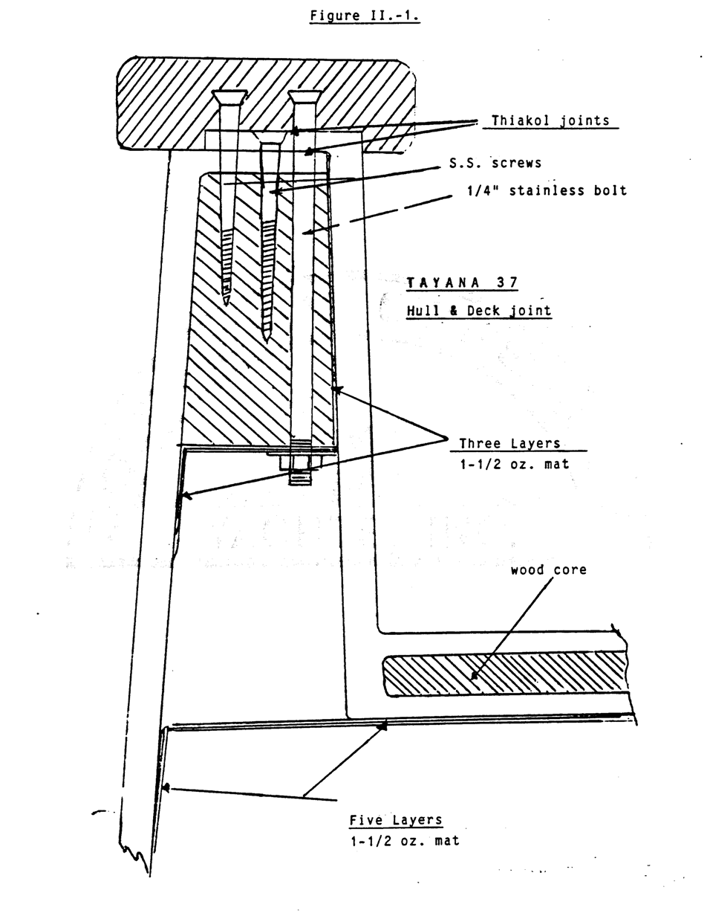

IMPORTER’S DOCUMENTS (No information provided in manual)

- PROCEDURES AND DATA FOR DOCUMENTATION

Documentation must be accomplished with the United States Coast Guard in the United States or with the governing agency in the country where your vessel is to be registered. We suggest you contact the Documentation office nearest you for full details, forms, and instructions.

The following notes and references are made for your information and convenience. They should in no way be misconstrued as complete and detailed instructions:

Procedure

Pleasure Class Under 20 tons requires a Yacht License. Twenty tons and over requires a certificate of Enroll- ment and a Yacht License.

Application for - Requires a Builder's Certificate
Admeasurement issued by the builder on the pre- scribed Coast Guard form. This certificate will be retained by the Coast Guard with certified copies available to the owner.

Admeasurement The admeasurer uses data in the Builder's
Certificate (BC) to compute net tonnage. The following formulas are used for sailboats:

Gross Tonnage = 1/2 (LBD/100) Net Tonnage = 0.9 (Gross Tonnage).

Where: L = Length
B = Breadth D = Depth

Official Number - After admeasurement files your certificate of tonnage, application is made for an official number. Title and mortgage papers are required.

Additional Forms - Applications for number.

Declaration of Ownership and/or

Extent of interest.

Identification of Owner's or Existing Mortgages.

Declaration of No Foreign Interest involved. Declaration of Master of Vessel.

Declaration No freight or Commercial Passengers to be Carried on Board.

Designated Home Port-Licensing Office.

Designated Hailing Port-Berth Marking Certificate

Commercial Class Contact your U.S. Coast Guard Documentation Office for
information- due to the complexity of application.

Volume in Fuel Tank in Bow of older Tayana 37 as a function of height of fuel in tank. As the tank is shaped in the form of a polyhedron, the exact relationship of fuel level to total volume is non-linear and difficult to assess. Based on data provided by Tom Beard in TOG News.

Fuel Tayana 37 BowTank

25

20

15
Depth

10

5

0
0 10 20 30 40 50 60 70 80 90 100
Gallons

CHAPTER III COMMISSIONING AND DECOMMISSIONING....................... III-2

A. INITIAL COMMISSIONING....................................................................................................... III-2
Check List on Commissioning ......................................................................................................... III-4
DELIVERY INSPECTION ................................................................................................................ III-5
LAUNCHING INSPECTION ............................................................................................................ III-5
ENGINE INSTALLATION........................................................................................................... III-6
LIFELINES, PULPITS AND STANCHIONS .............................................................................. III-6
SPARS AND STANDING RIGGING (Pre-Stepped) ................................................................... III-6
SPARS AND RIGGING (After-Stepped)...................................................................................... III-7
STEERING INSPECTION ............................................................................................................ III-7
FRESH WATER SYSTEM .......................................................................................................... III-7
MARINE TOILET AND WASTE LINES .................................................................................... III-8 BILGE PUMP ................................................................................................................................ III-8
OTHER SYSTEMS & EQUIPMENT ........................................................................................... III-8
CHECK JOINERWORK ............................................................................................................... III-9
WATER TEST DECK ................................................................................................................... III-9
SEA TRIAL ................................................................................................................................. III-10 NOTES ON WEATHER AND SEA CONDITIONS.................................................................. III-10
B. OWNER COMMISSIONING ..................................................................................................... III-11 C. DECOMMISSIONING FOR STORAGE (Winterizing) .......................................................... III-13
1. Drainage of fresh water system ................................................................................................... III-13
2. Head and holding tanks ............................................................................................................... III-13
3. Thru-hulls .................................................................................................................................... III-13
4. Engine .......................................................................................................................................... III-13
5. Clean yacht interior....................................................................................................................... III-14
6. Remove the following gear:.......................................................................................................... III-14
7. Drain shower pan and clean strainer............................................................................................. III-15
- Wash exterior. Polish, wash, and lubricate metal deck hardware................................................. III-15
- Wash and wax spars. Lubricate winches and sheaves. Inspect for any damage........................... III-15 10. Clean standing rigging and inspect for damage. ......................................................................... III-15
11. Review manuals for all optional equipment. .............................................................................. III-15
12. If boat is hauled, clean and inspect bottom thoroughly... ........................................................... III-15
13. It is a good practice to record items… ........................................................................................ III-15
14. You may wish to use deck covers…........................................................................................... III-15

D. RECOMMISSIONING AFTER LAY-UP ................................................................................. III-15
1. Check operation of all thru-hulls before launching boat. ............................................................. III-16
2. Apply anti-foulant bottom paint. Add zincs, if required............................................................... III-16 3. Clean exterior of boat thoroughly................................................................................................. III-16
- Re-install charged batteries, checking terminals for correct polarity. .......................................... III-16
- Check notes on decommissioning. make any necessary repairs. .................................................. III-16
- Launch, step spar, connect rigging, bend on sails. Check all components prior to re-installing them.
.......................................................................................................................................................... III-16
7. Reconnect coupling and check engine alignment. ........................................................................ III-16
- If engine was drained, replace all drain plugs, tighten caps, and shut drain cocks. Fill and bleed engine cooling system....................................................................................................................... III-16
- Fill fuel tank. Bleed engine fuel system per instructions in engine manual................................. III-16
- Replace hot water heater plug and reconnect water line at pump. Flush the fresh water system, then fill the water tanks. ........................................................................................................................... III-16
- Clean and inspect engine and engine room equipment. Check oil levels throughout................. III-16 12. Clean interior thoroughly............................................................................................................ III-16

13. Check operation of all systems. .................................................................................................. III-16
14. Install cushions, carpet, electronics, and other loose gear removed during winterizing............. III-16 15. Sea trial. ...................................................................................................................................... III-16

Chapter III COMMISSIONING AND DECOMMISSIONING

INITIAL COMMISSIONING

The commissioning of your yacht is essentially an owner's responsibility. SOUTHERN OFFSHORE YACHTS can provide you with this service or recommend a yard which is competent in commissioning TAYANA yachts.

The initial commissioning is extremely important. In addition to putting the yacht into service, the following functions are also served:

  - Shipping Damage is revealed. The trucking company is liable for shipping damage. They require prompt notification of any claims against them.

  - Part shortages are revealed. TAYANA boxes the loose gear and provides a packing list. Occasionally errors are made.

  - Quality defects are revealed. Your yacht is thoroughly checked at the plant.
Our quality program for each yacht includes a water drench test, functional testing of all systems, and visual checks of the entire yacht. However, overseas and overland travel often cause leaks and other problems which are difficult to detect by visual inspections alone.

  - Engine delivery check-out service is performed at the factory. However, the engine and the alignment of the power transmission system should be re- checked after the yacht is launched.

The following functions should be performed during the initial commissioning. Detailed procedures are described in their respective sections of this manual, and should be reviewed before initiating commissioning.

- Inspect hull, deck, rudder, propeller and shaft. and spar for shipping damage.

- Inventory all loose gear and report shortages or damaged parts.

- Your yacht may have been partially winterized for winter shipment. Drain plugs will be found in a bag in one of the lockers. Replace all drain plugs.

- Install through-hull fittings for owner and/or dealer supplied equipment.

- Prepare and paint bottom. For maximum anti-foulant life, a full second coat of bottom paint is recommended.

- Launch and inspect all underwater fittings for leaks.

- Fill fuel, water, and propane tanks and search for leaks.

- Install pulpits, stanchions, and lifeline lines. Safety lifeline ends and gates.

- Install standing and running rigging on mast. Check mast wiring and lights.

- Step mast, set up and adjust rig, pin and tape all turnbuckles, check halyards and install mast boot, if required t-mast boot not supplied.

- Reeve sheets, bend on and hoist sails, furl sails.

- Align engine to .002" max. clearance.

- Check oil and water level in engine.

- Complete installation of owner or dealer supplied equipment.

- Check battery condition and recharge, if necessary.

- Check engine operation.

- Check operation of all systems and equipment.

- Check all doors and drawers for proper movement and secure latching.

- Water test decks, fittings, and ports and search for leaks.

- Sea trial under power and sail.

- Re-check for leaks in interior plumbing systems (fuel, water, and waste) and exterior hardware.

- Clean interior and exterior of yacht thoroughly.

Check List on Commissioning
The next few pages provide you with a checklist similar to that used by SOUTHERN OFFSHORE YACHTS to inspect and commission TAYANA yachts. Your completing this checklist will provide you with a "condition report" of the boat before and after initial commissioning.

Receiving and Commissioning Check List (For Owner's Records)

Comments:

Names of Company and Individuals Involved Commissioned by:

Sea Trials by: Compass swung by: Engine start-up by:
Electronics checked by:

DELIVERY INSPECTION

 | YES | NO | CORRECTED
Boat properly cradled
Spars properly cradled
Free of sideswipe damage
Companionway seals unbroken
Absence of exterior hardware theft
Loose gear inventory complete
Propeller secured properly
Rudder moves freely
Prop shaft turns freely
All below waterline fastenings are tight
All plumbing thru-hulls connected and securely fastened
All thru-hull valves closed

LAUNCHING INSPECTION

 | YES | NO | CORRECTED
Boat properly slung during launch
No damage during launch
Thru-hull fittings leak-free
Rudder bearing leak-free
Shaft packing nuts adjust to 1 drop/30 seconds with
engine off
Thru-hull valves, connecting and plumbing leak-free with
valves open

ENGINE INSTALLATION

 | YES | NO | CORRECTED
All mounting bolts tight
Engine aligned to .002 max. clearance
Coupling bolts tight
Shaft set screw tight and secured with safety wire
Crankcase oil level full
Transmission gear box oil level full
Throttle/shift linkage secure
Engine stop connection secure
Drain plugs installed and petcocks closed
.

LIFELINES, PULPITS AND STANCHIONS

 | YES | NO | CORRECTED
Pulpits and stanchions secure
Lifelines properly tensioned
Lifeline end fittings safety-wired
Gates function properly
Lifeline wires free of physical damage

SPARS AND STANDING RIGGING (Pre-Stepped)

 | YES | NO | CORRECTED
Mast free of physical damage
Rigging free of physical damage
Mast wiring and lights functional
Masthead pins secured
Spreaders fit and properly secured
Standing rigging and topping lift _ properly fastened to
spar and pinned
All fasteners tight
Halyards installed

SPARS AND RIGGING (After-Stepped)

 | YES | NO | CORRECTED
Standing rigging adjusted
Turnbuckles pinned and taped
Roller furling systems properly assembled
Spreader angle corrected
Mast rake correct
Winches run free
Sails fit and furl freely
Sheets installed and functional
Halyards function properly
Mast boot installed (if required)
Mast lights operational

STEERING INSPECTION

 | YES | NO | CORRECTED
Wheel rotates easily and uniformly
Steering cables properly tensioned
No unusual pump noise. (if hydraulic)
Connections at rudder post tight

FRESH WATER SYSTEM

 | YES | NO | CORRECTED
Cold water runs freely from all faucets
Hot water runs freely from all faucets
Hand pump operational
Shower operates properly
Electric pump shuts off, w/faucets closed
Plumbing system free of leaks

MARINE TOILET AND WASTE LINES

 | YES | NO | CORRECTED
Marine toilet operates properly
Marine toilet free of leaks
Sinks drain properly and no leaks
Shower drains properly and no leaks
Ice box drain functions properly
Cockpit drains function properly

BILGE PUMP

 | YES | NO | CORRECTED
Electric bilge pump operates in manual setting
Electric bilge pump operates in automatic setting (if
installed)
Manual bilge pump operates properly

OTHER SYSTEMS & EQUIPMENT

 | YES | NO | CORRECTED
Stove operates properly
Engine room blower operates properly
All dealer or owner installed electronics operate properly
Emergency tiller operates properly
All deck mounted winches operate properly
Anchor rollers rotate smoothly and shaft properly secured
All deck blocks rotate smoothly
All portlights and hatches operate correctly. port screens
present

CHECK JOINERWORK

 | YES | NO | CORRECTED
All drawers pull smoothly and latch in closed position
All drawers open smoothly and latch in closed position
Sole drop-ins fit properly
Berth access panels fit properly

WATER TEST DECK

 | YES | NO | CORRECTED
All fasteners tight
Port lights free of leaks
Portlight drains function properly
Hatches free of leaks
Toe rail free of leaks
Other deck hardware free of leaks
Cockpit drains operate properly

 | YES | NO | CORRECTED
ALL COAST GUARD REQUIRED SAFETY
GEAR ABOARD.

 | YES | NO | CORRECTED
REGISTRATION NUMBERS MOUNTED (If
APPLICABLE.)

SEA TRIAL

 | YES | NO | CORRECTED
Engine, engine controls, engine instruments, and drive
train operate properly
Steering system operates properly
All sail handling gear operates properly
All sails OK
No excessive weather or lee helm
Mast tuned under sail
Compass swung
All electronics operate properly

NOTES ON WEATHER AND SEA CONDITIONS

OWNER COMMISSIONING

There are a couple of very significant advantages that accrue to the owner who commissions his own yacht:

- He will probably save between $600 and $1,000 dollars getting his yacht assembled and ready for sailing.

- He will learn his yacht from top to bottom and will benefit greatly from the confidence and practical knowledge that he will have at his fingertips.

In addition, there will be increased pride of ownership and a greater tendency to stay on top of necessary care and maintenance which will pay great dividends over the long run.

As you can imagine, there are a few disadvantages:

It does require some experience and a level of skill that is above that of the average homeowner who does some of his own home maintenance. Commissioning is not merely an assembly job.

It requires time A professional crew can commission a TAYANA 37 in about eight-days, for example. The average owner/commissioner takes - over a month.

One must find a yard that allows owners to work on their own yachts. This is not always easy. Some yards will allow one to do certain things while demanding that certain work and materials be supplied by the yard. This not unreasonable requirement can obviate quickly many of the savings which one might have expected by doing his own commissioning.

The commissioning list shown here outlines what is required to commission yachts sold by SOUTHERN OFFSHORE YACHTS. You will note that it does not include the installation of such extras as instruments, radios, refrigeration, air conditioning, and similar extras that are normally purchased separately. The list only includes those operations that are required to make the basic yacht ready to sail.

Tools required are generally pretty basic. A good carpenter's tool chest of hand tools (hammer, pliers, rulers, screw drivers, etc.), adjustable wrenches between 1/4" and 1- 1/4", a set of box and open end wrenches between 1/4" and 1-1/4", a small electrical tool box including wire strippers and solderless connectors and terminals, a mechanic's tool box including a feeler gauge, channel locks, and a set of socket wrench's sized above, and a selection of stainless steel fasteners. Also very useful are a portable workbench like the workmate, a 3/8" variable speed electric drill. hole saws, soldering iron with plastic cutter, materials for splicing and whipping line, and a plastic covered notebook.

Most of the items on the commissioning list are pretty self-explanatory. Nevertheless, it would be useful to comment on certain items that seem to be most difficult for people who have never commissioned a yacht before:

GENERAL. It is important to check the inventory very carefully. Look in every nook and cranny. The factory is usually very careful and pack all that is supposed to come with the yacht. However, the workmen who do the packing are skilled at putting things where no body would think to look. We have had customers discover parts as much as nine months after the yacht was delivered, and they thought they knew every locker in it.

RIGGING. You may find that some sail cutting is necessary as indicated in the list. You will be expected to arrange and pay for such things as shortening the foot of a staysail while SOUTHERN OFFSHORE YACHTS will take care of such things as sail slides which may be off-size or major sail modifications should they be necessary.

ELECTRICAL SYSTEM. Make sure that the green bonding wires are connected to all metal parts such as chainplates, through-hulls, and tanks. Also, be sure to put a zinc on the shaft as this is not done at the factory.

PLUMBING SYSTEM. The most critical item is the installation of a propane system if this is part of commissioning on your particular yacht. This system must be done correctly to insure safety. If you are unsure, it would be best to hire professional help.

MACHINERY SYSTEM. Most people have never aligned an engine and this is apt to be the most difficult problem. Here again, if one cannot do the alignment with confidence, professional help should be obtained. The yacht's power train will not be warranted if it is found that a failure was due to misalignment.

MISCELLANEOUS CHECKS AND INSTALLATIONS. The most common question is what constitutes minor damage and blemishes. A general rule that is loosely applied is that if the damage were too small to be economically reported to an insurance company it would be repaired as part of the commissioning at no extra cost. Commissioners build this potential extra work into their estimates for commissioning. Some examples of work which would be expected of the commissioning crews (and the owner/commissioner) would be repair of gelcoat scratches, small (say a few inches) gelcoat chips, teak damage which might require minor scarfing, varnish scratches which require revarnishing of say 10 square feet, refinishing minor-scrapes and blemishes on a spar finish. Things that would be beyond commissioning and would be covered by SOUTHERN OFFSHORE YACHTS would include structural damage, major dents in spars, blemishes that require a major refinishing job such as repainting the deck. Note that these are examples only- each situation would have to be dealt with in a case by case basis.

SEA TRIALS. A sea trial must be done with SOUTHERN OFFSHORE YACHTS personnel aboard. The commissioning job will be inspected, all systems will be tested, and if the work is deemed satisfactory the warranty coverage will be undertaken. If some item(s) are not done properly, the warranty will not apply until satisfactory adjustments are made.

DECOMMISSIONING FOR STORAGE (Winterizing)

Winterizing consists of removing gear and equipment that may be damaged, removing liquids that may freeze, thorough cleaning of the yacht, and protecting the yacht from the elements. Procedures for winterizing are described below:

- Drainage of fresh water system

  - Open faucets and run pump until water flow stops.
  - Disconnect hoses at pump and use air pressure to blow out water in low spots.
  - Remove drain plug on bottom fitting of water heater.
  - Pump hand pump until water flow stops.
  - Leave all faucet valves in open position.

NOTE: Non-toxic anti-freeze for fresh water systems is available from many marine supply stores. This is recommended, since it will protect the system from any accumulations of water that were missed in the draining operations. Follow the instructions on the can. We understand that some owners have used vodka for the same purpose- with favorable results.

- Head and holding tanks

  - Winterize head by following the procedure given in the manufacturer's manual.
Empty holding tank and rinse with fresh water and pump out again.

- Thru-hulls

  - For in-water storage, all thru-hull valves, except cockpit scupper valves, should be closed.
  - For out-of-water storage, leave valves open.

- Engine

  - Engine coolant. Two acceptable methods of winterizing the engine cooling system are:

(1). Complete drainage- involves closing thruhulls, removing all drain plugs on the engine and muffler, and opening drain petcocks per manufacturer's instruction. Store with expansion tank cap off and salt water pump cover loose.

(2). Anti-freeze: Drain system per instructions above. Close petcocks and replace drain plugs. Disconnect intake side of raw water pump hose

and feed it into a bucket of premixed anti-freeze solution. Run engine until anti-freeze is discharged from the exhaust and then shut the engine off. Finally, fill the fresh water cooling system with anti-freeze mixture.

  - Drain and clean engine seawater strainer and leave top loose.
  - Check water separators in fuel system for water accumulation. Drain as needed
  - . Check engine handbook for further "lay-up"- details.

NOTE: Failure to adhere to the manual can affect your engine warranty.

- Clean yacht interior

  - Clean and drain bilges.
  - Remove all perishables.
  - Wash out and dry refrigerators and/or ice boxes. Leave lids off and/or doors open. Empty all compartments, drawers.
d hanging lockers. Clean and leave compartments open.
- Clean all interior surfaces.
- Clean and apply spray lubricant to steering units, engine coupling, hose clamps, rudder packing glands, shaft log packing gland, gate valves, and throttle/shift controls.

- Remove the following gear:

  - Electronics. Store at home or send out for any professional attention that may be required.
  - Compass.
  - Cushions, seat backs, carpet, curtains, towels, etc. Store in dry area to prevent mildew.
  - Interior light bulbs. Spray sockets and bases with WD-40 or CRC 6-66 to prevent corrosion.
  - Batteries. Store in warm, dry location. Check condition periodically and slow charge as required.
  - Sails. Wash and let dry thoroughly. Store in dry area.

- Drain shower pan and clean strainer.

- Wash exterior. Polish, wash, and lubricate metal deck hardware.

- Wash and wax spars. Lubricate winches and sheaves. Inspect for any damage.

- Clean standing rigging and inspect for damage.

- Review manuals for all optional equipment.
Follow any winterizing procedures given. Generators, air-conditioning systems, and some refrigeration systems are among those systems which require winterizing.

- If boat is hauled, clean and inspect bottom thoroughly...
Pay particular attention to signs of structural damage to glass, rudder operation, gudgeon weldment and fasteners, electronic senders, thru-hulls, propeller, and zincs.

CAUTION: Be certain that the prop shaft coupling is disconnected prior to hauling the yacht, and follow hauling instructions in this manual.

- It is a good practice to record items…
that were given attention and any defects found during decommissioning. This list will be valuable to you when recommissioning in the spring.

- You may wish to use deck covers…
and/or various devices available to prevent ice formation around a yacht stored in the water. These will provide additional protection to the yacht during the winter months. Consult your local marina for further information and sources of this equipment.

RECOMMISSIONING AFTER LAY-UP

Recommissioning after lay-up is somewhat less involved than the initial commissioning. The following steps are suggested:

- Check operation of all thru-hulls before launching boat.

- Apply anti-foulant bottom paint. Add zincs, if required.

- Clean exterior of boat thoroughly.

- Re-install charged batteries, checking terminals for correct polarity.

- Check notes on decommissioning. make any necessary repairs.

- Launch, step spar, connect rigging, bend on sails. Check all components prior to re- installing them.

- Reconnect coupling and check engine alignment.

- If engine was drained, replace all drain plugs, tighten caps, and shut drain cocks. Fill and bleed engine cooling system.

- Fill fuel tank. Bleed engine fuel system per instructions in engine manual.

- Replace hot water heater plug and reconnect water line at pump. Flush the fresh water system, then fill the water tanks.

- Clean and inspect engine and engine room equipment. Check oil levels throughout.

- Clean interior thoroughly.

- Check operation of all systems.

- Install cushions, carpet, electronics, and other loose gear removed during winterizing.

- Sea trial.

NOTE: The check list provided in Section III-A will be a useful reference for the yacht's condition after recommissioning.

CHAPTER IV . OPERATING PROCEDURES ..................................................................... IV-1

- SAILING THE TAYANA 37 CUTTER IV-1

- SAILING THE TAYANA 37 KETCH IV-2

- TUNING THE SPARS AND RIGGING IV-3

- TUNING UNDER SAIL IV-3

- HANDLING UNDER POWER IV-4
1. Pre-Starting Check-Off..................................................................................................................................................IV-4
2. Starting Procedures........................................................................................................................................................IV-5
3. Engine Operation ...........................................................................................................................................................IV-5
4. Engine Shut-Down ........................................................................................................................................................IV-6

- Fuel System IV-6

- Electrical Systems IV-9
1. The DC Electrical System.............................................................................................................................................IV-9
2. The Alternating Current System ..................................................................................................................................IV-13

- THE PLUMBING SYSTEMS IV-15
1. The Fresh Water System..............................................................................................................................................IV-16
2. Bilge Pumps.................................................................................................................................................................IV-16
3. Holding Tank ..............................................................................................................................................................IV-18
4. Toilet...........................................................................................................................................................................IV-18

Chapter IV . OPERATING PROCEDURES

SAILING THE TAYANA 37 CUTTER

Most people have learned to sail on sloops, and they don't realize that sailing a cutter is somewhat different. Remember, the sloop has its mast stepped about 25 percent of the on-deck measurement back from the bow--the cutter mast is about 40 percent of the same measurement back. In addition, cutters generally have bowsprits which let them carry more sail forward of the mast than the average sloop.

With these simple differences in mind let's look at how one sets the sails on the TAYANA 37 cutter. As the sails fill and you are on or near the proper course, set the jib or Yankee so that it fills and is almost, but not quite, on the point of luffing. You will note that the set of the jib effects the flow of air to the staysail. Once the jib has the proper shape and set, set the staysail in essentially the same manner--that is, let it out until it just starts to luff, and then pull it in until it stops. Finally set the mainsail again set it at the point where it just stops luffing.

The rules for sail shape apply to your cutter just as they do to a sloop. Generally speaking, the higher the wind the flatter the sails. Shaping your sails for wind conditions and getting the most from your yacht is one of the peculiar pleasures which sailors find

in the sport.

As the wind rises to about 18 knots, you are likely to get better performance if you take a reef in the main. Your yacht has been set up for jiffy or slab reefing. When you reef, it is best to loose your sheet somewhat to get pressure off the sail (do not simply let it fly), raise the end of the boom with the topping lift, pull the clew reefing line tight until the first reefpoint at the leech becomes the clew. Then loose the halyard and pull the reef point on the luff down to the reefing hook.

When the wind gets between 22 and 25 knots, you will probably feel the need for a second reef in the main. Remember, if you think you should reef--reef! As the wind increases, if you are sailing relatively close to the wind, it is better to remove the staysail first and leave the jib flying; if, on the other hand, you are on a broad reach, it is better to remove the jib and proceed under main and staysail. Remember, you cannot sail a cutter well under mainsail alone. The position of the mast generally prevents good balance and weather helm can make the yacht unmanageable. The TAYANA 37 will balance, however, under staysail alone, and the yacht will do very well in 40 knots or so of wind with the staysail alone drawing.

SOUTHERN OFFSHORE YACHTS Generally recommends a sail inventory that includes a light weather sail such as a three quarter ounce cruising -spinnaker, spanker. or whatever name you prefer for such a sail. This sail will add greatly to your pleasure and boat speed in light winds--say up to 12 knots. At greater wind speeds, working sails do fine. A Genoa is great for close wind work, but it is very bulky and difficult to stow.

You will find that the TAYANA 37 has an amazing turn of speed under almost any wind conditions. You are going to surprise a lot of people out there when you go sailing by them. You will find that tacking is easy, and there is really no excuse for getting into irons even in light breezes. When you tack allow the yacht to go well through the wind-- get her going off the wind and gradually bring her up close. You will find that you will tack through 90 degrees with working sails in breezes of eight knots or more.

SAILING THE TAYANA 37 KETCH

Much of what was said above about sailing the cutter applies to sailing the ketch. Set your sails from fore to aft, shape the sails for wind conditions, and give her the proper balance. When reefing is called for, always take your first reefs in the main. In the ketch, you can achieve a very fast reduction in sail by dropping the main altogether. The yacht will balance well and stand up to winds in the 25 to 30 knot region. When you are hard on the wind you will find that your mizzen becomes quite useless. Don't be tempted to haul the mizzen boom to windward to try to get the mizzen drawing; this simply puts a brake on your performance. Bite the bullet and take the mizzen off when close to the wind, and your performance will be at its best. Similarly, on a run you may want to get the mizzen down. In light winds when you have a light air sail flying, you may find the mizzen interferes with the more efficient sails forward. In heavy air, the mizzen may add little or no performance and become too much for a short handed crew to bother with.

TUNING THE SPARS AND RIGGING

Tuning is probably the most difficult. and perhaps the most enjoyable part of sailing. Remember, just as a car runs badly with a poorly tuned engine, your yacht will never perform to her potential unless you learn to tune her rigging and spars. Forget all of those rules of thumb which say that the-mast must be raked so much, the boom should be horizontal, the shrouds should sound a perfect G when snapped with the thumb and forefinger, or any of the dozens of others which are still current. Tuning is correct when the yacht sails up to her full performance and is comfortable and easy to handle. There are no other criteria.

Let us presume that your yacht is commissioned and essentially ready for sailing. The first task is to set up your rigging and mast. Using the forestay and the backstay take all of the rake out of the mast--it should be vertical. With that accomplished, make sure the mast is not leaning to port or starboard. Use the upper shrouds to correct this, if necessary. Now tighten the upper shrouds and the fore and back stays until looking up the mast sail slot you see the first hint of an '"S" bend. Loosen the upper shrouds until the "S"" bend just disappears--there will still be a simple bend. Using the intermediates and lowers, make the mast perfectly straight. Check to see that it is perpendicular to the deck. The shrouds and stays then will be properly tensioned and your rigging and spars are now ready for a sail.

TUNING UNDER SAIL

Try to make your first tuning sail in a breeze of ten to twelve knots. Put the yacht hard on the wind with sails sheeted hard in. Look up the mast and see if there are any bends or curves--there shouldn't be. If you see a lateral bend, use the shrouds to straighten the mast. After a few tacks your mast will remain straight.

Next put the yacht on a close reach, say 60 degrees from the apparent wind and test your helm for weather helm. You should have either a neutral helm or a very light weather helm. Remember, if you have anything other than a light helm in light to medium weather, helm can get out of hand when the wind really freshens. If you find "excessive" weather helm, rake your mast more forward using the forestay and backstay. When the feel of the helm is satisfactory your mast is probably at or close to its optimum raked position--you should not worry if the mast rake is actually forward rather than aft.

It is important to note that weather helm is essentially a function of the position of the center of effort relative to the position of the center of lateral resistance. While the position of the center of effort can be moved by raking the mast, it is also moved by the set and shape of the sails. As you tune your yacht you will come to "feel" the differences your adjustments make and, with patience, you will get to know when you have hit that combination of mast position and sail set which makes her perform best. There are several good books are on the market which describe tuning in great detail--they are

well worth investing in.

Once your yacht has been tuned close to the wind and on a few reaches, you are pretty well finished. You will find that she goes well down wind and should have an acceptable helm on all points of sail. As you gain experience, you will find yourself doing more and more fine tuning. It will pay off in fast passages and bets at the yacht club bar.

HANDLING UNDER POWER

The TAYANA 37 is a fast yacht under power. Given a clean bottom and propeller, reasonable loading and no big seas, the yacht will go over seven knots with its standard YANMAR 3QM30 diesel at about 2000 rpm. You will find she has little tendency to "hobby horse" and your engine will take her out of those difficult rough inlets that can actually stop lesser yachts.

Backing under power takes practice. The yacht tends to back to port and one must take this tendency into account. One way to back, if there is room, is to get some backing way on her, put the transmission into neutral and steer back with the rudder. In closer quarters be prepared to "kick"" the stern by putting the yacht into forward, putting the rudder hard to port, and throttling the engine to full speed. You will find that this tends to push the stern to starboard; when you are headed properly again go back into reverse. It is a good idea to take your yacht out round a buoy and practice maneuvering. The buoy gives you a reference to measure what your yacht is doing, and the open water insures that you don't run into anything.

- Pre-Starting Check-Off

It is advisable to use a pre-start check list, as even the most experienced skipper can overlook an important detail that may evolve into an unpleasant or costly mishap. The check list will vary, as each owner may have optional equipment that will require attention at this time.

The following procedures are offered to help you develop your check list:

  - Check fuel level.
  - Open fuel shut-off valve.
  - Check engine oil and transmission.
  - Check for signs of fuel or oil leakage.
  - Check engine coolant level.
  - Open sea water intake to engine.
  - Check bilge, shaft log area.
  - Check battery switch "on".
  - Turn on ''blower".

- Starting Procedures

  - Release shaft lock, if so equipped.
  - Set controls in neutral. Pull throttle control knob "out" if equipped with single lever control.
  - Check operation of "stop" control.
  - Advance throttle slightly--approximately 1/4.
  - Turn ignition switch to "on" and operate "starter".

NOTE: Some engines are equipped with "pre-heat".
Check engine manual for instructions.

  - Operate engine about 1000 rpm. Check immediately for oil pressure reading.
  - Check for water discharge.
  - Check ammeter for "charge" indication.
  - Allow engine to reach normal operating temperature and observe any tendency to continue to rise.
  - A final visual check of the engine room is recommended, as the engine is warming up.
  - Check forward and reverse operation at idle speed before "casting off" lines.

- Engine Operation

  - Run engine at speeds as recommended in engine manual. Always reduce engine rpm to "idle" before shifting, and make throttle adjustments gradually.
  - Observe engine instruments periodically.
  - Avoid long periods of maximum rpm, as well as extended "idle" periods. Always run engine long enough to reach normal operating temperature, as short runs cause excess engine deposits and sludge formation in oil
  - Become familiar with the sound of your engine at its cruising speeds, and note any vibration characteristics. When an abnormal sound or vibration occurs, reduce rpm and make a quick check of instruments and conditions. Have problem checked as soon as possible.
  - Observe ammeter readings periodically; and -as battery becomes charged (low charge rate), you may switch over to the #2 battery.

CAUTION: Do not turn battery switch to "off" position while engine is running. To do so may damage voltage regulators and possibly destroy diode rectifier in the alternator. It is advisable to reduce rpm to idle if possible while switching batteries to prevent an unnecessary surge on the system.

The alternator should not be charging at maximum for long periods of time. If this occurs, it is advisable to allow a cooling off period at 10 minute intervals, switching to the "charged" battery or operating at lower rpm's.

- Engine Shut-Down

  - Allow the engine to idle for a few minutes before stopping, and check instruments for proper readings.
  - Pull "stop" control and hold until engine stops. Return to "run" position.
  - Turn "off" ignition switch and blower.
  - Close fuel valve and seacock if boat is to be left unattended.
  - Visually check engine room and bilges for leakage.

NOTE: Check engine "hours" for maintenance scheduling (see engine manual).

READ AND USE YOUR ENGINE MANUAL.

Fuel System

The fuel tank on your TAYANA 37 is of Black Iron and has a capacity of about 100 gallons. It is located either under the cabin sole or under the forward berths. Access to the dipstick plug and fuel shut-off valve is under the sole or berth. See Figure IV.-1.

An optional 50 gallon fuel tank may be mounted in the lazarette. When dual tanks are installed, the fuel selector valves are located under the engine access drop-in.

The handle on the shut-off valve must be parallel to the valve when "on" and at a right angle when "off".

A bulkhead mounted fuel filter/water separator is recommended in-line between the engine and tank. Check periodically for water accumulation at this point by removing bottom plug and draining into a container. Replace the element at least once each season, or as required by manufacturer's recommendations. There is also a final fuel filter in the engine itself, and it should be changed at intervals specified in your engine manual.

The fuel tank and fill deck-plate are electrically bonded to the main ground at the engine. Although diesel fuel is considered relatively safe, safe fueling practices are always recommended:

    - Turn off heaters and galley equipment.
    - Extinguish all cigarettes, pipes, etc.
    - Stop engine and turn battery switch to "off".
    - Close all hatches and ports to prevent entry of fumes.
    - Do not attempt to take on fuel in rough water or inclement weather, as water might enter through the deck plate.

    - Avoid fueling after dark or in poorly lighted areas.
    - Maintain continuous contact between the nozzle and the deck plate fitting to eliminate the possibility of static electric discharge while filling.
    - Take on only gallonage anticipated by the fuel gauge. Do not overfill to point where fuel remains in fill hose.
    - Wipe up or wash down spills after replacing and tightening deck plate cap.
    - Open all hatches, air bilges, and operate blower before starting engine or re- lighting galley stove. Turn batteries "on".
    - See engine manual for "bleeding" procedures.

Another note worth mentioning is to acquire your fuel from a reliable source. A diesel engine requires clean fuel; water and dirt being its worst enemy. Keep a clean and tight fuel system, and you will have a most reliable engine.

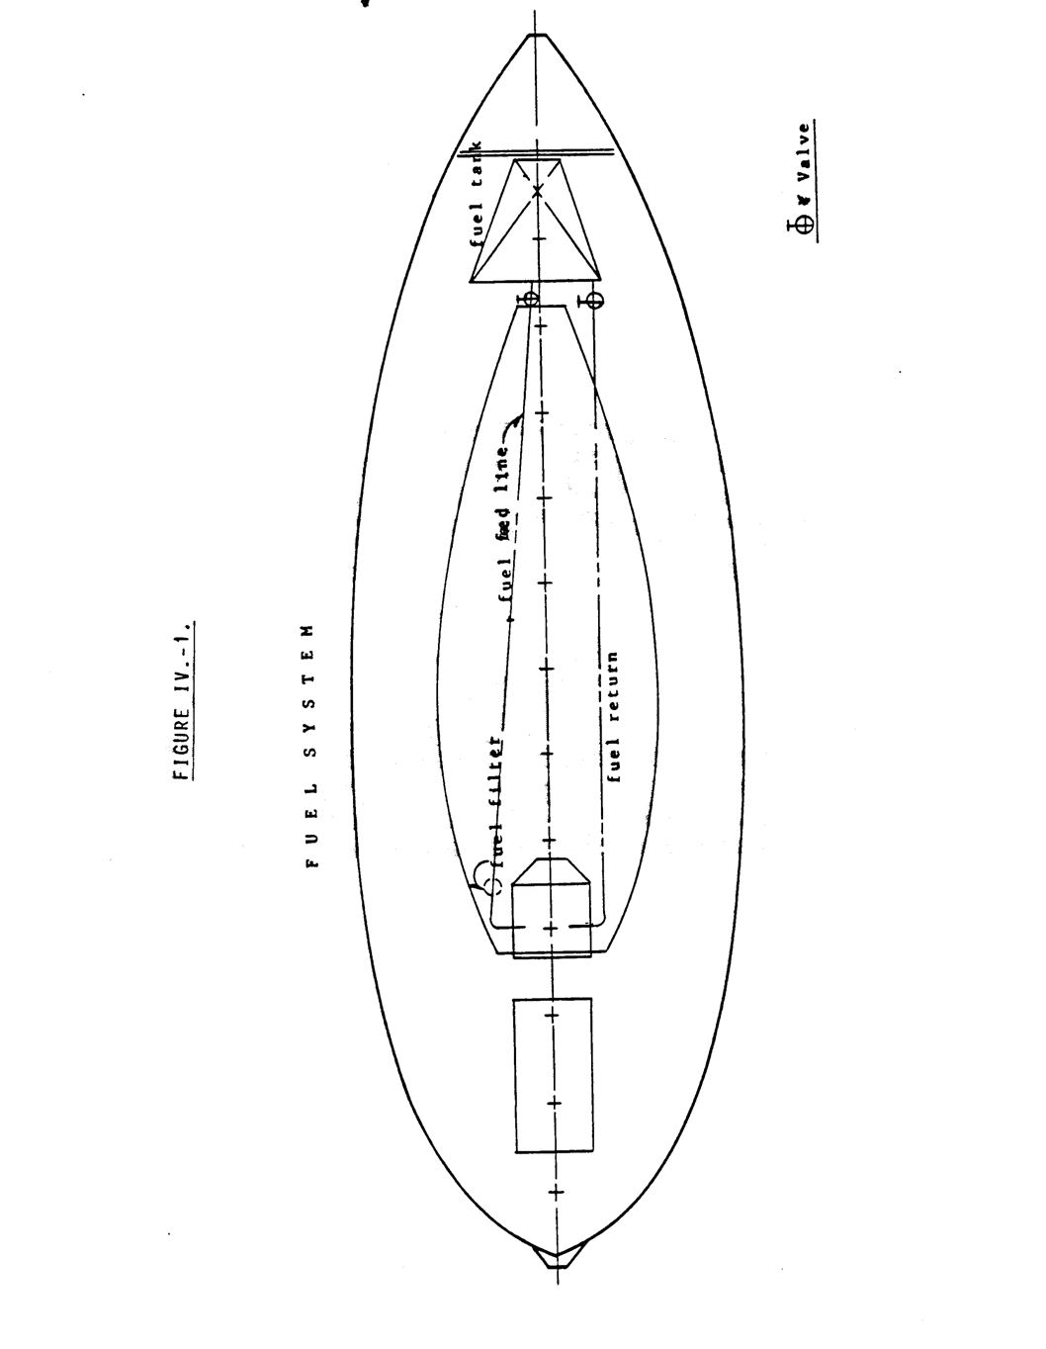

Electrical Systems

You will operate two different electrical systems on your TAYANA 37--a direct current (DC) system which is the primary electrical system and an alternating current system (AC) which is used primarily at a dock. Neither of the systems is difficult to use but certain important rules must be followed.

    - The DC Electrical System

The primary source of electrical DC power is the storage battery(s). It is important to remember that storage batteries are not the unlimited source of power to which one is accustomed in the home. While a battery is rechargeable, one can only take out of it what one has put into it. Thus, it is important to keep track of how much charging is done and how much current is drawn by the various DC accessories. When the engine is running, accessories are not likely to draw enough to run down a battery-- the engine charge will maintain battery charge level. Under sail, however, lights, instruments, autopilots, and other such wonderful devices can bring a battery to its knees in relatively quick time.

- The Energy Audit System

The best system which we know to help you use your power wisely is the DC energy audit. Make a list of every DC electrical device, which you have on board. Determine from markings on the equipment or from equipment handbooks how many amperes each device draws in normal operation. Add al1 of the amperes together and you wi11 see how much TOTAL current would be drawn if al1 devices were operated at one time. The Table on the following page will help you make such an audit for your yacht. See Table IV.-1.

Your battery(s) are rated by ampere-hours. For example, a standard battery, which comes with the TAYANA 37, is rated at 120 ampere-hours. Theoretically, this means that the battery will provide one ampere 120 hours or 120 amperes for one hour. As with most things the theoretical capacity and the actual usable capacity are quite different. In the case of a wet cel1 battery one should plan on a maximum capacity of 50 percent of the rated capacity. Thus, your standard battery wi11 provide you with about 60 ampere-hours

On your electrical control board you wi11 find a DC ammeter which shows the number of amperes which are being drawn from the battery at any particular time. It is easy to see that if your ammeter shows 10

amperes for one hour, you will have drawn a total of 10 ampere-hours from your battery(s).

Let's look at a practical example of how you can use your electrical audit and ammeter to know when recharge is going to be required. Let us say that you are sailing overnight and that you have just turned on your running lights and compass lights. The battery(s) are fully charged. You note that the ammeter shows 5 ampere draw. It is 2000 hours. At 0600 the next morning the sun rises and you shut off the running lights. The draw is now zero--nothing else is running. You have drawn the amazing total of 50 ampere-hours (5 amps x 10 hours). If you had a single battery with 60 ampere-hours usable capacity could you now start your engine? Yes, you could. A starter requires about 60 amperes to turn over a diesel engine. If it takes one minute to turn over the engine before start (an unusual situation), you can see that starting would, in effect, require one ampere- hour.

You must remember that much more than your running lights are apt to come on during the night. The electric bilge pump may come on; the pressure water pump may come on; you may be using an electric autopilot; you may require deck flood lights; somebody may play the stereo. All of these devices may require so much power that you end up with insufficient charge to turn your engine over.

Do not switch to "off" position with engine running.

"Both" position is intended for emergency or extended engine cranking ability. Ordinarily, one should charge one battery at a time while the engine is running. Continuous running in the "Both" position when the batteries are in a low state of charge, can cause overload and possible damage to the engine alternator.

TABLE IV.-1.
Device | Voltage | Current Draw
Total DC Current Draw........................................................................................

  - Electrical Panel

The AC-DC breaker panel is generally located under the companionway or in the navigator's station. This panel is equipped with high quality circuit breakers.

Each DC circuit breaker is wired to an indicator light to show at a glance if the circuit is on. The DC indicator lights are solid state light emitting diodes, which require very little current draw.

The DC ammeter monitors the amount of current being drawn from the battery, and the DC voltmeter gives an indication of the battery's condition. You must throw the battery test switch to get a battery condition reading.

Voltage readings may be interpreted as follows

 | BATTERY READING | BATTERY CONDITION
Engine off and electrical  system under minimal or no load | Below 11 volts | Very low
Engine off and electrical  system under minimal or no load | 11-12 volts | Low
Engine off and electrical  system under minimal or no load | 12-13 volts | Well Charged
Engine running fast idle or  above | 13-13.5  volts | Low charge  rate
Engine running fast idle or  above | 13.5-15.5 volts | Normal  Charge
Engine running fast idle or  above | 15.5 or higher | Excessive voltage  (Voltage regulator defective. Replace or adjust)

The voltage readings should be taken in either battery position, not in "both" position.

Start your engine using the battery with highest charge and allow time for the battery to return to its full charge state before putting it on reserve. When switching over to the other battery, be sure not to Switch through the "off" position. This would damage the regulator and possibly the alternator diodes. The "both" position is for emergency or extended cranking periods and should not be used to charge two batteries at the same time. This could overload the charging circuit if the batteries are low.

Engine Control Panel

The engine control panel incorporates a visual warning System, which is activated by the engine oil pressure, electrical charge and temperature sensor switches.

The oil pressure light will operate each time the engine is started until oil pressure builds up. It gives a constant check on the operation of the system. The other lights will light when the engine key is turned on, and they will go off as soon as the engine starts.

    - The Alternating Current System

The alternating current system is essentially an auxiliary system of power, which is activated through a shore power cord attached to a dockside power source. Some yachts also have an on-board 110 volt AC generator that would provide power while underway. The AC system that comes with the yacht is a three-wire shore grounded. The shore power inlet is rated at 30 amperes and is generally mounted on the aft, outer face of the coaming.

The AC Electrical Control Panel

The AC electrical control panel is a part of the ships electrical panel partly described on the previous page. On it is located the main circuit breaker for the AC system. Each AC circuit is protected by a double pole breaker, which breaks both sides of the circuit when it is tripped. For reasons of safety, it is recommended that all appliances used aboard be equipped with a three-wire grounded cord.

Hot Water Heater

The hot water heater is connected to a breaker on this panel. Some heaters have a high temperature re-set button built into the heater. Before applying power to the water heater, always be sure the heater has been filled by turning on one of the hot water faucets long enough to get a steady flow. An empty hot water heater may burn out the heating element before the temperature re-set button can break the circuit.

Connect Procedure

The proper-procedure for connecting shore power to the boat safely is as follows:

        - Turn ship's main breaker to "off".
        - Turn receptacle on dock to "off" if possible
        - Connect cable to power inlet on boat first, (to prevent handling a “live” powerline and possibly coming in contact with water.)
        - Route the cable in such a way as to prevent strain on either connector, allowing for the rise and fall of the tide, and to prevent chafing.
        - Connect to dockside receptacle and turn shore switch on.
        - Turn on ship's main breaker.

Disconnect Procedure

--Turn off ship's main breaker.
--Turn off dockside power and disconnect cord.
--Replace all weather-tight caps on receptacles.
IMPORTANT NOTICE:

The owner must be aware of the hazards of using high voltage AC aboard ship, and should maintain this system in safe condition. (See MAINTENANCE AND MAINTENANCE PROCEDURES.)

Don't take chances handling AC equipment in wet weather or while washing down topsides. Caution guests and children about hazards, and do not use any equipment that does not function properly or is suspected of being defective.

Battery Charger Option

The battery charger, or converter as it is also referred to, is connected to the feed or "output" side of the main battery switch. This allows you to select either or both batteries to be put "on the line" for charging when the engine is at rest. It also insures that, when the battery switch is "off", all circuits are positively disconnected from the batteries during an emergency shutdown.

Do not turn the battery charger on when the battery switch is in the "off" position. This could possibly feed the ship's circuits without the back-up support of the batteries. It could also cause premature failure of electrical equipment in the boat and if the regulator section of the charger should fail, allow high voltage into the system.

The battery charger has an automatic cut-off circuit, which is wired to the engine electrical system. Whenever the engine is started, the charger will shut off and allow the engine-driven alternator to take over, returning to service when the engine is stopped.

The charger is protected by internally mounted fuses on the AC and DC circuits, as well as the main circuit breaker on the AC panel. Be sure all the related circuits are "off" when opening the charger cabinet for service. The charger is an air-cooled unit with louvers on top and bottom. Care must be taken not to restrict the ventilation provided, nor allow small tools or hardware to fall into the charger while performing maintenance work in the engine room.

THE PLUMBING SYSTEMS

Your yacht has several plumbing and sanitation systems which, while easy to operate, require some care to avoid spills or the pumping of waste overboard when that is not the intention.

- The Fresh Water System

Your yacht is equipped with a full pressure fresh water system for both hot and cold water. It allows you to draw fresh water in the same way and with the same convenience you have become used to in the home. But there is a disadvantage to this -- you will have a tendency to use your water as you do in the home and this is generally wasteful. At home this waste translates into bigger water bills. In a yacht at sea such waste can lead to real trouble. Training yourself and your crew to save water is absolutely essential. If you find you have trouble doing so, you may find it worth while installing, if you have not already done so, a manual water system. The manual system requires hand or foot pumping and it invariably results in better water conservation. See Figure IV.-2.

- Bilge Pumps
The TAYANA 37 is equipped with two bilge pumps--one electrical and one hand operated. Both of these pumps should be checked every day that the yacht is sailed.

The electrical bilge pump is by PAR and is located in the same compartment as the fresh water pump. The intake hose goes down past the engine and into the bilge sump below the engine. The pump outlet is just above the water line on the side of the yacht. The most common failure is a dirty pick-up screen. This may be cleaned simply by pulling the intake hose up from the sump and removing the dirt. A few failures because of dirt in the bilge will probably result in a greater effort to keep the bilges clean and sweet.

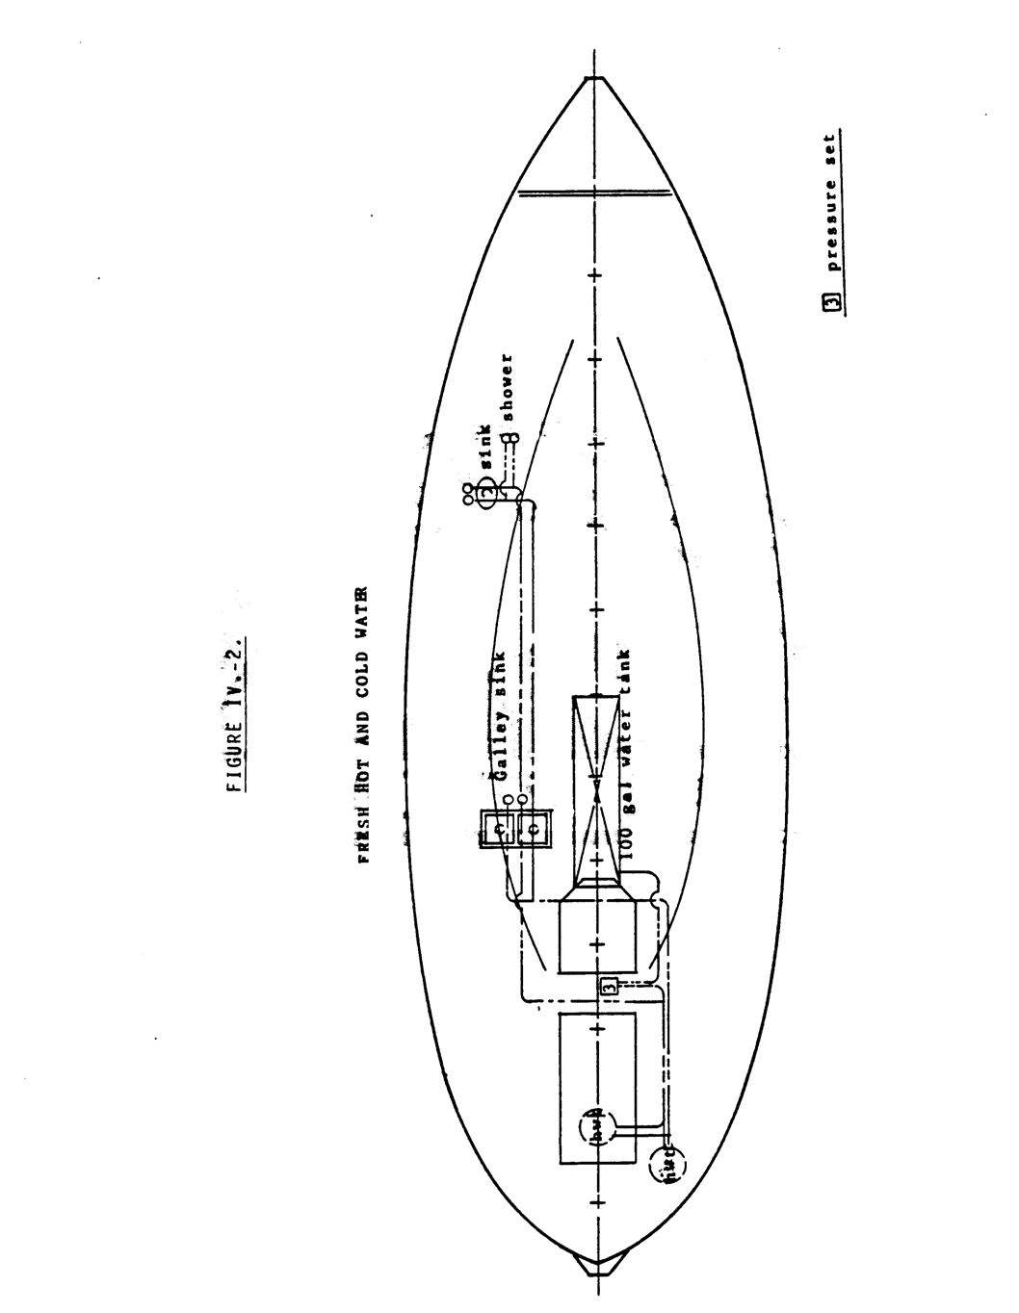

The hand bilge pump is generally located around the mast step. The hand bilge pump serves two purposes -- it pumps the bilge and it pumps the holding tank. By following the intake line from the pump aft, one will come to a set of two valves. With one valve closed and the other open, you can see that the pump clears the bilge. By reversing the closure of the valves the pump clears the holding tank. A little experimenting will show you the proper valve operation.

There is generally a third bilge pump mounted on the engine. This pump is always operating when the engine is running. If your engine has such a pump it is important to remember that the bilge is constantly being cleared and a leak might not be apparent by simply looking into the bilge to see if there is water.

- Holding Tank

Your 37 has a holding tank system which is legal anywhere. The toilet may be pumped either into the holding tank or overboard directly. If the holding tank is used, it may be cleared either through an on-deck fitting or by the use of the bilge pump as described above. The holding tank is located under the engine. It should be kept clean by pumping clear water into it periodically. Detergent is useful if the tank has been used. The inlet to the tank may be reached by lifting the fresh water tank and getting into the bilge.

- Toilet

The toilet is one of the standard U.S. makes which uses seawater for flushing.

The intake and the exhaust are both below the water line. The intake is well forward of the exhaust opening. Each opening is protected by a thru- hull fitting. The exhaust line has a loop, and its thru-0hull seacock is kept open except when the boat is unattended. By opening/closing valves located on either side of a "TEE" in the exhaust line, discharge can be sent overboard (normal) or to the holding tank. (NOTE: Before shifting to the holding tank, close the overboard discharge valve and then open the holding tank line valve.)

The sequence for operating the toilet is as follows:

  - Pump, slowly, until bowl is nearly exhausted. Normally this will require three to six pumps.

  - Open the intake thru-hull fitting located just outboard beside the seat.

  - Flush completely by pumping at least thirty times.

  - Close the intake thru-hull fitting.

  - Pump to nearly exhaust the bowl. This will take about five or six full strokes.

NOTE: Do not leave the intake valve open. The valves in the pump may have a slight leak-thru, and the bowl may overflow with sea water.

CHAPTER V MAINTENANCE AND MAINTENANCE PROCEDURES .................................V-2

A. THE HULL- ..................................................................................................................................................................... V-2

B. THE DECK AND CABIN TOP..................................................................................................................................... V-3

C. INTERIOR WOODWORK........................................................................................................................................... V-4

D. SPARS, RIGGING, AND SAILS ................................................................................................................................... V-5
1. Wood Spars....................................................................................................................................................................V-6
2. Aluminum Spars ............................................................................................................................................................V-7
3. Standing Rigging ............................................................................................................................................................V-8
4. Sails ...............................................................................................................................................................................V-9
5. Running Rigging.............................................................................................................................................................V-9
6. Winches ........................................................................................................................................................................V-10
7. Blocks ...........................................................................................................................................................................V-10

E. AUXILIARY ENGINES AND RELATED SYSTEMS ............................................................................................. V-11
1. The Engine....................................................................................................................................................................V-11
a. Installation................................................................................................................................................................V-11
b. Maintenance .............................................................................................................................................................V-14
(1) Break-in Period.................................................................................................................................................V-14
(2) Before Each Outing ..........................................................................................................................................V-14 (3) Every 150 hours or 3 months (whichever occurs first)......................................................................................V-15
(4) Every 450 hours or 12 months (whichever occurs first)....................................................................................V-15 (5) Every 2400 hours...............................................................................................................................................V-15
(6) Bleeding The Fuel System................................................................................................................................V-15
2. Drive Train ..................................................................................................................................................................V-16
a. Engine Alignment ...................................................................................................................................................V-17
b. Transmission ...........................................................................................................................................................V-17
c. Stuffing Box ............................................................................................................................................................V-17
d. Cutlass Bearing .......................................................................................................................................................V-18

F. ELECTRICAL SYSTEMS........................................................................................................................................... V-18
1. The 12 Volt D.C. System - Figure V.-2.) .....................................................................................................................V-19
a. The Electrical Panel .................................................................................................................................................V-21
b. Master Battery Switch.............................................................................................................................................V-23
c. Alternator, Engine Mounted....................................................................................................................................V-23
d. Electrical Starter......................................................................................................................................................V-23
e. Wire Runs ................................................................................................................................................................V-23
2. The 110 Volt AC System.............................................................................................................................................V-26
3. Protective System ........................................................................................................................................................V-26
a. Bonding ....................................................................................................................................................................V-26
b. Zincs.........................................................................................................................................................................V-26

G. PLUMBING AND SANITATION SYSTEMS........................................................................................................... V-27
1. The Fresh Water System..............................................................................................................................................V-27
2. BiIge Pumping Systems (SEE FIGURE V.-3.) ............................................................................................................V-28
3. Sanitation Systems ........................................................................................................................................................V-28
a. Holding Tank ...........................................................................................................................................................V-28
b. The Toilet.................................................................................................................................................................V-29
c. Sinks........................................................................................................................................................................V-29

Chapter V MAINTENANCE AND MAINTENANCE PROCEDURES

Few persons today are under any illusion that a fiberglass yacht is "maintenance free". As a matter of fact, from the standpoint of cosmetics alone, a fiberglass hull requires nearly as much time to take care of as a wooden hull of similar size. Washing, waxing, and touching up little nicks and scrapes are time consuming and demanding tasks which must be done consistently if the yacht is to retain its new look.

The advantages of fiberglass lies in areas other than cosmetics-strength, for example. Fiberglass reinforced plastics (FRP) are amongst the strongest boat building materials ever developed. Even a moderately well built FRP yacht will be stronger and more endurable than the best wooden built a few decades ago. In addition, fiberglass is impervious to most of the ills which can be disastrous in other materials -- it doesn't oxidize like steel; it isn't affected by electrolysis like aluminum: it doesn't rot like wood. While it can be damaged by physical impact and the resin will burn, neglect of surface damage generally does not result in more serious deterioration as it certainly would in a steel or wooden hull.

THE HULL-

Generally, SOUTHERN OFFSHORE YACHT recommends that their customers purchase a white hull. This means that little dings and scrapes do not show up, as they would on a colored hull, and one is not under as much pressure to make immediate repairs.

Normal periodic maintenance consists of waxing the hull with any of several good fiberglass or automobile waxes on the market today. Waxing should be done from the shear down to and including the waterline stripe. Wax should not be put over the bottom paint which may be at or above the normal trim waterline of the yacht.

Scrapes and scratches in white gelcoat are relatively easy to repair. There are several gelcoat repair kits on the market which will do a fine job if the directions are followed closely. Bigger gouges can be filled with either polyester or epoxy putties before the gelcoat repair system is used. Colored gelcoat presents the additional problem of color matching. Again, there are several systems on the market which will make it possible to match the original gelcoat color.

It is a good idea to inspect the bottom periodically. In areas such as the Chesapeake Bay, groundings are generally not serious. the muddy bottom is unlikely to.do any serious damage. groundings on rock or coral are a different

story. If possible, the hull should be inspected immediately after the hard grounding on one of these latter bottoms. If deep scrapes are found or if the fiberglass has actually been crushed or distorted, the yacht should be hauled at your earliest convenience and the damaged fiberglass repaired. While we do not wish to exaggerate the potential for water to soak into the damaged surface, the possibility is there and immediate repair will limit the area of potential water saturation. A good fiberglass repair kit is shown in the table.

Your TAYANA 37 comes with a heavy rub rail bolted and glued to the side. This is primarily to protect the sides, but it is also a thing of beauty when properly maintained. A wise investment is a stainless steel or bronze striker. This will take a great deal of the abuse which otherwise would have to be absorbed by the wood. The rub rail is very often neglected during cleaning. It should be cleaned, sanded, and oiled in the same manner as other teak on the yacht. (See discussion below).

THE DECK AND CABIN TOP

The deck of the TAYANA 37 is molded in essentially the same manner as the hull--in a one piece mold following the fiberglass schedule shown above. When the deck is removed from the mold, most of the teak trim is installed before the deck and hull are joined. Teak decks, teak facings on the cabin, and teak in the cockpit are all installed after the deck is joined to the hull.

The fiberglass of the deck and cabin are cleaned and maintained in the same manner as the hull. Any one of several good cleaners and waxes will tend to help keep colors bright and new looking. The big job will be teak maintenance. In the old days teak decks were maintained with a holystone and salt water. The holystone was a large piece of pumic rock which was rubbed across the deck to clean and polish wood. When done regularly, the teak was kept a beautiful, natural silvery color which was quite striking when contrasted with to painted surfaces and natural wood colors. The salt water helped keep the teak in good shape because salt would be left in the wood as the water evaporated. Because the salt was slightly hygroscopic (attracts moisture), the teak did not dry out rapidly. Of course, wetting and cleaning had to be done daily if the deck was to be kept in the best condition.

Not many people are going to holystone their teak daily in this day and age, although that is to be highly recommended. Most people seem to prefer the deep brown of newly oiled teak. There are several products on the market which make it possible to keep the beautiful brown of teak without a great deal of heavy labor. These products are strong and corrosive and must be used infrequently and with great care.

When you receive your yacht, the teak will have been cleaned and will be relatively dry. It should be cleaned with common washing soda that one can

V-3

obtain in the laundry section of any well-stocked grocery store. Washing soda is an excellent cleaner and has a tendency to bleach the wood somewhat. It will not damage paint or gelcoat, unlike some teak cleaning products, although it should be thoroughly cleaned off. Use about one cup of washing soda in a bucket of water (more soda if the deck is really dirty), and one of the many plastic scrubbing pads which are on the market. Scrub the teak with the soda solution until the wood is thoroughly cleaned. Then rinse thoroughly and let dry. Avoid using deck or scrub brushes, as these tend to damage the softer parts of the grain and leave the teak rough.

The number of teak oils on the market is virtually endless. We have found that the best are those which contain a minimum amount of varnish. Such oils do not leave quite as brilliant a finish, but they last almost as long, and they age more gracefully. If one wishes to maintain the brilliant teak brown, he will have to clean and reoil every four to six weeks in tropical areas; somewhat less frequently in higher latitudes.

The polysulfide products that are used to caulk the teak decks merit some special consideration. Certain of the more corrosive teak cleaners and at least one teak oil product can damage polysulfide. As mentioned above, corrosive teak cleaners should be used infrequently and the directions should be very carefully followed. These compounds should be washed off completely and as soon as the directions permit, even if the product is advertised as not hurting caulking compounds. On the other hand, teak oils that can soften polysulfide should never be used. One of these oils is reputed to be a widely advertised two part product.

The polysulfide caulking is relatively easy to maintain and repair. The most common problem is that the caulking pulls away from the teak and breaks the seal. When this happens, it does little good to try to fill the resulting space with more polysulfide because the new material will adhere neither to the old polysulfide nor to the teak. The old polysulfide should be completely removed and then the teak should be primed with the primer recommended by the manufacturer. Once the primer has dried, the space should be filled with fresh polysulfide--leave a bead which is higher than the surrounding wood. It will take several days for the polysulfide to cure. Note that moisture tends to increase the rate of curing, and it is a good idea to keep the caulking damp. Once cured, the caulking can be sanded off flush leaving a practically invisible repair.

INTERIOR WOODWORK

Interior woodwork is generally solid teak staving or teak faced plywood panel. Both of these are maintained in the same manner if they are unvarnished or natural. If you have ordered your yacht with natural wood which you wish to keep light, it is best to finish the teak with a light wax. The process is simple. The wood should be thoroughly cleaned--start with a vacuum cleaner and get all of the

saw dust and loose dirt; then use a damp cloth (no soap) and get all of the residual fine dust; follow this with a solvent wash to eliminate any excessive surface oils; then spread on the wax according to manufacturer's directions. Any of the light furniture waxes can be used for this application. Some people have had excellent results using bowling alley wax. This wax, which takes a longer time to apply, but it is tougher than most liquid waxes and requires less maintenance. If you want your interior teak to be a little darker and to take on the patina of fine furniture, one can use oils rather than wax. Cleaning should be accomplished as described above and then the wood should be covered with lemon oil or such commercial products as Liquid Gold or “Sheila Shine”. The latter two products have an oil base which soaks into the surface of the wood and a wax which fuses to the surface and provides a protective coating. The oil does darken the wood somewhat. If your yacht has a varnished interior, you will find that maintenance is much like keeping furniture looking nice. You will clean the surface with water and mild soap solutions and "dust" using one of the many dusting products available at the local supermarket.
The sole merits special consideration. Obviously one cannot use ordinary waxes-- they would ruin footing. If the sole is left natural it should be cleaned as described above and covered with Liquid 601d or Sheila Shine. These products protect the surface but do not seem to leave the sole slippery when wet. If the sole is varnished with a satin coating it will be a little more slippery but may be all right. If it is too slippery when wet, it can be coated with polyurethane--this product is not at all slippery when wet. The directions for preparing the surface should be followed religiously as polyurethane is generally not compatible with other types of varnish.

Bronze presents a special cleaning problem. Ordinary metal cleaners will not clean or polish bronze. Brass cleaners, for example, will not touch the green corrosion that disfigures bronze ports. The best product we have found is Amway metal cleaner. The Amway is an excellent general metal and bronze cleaner to have aboard for both interior and exterior use. In the case of bronze, once the metal is cleaned and polished, it should be coated with a spray wax such as the Amway colorless shoe polish.

SPARS, RIGGING, AND SAILS

The primary means of propulsion is the sailing rig, yet it is sometimes the most neglected. This is probably because it is very reliable and because most people believe they have an intuitive understanding of it and neglect it through misplaced familiarity. However, maintenance is vital. Failure of your rig can be far more catastrophic than engine failure—one doesn't merely lose power; he may sustain damage to the yacht and injury to personnel.

  - Wood Spars

If you have wooden spars with your yacht you can be assured that you have some of the finest available. TaYang uses a very fine grade of spruce that has been well seasoned. All glues are epoxy and screws and fittings are stainless steel or marine bronze. The workers in TaYang's spar shop are among the yard's most experienced.
Probably the single most important maintenance item on a wooden mast is the condition of the bedding under the fittings. Normally fittings are bedded in polysulphide at the factory. This is done to keep water from gathering under the fitting and causing dryrot. The bedding of fittings should be checked at least once a year. If the bedding shows signs of deterioration, the fitting should be removed, all of the old bedding should be cleaned away, and new bedding applied.

Varnished spars are certainly the best looking, but they also require the most maintenance. This is particularly true if the yacht is operating in southern waters. The biggest enemy of varnish is the sun and the finish must be watched very carefully. The varnish job done by the factory is barely adequate. They use reasonably good varnish, but it does not contain ultraviolet shielding and insufficient coats are applied to insure long life.

We recommend to all owners with varnished spars, particularly those in the south, that at least five more coats of varnish be applied before the spars are installed on the yacht. These additional coats will insure that additional varnishing will probably not be required for about eighteen months.

Varnished exterior surfaces should be examined constantly. If deterioration or damage is spotted, it should be taken care of immediately. The damaged area should be sanded and new varnish applied to the area using four or five coats. A useful maintenance item is a spray can of spar varnish. If a varnished surface is damaged during a cruise or race and there is not time for a permanent repair, the area may be prayed to prevent further deterioration.

We recommend that owners who operate in southern waters with wooden spars paint them white or off-white. The paint is not susceptible to ultraviolet damage and they tend to reflect heat. A well painted wooden spar does not need to be repainted for at least 24 months if the finish has not been physically damaged. Bedding is just as important as with a varnished spar and should be checked regularly. One argument against painting has been the perception that paint might hide an area of rot and the resulting delay in discovering the problem could be serious. We have not found this to be the case. If painted spars are examined on a regular basis, rot and excess moisture will be readily apparent --paint will discolor and peel.

  - Aluminum Spars

The primary advantage of aluminum spars is the reduction in maintenance. One should not conclude, however, that aluminum spars are maintenance free. Like fiberglass, aluminum requires constant and conscientious care if its appearance is to be maintained. Again, as with fiberglass, if damage to finishes does occur, one is not quite so pressed to get a repair done because further deterioration is not likely.

The aluminum spars with a TAYANA 37 may be finished either by anodizing or painting. Anodizing is a process by which a protective coating is formed which is superior to paint. It is done in a special bath before any of the fittings have been installed. Anodizing cannot be renewed by the yacht owner. Painted spars are maintained in much the same way as painted wooden spars. Generally, the paint used is polyurethane, a very hard, color fast paint. Maintenance consists of watching for scrapes and gouges and repainting them when they occur. A small spray can of automobile finish is very handy for this purpose. Simply remove the damaged paint, then sand lightly with about a 300 grit wet or dry sandpaper, and spray on the new finish.

Aside from physical damage, owing to impact or scraping, the greatest cause for damage on an aluminum spar is galvanic corrosion. Any nonaluminum fitting that is bolted, screwed, or riveted to an aluminum spar must be bedded just as was the case with wood spars. The bedding, in this case, acts as an electrical insulator rather than as a means of keeping water from behind the fitting. If dissimilar metals are not isolated from the aluminum, one will soon find that the aluminum pits and forms a fine powder. This is nonreversible damage that must be avoided at all costs. If it is discovered, the fitting or fastener around the corroded area must be removed and reinsulated with a bedding compound or a sheet insulation such as neoprene or rubber. The pitted area may be filled with epoxy or polyester putty before repainting, but this is only cosmetic--the putty will not restore the lost strength in the damaged area.

One must consider that an aluminum mast that has been badly dented is no longer safe. Dents that are half an inch or more in depth and which have a diameter of a third or more of the spar constitute a serious weak point. If the spar is put under serious stress at that point, the chances are that the section will collapse. If you should find a dent that large, contact a professional yacht rigger for advice.

Mast spreaders are particularly critical to the health of your rig. They allow the long upper shrouds to take up the loads that are transmitted to the upper part of the mast during sailing. As a result, they are under tremendous compression. It is particularly critical that they be examined regularly to see

that there is no distortion or cracking. The outer tips of the spreaders should be raised above the spreader base so that the compression load is transmitted down the spreader to the mast and not at an angle which would tend to force the spreader to bend under load.

  - Standing Rigging

Standing rigging is made up of stainless steel cable with various attachment fittings of chromed bronze and stainless steel. The wire used is 1/4 or 5/16 inch lxl9 wire. Either size cable is sufficiently strong to bear the rig under winds of hurricane strength. The lxl9 refers to the winding of 19 single strands of wire to make the cable. This winding makes the cable stiff and strong, but it would be unsatisfactory if it were required to run through blocks or go around sharp corners.

Most TAYANA 37s are delivered with swaged fittings. Swaging is a process that actually squeezes a hollow cylinder onto the cable. The process was developed for the aircraft industry, and the strength of the joint is nearly as great as the tensile strength of the cable.

Some 37's have been delivered with the wedge type fittings that are most often known by the trade names Sta-Lok or Norseman. These fittings get their strength from a conical bronze core that is forced against the cable within the fitting. It too is stronger than the tensile strength of the cable. It has the added advantage that it can be installed by the owner with two common adjustable wrenches. It must be remembered, however, that the wedging cones are not reusable and extras should be carried at sea.

Turnbuckles are generally chromed-bronze cylindrical type. They are made to be set up with two wrenches – one to hold the cable and one to turn the turnbuckle itself.

Standing rigging should be inspected regularly. And remember, it does one no good to simply inspect the bottom fittings and ignore those up on the mast.

The most common failure is cracked swage fittings. All attachment fittings should be carefully examined at least once a month. Look at them closely. Sometimes the cracks are hard to see. If in doubt carefully spray the fitting with a can of red paint and then wipe the paint off with a hard cloth. If there is a crack, the paint will get into it and show up when the paint on the fitting is removed. (A better method is to use a spray can of special dye. The dye goes into the crack more readily and shows the crack more clearly. Such dyes are available at better equipped marine and industrial supply houses.) Any crack is bad but not a cause for panic. As a rule of thumb, if a crack is

V-8

longer than the wire diameter, the swage should be replaced immediately. If the crack is less than the wire diameter, the strength of the swage is probably not yet seriously compromised and replacement can be delayed—but watch it like a hawk.

  - Sails

Sails that are delivered with your yacht are very high quality and well cut. The subject of sails is worth a book in itself, so the discussion here will be short and sweet.

The greatest enemy of your sails is the ultraviolet in sunlight. You have sailcovers – use them religiously. Sails that are stored under cover will last three or four times longer than sails which are simply furled on the spars and exposed to the sun.

It is also important to inspect your sails regularly for broken stitching and tears. These should be repaired immediately because they can result in catastrophic sail damage in a short time.

Sails should not be cleaned in a commercial type washer. Rather, it is better to lay them out on a flat surface, like a lawn, and use a soft brush, mild washing detergent and cool water. Once the dirt is off, rinse with a hose and be sure to get the salt off at the same time. As a matter of fact, it isn’t a bad idea to pull your sails up at the dock a few times a year and rinse them off with fresh water. Once in a while you may find some mildew on your sails. This can be cleaned off by a solution of chlorine bleach and water. For example, two or three caps of Clorox in a gallon of water will clean up most cases of mildew and if rinsing is done immediately no harm is done to the sails.

  - Running Rigging

TAYANA 37's are equipped with low stretch, dacron running rigging. While wire halyards do not stretch as much as dacron, they are more difficult to maintain and tend to damage the mast finish.

Running rigging is subject to three sources of deterioration--wear, chafing, and ultraviolet light. Care on the part of the owner can minimize these to the extent that the rigging should last three to five years without giving any trouble. Wear can be reduced by making sure that turning blocks and fairleads are kept clean and that the sheaves in blocks turn freely. It is also important that line be properly coiled and stowed so that crew members are not walking or sitting on it. Chafe requires that the line be protected at

V-9

chafing points. For example, it is not unusual for the jib sheets to chafe on the upper shrouds. If sheets are against wire for any period of time, cover the sheet at that point with some type of protection such as tape. It will pay off. Protecting the dacron line from ultraviolet is as important as protecting sails. Unfortunately, it is next to impossible to protect halyards very much, but sheets can be stowed under sail covers or they can be removed and stowed below.

  - Winches

Winches are among the most important and sophisticated devices aboard ship. Without them it would take ten big Swedes to operate a TAYANA 37; with them the yacht can be sailed anywhere by husband and wife. Winches are the most handy source of power aboard the yacht--you can set big sails, you can raise anchor, you can rescue a man overboard. You can lift an engine, all by using your winches properly. When you consider all the things you can do with these wonderful machines, think back on your high school physics classes. Mechanical advantage is the product of the mechanical advantage of the tackle and the mechanical advantage of the winch. Thus if you are lifting the 400 pound engine out of the yacht using your four part vang and you lead the vang to a winch with a mechanical advantage of 10, you can lift the engine with a force of only 10 pounds!

In spite of the importance of the winch to the proper operation of the yacht, it is one of the most neglected items aboard. The average sailor seldom takes his winches apart for lubrication and maintenance. Don't be one of these average sailors. Take your winch apart at least twice a year and lubricate it in accordance with the manual that has been supplied to you. And while you have it apart, check the mounting bolts; they should be tight and solid. If you find any sign of corrosion owing to galvanic action, renew the insulation material.

TAYANA 37s come with either Barlow or Lewmar winches. You will find diagrams and exploded views of both of these makes at ANNEX 1.

  - Blocks

The blocks which come with your yacht are very strong, well made with teak cheeks and roller bearings. Under normal sailing conditions they will last five to ten years. Maintenance is easy. They should be washed with fresh water a couple of times a year and the teak should get essentially the same treatment as teak elsewhere on the yacht. The ferrous chloride that tends to develop on the 304 stainless steel should be cleaned off with soap and a plastic scrub pad. Nothing else is required.

AUXILIARY ENGINES AND RELATED SYSTEMS

  - The Engine

Your TAYANA 37 is delivered with a standard Yanmar 3QM30F diesel engine, the new Yanmar 4JHE diesel, or with an optional Perkins 4-108 diesel. A very small percentage have some other make engine. The discussion that follows applies to any diesel auxiliary which you selected. Specific procedures for service and maintenance are found in your engine manufacturer's handbook, and they should be followed religiously.

Remember, your engine is like-a dog--it thrives on attention and dies quickly of neglect. A small diesel which is run regularly, serviced faithfully and cleaned consistently will last 10,000 hours before major maintenance is required. Think about that!! If you treat your engine right, you'll never have to buy a new one! Ignore your engine--think about it only when you need it-- and you will find yourself spending about $5,000 every three years or so.

    - Installation

Your engine has been installed by highly experienced mechanics using the best materials. The mounts are bolted to a glassed foundation to provide stability and quiet operation. The engine mounts themselves are of the flexible type to help eliminate vibration in the hull. The propeller shaft is 1-1/4" stainless steel which is connected to the transmission by a flexible coupling. The shaft goes through a bronze shaft log and gland to a cutlass bearing mounted in a bronze casting outside of the hull. The standard propeller is a three bladed bronze wheel generally 18" in diameter with a 12" to 14" pitch.

The exhaust system is of the wet type--that is water is injected into the gas stream and ejected through a muffler and check valve. See figure V.-1. This system is common on sailing yachts because the water cools the exhaust fumes thus cutting down the heat radiated into the engine spaces and eliminating fire hazards. As can be seen in the figure, a siphoning break must be installed to prevent water from backing through the system and into the engine. Newer TAYANA 37s have exhaust systems made primarily from plastic (ABS) mufflers and neoprene reinforced hoses. Older yachts have stainless steel systems composed of an expansion (bellows) exhaust pipe, jacketed pipe, stainless steel water locks and

mufflers, neoprene hoses, and bronze check valve. These latter systems are quite satisfactory, but they are not as durable nor are they as easy to maintain as the new systems.

V-13
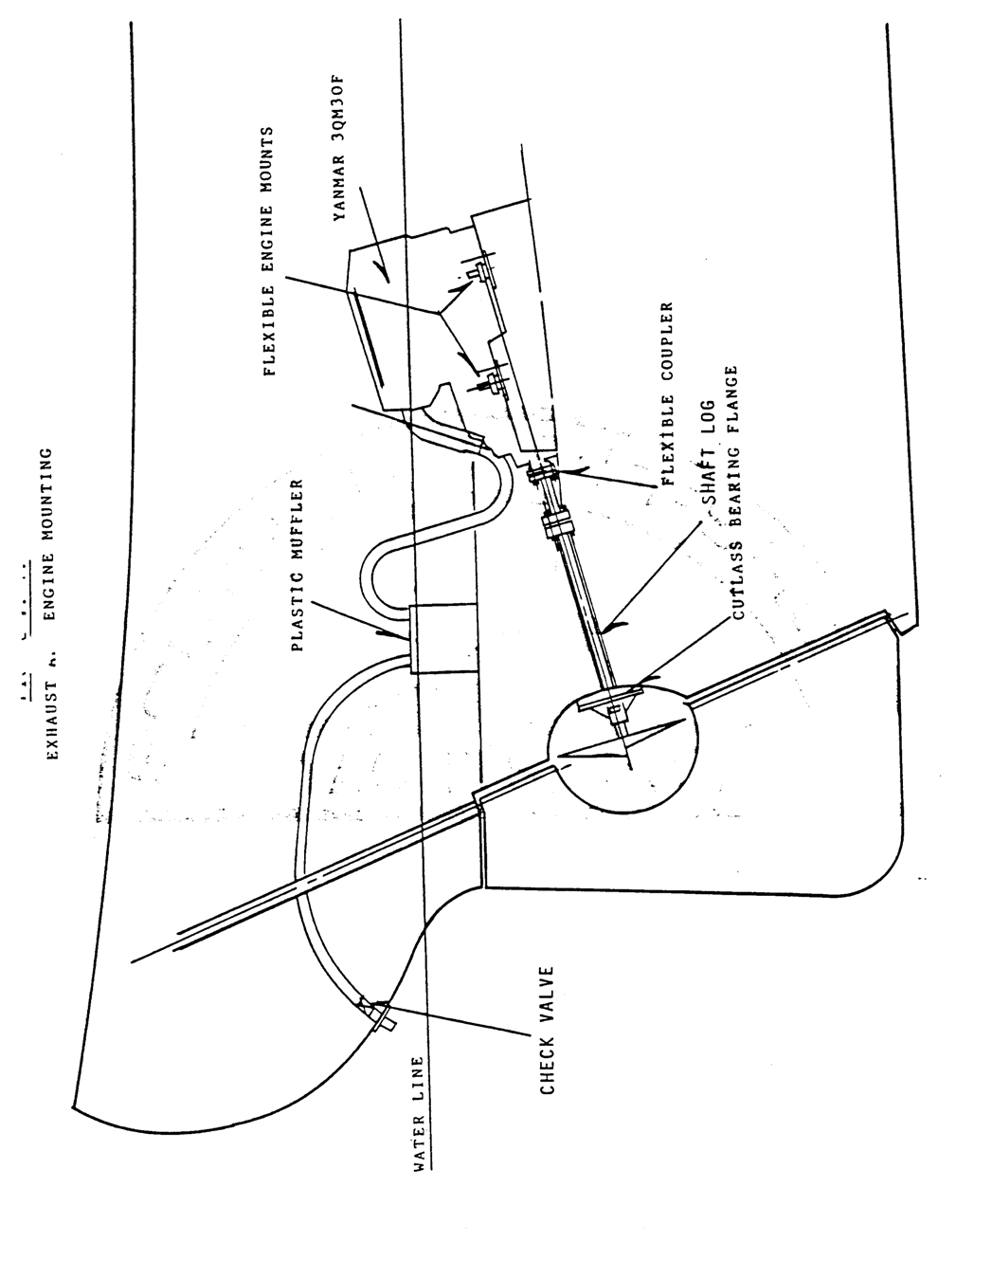

The standard fuel tank is made of black iron, is baffled, and has a large manhole with bayonet gauge. A copper fuel line is taken to the engine's primary filter through a ball valve normally located right by the fuel tank. Depending on the type of engine, the fuel return line may inject fuel back into the fuel line at the engine filter or lead excess fuel all the way back to the fuel tank. It is a good idea to install at least one line filter/water separator and an electric pump into the fuel line before you undertake any long voyages. The electric pump will make it far easier to bleed the engine should that be necessary.

Raw water for cooling is taken in through a seacock generally located behind the engine. Note that this intake line has a large filter before the engine. Cooling water is led to the heat exchanger in the fresh water reservoir and then into the exhaust system to cool exhaust fumes.

Maintenance

Please consult your engine manual for detailed procedures. The engine manual must be followed exactly to obtain maximum engine life and to keep your warranty in effect. The following sections summarize the maintenance requirements described in the manual and are intended as general information only.

- Break-in Period

During the first fifty hours of operation, the engine should not be run at maximum rpm. At fifty hours, the following service should be performed:

  - Change engine oil and filter.
  - Tighten cylinder head nuts in correct sequence to correct torque.
  - Re-set valve clearance and check oil feed to rockers.
  - Check belt tension.
  - Check all external nuts, set screws, etc., for tightness.
  - Check shaft coupling alignment.
  - Check fuel, oil and coolant levels and look for leaks.
  - Adjust idle speed, if necessary.

- Before Each Outing

  - Check coolant level.
  - Check engine oil level
  - Check transmission oil level.
  - Look for evidence of leaks under engine.

- Every 150 hours or 3 months (whichever occurs first)

  - Change engine oil and filter.
  - Check drive belt tensions.
  - Clean air intake.
  - Clean motor trap.
  - Look for evidence of leaks.

- Every 450 hours or 12 months (whichever occurs first)

  - All steps under item (3) above.
  - Change final fuel filter element.
  - Check hoses and clips. (d)Drain and clean fuel tank. (e)Change gearbox oil.
(f) Service atomizers.

- Every 2400 hours

  - Have an authorized engine mechanic examine and service proprietary equipment such as starter, generator, etc.
  - Adjust valve tip clearances.

- Bleeding The Fuel System

  - Check fuel tank shut-off to be “on".
  - Check fuel filter for sediment or water by opening drain plug on bottom. Replace plug.
  - Follow routing of hoses from fuel filter to engine lift pump, inspecting hoses as you go. On the engine pump, you will find a lever which allows you to manually operate the diaphragm inside, against spring tension. It may be necessary to turn the engine over with the starter slightly to allow the pump arm to relax against the camshaft. This allows more stroke with the manual lever you are operating.

  - Follow the fuel line from the pump to the engine fuel filter and locate the vent plug on top. Loosen plug two or three turns.
  - It is advisable to have some large rags on hand to catch oil that will be expelled from this point in the course of bleeding.
  - Begin operating the manual lever. This may take several minutes as the filters will need to fill up (as well as the lines). Operate the manual lever until fuel flows freely from the filter plug with no signs of air bubbles.
  - Loosen the bleed screws on the injection pump.
  - Operate pump again until fuel flows freely with no air bubbles.
  - Re-tighten the vents beginning with the lowest point (the filter, the head locking screw, and the governor vent screw).
  - Wipe up any spills at this time.
  - Slacken the union nut at the injection-nozzles.
  - Move throttle to full rpm and check to see if the "stop" control is in "run" position.
  - Crank engine with starter motor until fuel flows from each injector.

NOTE: Do not run starter motor continuously. It normally takes 30
to 60 seconds of cranking to completely bleed the injector lines.
20 seconds of cranking with about a two-minute rest between periods will be easier on the starter,
motor, and battery than steady cranking.

  - Re-tighten injector lines, wipe spills .
  - Re-set throttle position and proceed with normal start-up.
  - Allow sufficient running time to recharge battery.

* Hint: Very often the Yanmar 3QM30 engine can be bled simply by loosening the bleed screw on top of the engine oil filter and the bleed screw on top of the injection pump. Try it.

  - Drive Train

Engine Alignment

The propeller shaft of the TAYANA is 1-1/4" diameter stainless steel. The shaft is checked for accuracy initially at the factory during installation and is carefully aligned to the engine with the hull being properly supported and level. At this time, the shaft log and bearing is bonded to the hull penetration. The coupling to the engine is checked again for alignment by the commissioning team prior to delivery of the boat.

This alignment check should be made periodically, since the action of a rough sea could possibly change the shape of a bolt enough to disturb engine alignment. If, after the first rough water experience, the alignment has not changed, it is usually only necessary to make the check once per season.

The alignment is considered acceptable if there is a gap less than .005” per inch of face diameter of the coupling –(.002 for a 4” coupling, .0025 for a 5" coupling). The feeler gauge is inserted between the flanges at four points 90 degrees apart. Then check again keeping the engine coupling stationary and rotating the shaft coupling 90 degrees at a time. This checks the squareness of the coupling face to the shaft centerline. The engine alignment is adjusted by raising and lowering the adjusting nuts at each mount. To make lateral adjustment, loosen the mounting pad screws that anchor the engine to the bed. You will note there are slots in the mount pad which allow a reasonable amount of adjustment side-to-side.

After adjusting and re-tightening all mount screws and lock nuts, double check the alignment.

In the absence of a feeler gauge, the alignment can be checked fairly accurately with a strip of paper. Insert the paper between the two halves of the outer flange and rotate both together 360 degrees. The paper should remain in place through the complete turn.

Transmission

Periodically check the oil level in the transmission and inspect the control cables for signs of damage, chafing, corrosion or loose fasteners. Lubricate the moving parts with spray lubricant or light grease.

Stuffing Box

The gland (stuffing box) should be tightened at least once per month to see

that no more than one or two drops per minute flow in. If new packing is required, packing materials can be purchased at any marine supply. Repacking requires about 10 inches of 3/16 material. Remove the nuts from the two retaining bolts which hold the collar in place. Pull the collar up the shaft toward the engine. Water will flow in rather heavily, but it will be easily controlled by the electric bilge pump. Wrap the packing material around the shaft just in front of the gland. Pull the collar down the shaft so that it tends to push the new packing material into the gland. Using the nuts on the retaining bolts, force the packing material evenly into the gland and tighten until there is a water flow of only about one drop per minute. Then install and tighten the locking nuts.

Cutlass Bearing

The cutlass bearing is mounted in a bronze casting as shown in figure V.-1.. This casting is designed to allow full flow of water throughout the length of the bearing. This is important because the cutlass is water lubricated.

A cutlass bearing should last several years. When the bearing is new, the shaft will be tight and no lateral movement will be apparent when trying to push the shaft side to side. As the bearing wears, one can move the shaft slightly from side to side or up and down. Once that lateral movement is more than about 1/16", the bearing should be changed.

Changing the bearing is a major maintenance job and might be best left to the professional yacht mechanic. It requires that the boat be hauled. The shaft must be removed by loosening the coupling set screws and pulling the shaft back through the gland. The four nuts on the bearing casting retaining bolts are removed. The casting itself is threaded to the shaft log. Therefore, one must unscrew the shaft log from the casting. Once the casting is removed, it is a simple matter to drive out the cutlass.

It is not always necessary to remove the cutlass bearing casting. After the shaft is removed, the bearing can sometimes be drawn from the casting. One technique is to saw a small section out of the bearing so that it can be compressed and drawn. One must use an unframed hacksaw and be careful to saw only the bearing.

ELECTRICAL SYSTEMS

As mentioned in an earlier section. the TAYANA 37 has two standard electrical systems--a 12 volt system which gets its power from batteries and the engine alternator, and a 110 volt system which is powered through the shore power cable or with an on

board generator. A modern yacht is highly dependent on these systems and it is essential that they be maintained.

- The 12 Volt D.C. System - Figure V.-2.)
The primary source of 12 volt power is the battery bank which comes with the yacht. The battery(s) are used both to start the engine and to provide power for the various electrical equipment on the yacht. The battery(s) are charged by the engine-mounted alternator or by a battery charger (converter) which is connected to a 110 volt power source.

Battery maintenance is simple but demanding - you should check your battery water at least once a month whether you have sailed the yacht or not. This is particularly important if you have a 110 volt converter or battery charger in operation. The electrolyte (acid) level should be maintained to cover the plates in the battery. It is best to use distilled water in your battery(s) but that is not totally necessary. Clean, drinkable water can be used if distilled water is not available. NEVER USE SALT WATER. Excessive need of water is an indication that the charging rate is too high. A check of the charging voltage should not read over 15 volts. Should you spill electrolyte from the battery, it should be neutralized with baking soda. Remember, battery electrolyte is sulfuric acid which is very corrosive. It will eat into your skin, wood, cloth, and some metals. Don't neglect a spill. If it gets on your skin, wash it off immediately with soap and water. One other battery maintenance point is the two poles. Make sure connections are clean and tight. A thin layer of grease will help keep battery connections clear of corrosion.

The use of a hydrometer is an inexpensive and accurate measure of the battery's condition. Specific gravity measurements of the electrolytes should read between 1.275 and 4.280 on a normally charged battery. All cells should read relatively equal; any one cell that has noticeably low reading is an indication of a bad cell, and the battery should be replaced.

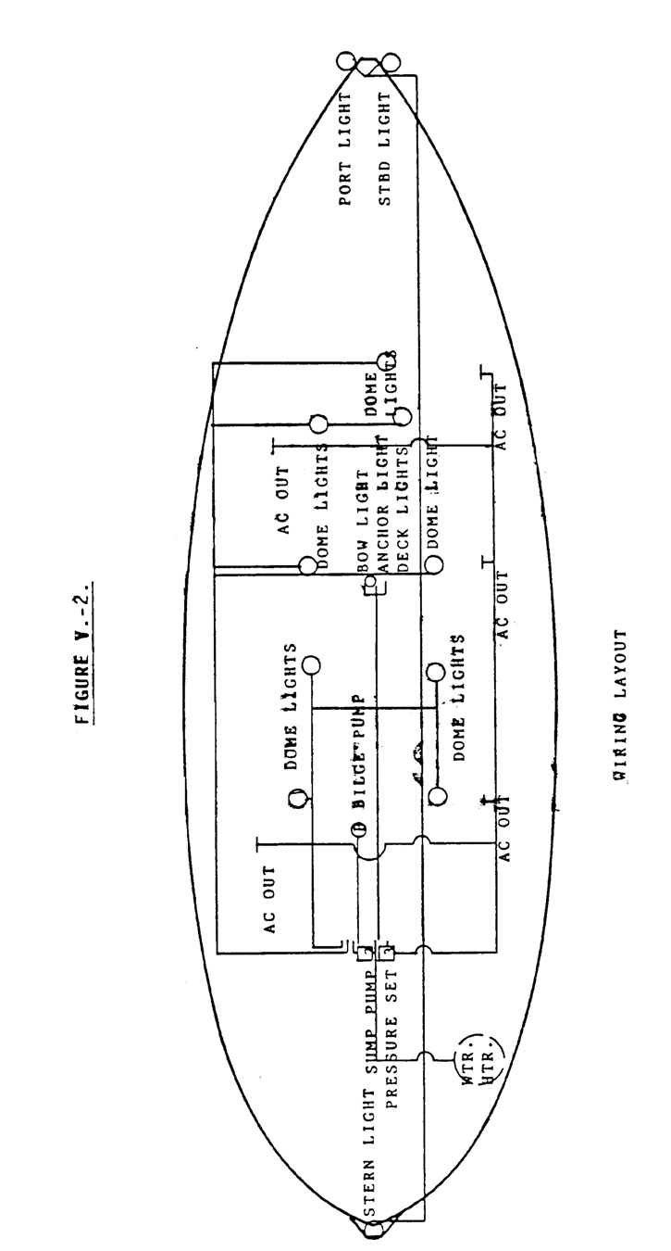

The Electrical Panel
The electrical distribution panel controls all of the 12 volt electrical circuits in your yacht. You will note that it has both a battery condition meter and an ammeter. The battery condition meter tells you the measured state of the charge existing in your batteries; the ammeter tells you how many amperes are being used at any instant of time. The various circuits go through the circuit breakers on the board. These circuit breakers act as both a switch and as an overload protection device.

There is very little maintenance necessary on the panel. Open the door and look at the back of the panel. You will see colored wires, which go to the various electrical devices--the colors allow you to find the same wires throughout the yacht. The panel should be kept dry at all costs. If a circuit breaker trips and cuts the circuit, there is an overload condition. This is usually because there is a short circuit. Always attempt to discover what caused the circuit breaker to trip before depending on that circuit again.
SEE TABLE V-1.

TABLE V-1.

ELECTRIC WIRE NUMBER & COLOR CODES

12 V.D.C.

MAST LIGHT #12 RED
BOW LIGHT #12 BLUE
SPREADER LIGHTS #12 YELLOW
STERN/SIDE LIGHTS #14 WHITE FORWARD CABIN LIGHTS #12 BLUE
AFT CABIN LIGHTS #12 LIGHT BLUE
ENGINE ROOM LIGHTS #12 TAN
COMPASS LIGHT #14 WHITE
SEARCH LIGHT #12 BROWN
HORN #14 YELLOW
WIPER #12 RED
WATER PRESSURE PUMP #12 WHITE BILGE PUMP #12 BROWN
SEA WATER PUMP #12 PINK
SUMP PUMP # 12 0RANGE
BLOWER .#12 GREEN
ENGINE START #10 WHITE
ENGINE STOP #12 RED
ENGINE TO BATTERY #00 (+) RED
(-) BLACK
PANEL POWER #08 RED
BONDING WIRE #08 GREEN
ALL NEGATIVES BLACK

110 Volt A.C.
- SHORE POWER (PLUG) #10 RED (+)
- #10 BLACK (-)
- #10 GREEN (GROUND)
- SHIP OUTLET #10 RED (+)
- #10 BLACK (-)
#10 WHITE (GROUND)
- REFRIGERATOR #10 ORANGE
- WATER #10 LIGHT BLUE
- BATTERY CHARGER #10 YELLOW

Master Battery Switch

All TAYANA Yachts come with a two position battery switch. This switch allows you to put one battery at a time into the circuit or to use both batteries at once. It is a make before break switch so one can select batteries at will while the engine is running; however, you must not put the switch on "off" with the engine on as damage to the alternator may result. There is little that the owner can do to maintain the master battery switch other than to keep it clean.

Alternator, Engine Mounted

A critical point in the DC electrical system is the alternator. It’s job is to maintain the battery's charge and cover the demands on the electrical system while the engine is running. The alternator converts mechanical energy into electrical energy, and the drive belt is its only link. This is normally the only periodic attention the alternator needs, maintenance- wise. With the engine stopped, the drive pulley on the alternator should not be able to be turned by hand. Belt tension may seem tight enough, but the pulley may still slip if the belt is glazed or oily. When checking or tightening the alternator and its connections, it is advisable to turn off the battery switch. This prevents accidental "shorting" of the output terminal which is "live" even when the engine is at rest.

Electrical Starter

The engine starter motor is the most demanding load that will be placed on the electrical system and is not fused or protected by an overload device. Therefore, it is wise to make periodic checks on the connections at the starter and solenoid switch for tightness and cleanliness. Do not allow tools or other metal objects to come into contact with these connections while the battery is "on".

Wire Runs

Wiring in your yacht is generally carried through wiring conduits. These conduits protect the wires from wear or impact. The color code used is shown in Table V-1. Where wiring is exposed, it should be checked to see that it is clear of potential harm. Terminal blocks and other exposed wire termination points should be sprayed with WD40 or some similar

moisture eliminating product.

V-25
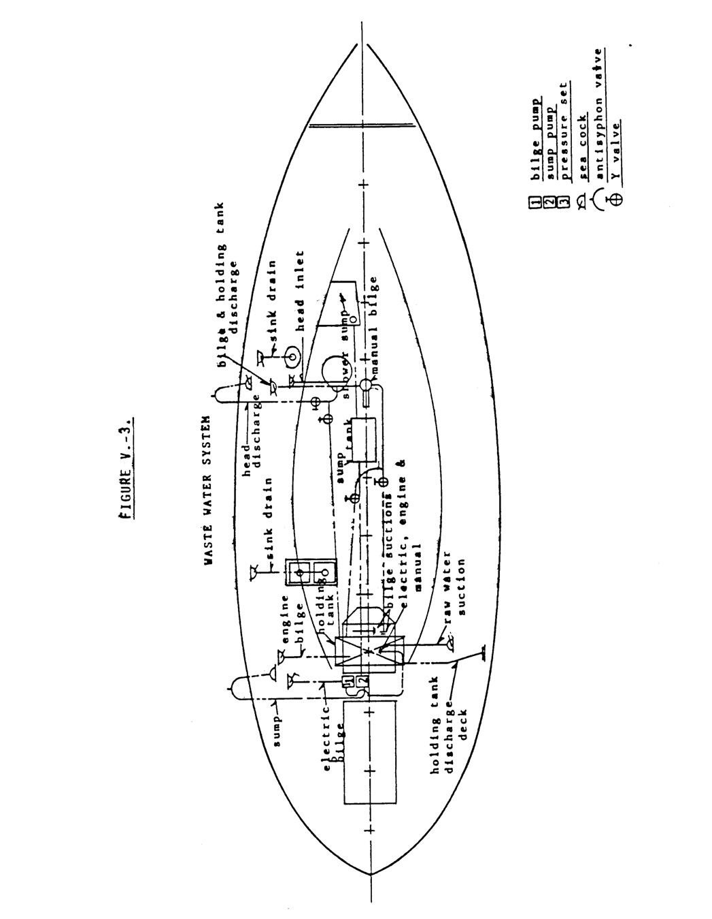

- The 110 Volt AC System

The 110 volt AC electrical system is connected to the shore power system. Its functions are primarily water heat, battery charge, power outlets, and sometimes refrigeration and air conditioning. The service capacity is thirty amperes and the system is protected to that level. Maintenance wise there is little that the average owner should do. Whenever working on the back of the panel, it is wise to shut down 110 power. Remember, a yacht is a damp environment, and this tends to increase the dangers of electric power. The 110 volt system is grounded in the yacht and this ground should remain. SEE WIRE COLOR TABLE V.-1.

- Protective System

Bonding

Your yacht is bonded to help prevent galvanic corrosion. All metal parts of the yacht which might come in contact with salt water are bonded by green electrical wires in order to provide a low resistance electrical path for stray currents. Thus, there is a reduced likelihood of current running through the salt water "electrolyte" and destroying the metal parts. The bonding system should be checked to make sure that all of the connections are good and clean.

Zincs

Sacrificial zincs are bolted onto your rudder and if commissioning is done by SOUTHERN OFFSHORE YACHTS, a shaft zinc has been installed. You should check zincs frequently at first to see how fast the metal is sacrificed. You will then have some idea of how often they must be replaced. It is not a bad idea to have a separate zinc clipped to a shroud and hung over the side while at the dock. This will save your installed zincs and offer some extra protection. To be effective, of course, it must be clipped to a metal part that is wired into the bonding system.

It might be well to note here that there are zincs in the cooling system of your engine. These also must be checked and replaced as they are sacrificed. Refer to the engine manual for their location.

PLUMBING AND SANITATION SYSTEMS

Plumbing and sanitation systems are generally very reliable and require relatively little maintenance. A program of inspections will usually prevent most problems from developing. The critical points in the systems are the pumps; everything else is pretty simple and reliable.

  - The Fresh Water System

The heart of the pressure water-system on the TAYANA 37 is the PAR medium duty diaphragm pump. This pump is generally located in a compartment aft of the companionway ladder along with the electric bilge pump and the shower sump pump (an option). It can be recognized by the pressure switch located on the side. You will find d manufacturer's parts list and a description of the pump among the papers delivered to you with the yacht.

These pumps are highly reliable and will operate a couple of years without any real maintenance requirement. If an occasion arises where a pump fails to operate, one should first check the pressure switch. This simple switch can accumulate dirt and not turn the pump on. If this should happen, turn off the power to the pressure water system, remove the pressure switch from the pump, and remove the switch housing. If the switch is dirty, carefully clean out the accumulation, reassemble the switch and try the system. If this does not solve the problem you probably have a defective switch and it should be replaced. Two other common faults can cause the pump to malfunction--a broken belt, which is immediately obvious, or defective diaphragms. To check the diaphragms, remove the four screws in the top of the pump housing and carefully lift the top off. You will see two diaphragms; examine each. If they are defective it will be obvious--they will have holes or they will be out of the diaphragm frame. Defective diaphragms should be replaced. PAR does produce rebuild kits for these pumps. While it is not a bad idea to have a rebuild kit, the most common requirement will be for a pressure Switch, diaphragms and belts.

Maintenance of the fresh water system requires little more than tightening the hose clamps to prevent leaks. If your pressure pump comes on at intervals when there is no demand there is almost certainly a leak which is allowing the pressure within the system to drop. Inspection will almost invariably show that there is a loose connection and air is getting into the lines. Again, tightening the clamps will normally solve the problem.

Your hot water system is based on a ten gallon hot water heater, usually made by American Appliance, Inc. It has both an electrical heating element and a heat exchanger which gets hot water from the engine. It requires very little maintenance beyond keeping it clean and all connections tight. The hot water

heater will last at least 5 years. The most likely failure is the electrical heating element. If this should happen, a new element may be obtained from almost any camper store and it is a simple matter to install.

  - BiIge Pumping Systems (SEE FIGURE V.-3.)
The TAYANA 37 is equipped with two bilge pumps--one electrical and one hand operated. Both of these pumps should be checked every day that the yacht is sailed.

The electrical bilge pump is by PAR and is located in the same compartment as the fresh water pump. The intake hose goes down past the engine and into the bilge sump below the engine. The pump outlet is just above the water line on the side of the yacht. The most common failure is a dirty pick-up screen. This may be cleaned simply by pulling the intake hose up from the sump and removing the dirt. A few failures because of dirt in the bilge will probably result in a greater effort to keep the bilges clean and sweet.

The hand bilge pump is generally located around the mast step. The hand bilge pump serves two purposes--it pumps the bilge and it pumps the holding tank. By following the intake line from the pump aft, one will come to a set of two valves. With one valve closed and the other open you can see that the pump clears the bilge. By reversing the closure of the valves, the pump clears the holding tank. A little experimenting will show you the proper valve operation.

There is generally a third bilge pump mounted on the engine Yanmar 3QM30). This pump is always operating when the engine is running. If your engine has such a pump it is important to remember that the bilge is constantly being cleared and a leak might not be apparent by simply looking into the bilge to see if there is water.

  - Sanitation Systems

Holding Tank

Your 37 has a holding tank system which is legal anywhere. The toilet may be pumped either into the holding tank or overboard directly. If the holding tank is used, it may be cleared either through an on-deck fitting or by the use of the bilge pump, as described above.

The holding tank is located under the engine. It should be kept clean by pumping clear water into it periodically. Detergent is useful if it has been used. The inlet to the tank may be reached by lifting the fresh water

tank and getting into the bilge.

The Toilet
The toilet is one of the standard U.S. makes using seawater for flushing. The normal maintenance is of the pump. Head manufacturers all produce pump rebuild kits and you should have one aboard at all times. Probably the dirtiest job afloat is cleaning a plugged head outlet line. The toilet outlet-becomes plugged because too much waste was allowed to accumulate and it cannot be forced around one of the sharp bends which is of necessity in the outlet line. There is little to do other than break the line at one of the joints and use a plumbers snake to clear the blockage. This type of blockage is best prevented by making the one who caused it clean the line.

Sinks

The galley and head sinks work the same. They are drained straight overboard through a check valve and through-hull. If the sinks refuse to drain it is generally because the check valve is stuck. Look at the drain hose and you will see a bronze cylinder with a hexagonal fitting on top. A sharp tap will usually free the valve. If this fails, remove the hex fitting and clear the valve.

