J-{', A - . *

...,:- ·..

TH I '3 11ANUAL' FOLLOl,J THE r.:ouip1-1f)JT IiANUFfil. I !J \Y . ·-. i. \ ';' . ;;'i_ l:_' T !l)N _1 .

'i'UJ.! liiiPP'f ..Al Ll Ni..

NUl I C E · f/; -'.:Hi l f.,

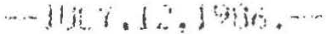

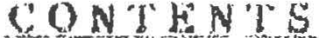

l. l HIJLL

l. :l UC.Cl". TU HULL J 1jI NT

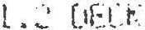L .4 BUU<tiU\[(;

i.;_; BAU.A') l

; ...;. 'UL{iEP

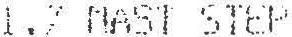

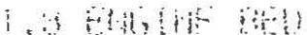/. 1 8fflJ!-!E '.> lAP llNb 1Ht EN:..;flt

2.? 5T1WT lNG PPOCFDUPE
2.3 AFT rn STliPT 1N(, 1 HE cNbINE

2. 4 STOPP ING THE EM(, \NE
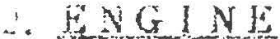.·
/ • 1) ENGINE COOLING f\NU f •'hl'<iJ').l ;y·.:;rrn

4 • 1 FUEL 1AtJt :

4. 2 DEet:: FlLLH'

- . J FUEL lAt1 UfJH

•.t. J FUEL f !L H'.P
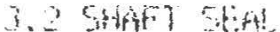

THE TINE TO PUT THE BOAi' AWAY IN GOOD. ORDER WiLL L:\Pi:U i TE l1N EAR.L Y LAUNCH IN THE

14.lHAULIN(i

THE LIFTING SLINGS IS TO GE PLACED AT 1\ LOU1T [f JN TO t,uo10 OAMAC>E TO THE PROPE ENSURE THAT THE CENTER OF GRAVITY OF THE E!OM 1·::. EiUWEEN THt: SLINGS. lF A KNOT M THESE AREAS 1T SHOULD BE IJITHDRAIJN PER THE l'!At.lllff\l:H1 H?S INSfRUCTIONS TO NJOID D
THE BOAT MUST SE IJELL SUPPORTED ON A C AOLE t.11 TH l'IOST OP THE WEIGHT ON THE K PAOS . FOR THE HULL SHOULD BE SMOOTH ANO :,;1-1A1--.E(I TO !HE HULL IF POSSIBLE. THE IDEAL stlPPORT PADS ARE IN LINE IJITH BULKHEADS IN THE BiJAl.

  - .HY LL BOTTQM
SC:RAPE ANO SCRUB THE HULL aonm1 TO Rtl10UE. ALL c Ol.JTH AS SOON AS THE BOAT lS

PAINTING SHOULD WAIT UNTIL SPRING FOft 8EST ?C:';:.1_ll.l'.. . Sff SECflON 12.

  - Z I NC...§_

REPLACE THE ZINC PU\TES AFTER BOTTUt1 PA!NTlN::, IN THE )P ING. fHf. ZINCS tlUST N

SECTION 10.3.

!4.4 FRESH WA'£ER SYSIEM
!JINTERIZE THE FRESH IJATER SYSTEtl WITH ONE OF Hit C01"1!1ERCIALLY AVAILABLE NON-T

DESIGNED FOR POTABLE \JATER SYSTEt1S . FOLLO t lHE lN ilVUCT!ONS CAREFl.JLLY.

TURN Off THE PRESSURE WATER PUMP. lHEN 1 fHE HlH WhTE : HEATER SHOULD BE TURNED

COOL. THE PP.ESSIJl?F.. EUEIJE UALUE t.Hil:J! '3HUULU UL 1Ji'tJJtJ1 TO RELIEIJE PRESSURE AND
HO I (\N() COLri HO ;E {_" l.i iNl:Cfi (itb . [If.I NU r ::q c,LL•t;;.Ji I : : i •i : i( ; ; r.:·:1.HiiNbfY HOEif.'. ) FP.01"1 T LENl;l'H OF 1/2" O!f'1f"1ETER BUGlNG TO CONNEC T THL ;!i.1 1 H!• 1_UUJ LINES TOGETHER TO BY - PUMP THE l.JATER SYSTEtl AND BOTH TANKS OPY 8i f !_iPNi:Jt ON lHE PPESSURE WATER SYS PUMP OUT FIRST ONE TANK ANO THEN THE OTHER ANO f{tl"!El-iBEP TO f'Ul'IP OUT THE FOOT PUt1
INSTALLED.

OPEN ANO DRAIN ALL SEACOCl<S APTB? HAULOUT. 1\LL '::.b\UJl'.KS ARE THE TEFLON SEAL TY
REQUIRE LUBRICATION. AHY IJALUES WHICH LEAK OR r1 .'E Olff[CLILT TO OPERATE SHOULD BE

SEACOCKS USED FOR DRAINAGE Of THE COCKPIT, ANCHOP LOCKER OR COCKPIT LOCKERS MU DRAIN THESE AREAS.

  - BI LG:E
COMPLETELY PUf1P THE BILGE FREE OF ANY lJf1H'.P NlD Cl.Ef1N OUT t'\NY DEBRIS PRESENT.

BE PUMPED ORY ANO HOSES DISCONNEC.TEO IF t·iECt-:S''.i1 P.\' lO ENSURE THAT NO WATER IS LEFT

  - I<;t: BOX
REMOlJE ANY REMAINING F,000 FROM THE ICE BOX f\ND Wf\SH 001,.IN THOROUGHLY WITH A IJAR SCl.UTION. oOoRs CAN BE RB10UED WITH A BAKlNG SODA ANO WATER SOLUTION. COt1PLETELY FRON THE BOTTOM OF THE ICE BOX. THEN LEAi.iE lHE ICE BOX LIO OPEN DURING STORAGE TO

  - §IQYE
. CLEAN THE STOVE THOROUGHLY. FOR CNG OR LPG STOUE5, REMOVE THE TANKS CONTAING G IN A IJARl1 ORY AREA.

  - C O Y E . _1i TJi.E JJ_ Li.\...T_
COtJER THE BOAT AOEQUA 1ELy OUR 1NG sroi;w E TO t''U.if:N r E.;.;CESS ll.IE IJEATHERING. NOTE
FIU1 CAN CAUSE EXCESSIVE FADING IN COLORED GELCOAT IF IN DIRECT CONTACT WITH FI8E
IS cAusEo BY A CHEMICAL REACTION BETIJEEN THE POLYETHYLENE ANO THE GELCOAT. THE BO
OF A BREATHABLE FABRIC OR BE Ol:::"'SIGNEO TO ALUM,J GOOD tJENT ILATION.

  - MAS I
THE ALUMINUM 11AST REQUIRES A MINIMUN OF CAf. E Mm rl"1NTENANCE. AT THE END OF EA BE IJASHEO IJITH A MILO DETERAGENT ANO WATf:Y SOLUllON, FOLLOIJED BY A COMPLETE RINSI TIE QFF ALL liALYARDS ANO LIFTS AND INSPECT rHE f'IAST COMPLETELY FOR SCRATCHES THRO OR A CLEAR LACQUER SHOULD BE APPLIED TO ANY SCRATCHE ; fOLINO TO PREUENT CORROSION.
CliECK ALL HAROUARE ON fHE f1AST CAREFULLY FOF.' SiGNS OF CORROSION AND CHECK THE FASTENINGS. MASTHEAD SHtAVES SHOULD SHOW NO SH,N':i OF :..1£'.AR AND SHOULD MOIJE FREELY.

- SA lLS

  - SAIL

AT PRESENT, THE UAST MAJORITY OF SAILS A E 11ADE FROl1 POLYESTER ANO NYLON. ALT

MATERIALS NEED FAR LESS ATTENTION THAN COTTON SA1L5 OF OLD. THEY \JILL LAST CONSI ARE TAKEN CARE OF CORRECTLY.
YOU SHOULD CHECK YOUR SAILS REGULA1LY BOTH l..ll·lf.N SET ALOFT AND IJHEN FOLDING TH LOOK AT THE SAILS CAREPULLY 'i'Oli Jlll NEARLY i1U'f1YS tml!CE SIGNS OF OAl1AGE STAP.T AREA OF CHAFE, A FEW BROKEN ST ITCHES. THESE Snt"ll.L PkOBLE11S SHOULD BE RECTIFlED A NO'f PUT OFF TO A LATEP DATE. REMEMBER THE OLD ':)AYHJJ_; 'A STITCH lN TltlE SAIJES 9,'
·lT USUALLY MEANS 'SAIJES 9,000 ' •

lJHEN YOU FI NO ONE OF THESE PROBLEMS UN 'l'OUP SA t L, TRY ANO FIND THE CAUSE OF I
RECTIFIY THE OBJECT HICH IS CAUSING THE PROBLEM, IT WILL ONLY HAPPEN AGAIN.
SOME COtlMON •SAIL KILLERS• AAE LlSTEO BELOW FOU .(Jl.JED BY SUGGESTIOf>.JS ON HOW TH
t. RIGGING SPLII .f.J.1L£
THESE SHOULD ALW\YS BE TAPED UP.
2. _s P R .J:: t:\_lllU\. lUiD
THESE SHOULD E ITHEP T APELI IJP ()!:> riE nour.J[l :.j ! r H .:; q>l \. h-i rrit: ·.
3. lJ--E.E.. .L.LNK S T i\ 1'i T I o N s_
THESE CAN CATCH ANO CHAFE SAILS DURING TACK iNC.

ONCE YOU HAUE ESTABLISHED EXACTLY IJHERE YOUR SAILS CHAFE AGAINST SPREADERS AN A GOOD IDEA TO GET YOUR LOCAL SAiltlAKER TO SEl..t PAICHE ; Ol.iH' THESE AREAS TO PROTE
FURTHER CHAFE.
4. J'tlREA_D.. ljAfJ:;
IJHEN SAILS TEAR ·OTHER THAN IJHEN THEY HNJE (A l)(,HT ;unETHlNG SHARP, IT IS NEAR fAJLVRE, ANO IT NEARLY ALI.JAYS STARTS Fk>Ofl lHt. LFF.TH. WHAT USUALLY 11Af'PENS IS THA CHAFES THE STITCHING ON THE SEAM \JHERE THE CLOTH I ; TUP.NEO OLIEP. ON ITSELF TO FOR THE LEECH.
YOU SHOULO REGULARLY CHECK THE 5T ITCH l NG ON U1C H Sf.f\f1 IJHERE IT IS FOLDED OUER

(

19.1 121.l 0.C • SYSTEM
10.2 HOV A.C. SY5TEtl

10.3 BONDING SYSTEM

11. BATT E_l _'.L

11.l OPER1\l IUN Of- HIE 0.C. !JOL lllllt::k

11.2 BATTERY MA[NTENANCE

12. A N l' 1 F O !U::e.lJ lJi
12.1 PREPARATION
  - SELECTION AN ANlIFOULING COATI!K,

  - APPLY ING THE BOTT OM COAT INf;

13. i:J.llK.R..G...L._1). S li Mh.1.li.T_Kl'Lf\_I'{__ LE

14 • .W...UtIJUU...? .LN..G.
14.1 HAULING

14.2 HULL BOfTOf!

  - ZINCS
  - FRESHWATER 'tSfEtl
  - HEAD AND HOl.OING TANK

14 .6 ENGINE

  - FUEL SYSTEM
  - BATTERIES

14• 9 SEACOCK

14.10 BILGE
14.u ICE ox

  - STOIJI:'.

  - COUER lNG IHE BOAT

14 .14 tlASf

- G Q N S I R U C 1::._x Q t L _P_E
"J.- A I I... S

TA SHING YACHT BUILDING CO., LTD. USES HiGHE'. T UUfllll 'i llATERIALS A ID CONSTRU PRODUCTION OF THE TASHIBA YACHTS. THE ENGINEERING DEPAi.?intNT AT THE YARD KEEPS THE LATEST tlATERIALS AND CONSTRLICTlON 11ETHDC6.
THE FOLLOWING IS A BRIEF UESCRIPTION OF THE CU!iSTPUCTlON OF THE BASIC corlf>ON

  - JIU LL
TH' E HULL IS BUILT ACCORDING TO THE li¥.CHIETECT' ; PECIFICAT!ONS. THE LAMINAT!O

SEEN IN FIGURE l •
IT IS BUILT AS A ONE PIECE FIBERGLASS tJOLOING IHJ'H THE STRIPS OF liATERit1L AL THE BOOT TOP ANO WATERLINE AREA FOR ADOITIONAL :TRENC.TH. TIJO EXTRA PAIRS OF rtAT ON BOW TO REINFORCE THE 80\J AREAS. THE SHEEP HULL·(1ECK JOINT AREA IS ALSO SPEC !
TOP QUALITY U.S. MAOE GELWAT IS USED OF n-u: I '.:iiJP.!HAUC TYPE iJHICH HAS THE B
RESIS'fANCE.

  - DF;GK

THE OECI< IS CONSTRUCTED OF rHE SMIE GELCOi\ T 1VlO Flh' flr\ TE '.IAl S AS THE HULL. A CORED IJITH A HIGH STRENGTH ENO GRAIN LIGHT lJOO[l cm E 1.JHlLE THE 1·10RE VERTICAL SUR END GRAIN BALSA FOR LlGMl UEIG.-ff ANO "PRINT" RESISTMKE.
IN AREAS WHERE HAROl.JARE IS BOLTED THROUGH THE LlELK, llAR!NE PLYWOOD IS 1!3£0 A

CotlPRESS ILIE STRENGTH.

THE DECK LAMINATION SCHEDlll.E iS CALLECr OUT HJ i: !GUPE 1 .

1.3 I}F; K TO HULL JO INT
THE HULL FLANGE IS SPEC l ALL'( RE INFORCEO TO f P.OJi; THEN THE JO I NT BY THE APPLI C

FIBERGLASS LAYERS. THE DECK IS INSTALLED ON A LAYt.'.P OF ·.Hl··EC 5200 FOR HIGHEST S IJATER-TIGHTNESS. IT IS SCREIJEO IN PLACE tJI fH 5flr1 · s '. ELF TAPPING SCREWS ON 8" C
CAP RAIL IS INSTALLE::D ANO THE ENTIRE JOIN! l::.'· tlULltU TOGE:THB WITH 114' S.S. BOL

DETAILS OF THE JOINT nAY HE SEEN IN r!Gl.il<'E ::· .

- · _,,..·

THE TASHIBA 36 ANO 40 HAS A KEEL STEPPED MAST. THl-.'OUC,H A t'IAST DECK COLLAR WHI CABIN TOP: THE MST STEP STANDS ON A HEAUY HARt•.'000 BY 112 SELF TAPPING SCREW WHI IN PLACE ON BALLAST KEEL.
DETAILS OF MAST STEP MAY BE SEEN IN FIGURE 4 • (f0r! T831 ONLY>

t.e ENGINE llE 11
THE ENGINE BEOS ARE MOLOEO lN t\ SPECIAL 110LD TO SUBSTANTIAL THICKNESSES. THE
112• MILO STEEL PLATES EMSEODEO IN THE FIBERGLASS. THE'SE PLATES ARE LATER DRILLE THE ENGINE t10UNT BOLTS.
THE ENGINE BED NOLOING IS ACCURATELY LOCATED IN THE HULL AND HEAUlLY GLASSED
SEE FIGURE 5 FOR DETAILS.

1.9 DEC K .HAR UWA RE l..N S I l\ L L I\ T_l.illL
ALL OOCK HAR£)IJARE IS THROUGH BOLTED INTO POSlTION. THE DECK CORE IS REPLACED THE AREAS HRE FJTIINGS ARE ATTACHED. IN ADDITllJN, STAINLESS STEEL BACKING PLAT THE LOADS.
PERMANENTLY FLEXIBLE TYPE BEOOING COl'IPOUNDS ARE 0SEO '1-tMEN THE FITTINGS ARE IN

SEE FIGURE 6 FOR DETAILS.

·· PUB -

IF TI£ ENGINE CAN•T BE STARTED IN COLO WEATHER, PLEASE REFER TO THE OIJNER'

2.3 A FT E R S A BT.1Jl.!r, .I..ti.E. .E N_{;_.l.Jit:_
·-
1. CHECK FOR NORl1Al OIL PRESSUl<IE. SHUT DUWN THE tNt,IME if N(Wf1AL OIL PRESSUl<'E lS

SECONDS OF STAR"f ING.
2. tltEO< 111MEOIATELY FOR SEA IJATER FLOIJ THROUGH fHE EXHAUST OUTLET.
3. OPERATE THE ENGINE AROUND 890-900 R.P.M. FOR AT LEAST FIUE MINUTES TO ALLO!J E
RUN AT HIGH SPEEO DURING UARM UP PERJOO.
4. IF MARNING LMPS LIGHT UP OR THE ALARtl OElllC:E SOllNOS, IT tlAY BE AN INDICATION TR0UBL£ IN THE ENGINE. ALTERNATIVELY, THERE MAY BE A PROBLEM UITH TH€ UARNING SY THE ENGINE DEALER.
CAUTION• NE\JER SHUT OFF THE BATTERY Sl.tllTCH UHlLE THE ENGINE IS RUNNING AS SERIOU

f1AY RESULT.

2.4 STOPfIG. :r..H.Ji ENGINE..
PLACE THE CLUTCH CONTROL IN THE NEUH AL POSIT fON 1-)NO F UN THE ENGINE AT A LOW TO COOL IT DOWN. THEN USE 'CHE STOP CONTROL WITH THE ENGINE IDLING AND RETURN THE POSITION. ALllAYS CLOSE THE INTAKE SEACOCt\ WHEN THE ENGINE IS NOT lN U 'E.

2.5 . Efi{ll NE CQQL I NG | AND .IU.lful.U ST | SYSit;M
l HI RAW WATER | §YSTEM
RM.I YATER IS ORAi.JN THROUGH THE SEACOCK ANO THROUGH A RAU UATER FILTER BEFORE
THE ENGINE HEAT EXCHANGER. AFTER THE HtAl EXCHANliER, THE WATER PASSES OUER A HIG THEN 15 INJECTED INTO THE EXHAUST LINE. THE IJEtJTED LOOP PREIJENTS POSSIBLE SIPHON FILL THE EXHAUST SYSTEM ANO ULTIMATELY ENGINE CYLINDERS CAUSING SERIOUS DAMAGE.
THE EXHAUST HOSES SHOULD OE PERIODCCALLY CHEU'l:(J FOR CONDITION AND SECURITY,
TIGHTNESS.

11£ COOLANT FRon THE HEAT EXCHANGER IS FORCEO BY THE FRESH WATER PUMP ON THE

- -. ,-·

- I!Q W S RT R h N § M I S S I ·9 N.

IT. IS MOST IMPORTANT THAT THE SHAFT ALIGNMENT !S CHECKED BY THE DEALER DURING ALIGNMENTS ARE CAREFULLY CHECKED AT THE FACTORY' BUT SHIPPING sn ESSES ANO SLIGH DUE TO THE DIFFERENCES OF HULL SUPPORT BY THE CRADLE ANO THE 1,..IATER JILL CAUSE SO
THE ALIGNMENT SHOULD BE CHICl<ED 24-46 HOURS AFTER LAIJNCHING ANO AGAIN Al 100
UJBRATIOH IS NOTED.

3.1 SHAfT ALIGNMENT fRQCEUt.!ll.[
  - REMOOE COUPLING eot.rn ANO HOLOlNG THE FLANGES TOGETHER, INSERT FEELER GUAG
11AX111US'l°GAP BETIJEEN THE FACES AT ANY POINT. CHECK RADIALLY ALL AROUND THE COUPL ALIGNMENT IS ACCEPTABLE IF lT IS WITHIN .1 1111 OR • 004"
IF NECESSARY, ADJUST THE ENGINE tlOUNTS TO ACHlEl.IE TMIS TOLERANCE. RETIGHTEN A
MOUNT BOLTS ANO RECHECK t\L 1GNf1ENT.
2. lJHEN AL GNMENT l S ACH ItIJEO, POTAT E f HE F'PCiPt::U.tY '.)Hf.1rT C OUF'U NG HJ(! DEGREE

TRANSnlSSION COUPLING ANO • ECHECK AllGNflt.NT •
. IF IT OOES NOT R€MA1N IJITHIN .1 Mtl OR .004, THE SHAFT OR COUPLWG FLANGES ARE
REPAIRED.
3 HM REINSTALLING 1Hf! COUPLING BOLTS, USE •LOCK TITE" OR SltllLAR THREAD LO
BOLT SECURITY.
  - DRIP LE§ e SH I\ FT SE; h k
    - A ORIPLESS SHAFT SEAL IS USED IN PLACE OF Ttif. CONl.IENTIONAL STIJFfING BOX. T
HEAVY RUBBER BElL0\15 CLAMPED TO THE STERN TUBE WITH A SPECIAL PLASTIC RING AT IT STAINLESS COLL.AA, SEALED lJITH AN •o• RING TO THE SHAFT, lS CLAMPED TO THE SHAFT PUTS PRESSURE AGAINST l'HE PLASTIC RING ON lHE FLE'r.IBLE BELLO\JS. A5 THE S.S. COLLA SHAFT, IT BEARS AGAINST THE PLASTIC BELLOWS HID RING. ANO ALLOWS NO WATER INTO TH
THE AOIJANTAGES OF THIS SYSTEtl INCLUDE THE FACT THAT THERE IS NO STUFFING MATER REPLACE, ANO THAT THE GLAND REOUIRES NO 110JUSTfiENl. ALSO NOTE THAT THERE IS NO SH TRANSMISSION.
- 012 -

  - FUEL Ll\._N..K

THE BLACK IRON FUEL TANK IS LOCATED UNDE : f Hf CABIN SULE FORIJA D OF THE COMP

IJITH A DIP STICK ANO INSPECTION PLATE ON TOP OF THt TAN ;.
IT JS. RECOtlMENOEO THAT THE FutL TANI< BE PER£001CALLY CHECKED FOR WATER CONDE A SMALL HOSE TO THE LO\JESt POINT THROUGH THE DIPSTICK HOLE. THE IJATER YlLL SETT ANO CAN BE EASILY SUCKED OUT WITH A (;Et-IERAL PURPOSE PUtlP ANO THIS SHOULD BE DON THE FUEL TANK CAN BE SOUNOEO YITH THE llIPSTICr. OP WITH THE OPTIONAL FUEL GAUGE.

  - DiCK FI Li PLAll
THE OECK FILL PLATE ANO COllER ARE MOUNTED FLUSH WITH THE DECK. USE ONLY THE PROV IOEO TO REMOVE OR INSTALL THE COl•ER.

  - f\lEL TANK UNI
THE Fua iANK IS IJENTEO THROUbrl A FLEXIBLE HOSE THAT RUNS TO THE CABIN SIDE
PREVENT SEA IJATER FR011 ENTERING THE FUEL TANK.

  - SHU T-0 Ff. .Y.A.L..Y..E.
    - A FUEL SHUT-OFF UALl.if; IS LOCATED ON THE TUf' OF THE FUEL TANK. THE HANDLE IS
AT 90 DEGREES lff:N CLOSED. KEEP THlS l,JALOE CLOSED AT nll Tin£S WHEN THE ENGINE

4.5 FJJBL fl LIER
PRESENCE OF YATER OR OUST IN THE FUEL tlAY CAUSE FAILURE OF THE ENGINE ANO RA INJECTION EQUIPMENT. A RACOR FUEL FILTER/SEPAP.ATOR JS INSTALLED BETWEEN THE FUE FUEL FEED PUf1P WHICH SEPARATES IJATEP FPOtl THE FLlh li!F f!UCH CENTP.lfUGAL ANO GRAV
BOWL ON THE BOTTOll HA'.:; TO BE 1NSPECTH.i f'!:YlUUli_ !1L L 1• r-1_ 1P Wr\TEP N D LARGE · ;ouD·:>.
ELEMENT AT LEAST ANNUALLY.

YATER IN THE BO\JL IS A OISTINCTJIJE, LIGHT COLO ' \JH!CH CAN BE DRAINED BY THE P
BOTTON Wl£H NOTED.
A SECONDARY FUEL FILTER IS FITTED ON THE ENGINE, BETWEEN TNE FUEL LIFT PUHP A
-· 014 -

- F R. E s H w: A r E R. - y s '"r Et: M

THERE ARE TlJO YATER TANKS (STAINLESS STEEU. ONE IS UNDER THE PORTSIOE SETTE
ONE IS UNDER THE STARBOARO SIDE SETTEE.

  - WAIE R IhNK
EACH l.JATER TANK HAS A FLUSH MOUNTEO Of.CK FILL PUHL TO REMOOE OR INSTALL TH

THE SPECIAL lrJRENCH PROUIOEO.
A REl10UABLE INSPECTION PLATE ANO A OIP-STlCK ARE INSTALLED ON EACH TANK FOR

ANO CHECKING.
WATER LEFT IN A TANK FOR A LONG PERIOD OF THIE lJTlL BECOC'JE STALE. THE TANK M

IF THIS OCCURS ANO CLEANED WlTH A !.3AK1Nf SOUA tiN[l Wr\fl:J'. .CJLUTION FULLOl.JEO BY RI

  - W/\IER .YEtiT.
THE WATER TANK IS UENTEO THROUGH A FLE>'JBLE HOSE THAT RUNS TO THE CABIN SIDE

PREVENT SEA IJATER FROM ENTERING THE l1IATER TANK.

  - SHYT-OJrf Yi\LVf;

A S.S. MANJFOLO UITH TWO SHUT-OFF UALllES IS P Ol.HOED FOR TANK USE SELECTION.

  - PRESSURB WAl' R SYSTEM
A TN« VALUE SHOULO 8E OPEN WHEN THE PUNP 15 USED, OR DAMAGE TO THE PUMP MAY
PRESENT IN THE SYSTEM, THE PUnP MAY RUN 1NLIEF'JN1TELY, ANU WILL OIJERHEAT ANO OA11
PUMP. FOR THIS REASON, AU.IA YS TURN OFF THE PUl1P 1.-!HEN OUT WATER.
If THE PUMP CYCLES ON ANO OFF WHEN ALL TAPS A E CLOSED THERt:: MAY BE A LEAK
nusr BE FOUNO ANO EPAIREO TO PREUENT WATH! L\)SS.

  - ACGQMULAIE.R. IANK
A ACCUMULATER TANK IS MOUNTED HJ UNE AFTEP THE PP.ESSURE PU11P. THIS TANI< RED PULSATION ANO PREVENT RAP IO ON/OFF PU11P CYCLING. l T AL.0 ACTS TO CUSHION SUOOEN PRESSURE YHICH ASSURES A SMOOTH FLOtJ TO ALL FI X TIJPE5.

6. :t: Q 1 J,... E :r S :x· S . L J;i; J\4

ALL TASHIBA YACHTS COME EQUIPPED IJITH A MARINE HEAD AND HOLDING TANK AS STAN THE MARINE HEAD IS PROUIOEO lJITH A ·r UALUE IJHICH ALLOWS THE OPERATOR TO OIIJERT
·HOLDING TANK OR DIRECTLY OUERBOARD.
FOR TOILET SYSTEN SEE FIGURE 10 •

6.1 0 PE RAT IN <.i I.Q...l..L.KI
nAAe SURE THE INLET ANO OISCHARbE ·SEACOCK5 1 RE OPEN. MOUE THE lJALUE LEVE TO POSITION ANO OPERATE PUMP. RETURN TNE VALVE LEUH1 TO THE "ORVBOWL • POSITION AND LEAUE THE UALtJE LEUER IN THE •ORVOOJL • POSIT lON MHEN THE TO ILET IS NOT W USE, A
SEA-COCKS UHEN THE BOAT lS UNATTENDED.

6.2 .IQ EMPTX HQLJ)JJiG .UUU
AN OPTIONAL DISCHARGE PUttP CAN BE ORDERED Ok, PUMP OUT BY THE STANDARD DECK F IF ACCESS TO A DOCK SIDE PUNPING UNIT IS Alltt!LABLE. THE OPTIONAL PUMP SHOULD BE IS TOTALLY REttOVEO ANO AIR IS HEARD FLOWING THROUGH THE PU11P. IT IS RECOtlMENOEO THE HOLDING TANK OF WASTE, A DlSINFECTAN1 AND otOOOl<'ANT BE PUMPED THROUGH THE HE HOLDING Tf\NK ALONG IJITH SUFFICIENT RAIJ IJATER lO Flll THE HOLDING TANK. AFTER PU IJATER INTO THE TANK, RE-EMPTY IT AS OESCRtfJEO.

6.3 .l..f. Itl"E DIS HA RGE LJ.Jili lUt J.?...Mlt. .k.L...QGf.iE D,
ADV 1S AJ!..LJi T 0. C H E.c K TlU·:_ .f .P.J,J.LQ..Y{J_NJi .A..R..E A S
1. CHECK THE ;}PHOM tWf.Fit< FOi-' LLUi..!,Jl t ; Li'i L(i("(,;!J;. ;j':.f.' U.f\1"11'::: Ar o PtMOl)lNI_; THE

S!OE OF THE SIPHON BREAK .

2. CHECK THE INLET OF THE •y• VALUE BY REtlOUING lHE HOSE.

3. CHECK THE ONE WAY VALUE OUTLET BY PEMO. IING Ho::E.

NOTE• NEtJER TRY TO FLIJSH HARO ITEMS AS THIS IJ1LL DAMAL f. THE r!ARINE TOILET. AS A SPOILED VACATION, IT 15 MANDATORY FOR EUERY OWNE · TO UNDERSTAND HIS MARINE T SPARE PARTS (SEE HEAO 11ANUAL} , ANO THOROUGHLY f:W llF H lS GUESTS ON THE UNITS

THE TASH IBA YACHTS COME EQUIPPED Wl TH t1 l1ANUAL. BH.C,E PU11P ANO AN ELECTRIC PU

EQUIPMENT.

  - MANUAL BILGE _fJLM.r.
THE PUMP IS EQUIPPED WITH A BILGE STRAINER AND AN r1NT I SIPHON DISCHARGE LOOP.

INSTALLED ON THE COCKPIT SEAT BAO<-RE5T FOR EASY OPE.RATION.

  - ILBCTR IC BILGE fUMP
THE ELECTRIC PUtlP IS OPERATED BY usu ; Hit SIJfTCH ON THE D.C. PANEL. THE SUG
AUTONATIC FLOAT Sl.JlTCH WILL AtJf(JftPd !CALLY TUPN Uf·i Hil·. l'Ulll' Ui-frJ ElJtP EXCESS WATER

7.3 MAINTENANCE OP THE SYSTEMS lNUOLUES KEEP!N( THt INTA '.E SCREENS ClEAR OF OEB CHEcKS ON THE ANTISIPHON UALUE FUNCTION.
FOR BILGE PLUMBING SYSTEM SEE FIGURE 11 •

THE TASHIBA YACHTS ARE FITTE() WITH A STAINU::ss 5fEEL PEDESTAL OPERATING STEE

ARE ORIUEN BY A QiAIN OUER A SPROCKET ON THE STIJYING IHEEL SHAFT. THE STAINLES SPLICED TO THE CHAfN ENOS ANO RIJN 1.llA. SHEtWE(.:i TO THE 1111AORANT AT THE RUDDER POS THE TASHiBA PH rlODEL HAS A INOtifW ·:;lEt:YltJf.:, '.:1! i1f !UH !H Af)[1!TIOt·J TO THE PEDESTA
AREA. THE MAINTENANCE 11ND IN ;PE.U ION Of: Ti If: ':. 1 ··I i-i1 i '-_. t·>;::A:JH l f'•L Tlt fHf. 5AfETY O

  - MAINTENANCE AND INS PJ <;_T_L9Ji
THE STEERING CABLE TENSION CAN aE AOJUSTEO A f rHE QW1l:Jl. ANT BY TURNING THE NU TAKE-tlP EVES AFTER LOOSENING THE LOCI\ NUTS. THE '::;ArtE NIJM8Ek OF TURNS SHOULD BE 1 f1AINTAIN THE STEERING CHAIN AT mt: CENTER Po<.JIT!UN. UNLY ENOUGH CABLE TENSION r EL1111NATE ANY LOOS£ FEEL IN THE STEERING, ANO TD P )EUENT THE CABLES FORtl JUtlPING lN THE QUADRANT OR SHEAVES. EXCESSIVE TENStoN I.JILL OUICKLY CAUSE EXCESSlUE UEAR
SYSTEM.
ANNUAL LUBRICATION OF THE SYSTE11 rs UERY H1PORTNH. THE SHEAUES nusr BE CAREF
TEFLON GREASE. THE WHEEL SHAFT SHOULD BE Of LEl.J. THE PEDESTAL CHAIN ANO ALL EXPOS
LIGHTLY RUBBED HTH AN OILED CLOTH. HllS Jll.l. N.Stl UHH:r ANY Bf;'OKEN CABLE STRAN

THE CABLES MUST BE RE:PUKE.0.

CHECK THAT THE SHEAVES ANO QUADRANT Hfll,IE PROPEP AL lt.JNf!ENT TO THE CABLES ANO A FINALLY, RECHECK YOIJR STEERING WHEEL CENTE 11AvV, IF ANY, AND ADJUST AS NECES NOTE THAT THE STEERING CABLE SHOULD BE REPU1l.f.:O ftJEP.Y F IUf. YEARS Et..lf.N IF IJEAR
OLO CABLE CAN BE RETAINED AS A SPARE.

  - U ?l .QJ:. E MERGEN G Y T I L L.J';_g_

IF A FAILURE OF THE STEERlNG SYSTEl'l OCCUR:., !Hr Ulr:l<lCBKY TILLE!? CAN B£ USEO. THE RUOOE.R SHAFT IS MACHINED TO ACCOl10DtHt THE '.IOLYFT Al THE uASE OF THE TILL IT IS RECOtlttENOED THAT A snALL CABLE currrn 8f.. CAH..'JED ABOARD ALLOWING THE Ol.
A TANGLED CABLE 00 I C L'f AND REGA IN :·1TFH' f rJ1, ' ; 1r if >'' ! .

FOR STEER !Nb SYS l Ef1 SEE Fl 1;u '.E LJ hliU i.; .

IMPORTANI:
TO MINIMISE SHOCK ANO FIRE HAZAkt1S1
- TURN OFF THE BOAT'S SHORE POWER Sl.llTCH f!EFO ·t: CONNECTING OR OISCONNECTI

CA8LE.
2. CONNECT THE ')HO '.E POtJEH CABLE f\T THE 80f"1T F- lk'ST.

- IF THE POLARITY WARN !NG ll C.Hf ON THE Pt'1Nf:1. i ':;; ACT !UATED, IMtlEO 1ATEL Y DI

11N[l HAllE THE FAULT COR ECTED BY i1 UUt\U F !Ef1 fLtCH'lCIAN.

- DISCONNECT THE SHORE POWER CABLE Al THE ')f10PE OUTLET FIRST.
- IJHEN usING "IGTAl L ADAPTORS, ilAKE SUPf rHE uuTLE r BE I MG USED Is 110 l)Ol.

12U $ 110!.J ELECTRIC SYSTEtl SEE FlGUPE 15 •

10.3 B Q N 11 l Ny _Uli...U:_M _A.till. ..S.A.\;_lLLf_UU.AL. z..I..fi C s
THE :ASHIBA YACHTS ARE FIHEO IJllH A LOW PESJSTM·lCE COtlf'tON GROUND OR BONDIN{; CONNECTS t\LL LARGE METALLIC f1ASSES, ALL EQU1Pl1f:NT t f.'OUMr.6 U\C + 00, ANO f\LL VNO FITTlNGS, ELECTRICALLY TOGETHER. THIS 1·:, ·10 H6iJ;;. f 'liWi THE GROUNDS ARE ALL AT T REDUCE THE RISK OF ELECTPIC SHOO' . nT Tilt c,.;1 ;F !' !:li;., f HE POS .f81L HY OF 5TRAY Cl!
RE(llJCf:0•
IN ADDITION. rHf. s1s1;:11 ts ((JtiNECrt.;.o TO !Hr: ·_',; :;,.. ' /i ii:.':•. iHESE ZINC::: h.·t. HHE THE OTHER UNDERUATER ·METALS BY CORRODING Gt1LlJAN!Ct1lLi f- IW)l. THEY Will CONTINUE FITTINGS AS LONG AS THEY ARE ELECTRICALLY COHNECrt D TC1 1HEtl AND Iflt1ERSED IN THE
I f l 5 THEREFORE UERY 111PORTANT TO RENEW THE 21NC' ; k'f .t ULAP.L '( ANO BEFORE THEY ARE THEIR ORIGINAL SIZE. 1.JHEN REPLACING THE liNCS, DO rlOT PAINT THEtl OP. THEIR EFFECT ELIMINATED. THEIR ilOllNTlNG DETAIL;. Mt SHOIJM ll'J !· ;r"UH lr_. •
IF THE BOAT IS IN A tlARINA WHERE STRAY CUF:'kE.i'H '.» Pl)ll LITHER BOMS OR SHOP.E POt..I
CAUSE RAP IO z INC LOSS' TH Is PROCEIJIJRE t1AY 8E Fu:.U.it,:rn . PUh'CHASE A LARGE z I NC AT
LENGTH OF a GAUGE i.JIJ..1E. BOLT THE fJIRE TO THE z INL i'!r".t· li-Ki A GOOD ELECTRICAL CONNE
ZINC IN THE IJATER AND CONNECT IT TO ANY 80NOf.[J lltTr:1L Pr PT OF THE BOAT, SUCH AS T
THEN BEGIN 1'0 CORRODE, SLO I!NG THE Z ItJC l.0'35 t.tN ·; iiE i+bULrW SH IP' S l I NCS, ANO PR

11.
a 6: ... .l ..r E R x_

u- . .-

....- /_-·--·---

r ..

-L A "T 1'..f

-THE TASHIBA 31 IS FITTEO IJITH ONE lOOA BATTE!?{ AND A SELECTOR SWITCH IJHICH BATTERIES IF NEEDED. MANY 0t.JNERS 00 CONSIOFJlABL£ CRUISING ANO "LIUING ABOARD" BATTERY MAY BE ADDEO TO MEET THESE REQUIREMENTS AND ::EEP ONE BATTERY ONLY FOR STARTING. <TASHIBA 36 OR 40 IS FITTED IJITH HJO liJi.lf1 f3+\TTERIES AS STANDARD>.

11.1 Q f B RAT I 0 N .QJf. .I.lilt _Y_9_L...:r.M E T E R
TURN THE SELECTION si.11TCH TO •OFF • o •BAn• 1• OR •HATT • 2. • THEN, SELECT

tr2 (QPTlONAU ON THE "BATTERY TEST SWITCH. IT'S tJOLTAGE WILL BE INOICATED ON TH

IT 15 IMPORTANT TO KEEP BATTERIES FULLY CHAk'GECt Al l1LL TIMES. LOIJ BATTERIES FUNCTION OF A RADIO, DEPTH SOUNDER OR OTHER ELECWONlCS. A NO-LOAD READING OF
!JOLTS INDICATES A FULL STATE OF CHA GE.

11.2 BAIIERY .MAI NTF;NA!iCf:
CORRECT BATTERY USE ANO MAlN1ENANCE WILL Vi'UU1t·lG THEIR LIFE. THESE POINTS S

- SEOERE OVER-DISCHARGING NAY HARM THE 8ATTf..RY PLATES. THE OAtlAGE tJlLL BE RED
ARE PROMPTLY RECHARGED.
- THE BATTERIES MUST NOT BE ALLOWED .TO RErlAJN 8EL0lJ FULL CHARGE FOR AN EXTEN

IJ ILL OCCUR.
3: THE BATTERY TOPS SHOULD BE KEPT CLEAN ANO DRY TO AIJOIO TRICKLE DISCHARGING. SOLUTION tlAY 8E USED TO CLEAN THE TOPS, BUT UU NOl ALLO\J lT TO ENTER THE CE

BRUSH OR SAND P1\f-'fJ? MAY HE lJ £D. A Lj(Jff UJ<il 1:-i··., l_iF i't lPl)l.cUl"I J ELU" SHOULD

RETARD CORROSION.
THE CELL ELECTROLYTE LEIJEL MUST BE l1AlNTt\IM O. f· !LL THE CELLS WITH DISTILLED INOICAtOR. OlSTILLEO TER SHOULD ALWAYS tit: u:rt::L! UNLESS YOU KNOIJ THE LOCAL CHLORINE ANO I RON.

12. A N T I F Q U L I N (i_
_(, _N_ ..H U .L L ..

THE FOLLWING IS A GENERAL INTRODUCTION, FOLLOl,,I Pf1INT MANUFACTURER'S INSTRUC
TO THESE SUGGESTIONS.

i2.1' PRE PARAT IQN
THE PREPARATION OF THE HULL G1HTOT1 TO RF.CEJl.tt:. C1Jf1TlNGS IS CRITICAL TO THE PE

COATINGS. MOST COATING FAILURES ARE DUE TO POOP PRt:PARATlON.
THE NEIJ BOAT HAS A IJAXY SLICK SURFACE I.It-If CH MUS r 8E OROKED TO GIVE COATINGS USE 28-0 OR 320 GRADE SANO PAPER ON A SAND l NG BLOCK • C0/'1RSEV. PAPER t.J ILL SCRATCH AND IMPAIR ITS PERFORttAHt::E t\S A WATER BARRlER. THE iU 'FACE 11U5T BE SANDED UNTIL
WITH NO BEADING. IT SHOULD APPEAR EIJC:NLY (lULL !.lJ"fH NO bLOSS IJHEN DRY. IF AFTER

BEt\OS, WI Pf. DOWN THE SURFACE t.J ITH AN EPOt<''f Ti-Ii :·JNfi;• !0 PEMOUE t,JAX TRACES. ALLOl.J

12.2 S LE <; T I N G. A C 0 I\ I I N G. ..S--1:li T E_ M
AN EPOXY BARRIER COAT SYSTEl'l IS HIGHL'I RECOfl!"IENufI1 ro INCREASE THE TROUBLE-F

BY PREUENTING l.JATER PASSAGE INTO THE GELC01H AN[1 LA11INATE.

THE EPOXY BARRIER COATWGS AND THE ANTIFOULING F'tilNT rJUST BE COtlPATIBLE ANO

THE MANUFACTURER'S INSTRUCTIONS.
,
DIFFERENT ANTIFOIJLING PAINTS ARE SUITABLE FOi.! OIFFERENT USAGES ANO THE TYPE

SHOULO BE MADE BY DISCUSSING THE AO!,!ANTAGES OF f:N H I! TH THE PAINT SUPPLIER AND

APPL lCAT !ON OF COATINGS 15 DEPENDENT DN Ttit Ir' !1 Pl:. i·tJLLUlAi THE t1ANUFACTURER'

CAREFULLY.
NOTE ESPECIALLY THE YARNING ANO CAUTIONS l1ii.lf.N fft THE 1-1ANUFACTURER'S. ANTIFOL TO><IC, ANO EPOXIES ARE HIGHLY SENSITIZING. Pl?OPH:' BP!:ATHING EQIJIPtlENT, GLOllES A USED.

ALTHDlJGtl FRP fiOAT LOOKS Sf'IOOTH J\NU •:;HUH. i·a· l'· ,:11. rur'iU.'I A FAIRLY poi;mus fl THE PORES IN THE GELCOAT SURFACE WILL 8EC011E fiOl-?E PP.tJNOUNCEO. SUNLIGHT ANO 5AL GELCOAT, TURNING SHINY SURFACES DULL ANO CHALKY, iTf'i!NS lJlLL BECOtlE PERMANENT. REFURBISHING WORK I.JILL TAKE ON LARGE P PORTIONS.
Al.THOUGH A NEIJ BOAT COMES UITH THE NATURAL GLOSS OF THE FRESH GELCOAT COMBI
SE AGENTS USEO IN THE MOLD l NG PROCf..55 • HE SHEEN IJI LL BEGIN TO FAOE I MtlED TAKEN TO PRESERVE IT. THE BEST THING YOU CAN (JI) FUR A NEW BOAT rs TO PIJT A GOO 11111EDIAlEL'Y.
AS THE BOAT BEGINS TO LOOK USECJ, THE FOLLOl,JINI SfEPS MA'r' BE FOLLOIJEDs STARTING WITH A THOROUGH WASHING WITH WARn rRESii WATER, LIQUID DETERGENT AN
THE ENT!RE BOAT SHOULD BE SCP.lJBBEO DO .IN TO PE110UE D Wi , DP. I EO SALT , ANO ANY RE
POWDERS SHOULD BE USEO THAT MIGHT SCRATCH THE DELICATE GELCOAT SURFACE. PAINT OIL ANO EXHAUST STAINS ANO STUBBORN ST.'HN 1 LAN u::UALLY BE REtl()tJEO lJITH A CAUTI ACETONE, BUT REMEMSER THAT TOO MUCH CAN OAl1AGE THE GELCOAT. USE ACETONE Of.> PAIN
!JELL VENTILATED A :EAS AWAY FROtl FIRE OR ELECTPIC1i1L APPLIANCES. JEAA RUBBER GL ANO AUOIO BREATHING UAPORS.
ONCE THE HULL IS CLEAN, A LARGE AUTOt'lCIT!IJE-·':;TYLE BUFFER SHOULD BE USED ON f

SIDES. START l.JITH A MILO POUSHING COtlPOUNO HtLLOl,JlNG THE INSTRUCTIONS ON THE STAINS ARE ERASED BY THE COMPOUND, WHICH ALSO Rf.flOUtS ANY OXIOATION THAT MAY HA ON THE GELCOAT. DUPONT'S IJHlTE POLISHING C0f1POUND OP Sll11LAR TYPES MAY 8E USED ABRASIUE.>
THE MOST contlON r!ISTAKE THAT (11,.IN[I<':; fl(\t.:J i'· iU .ji?f'!_ r f\F'PLY THE I.JAX WHEN THE

RUBBING COtlPOUND. IT 15 lnPUPTANT TO ((l!JPU: f U t :· 1,1,;',;r; !Hf. ':>Ut.>Ft1CE, US!NG PLEN SPONGE TO SLUICE OFF THE RESIDUE OF RUBDtNG COfJPUUNU.
ONCE CLEAN AGAIN, THE HULL ANO SMOOTH OECK i1RU;S )HUULD RECEIVE A COAT OF PA UPON T TYPE OF !JAX USED, IT MAY BE APPLIED JH!Lt: THE HULL IS STILL CWIP OR IJ ORIEO, BUT BE SURE TO F'OU.OU THE OJREtTfONS CAPEFULLY. USE ONLY A MARINE PASTE
- 030 --

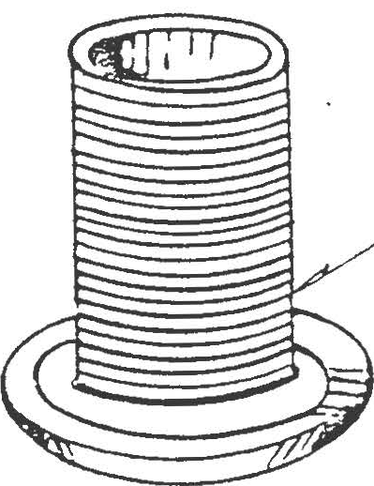

f-/().S€

T€FL.oJ- SE,A.
( A/EED A./V A

I
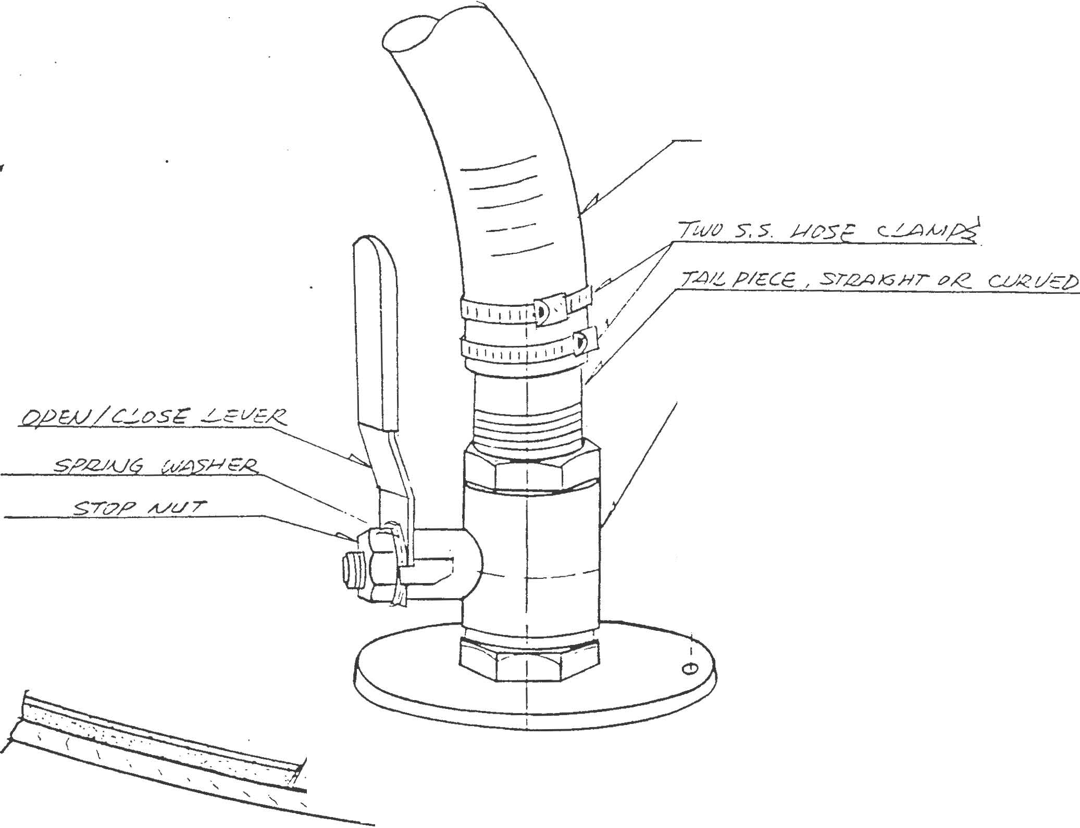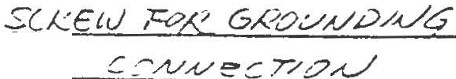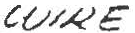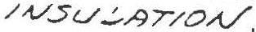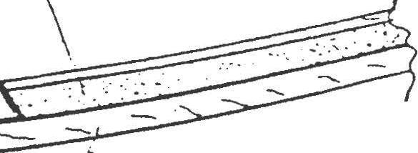f /:,12P 8.A;:
I / J{d:!"!;/ Ct?,
I
l / OP7/'oA

I j
:/ / ·/ // //}/Ji/ I/// I I
. '- --....... ......._I ' ' 'I ..._ ..... --

)JOTc:
@!-L i/A.L-t/c | /d opeJW..11?'1/ hVL/VE
I[IS | 560 | wHe/1/ ZA/ /o 0
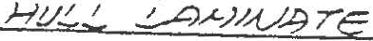

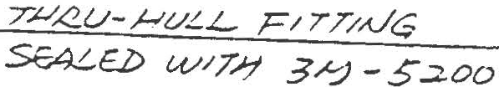

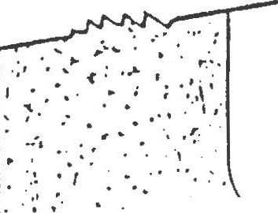... ,.. . . .. .

\ ...

t""' • • : • •• • ,
• • :• • ": I " •' ! , ,"". ·...
\ . . · :· .. ....

. '·'
.
. .. ..
, . .
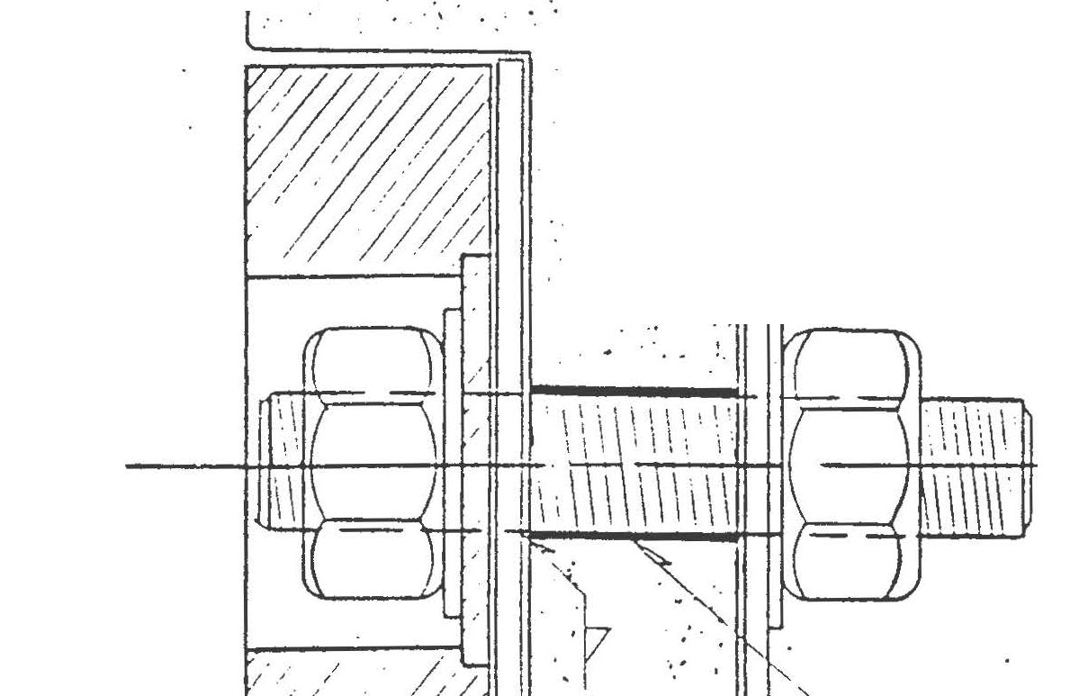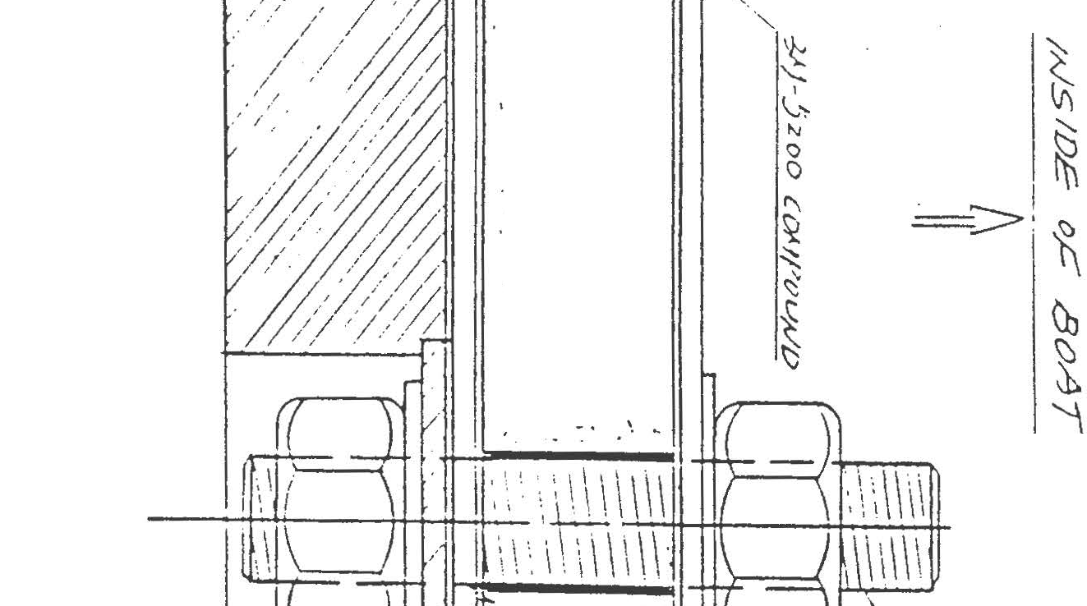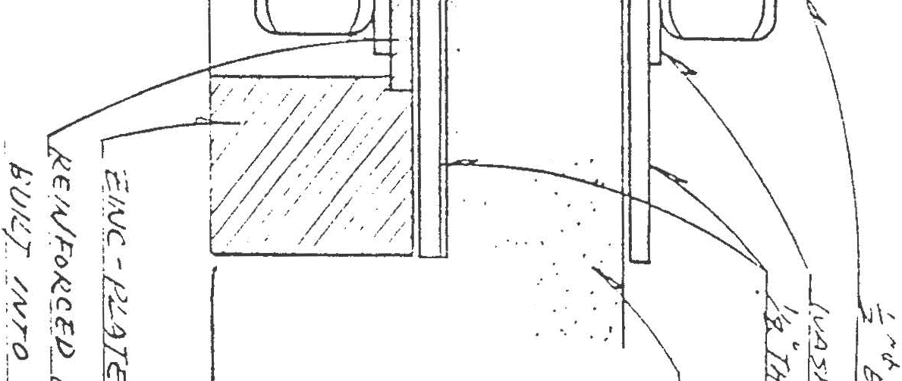·, l

. ,.,,.. . :. '.,
..... . .·
' .

.'
..·... .
.. . . L
... :,1
1· . ... ·.:
:
.,.\ . ·.:.'.:.·_.. ·:

. .· :

····,,, ·I•. '·,1
y
i • ••
. 1.. ' .':
t . ·•
.'

.. .

• ..,.··. I .
. . . .. . , .

...,
·. ·. '.. . " .

•.. . .
'..

,: ; .
,·. . / .
;,/

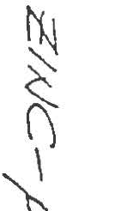

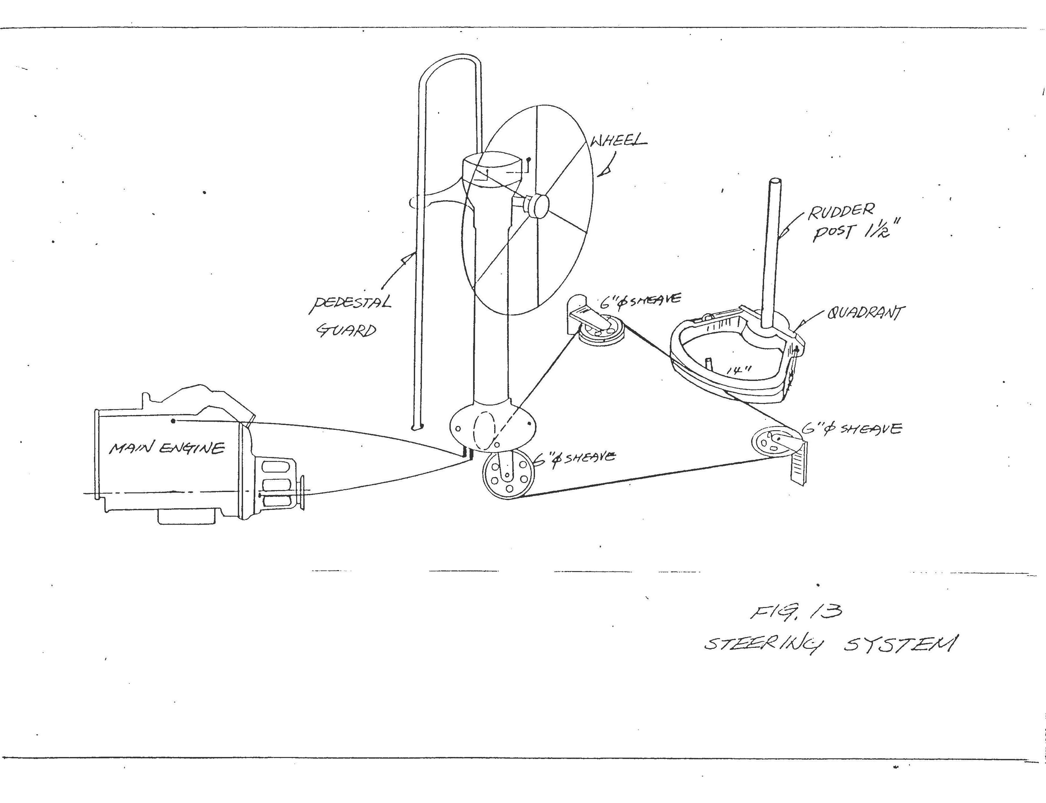

BATT.

SWITCH
61T\ET:STT. BBoMA.cIN.
  - VOLTS 0 c.NW£RE.

2
[J D

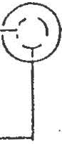SHORE POWER INLE:T

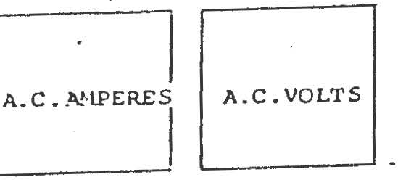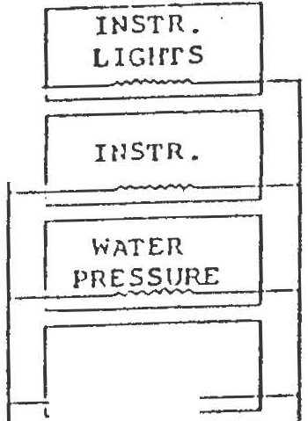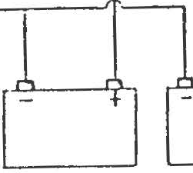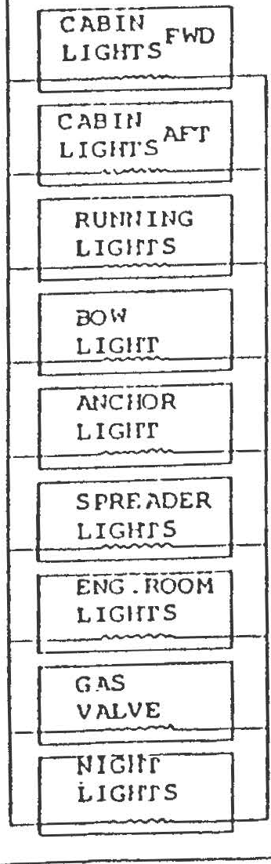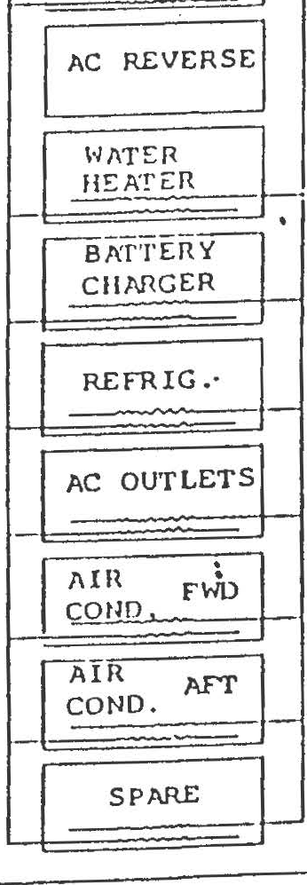
jlic \AIN
·1 _2H0RE

GROUtID

ERY ·

BILGE
PliMo

    - - 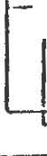
lsur1P
c 1 l PUMP

-
[ SPAAE L

sp/\RE:

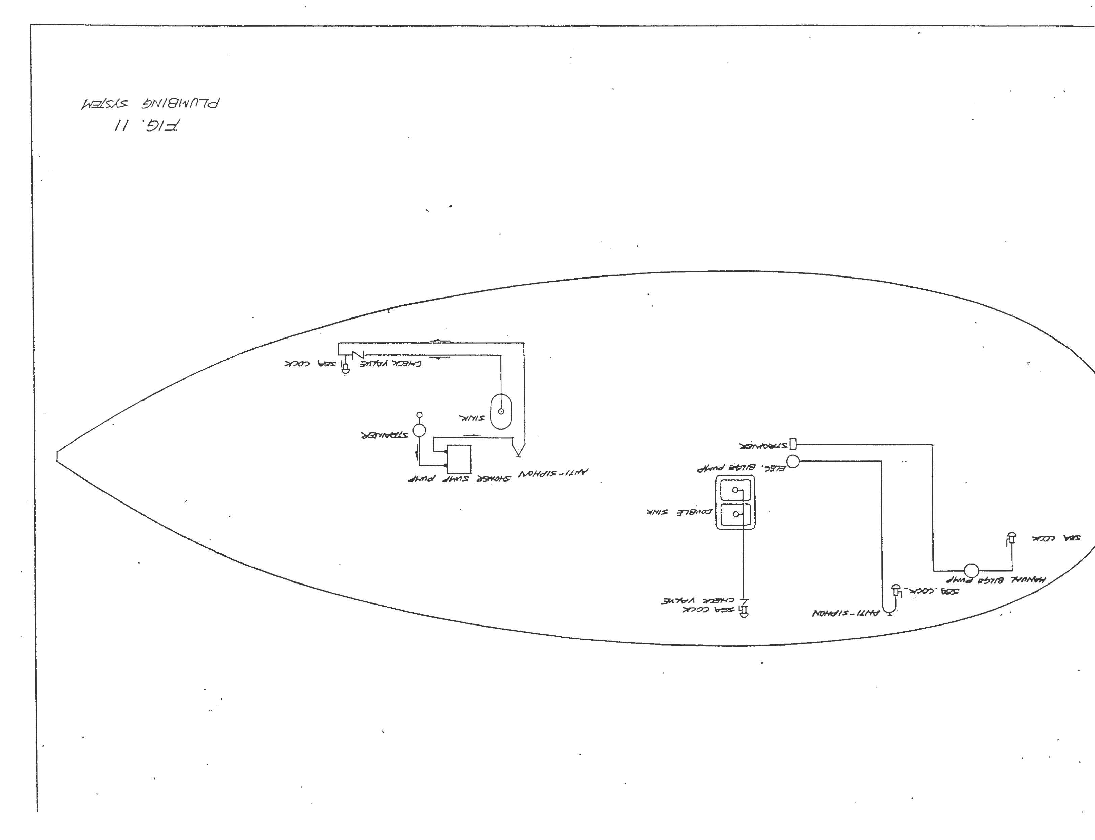

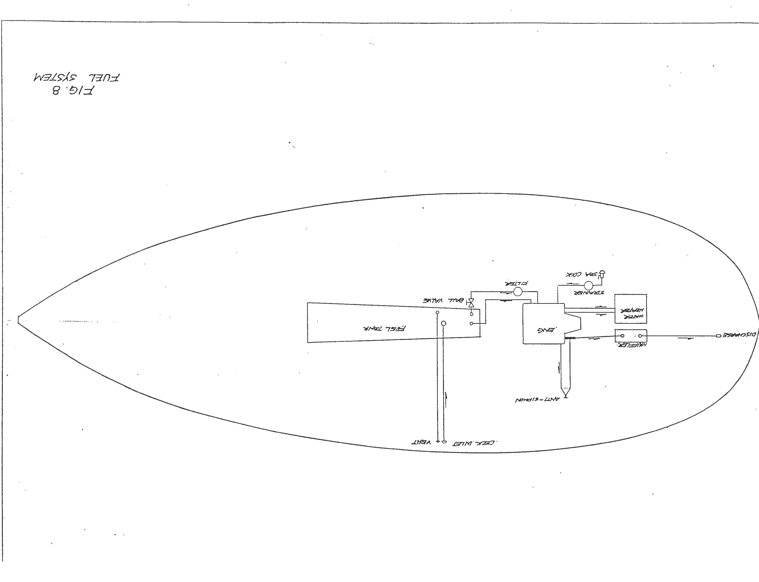

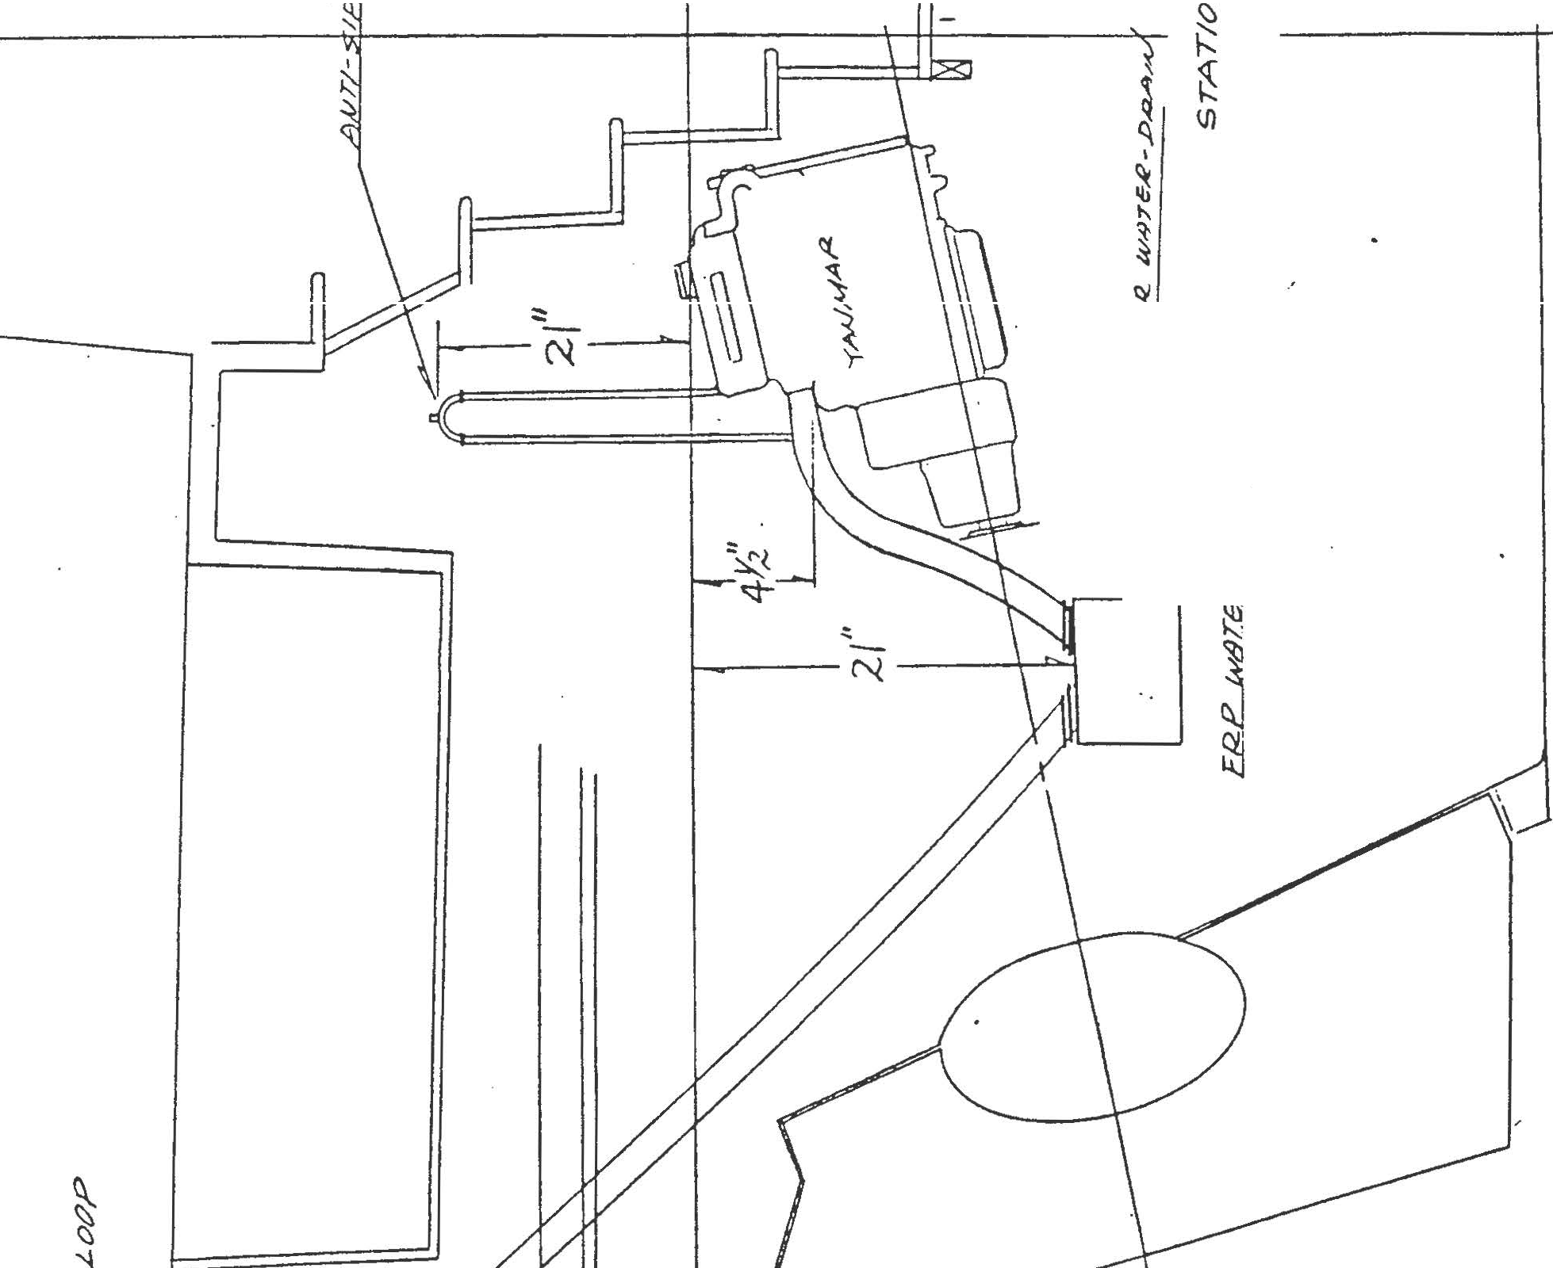a

\
.\

'
\II
I
"

1 s
\ ·
{
<;t-
-N

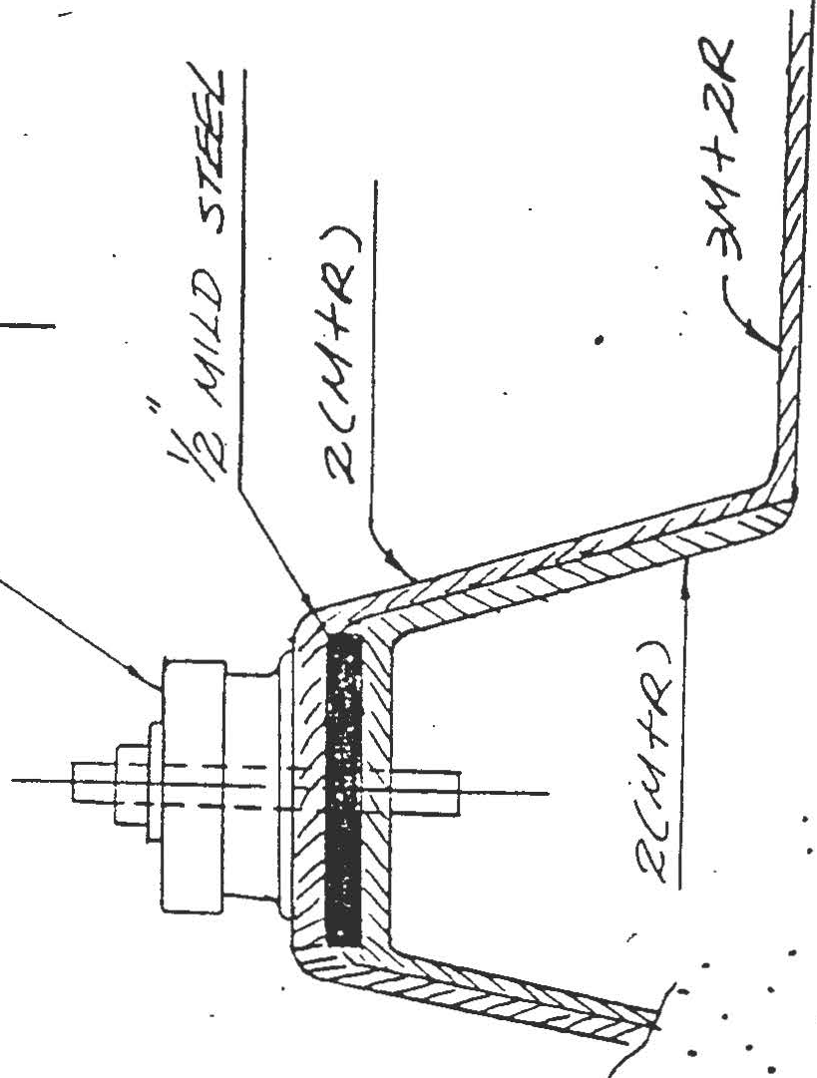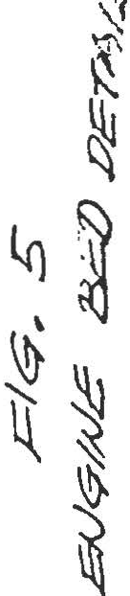1

:t:._: J,;:::; t- -;-- _:_

..- .. .

. . -. t·
. \( ...
.. • Ci..-.... ...
·

SR.".
x . .
• n.· • . . .

. .
...

. . . .. . . ..
.
. .',
. :::::, .... - · ...
• •<tl._. • • • \,)

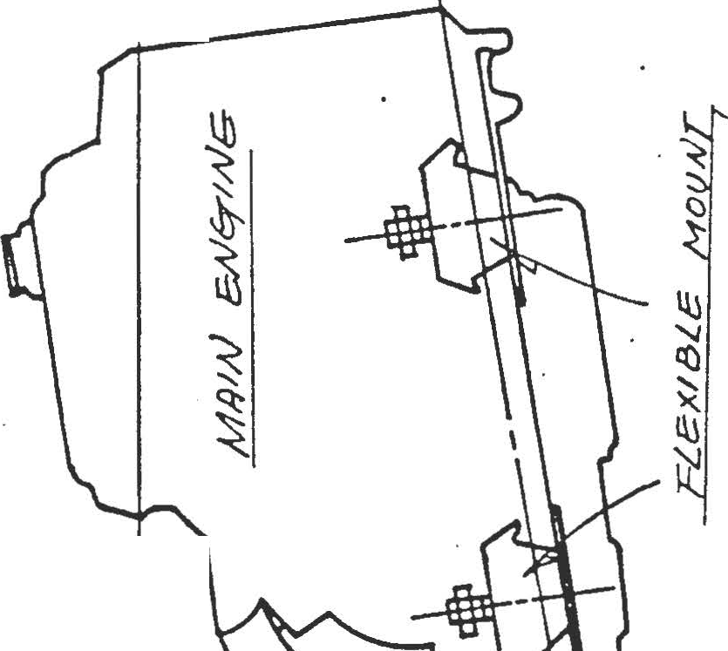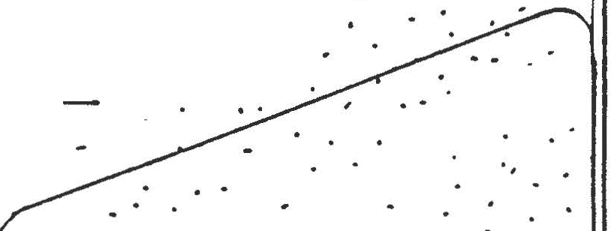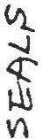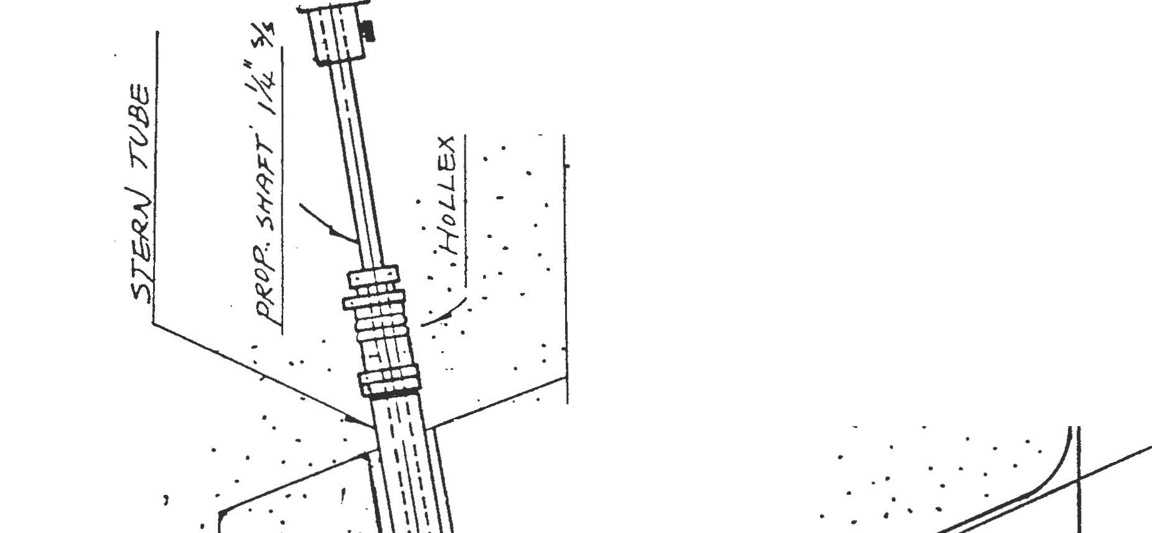. . .
..
'.·

I

S!IL T /IY TAk1.
/
DEC'.'< //YT.,JK.£

i1!1£:Y /
60

WATER TANK.

I SHOWER
I

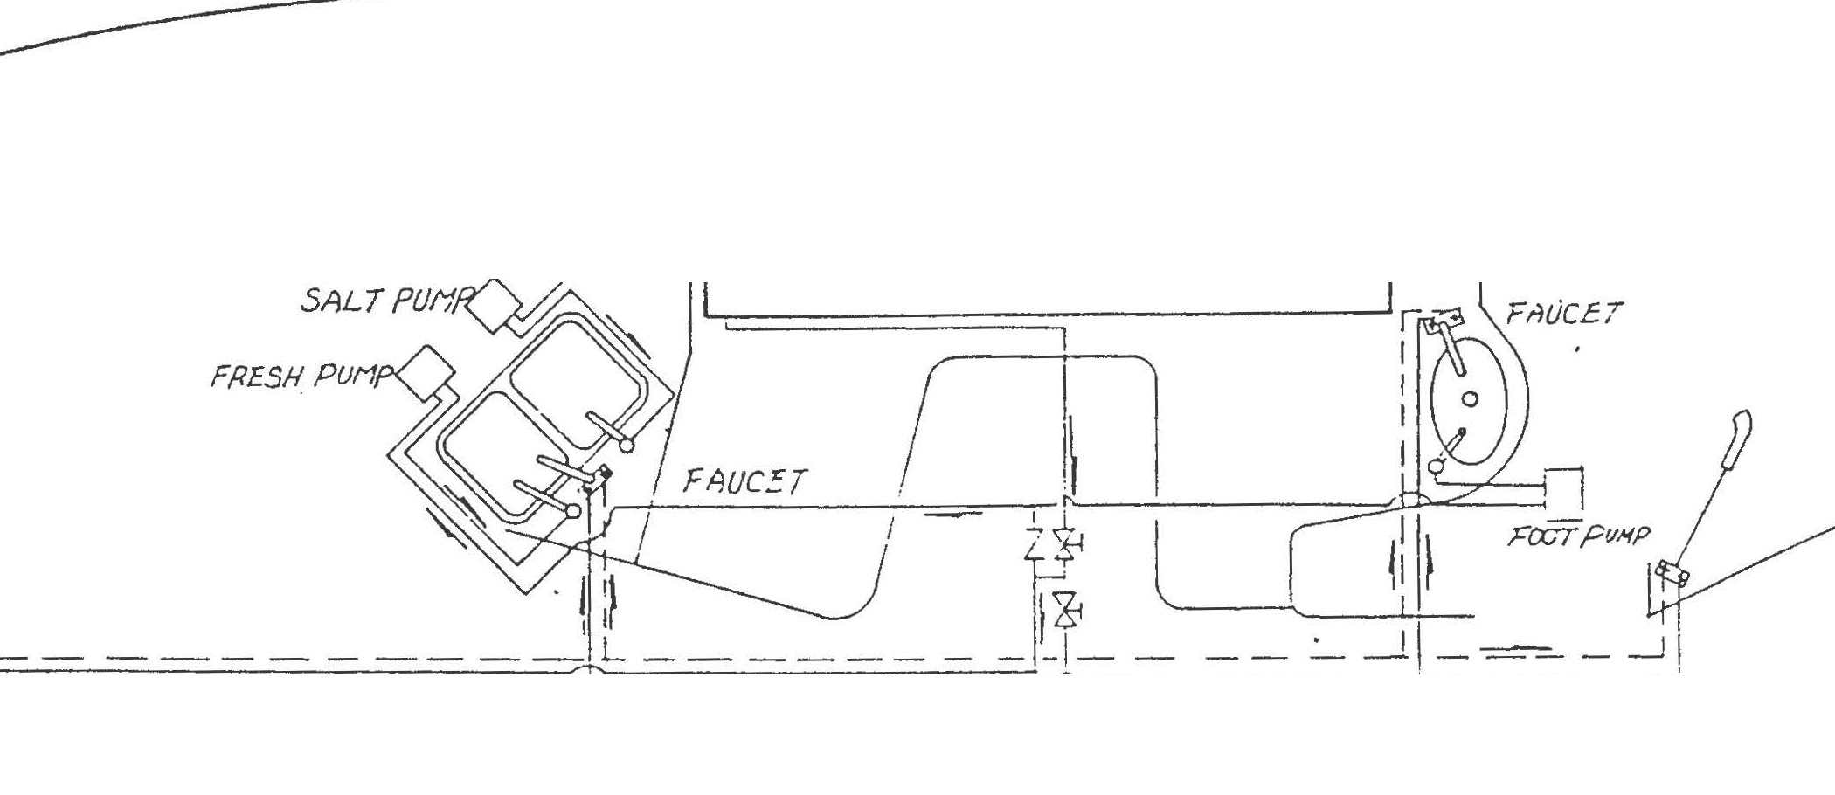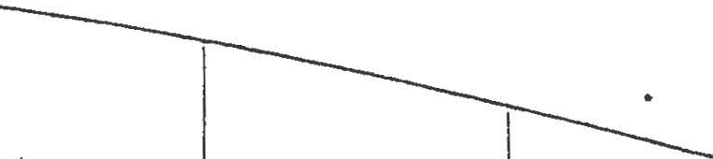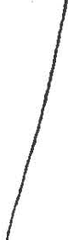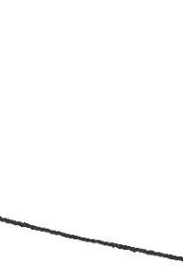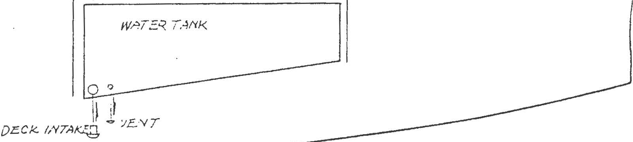

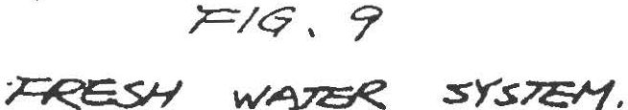

..

r.
i

t

..........
. ..
....:.·
. ..
·...
..·.
...
.:.

•........
...
.·, .
..·..
....
• ....

9\ &
-f
....

I\
t

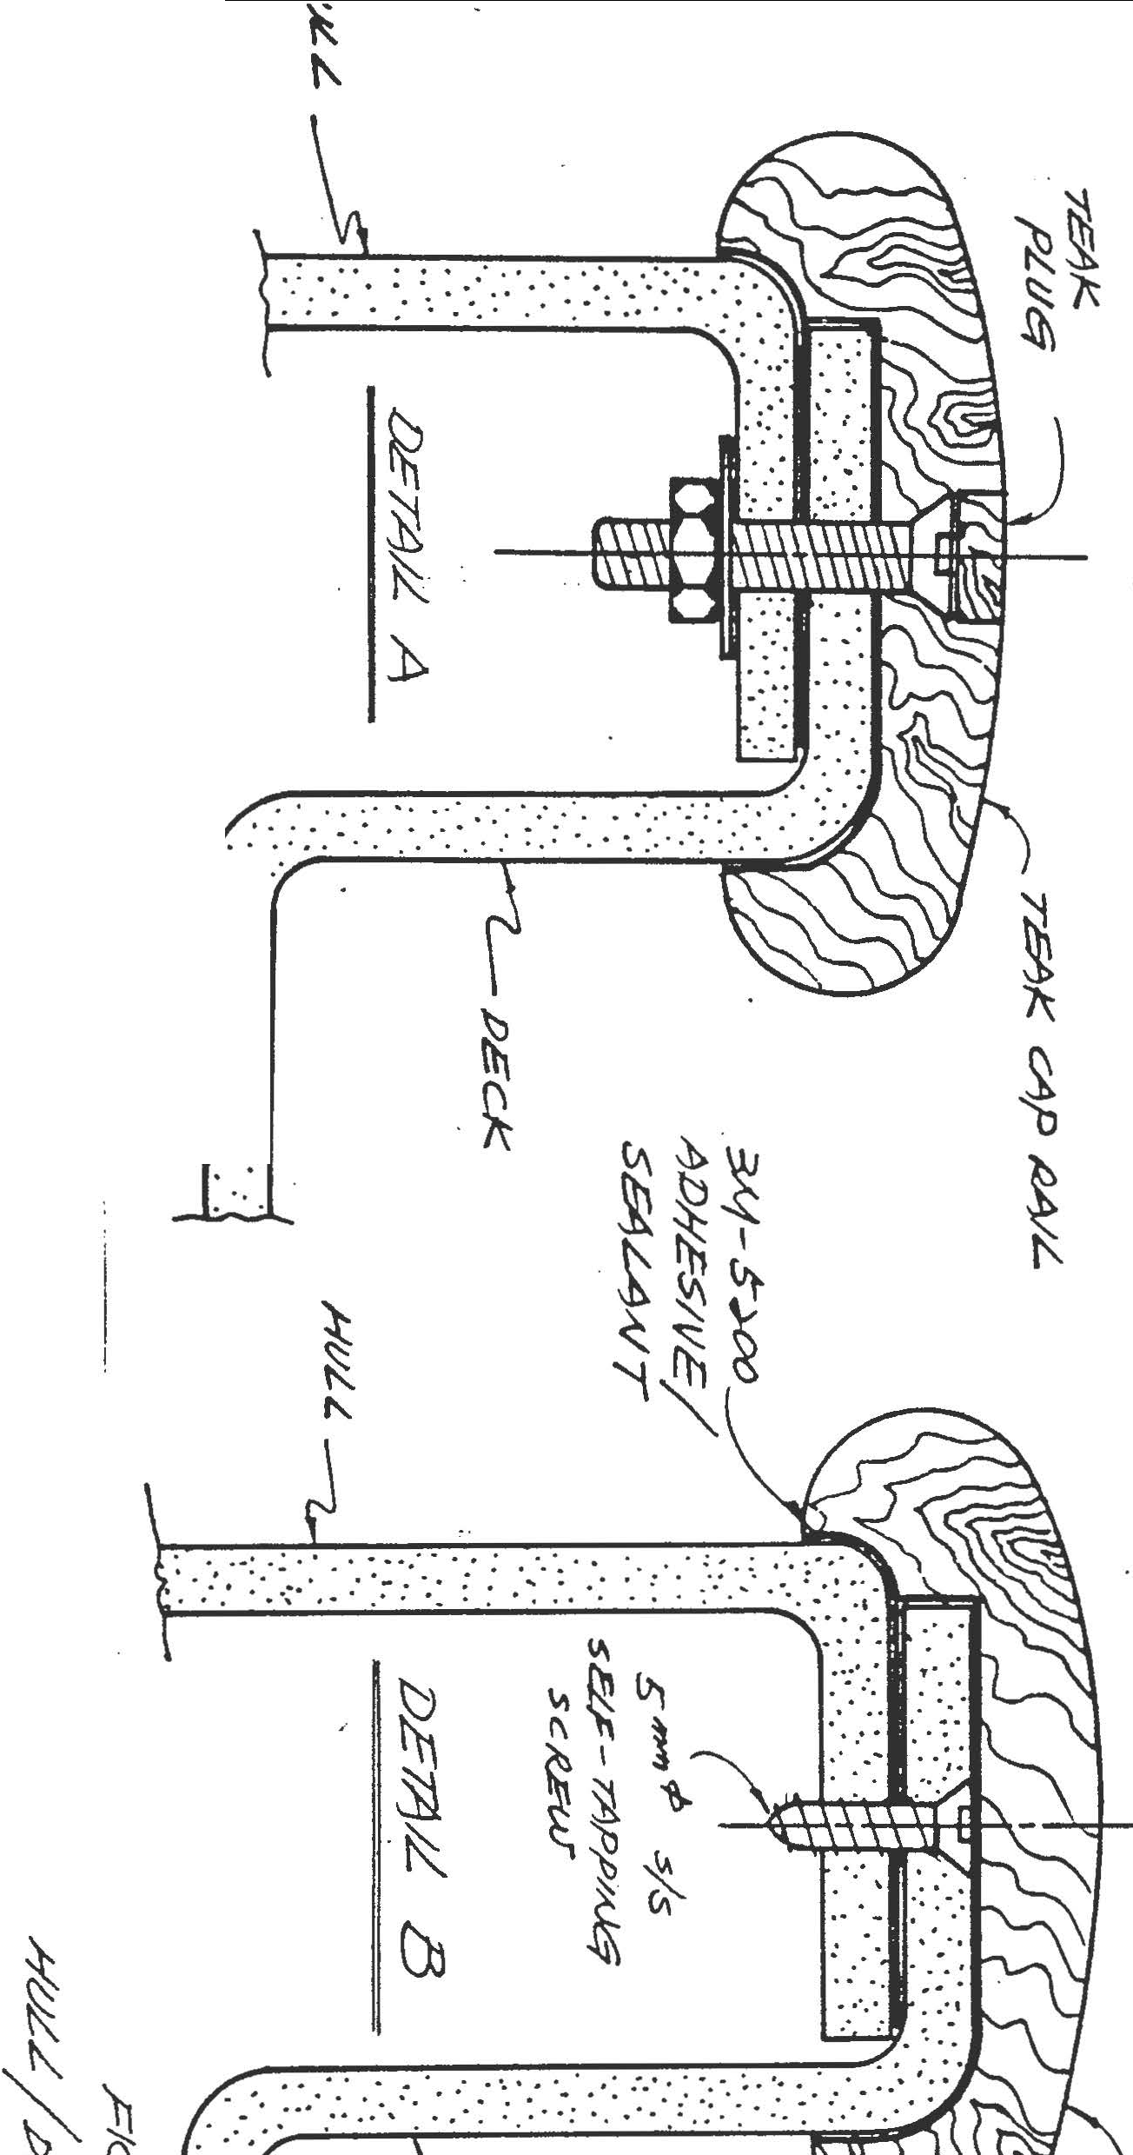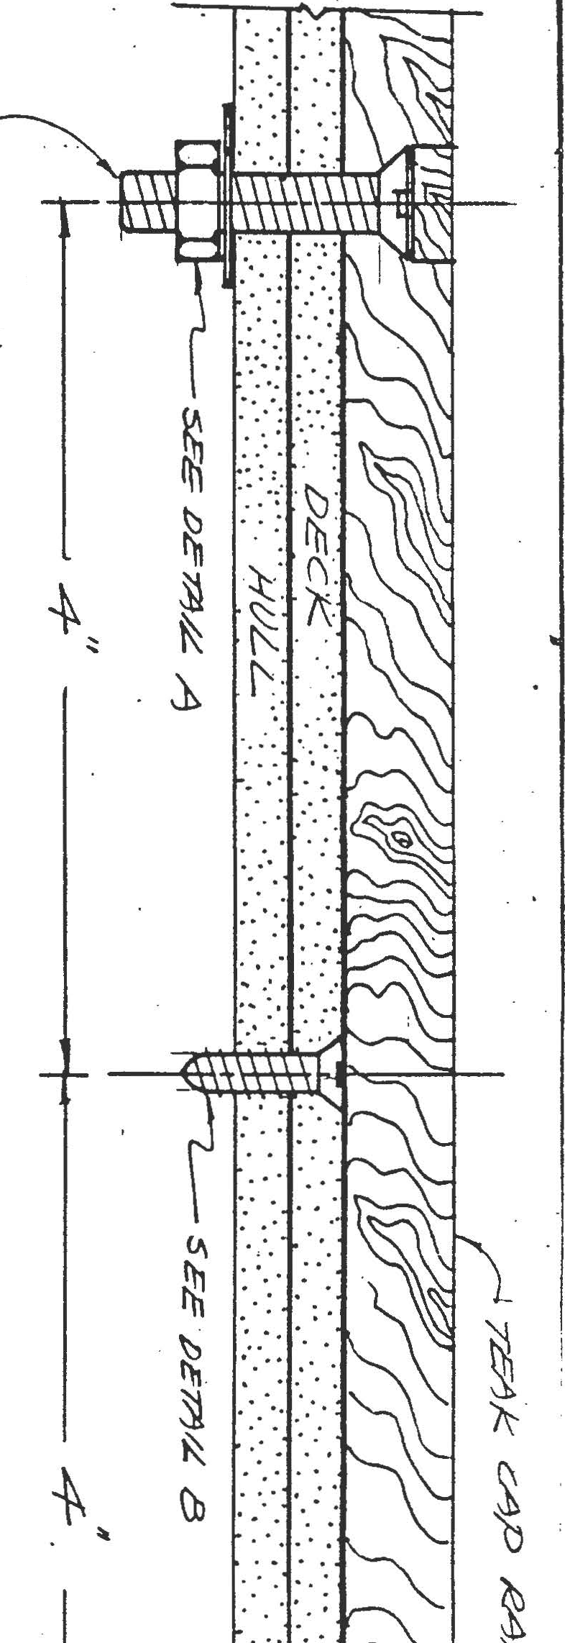... l\ t \K,;_
'\ K

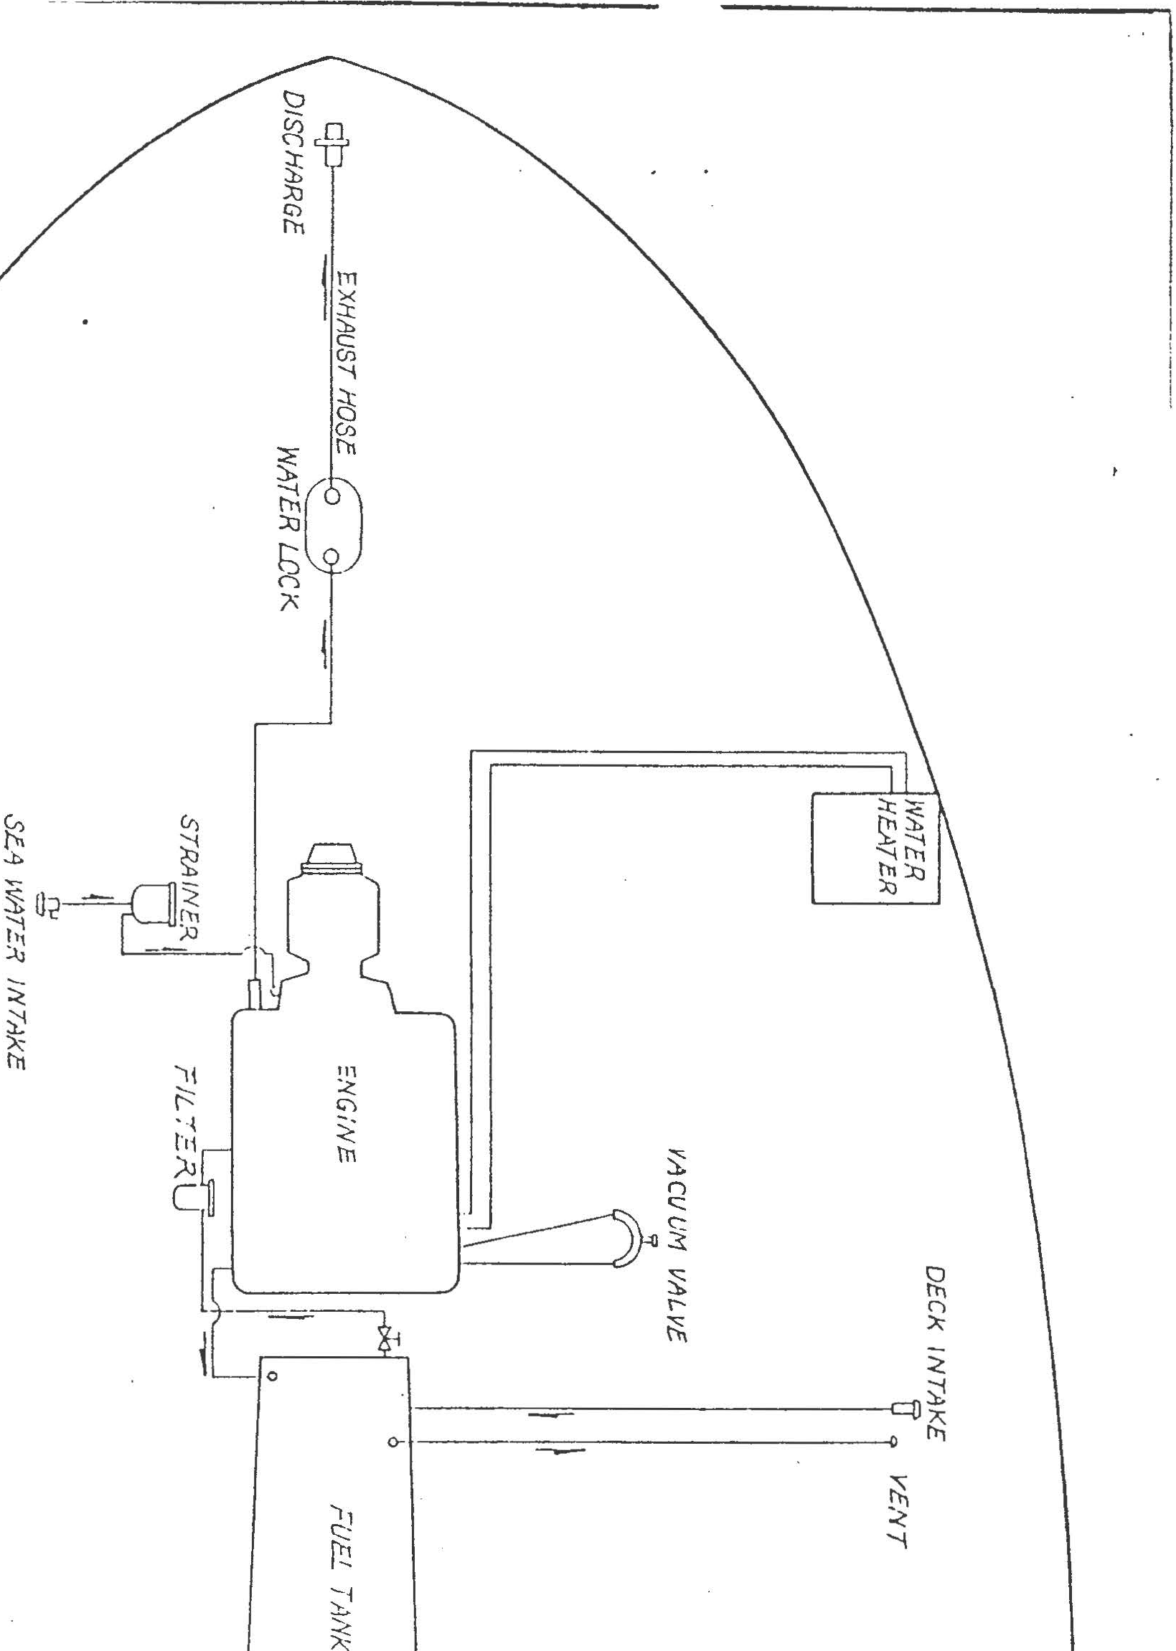

•

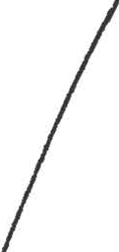

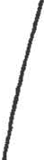

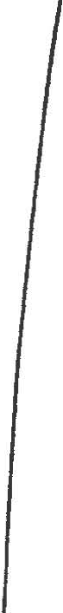

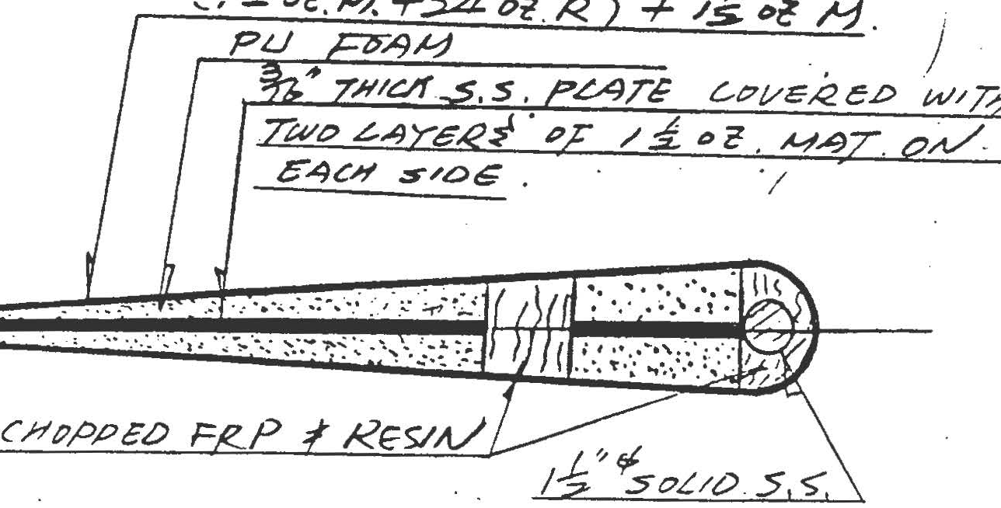

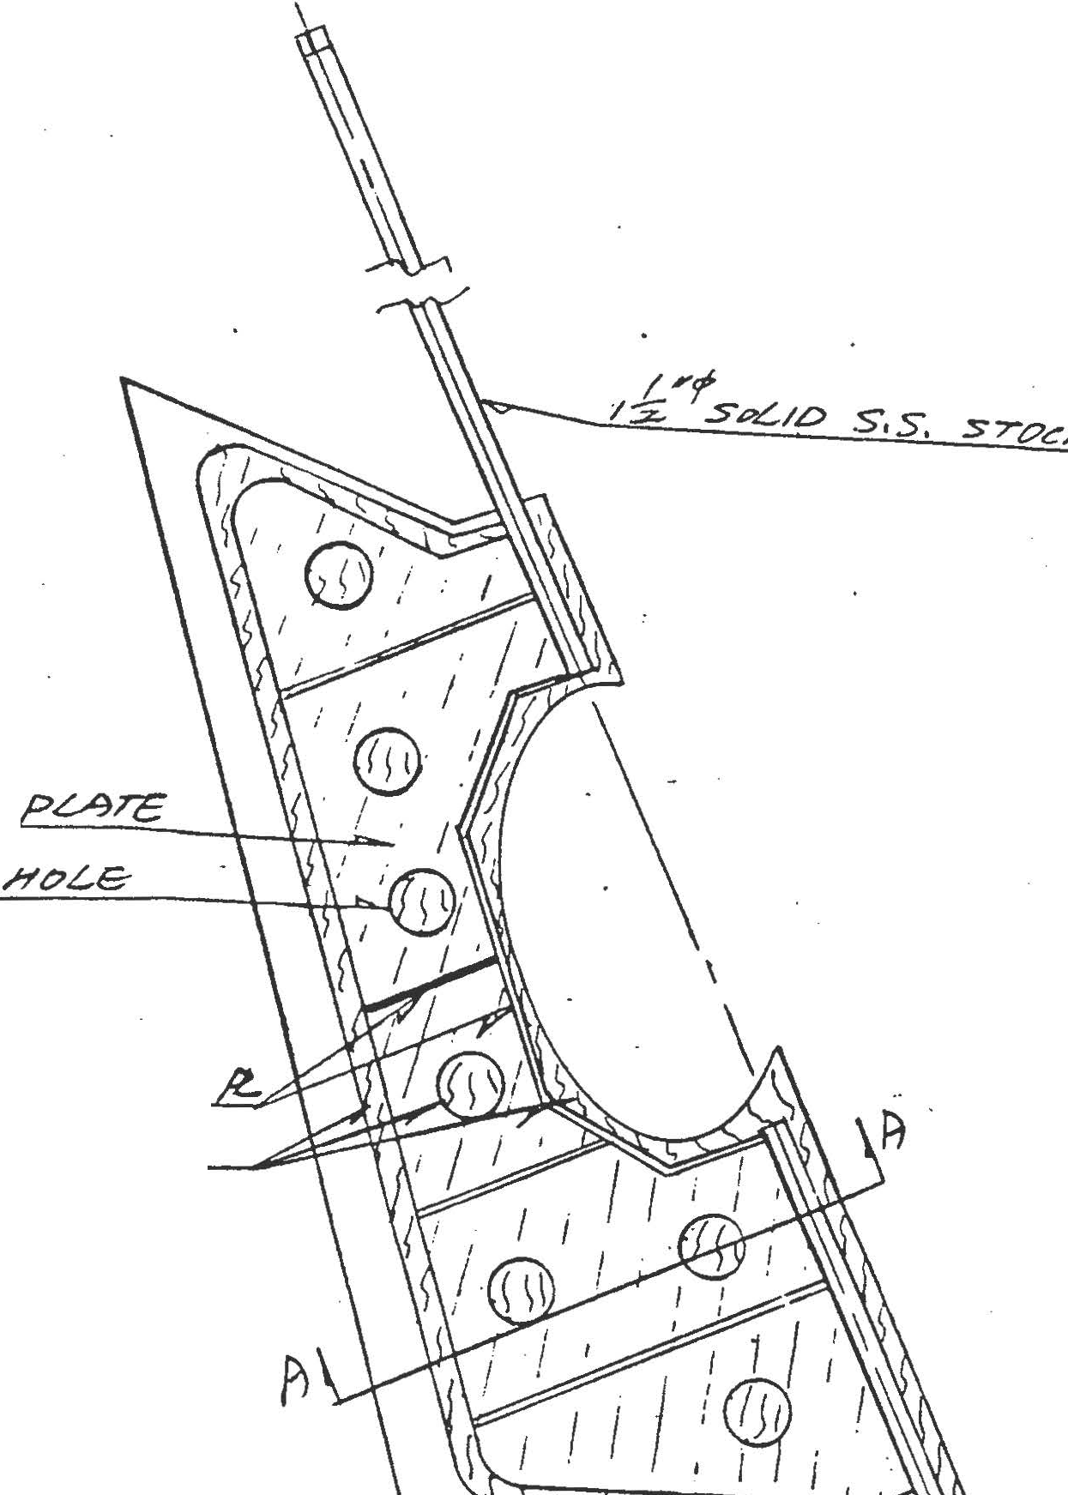I3t#T#ICkA./es.s S". :s.
.

;;
T//1drA/£>s 'Re/A/rt:/? P s.>.
C o 'PGO F/81:'-'<. .C. S

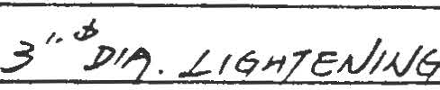

.f

;=-167; 3
/< UD.l>GR_ CbA/SrA?J •.J. C/?tJA

,·---------------------

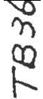

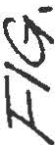

'I
,I
,
I
I'
I' .
[]DJ

\
-- - --

/\ /\

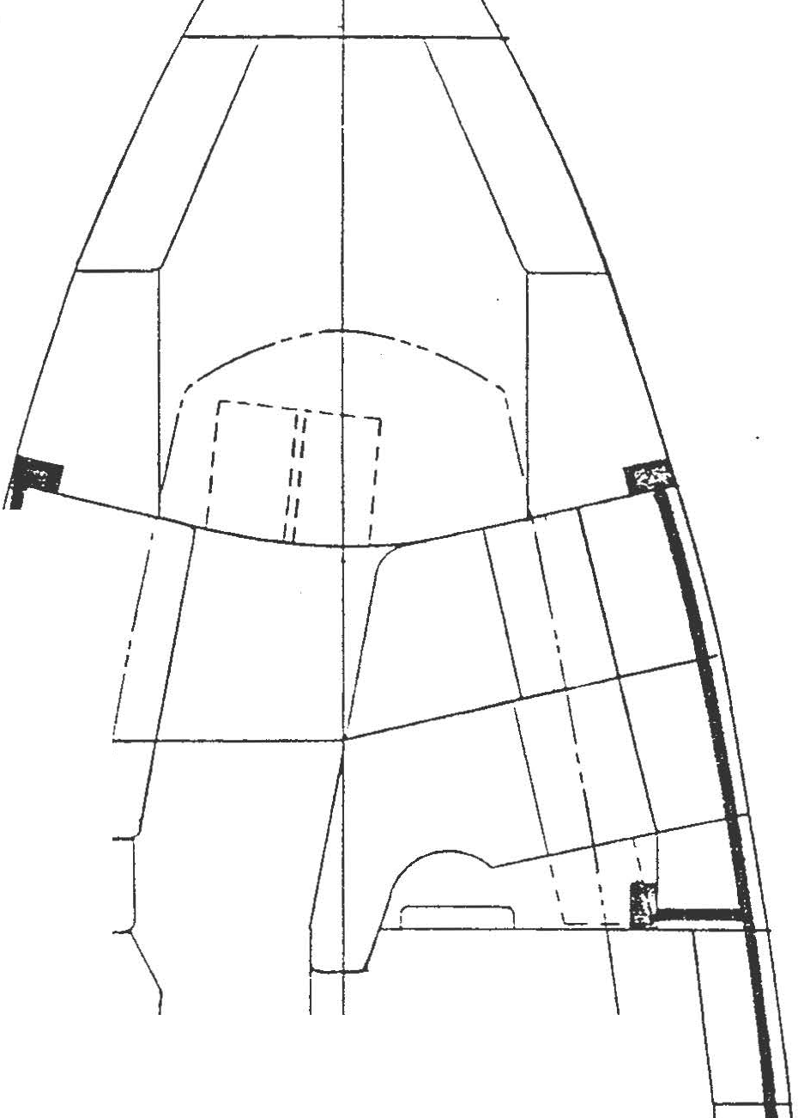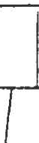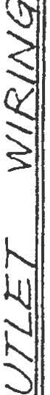I v v. \
<

! \
I· 1
-- -
v

: -
,
l
I

J_ C) C
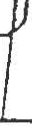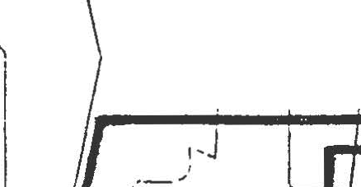, I .

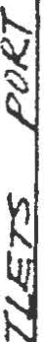

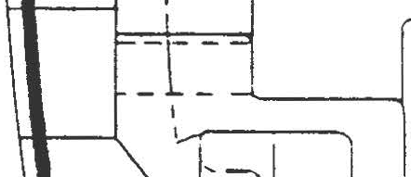

k
Q
\t

"l('
\ff

VJ

\..._

VI r 'II\
:t- :t

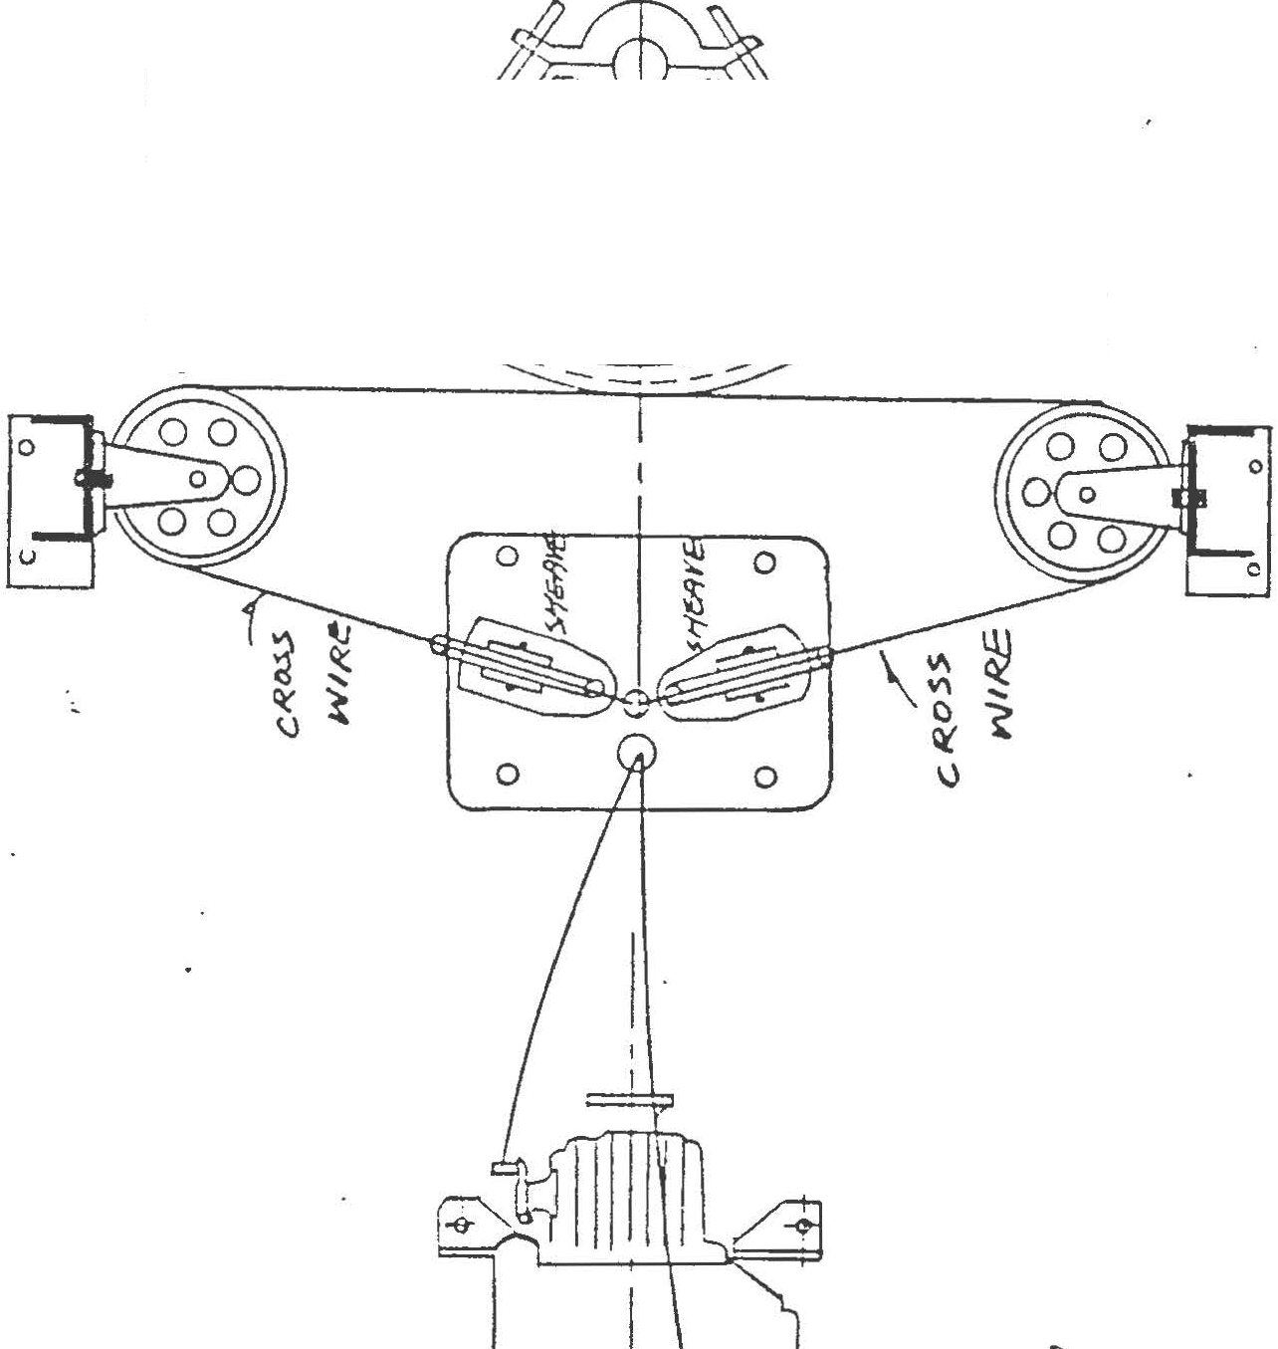"\.'£)

\,()

<

'

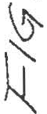

--------, _ !I -s·f}
C - :...S'f" ( "\,)
I /'1 "7':H'Vd ff.J./.IMS: O_L

IJ -
d-- -
-9 wws;"f -------
- - -I

I ::i- +r-------------, I

L l l +:...r
-- -- -
I I I
"l°iIt f:/..I I
DO
11-1 11 1 I
] L ' i
I I
.
Q)I }Q
(
b""'I

"
'q)
Q

Q -0
'<l
I I I
2
I ""
l
0 "
If,'
i......... ) i
I

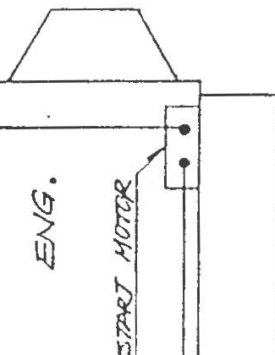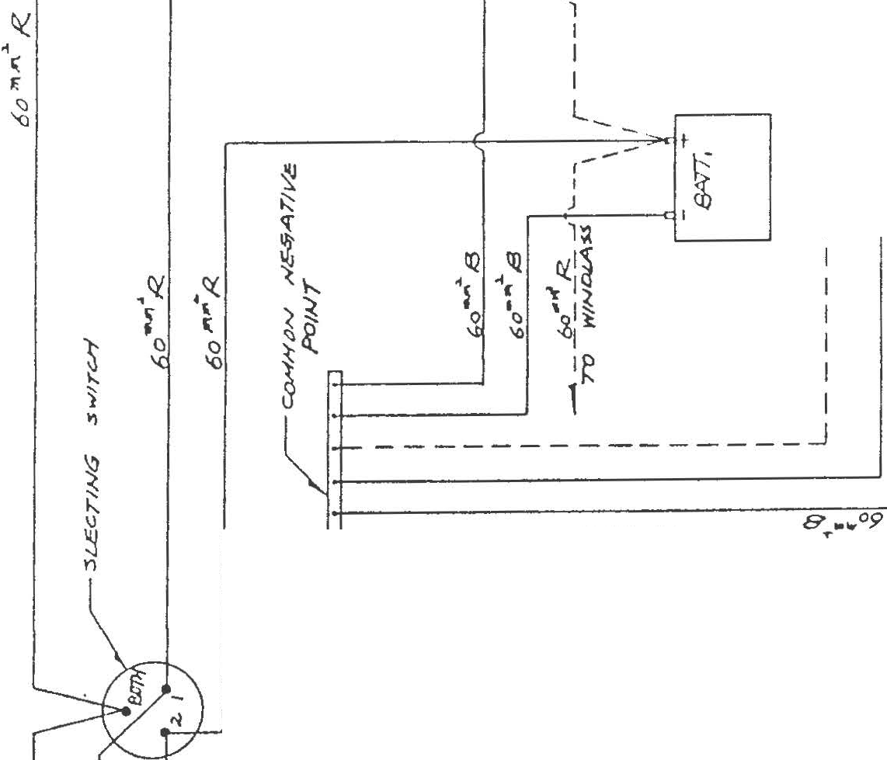fl I
C
....:. f'

- - ••"? ,...,,,... a.,
g" flj ,,,....,. /-O./.IA<$ (l.t.
1..1......----- -

1.t----------- ;?

·------------

.1----------·- ·ol"T

·---- ----- - - ;JSV

1-----------
---------=v.:i M
cu
'
1t 1l ll

iti:.

\.-.

--------S"O"o..o=zt..obt7

•r-
- - - - - - !JNl/

') %
L---------- Mz.,c

I,\
K

:::; gu •. 61_f?._---------

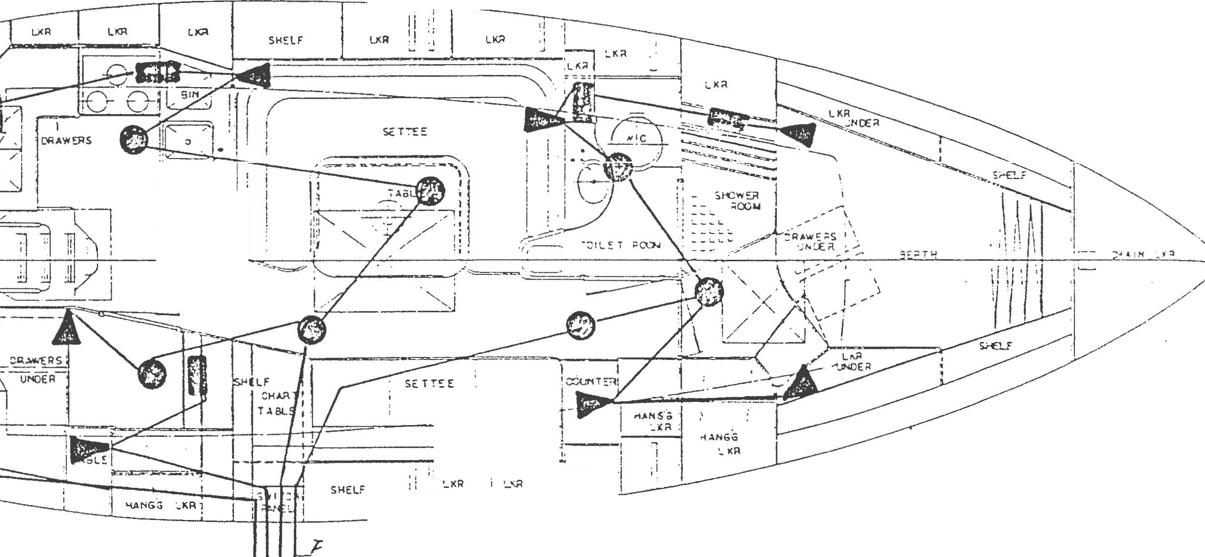1..1rc

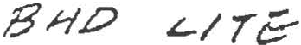CtlJT C-/(c

·jl r···
t'!I _ 0
, . ·:
!· · ·
--- -- i :
J ··''
·-.......----t.

-------

i '-AA
I
•I
. ·,

wl>. UJ81A/ L-/TC /..2 L?_ l.i'L
---·-
-·---------- . ·-----·-- . - ---- -- --··--··

,,_/.) T _ ??]£/tt!._ /TZ::-- (Z :U £--T. _._

/Jr"f' - !f./,,Y .'-17z-_ _ . (J ii L-f. _6c. .

- .z;;;J...Ki. Rcx'J.Nf k.l_'r'C:'---- / II- CK. '?c._ •

F/9. /5

{!./,?q£ j>t/1--1/'

/i/.L?,,1/1,<..lt '5N.

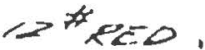

I ·. I
" . 1--- --\- ...-- 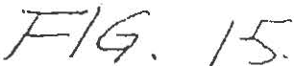
£._/J/Ee ?.€ £6.5 ti.I.'? /V"-/,P

/)f £
e-f. _}5t/f'_ f?P //" .

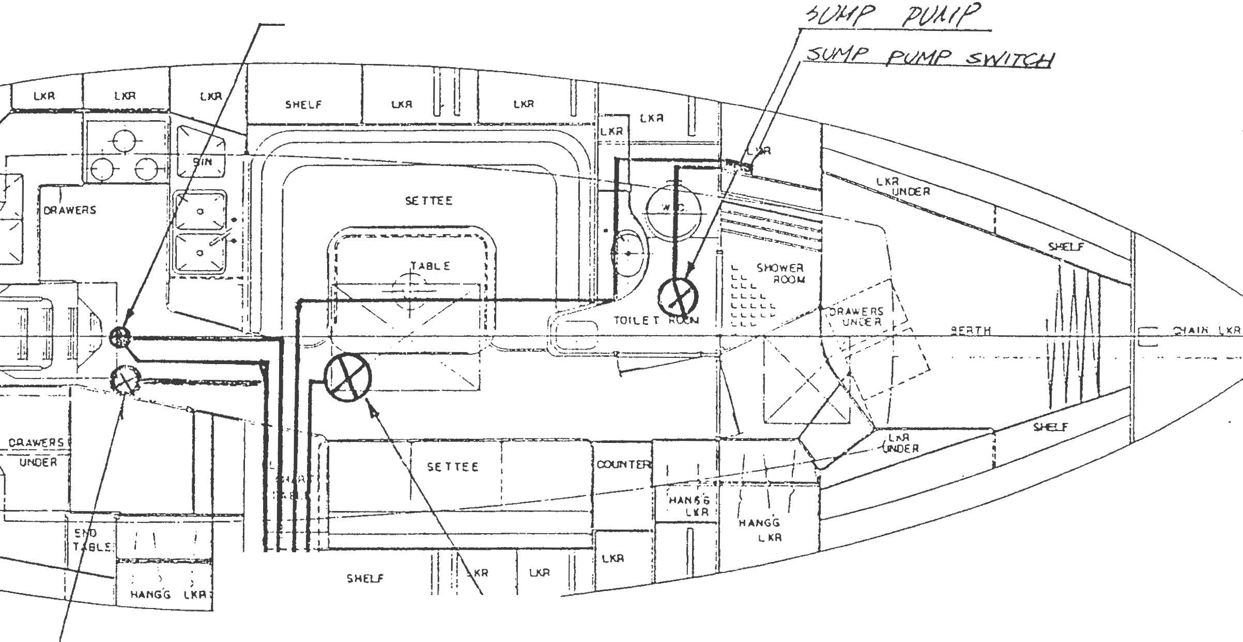
__??/.h'/' . /'(/,/?' / ..;;?.# ,P/4/A;:

_ 8/Lt:TC; ,?t/#/' .ltJ/J( /ttler U-1 .

_gr.-?66_ /!(/H/> 12·tt o =-

.ii
I;;J c,e", ( {IP770N/\L )

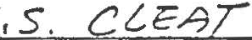

FR
Q.E/
£!'k!.
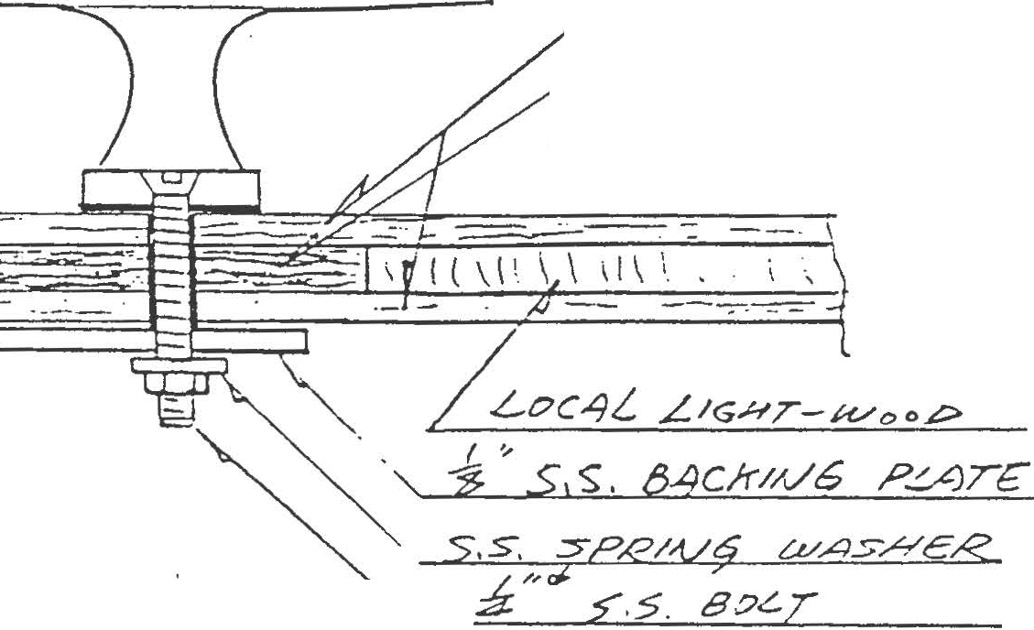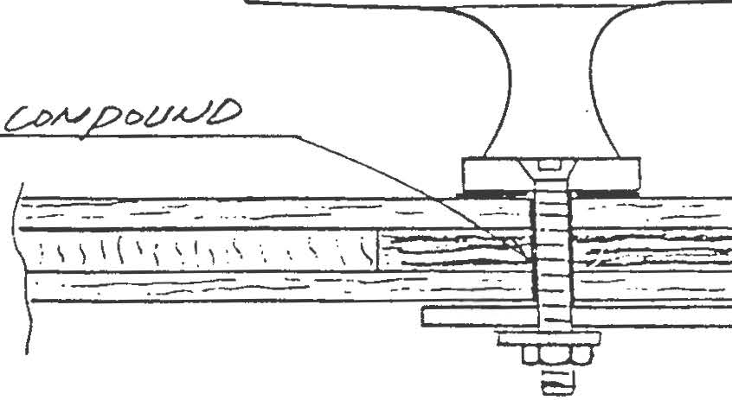 --

5 .S. 5T7MJCP/17.{/
?
;v-/ &
S&4LE.O i..v/ Co e
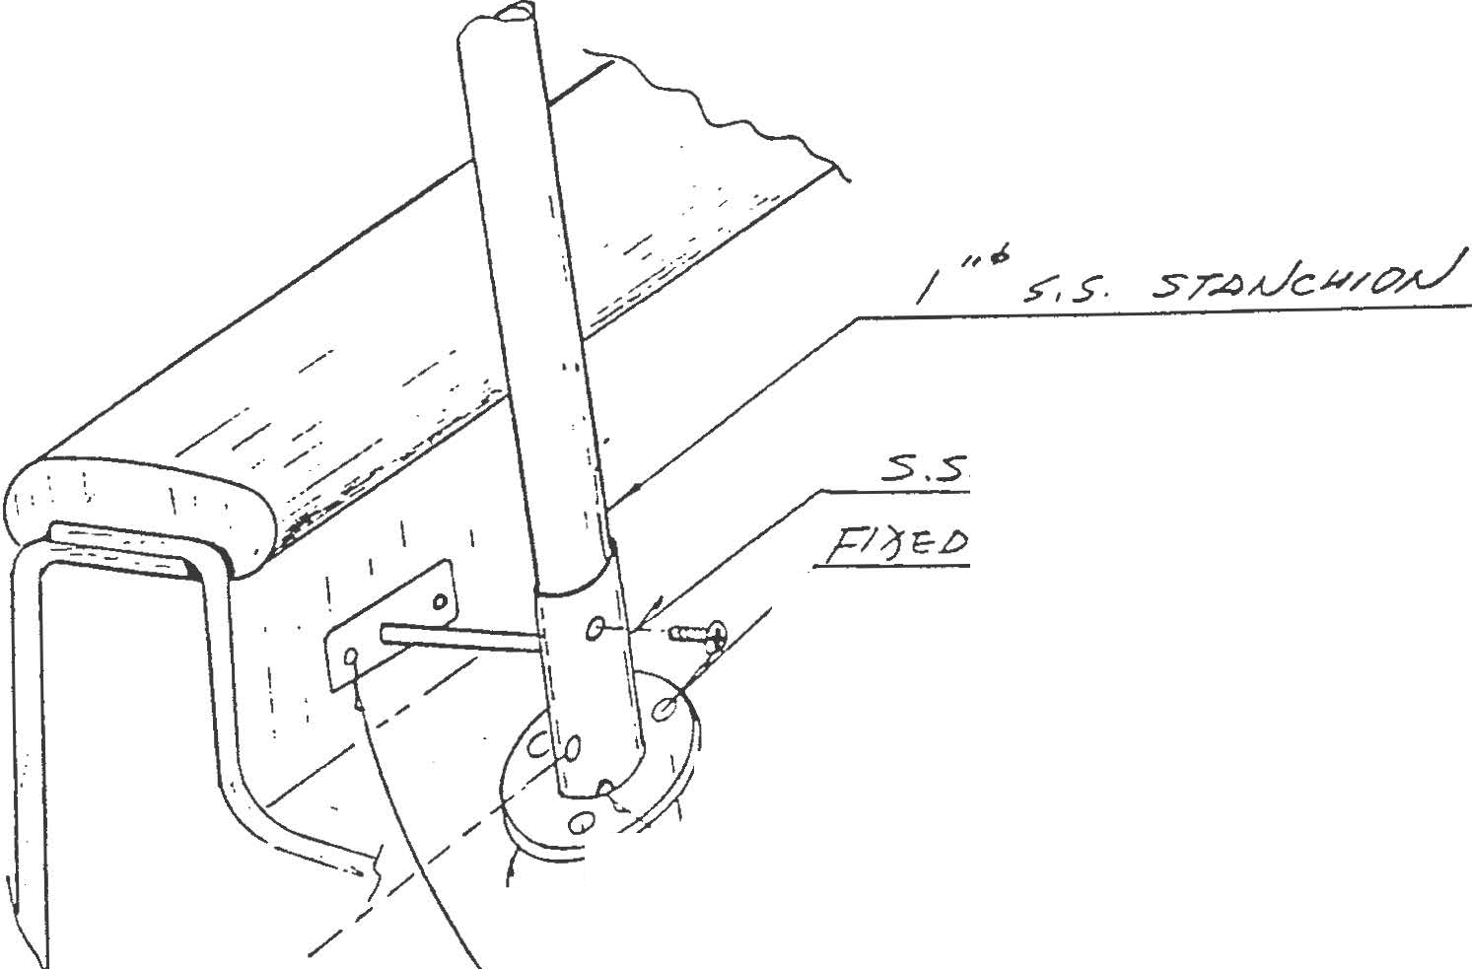\y "ft r,,w1ck,f/G s; ::s , S

, .,/' J
I -,

)_, / f...,/OL.€ Fo/.Z. {..VA Te DR

tef:
'=-=
n5/- s

F/?fe!:> W/ /P./O
8c> T.

:3 "cf / •.
& :S.S. BA C.H'/A/9

\ Fl; g_.£> w1z- _76. _x s.. . sc IA! roTAI.-/vvC? I
.Y PJA./01/o/,,/1=cz c,,.v2 r//8R/:9T/C7// RG" Or/ T£>PPe0 <?/./ ONG _s 1pF,-w;!JL t.... o ;z; >.s=

,,r:::::-Jq, 6
£?£CK #A,0/1//JRE /M

----··---··"-·--"---.-J···--·.-....,....
-------------------

. ... .. . ... .... . . ' •
......
.....
. ..
..:
.....·

\l

·. .
. ..
...
. ..
.. .. \)
• .....

9\ &

71\
t

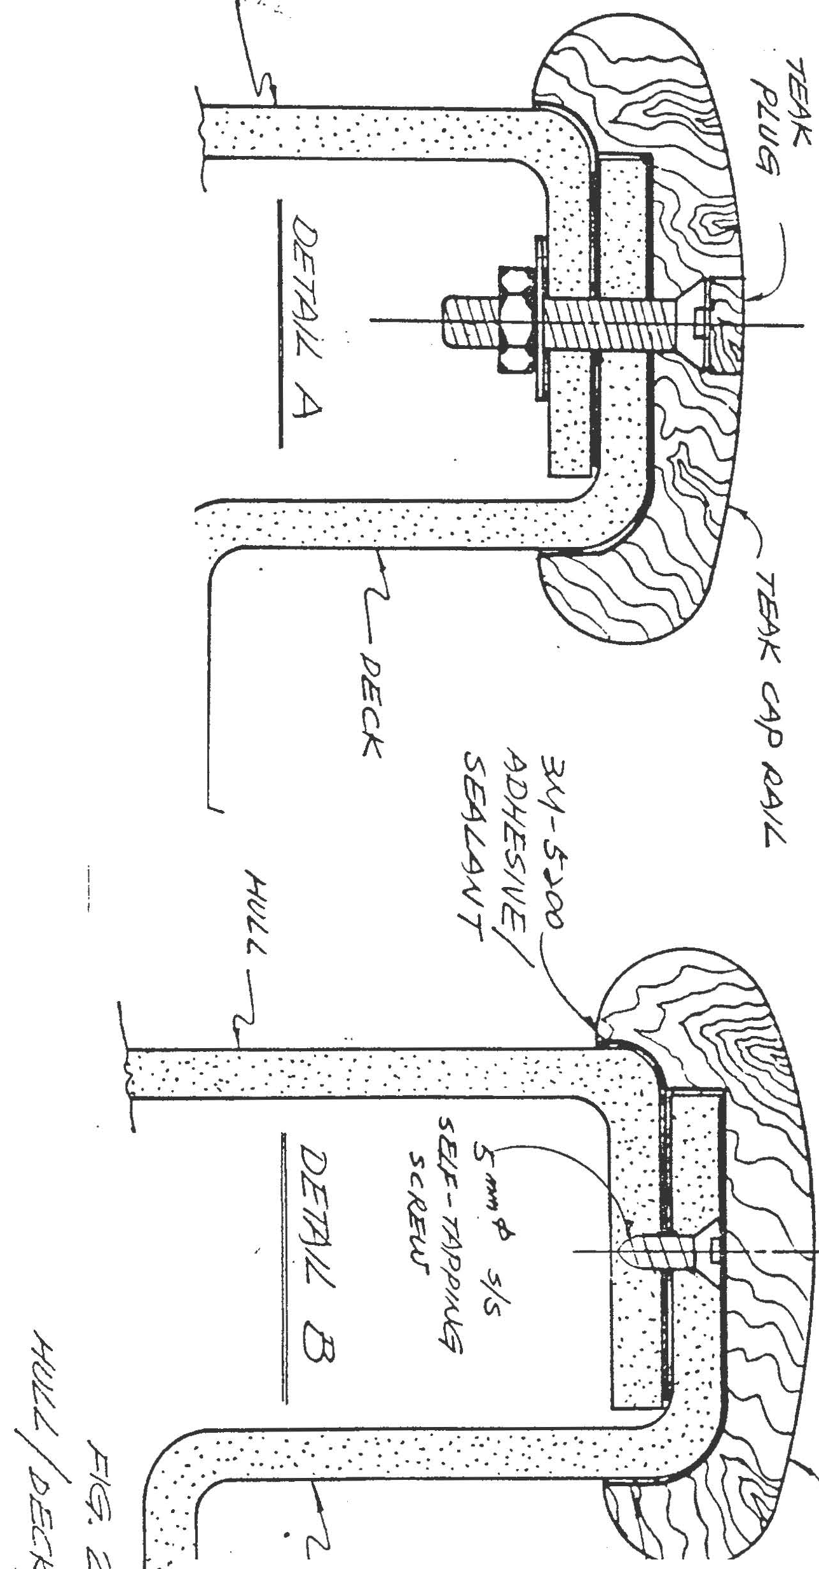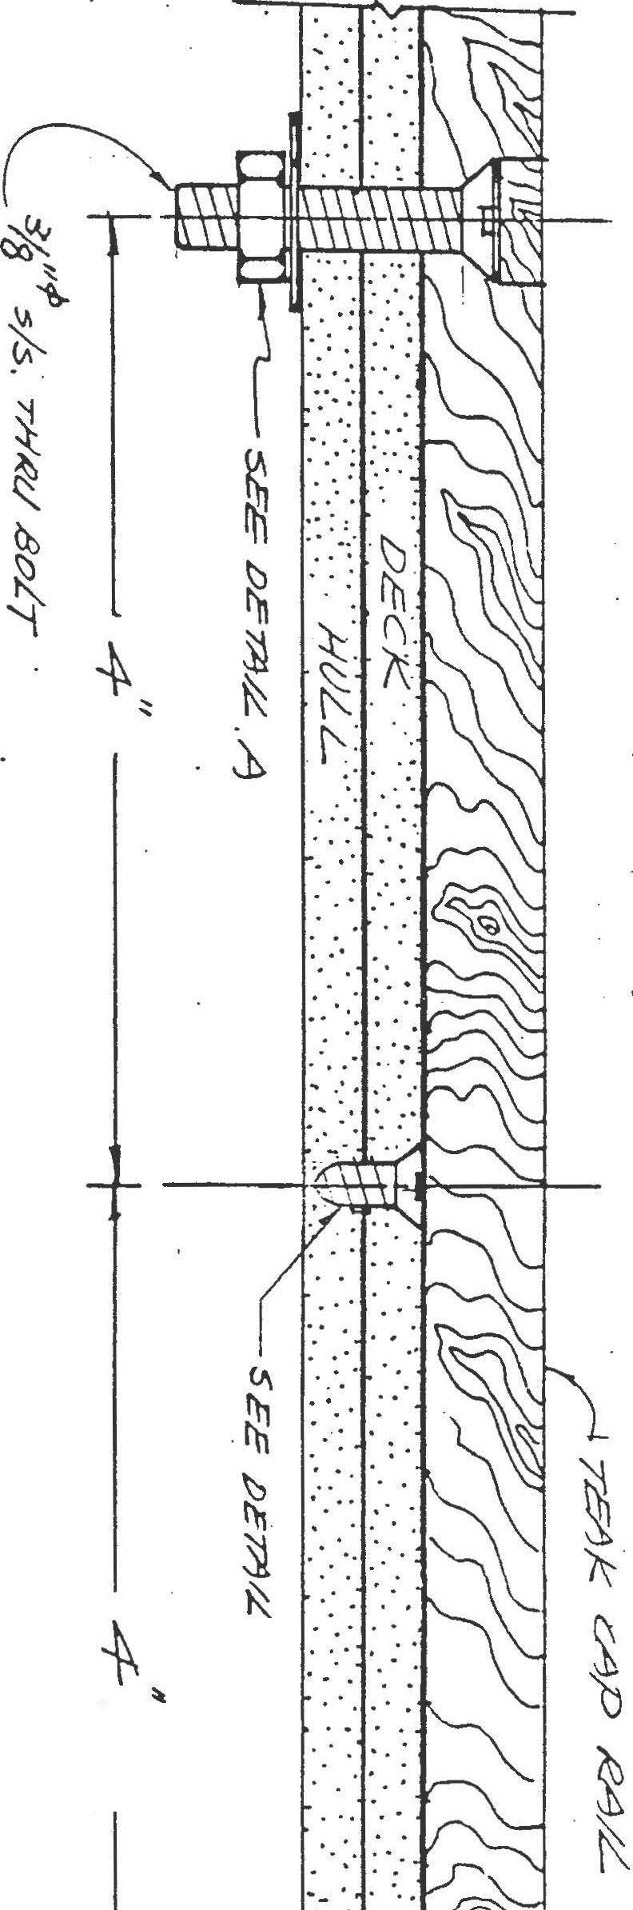
.:.- .
.. .
?\ Si

'\ K

M

1. c c 200 !- · CIJ>711
2 ,\f :: J CO fft,_, /VV \T
J. Al= 45 D /71,, 1\ Ll\7
4-. !<..' = 600 / ... 1/C.t-'LN ROV/Nc:;
5. R :r: Seo ·!/fr..' WO!, ::// [-<qi·'/,V(i

SECT/ON ''A ' G t- so!?.·µ T 3H
1
,.

-t- R.I -r Z {H 1 -t- f.C.)

..,. t M r -;- CN t R)
:: \181/ G .30 1,. 11 1
... ''C " G f- :)a ; ILfaf t /"f I .,. 4 (/"f'-tR.) -t- l'1 r ,r..;:.

'
AND
q -t" ;:;(!/\f I -r R r l'1 + c -r- 141 ..,..R
------.

C/\B/}../ TOf°
r;PSP./ S/Dc G t- 1-1' f- /v1 -r tv/' -(- ,":2' 'f· /'1 ..,.. COR.£ .,, .1'1
1
t· i?

------------···----
_ , G + 3°f ;'.,·,,..,, + 2 /'( T' 1' 1 ,.. R. I - :S c;'v{ I , f<.._)

....... "e"
_- 2_ "c .. - --;--;:.>--fi,/.f t Z/'1
- A + 4 C /'vf -r !E:) + /t_'_}/3_ =-

1

·,

--;:,;,;; + 2:11' + R r J-1 -t cc·, !: ·t- H' t- ,

C /JJ s/ D:C:: r H .,. t1 ..,.. l' f' + ,e.' - 1-1 .,- COl"'":'E , /·l 1 -:- 1<:::
- ------ --·-. -- ---------

<>/
..
I ,...,,

:s.ECT/aA/ UA'' Gi .,..30 ,,.,. 11 + M t- rl + c r r R..'
+- Z(/\1 i" A \
-
·'

:::
':S''
G -r :JO Jtr'/1 .., 1'1 ' -t -s (M f' R)

----. _._

c -.;:
"c''
G + ,::,TJ 1f.f l1 t M ' r /0 CH'-/' R)

Dc'L A'vO
c/'f:_V/ -.1 7v/::.
IC7
\

.-t :Z/'f, ..,.. R

t- )'1 I t

R r M -t

COP..£ t

M-1-

r ;.-1

:5/Lc JG

/Vf''

I I ·,

c;P.,e,v
-? -r -r !' _!!
:!_: r-:___-:.:_0 r R t- fat
-1- CORE
f' H -t
,<:( f,;-1

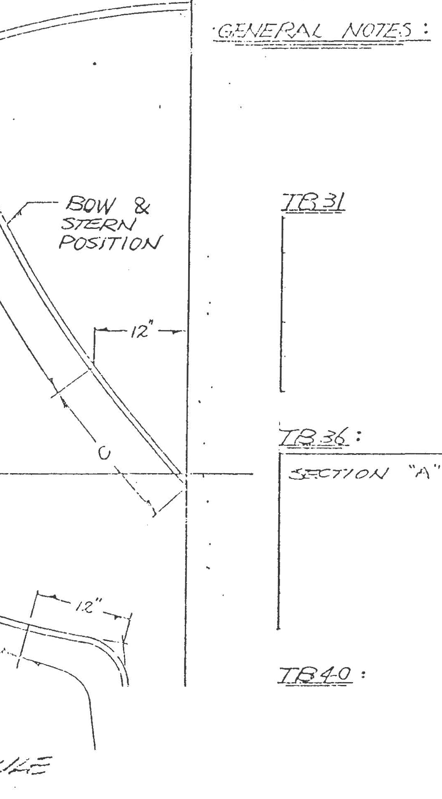--- ...

I

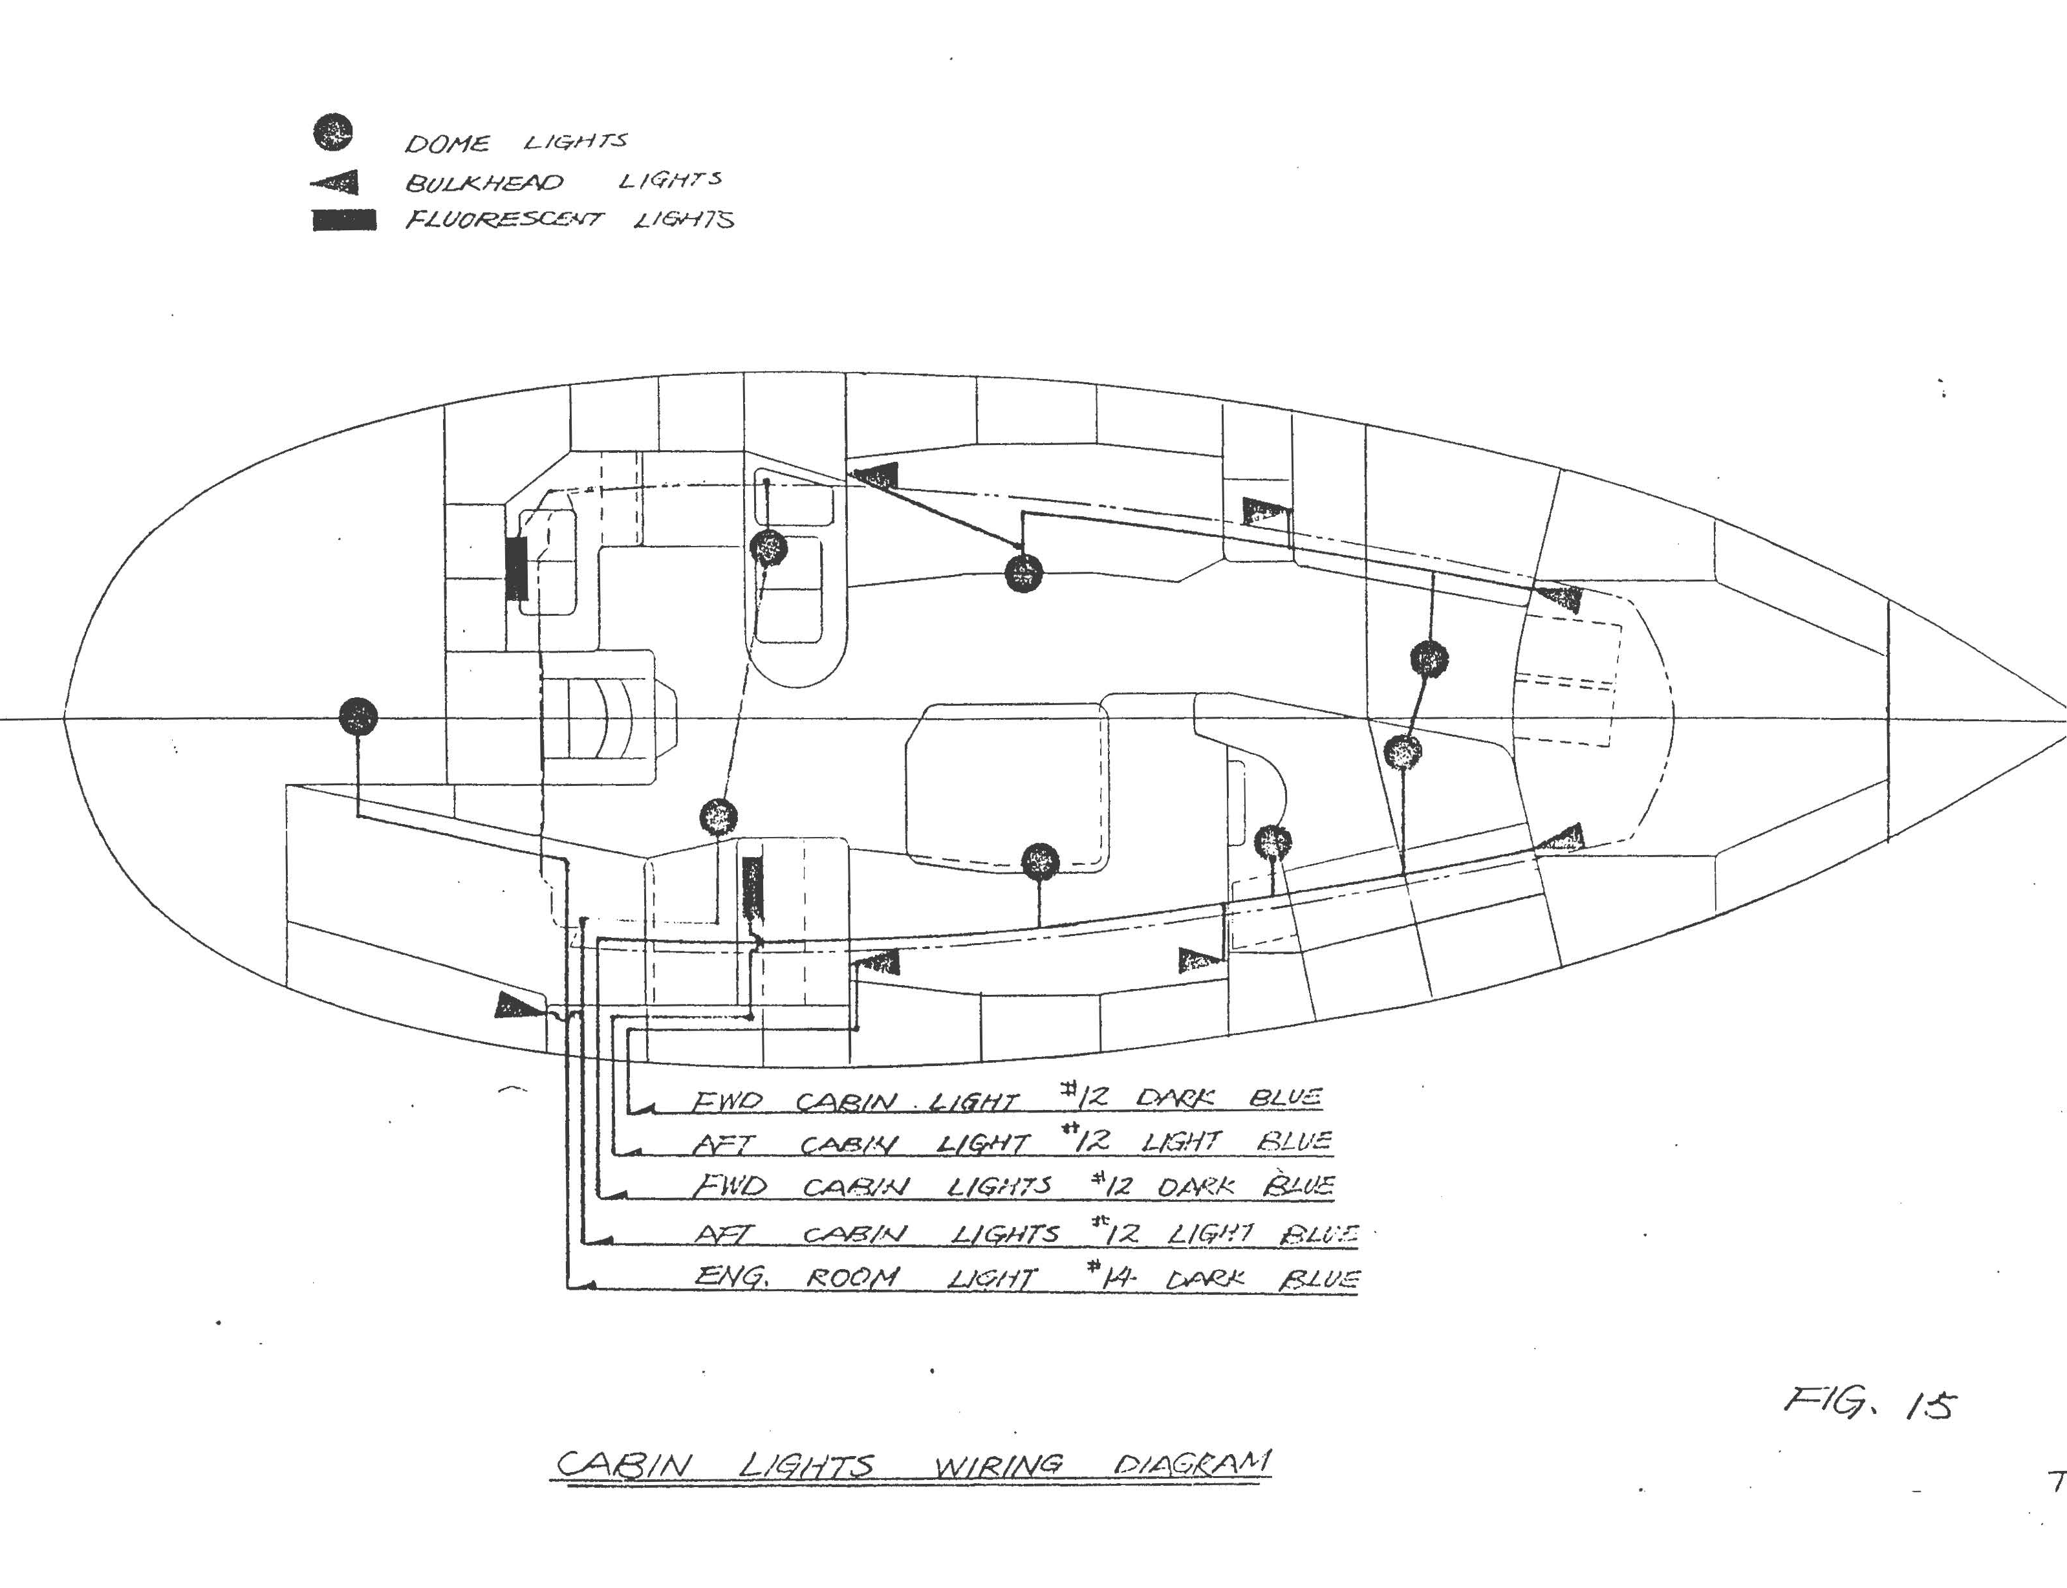

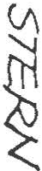

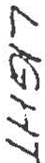- - - --'"1
OJ[]
--t----1
,
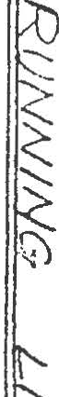t !
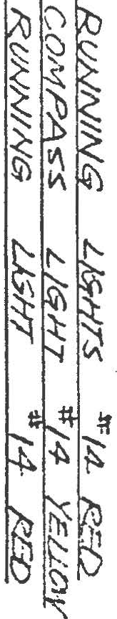I'
I
I..- \ I
\

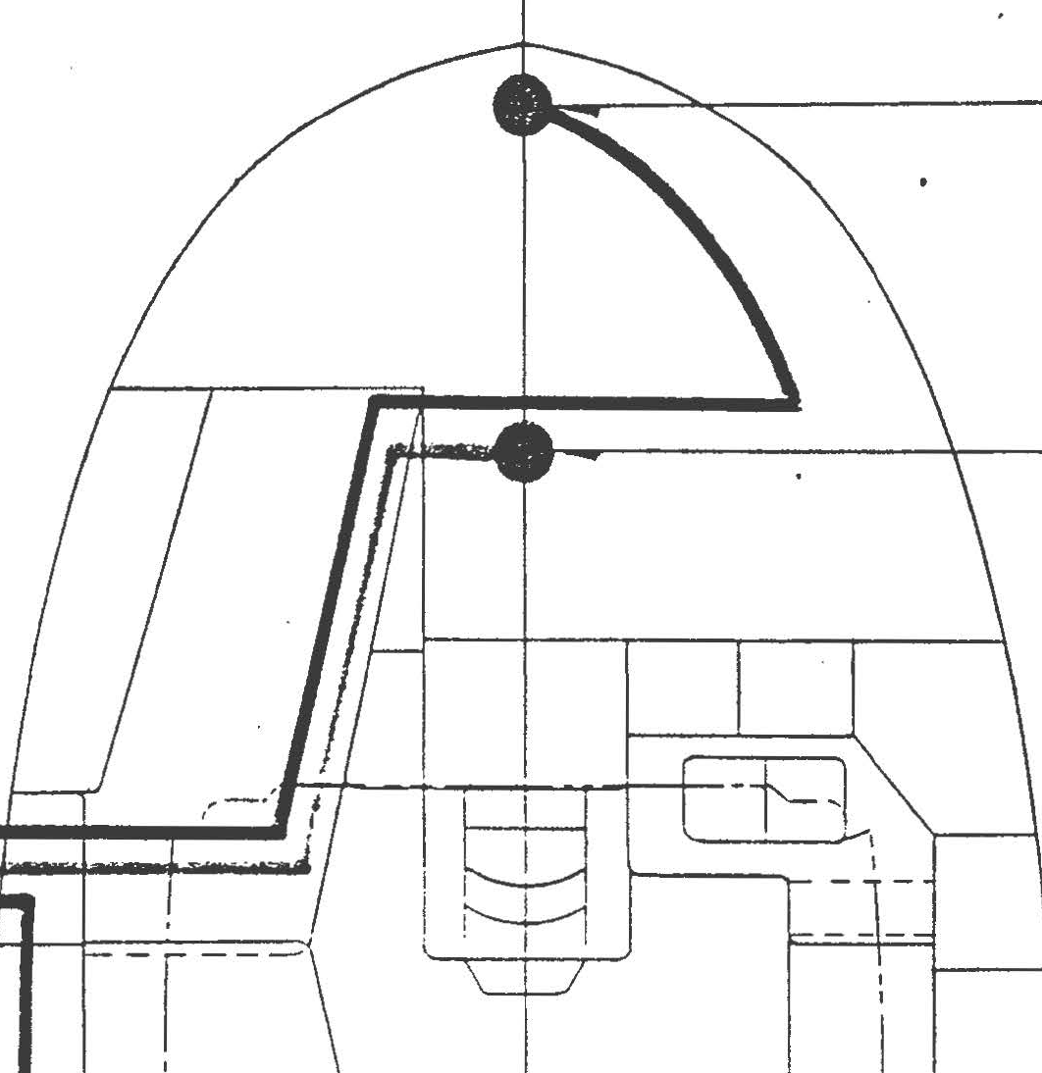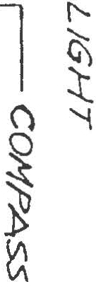
I-...;,: I ()
'
I
I
\..

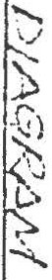\
- --
''

I
I/
I fl
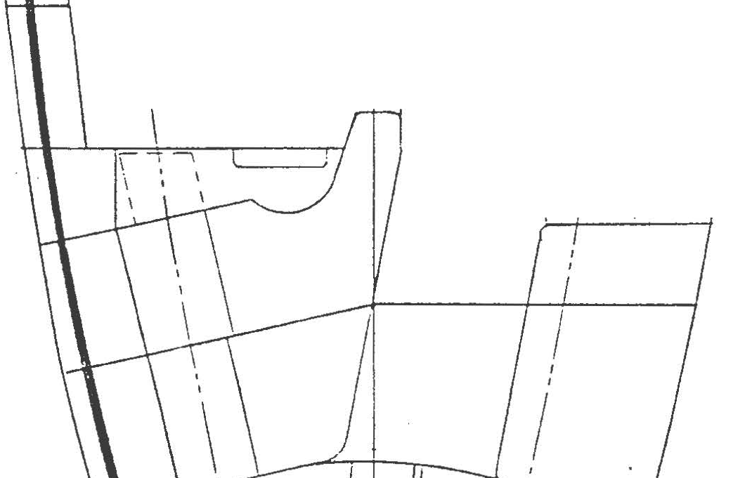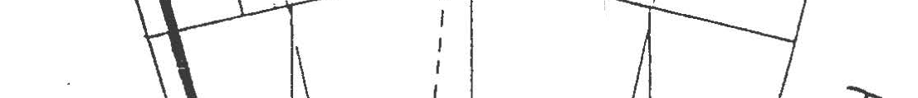I II I
L -!'-. J I

...;'•-'

...

. . . . ·'lb· ..
. . . .. . ....;t· •. c::
•
.· .. .
. ' .. . .
·

.... . . .
• •• • .
• ..JJ. •
.• •
-:i';::!. .

.. . ·.
. ..'(!:f\i . .
..", "f'iV\-.

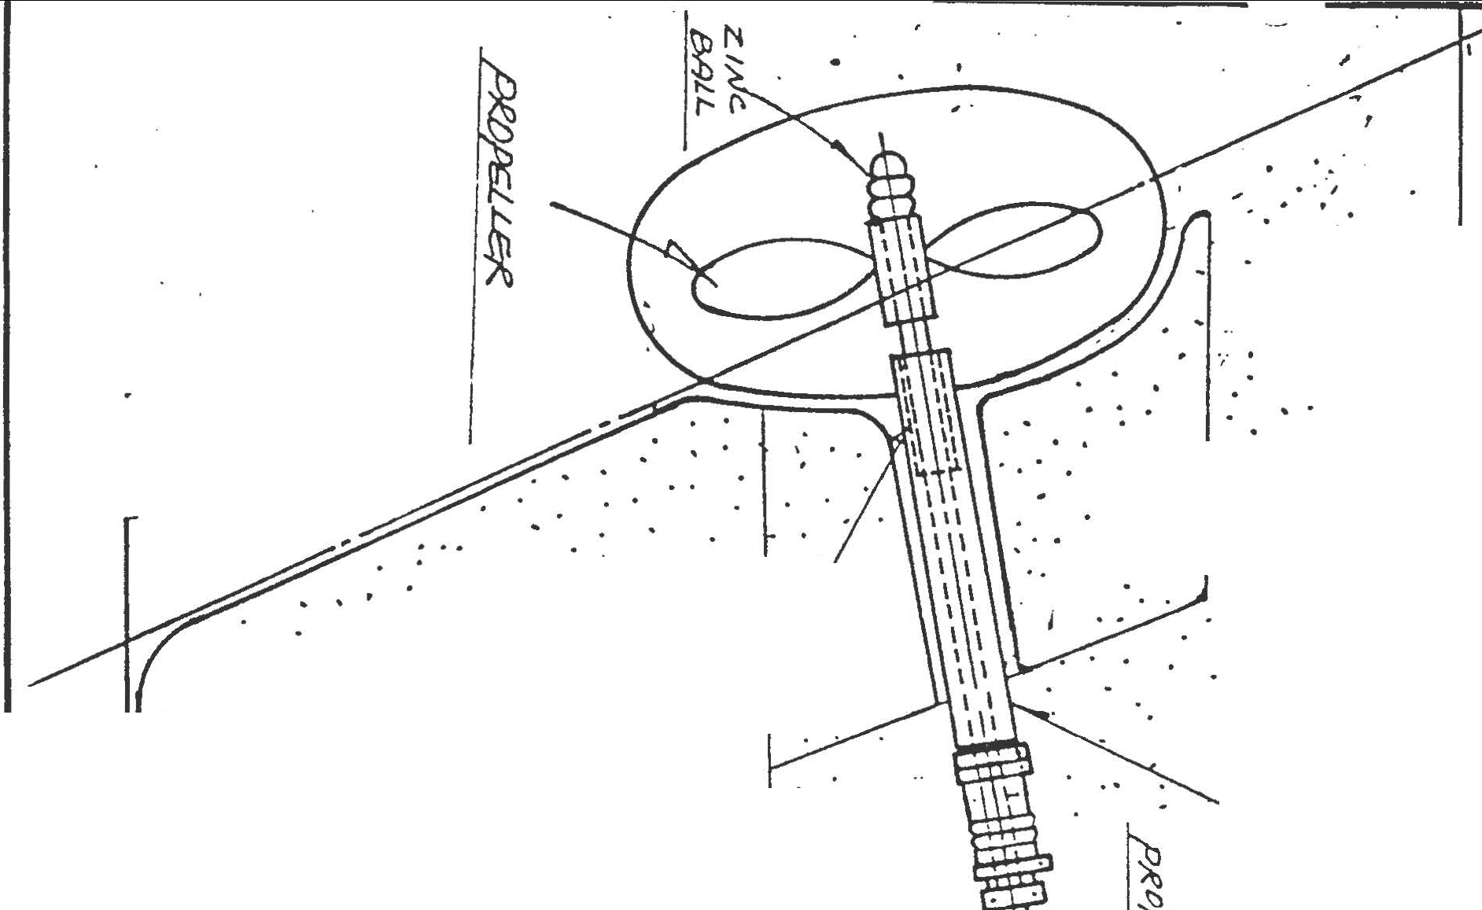• • . \:). . y . . .
...... ·
<:::.

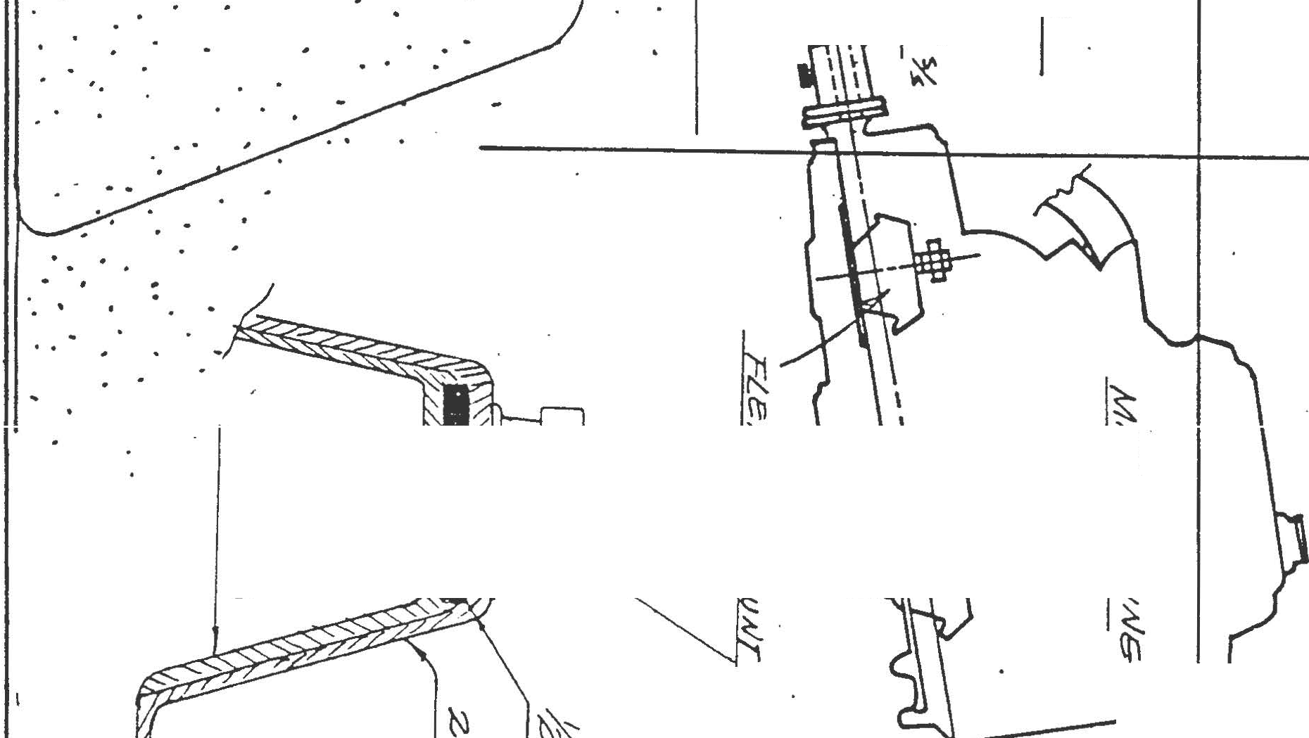

. r. ..: : .·. ...
. .....'; ·, .. . ·. ! . ' ·. \ ··: ·.·. . ;..
,• I• • ' • • • '
. . . .....
... ·. ' .

. '·' , .. .
; . .. ' : ·. ..:· '. .

•• • \ .·.• l • •••••• ' ••
.. .
.
.. ·.I
. . .... ,,,: . _:..,
: . ,. . ;
.
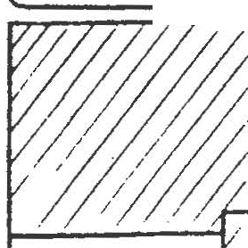•..... ·.·. ·. ,:
•' ..
I ' ..'..
. ' '

. ..
: . .

..
... .
..'.

:.'

.. . . . : L .
.

)>- ·.: .··<.·..'.':
·'• ' .
.
. ..• . ...
. . .

·. '·
·... . ·'

... .,:: . '. ' ,' . .
10 0
, : ' , 0 I • :. 0 ; " I .I
• r • I . • . • ,• ',, , •
.
• • I :' ' . I • / • • • ,.;./
. . .

. . ,.,,
... . .

. . ·
.
. .· ',,

: .··· : .
. _·.

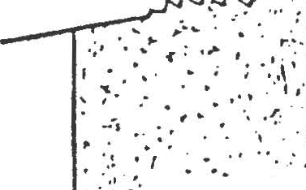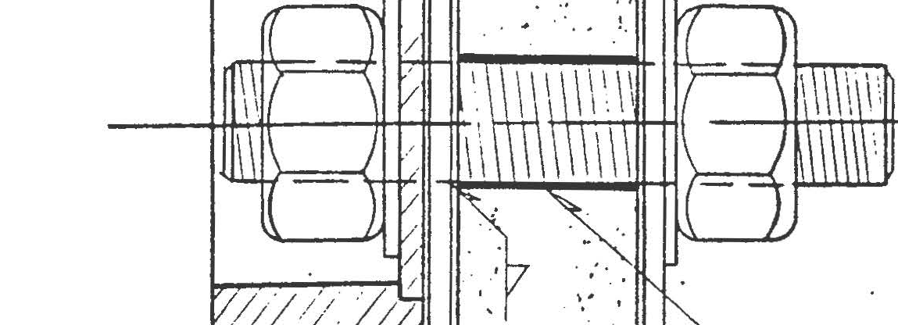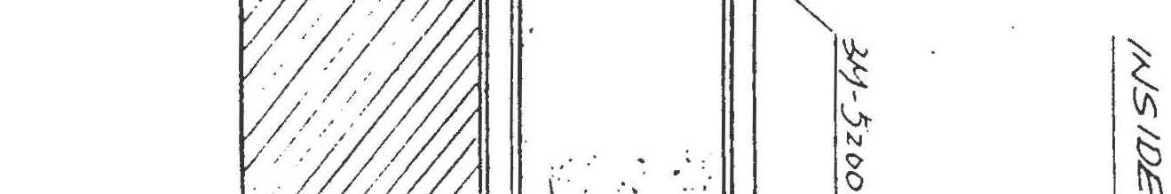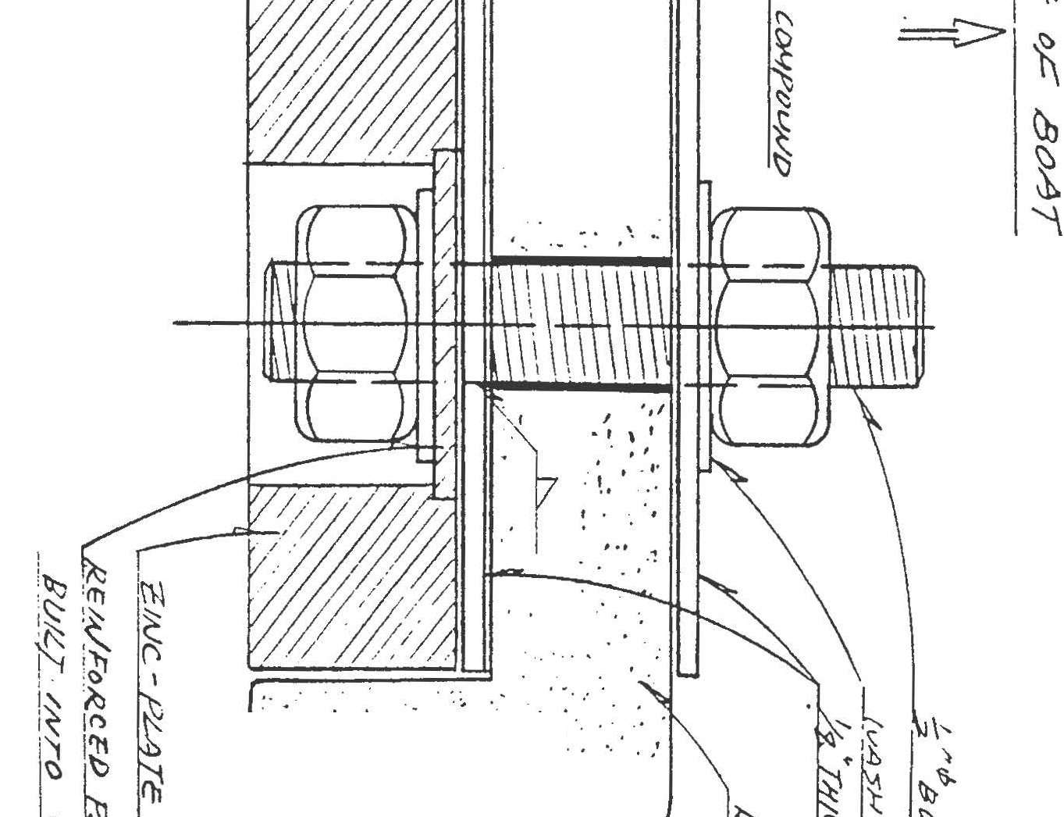:' . . :.-.. -:;..._;·.. s-
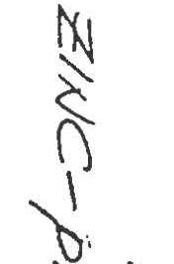. . · I ·." . '. ·· : :· · ('

.Ch

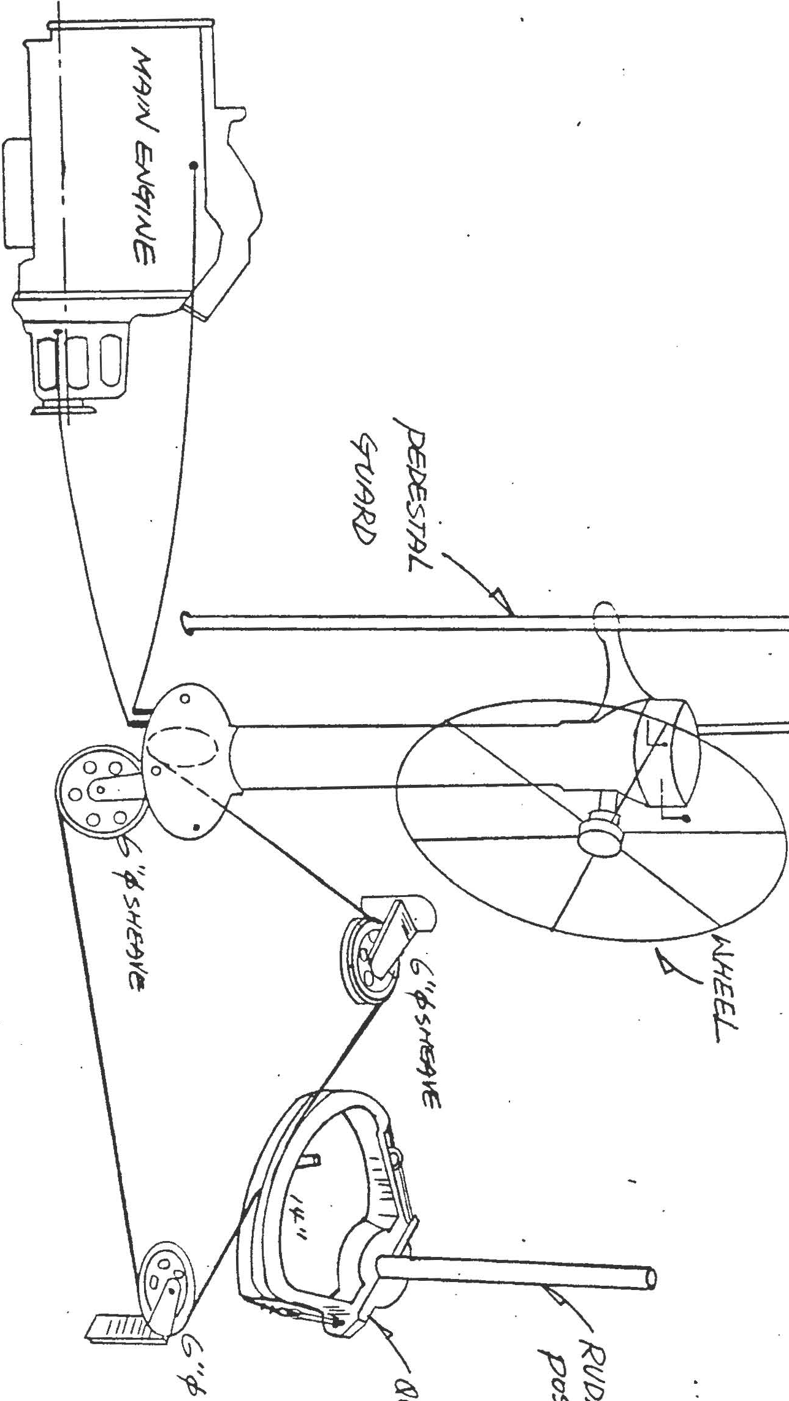

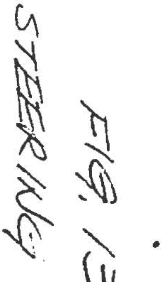··---

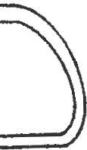

' I!
i

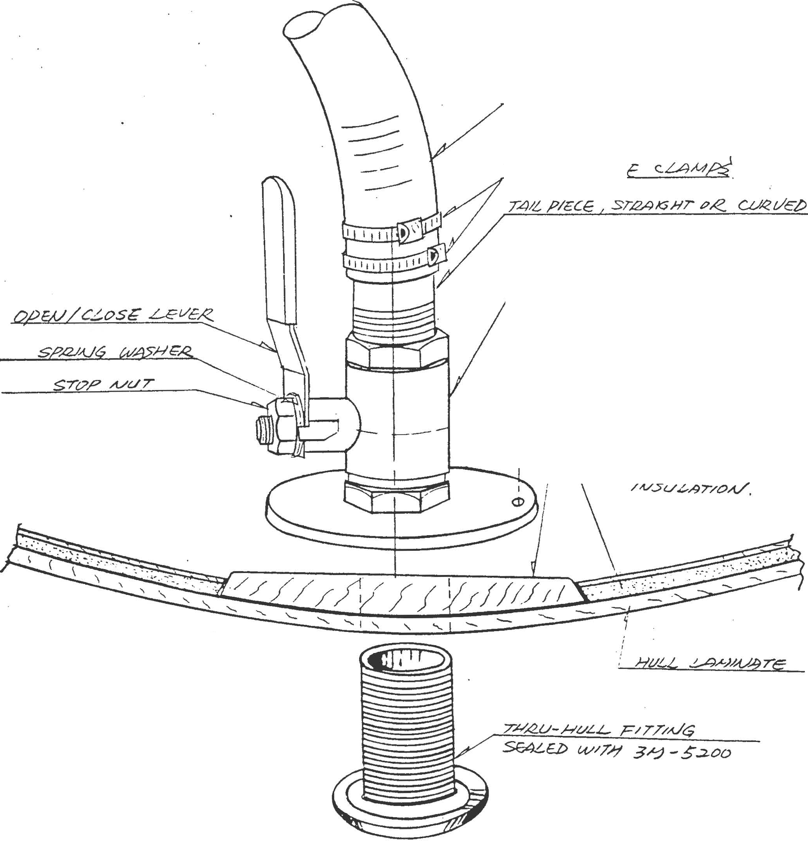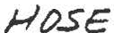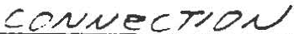

Two s. :s. uos

/€FLo,,</_ SE'_AL..
( A/€ED A./t? AA.

SO:.€tJ F<?&
I

Lf? FP-P Bh<IT
: 1J&/Z!/..Ct7H
1
t---<---'-'-'-..
I I I

AiOTE:
84!.-L V-4L..t/ 1d opWWh'G..V ht/LI-VE
ITIS .st:o wHe,A,/ LA/ ;70°

rlc?. /
/ -COCK .
I

TEST
MoA.cIN. B· B.

S/\TT.
O.C.N·U>ERE. D A.C.NU>ERESI A.C.VOLTS .

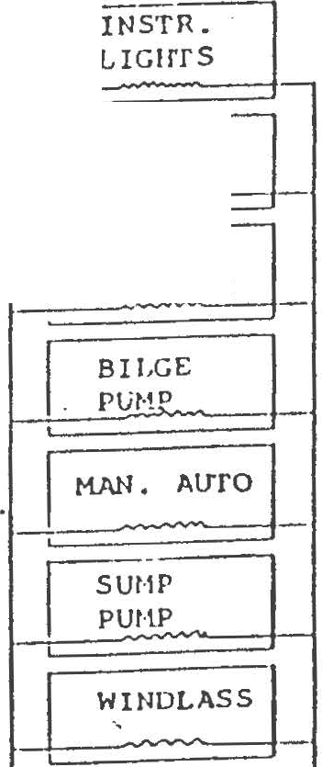BATT.

SWITCH
0BB
2
SHORE POWER
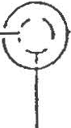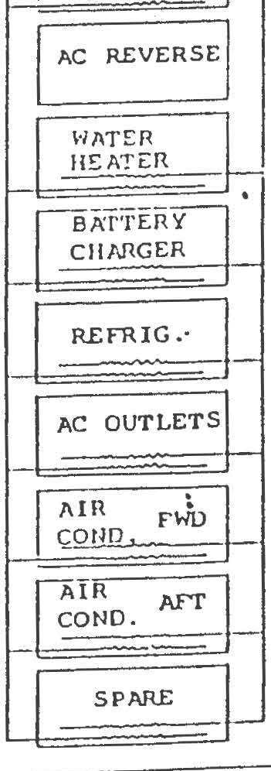IULET

AC MAIN
Si!ORE

GROUlffi

INSTR.

ER

R'/ ·

==
I PRE.SSIJRE

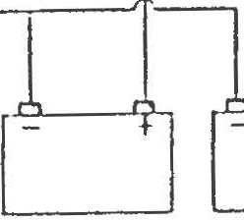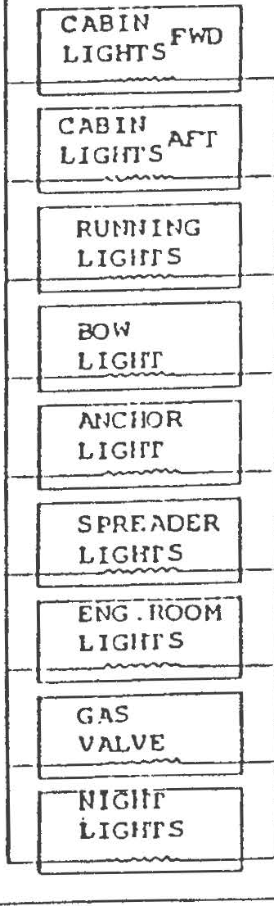

:=I S==PARE '-

1 SPARE

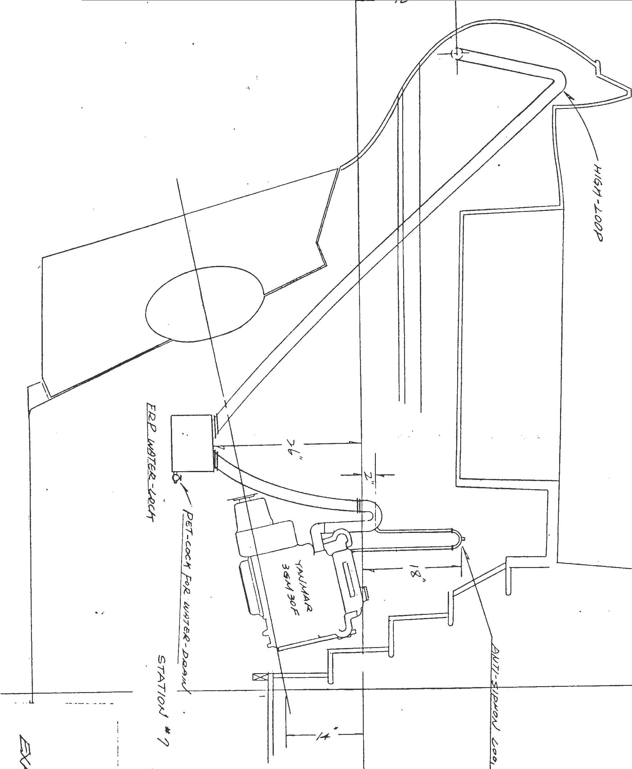

.....•.'l

. . .

. . .
. . .
. ' ... .. .

.....- ·. .
·... :.. ·......·..- .·.·_ *
.
.. • • • • (,'\ . • . ''l:b.
. . ' ....
··. .

• . . • .
· ·.
. .!1\ • ."" "' • •
'\'

. .

: ... .
;r.'
.
'

. . .
::i:·
·
t- .
I'
. .
1.1' '
'
j "
!""
It)

t;b
01

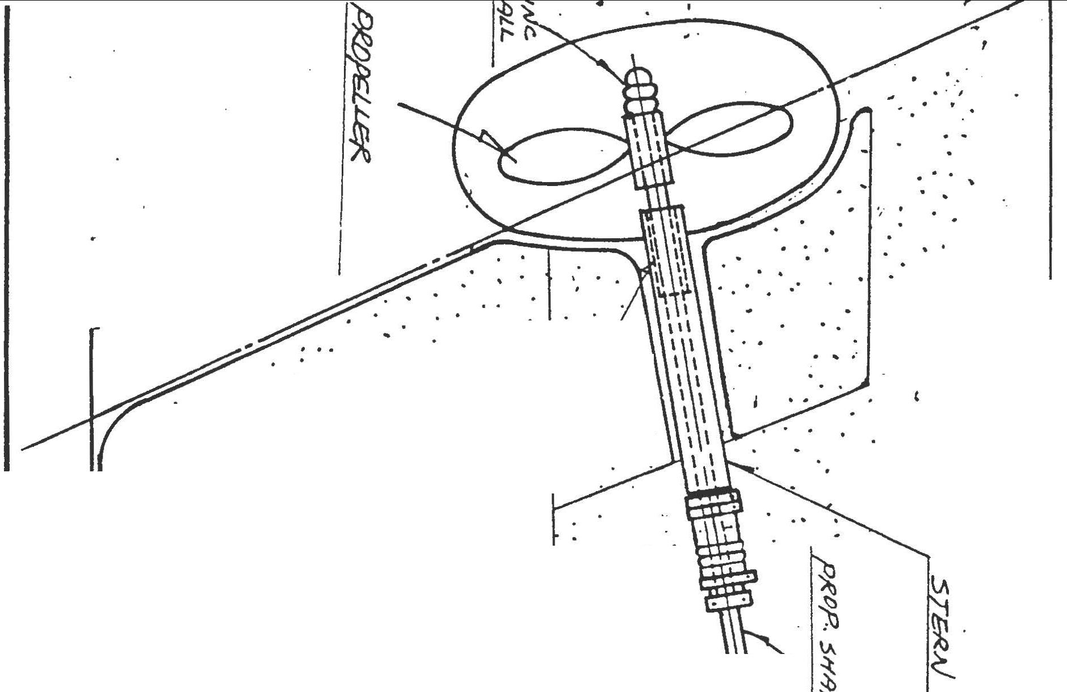

. .
.
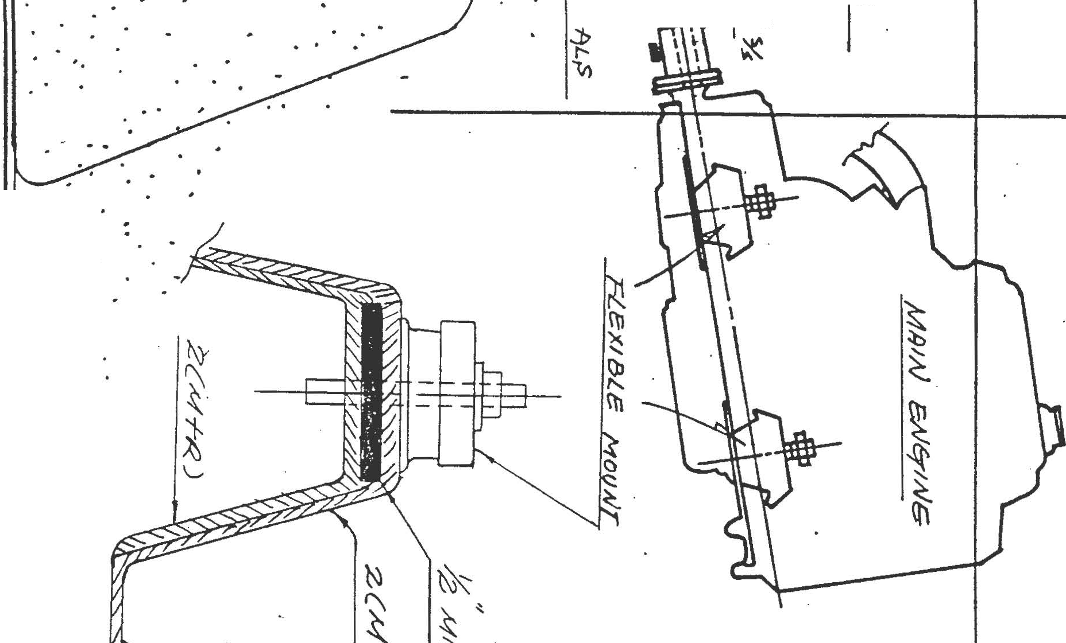. .

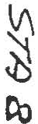



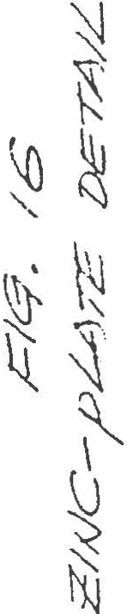.. :· ... . .
. ·.. ,. I .
. . . .
. : ... ' .
. ' ..,. . .
·, .·
...
' .
,,.---- ,''.·I
.
'

.. ' ...
. . ..

:,:-:.··...:.·: :\:

... ;..

.• ....
, _,. ..
,.·:· .. .
r .
.
. , . :. : . ;_ . · .

. .. . .
. ..
. - .
. ......

•
•··. ... . ..
. . . . . .. . ..·.. ·.

..··· :
i ·. ..

•.• • -I

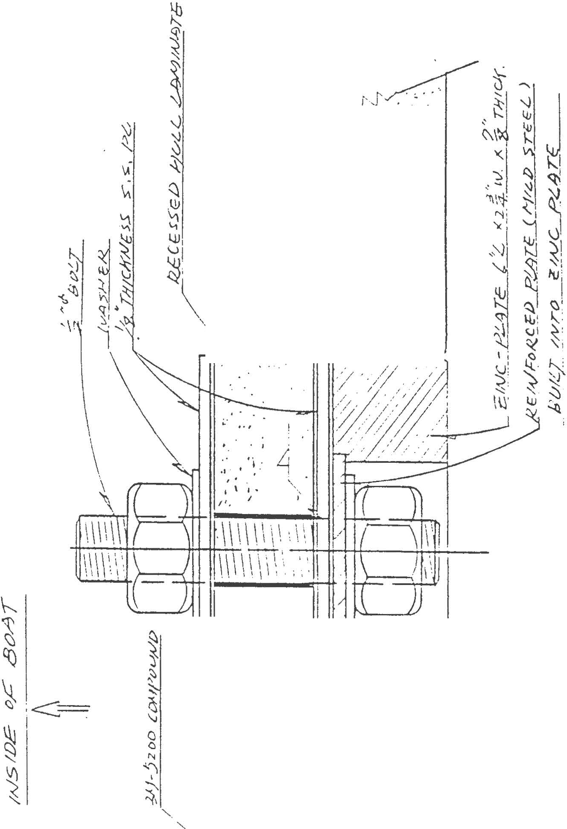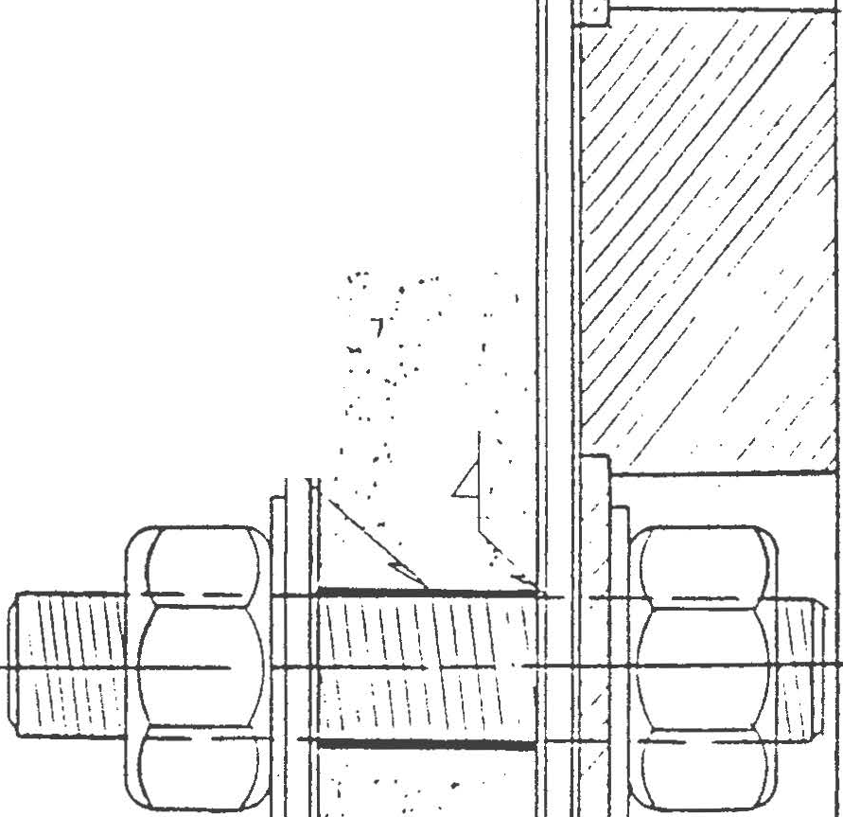
i

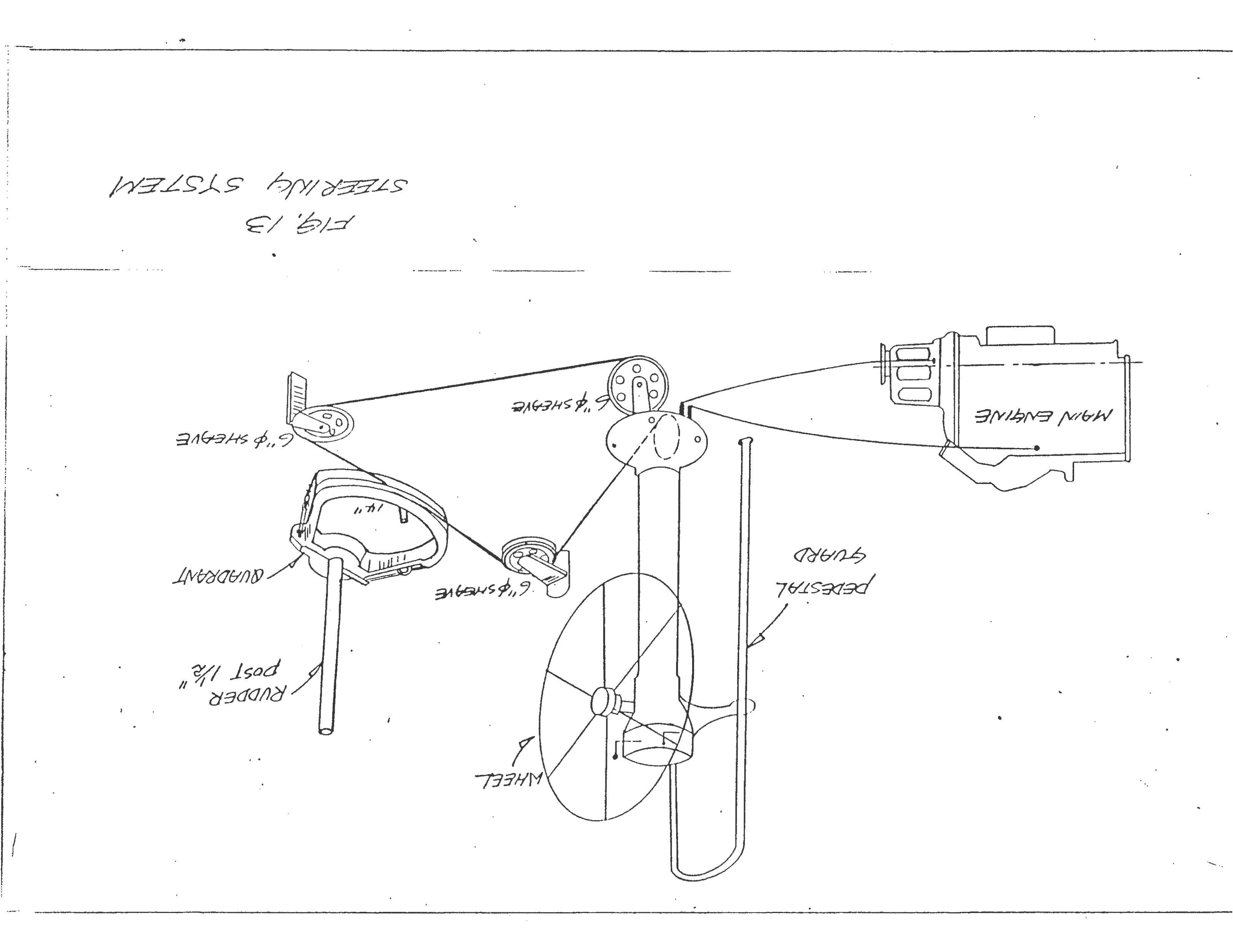

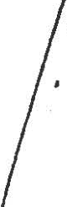\..-
<.
--
>

:::,J..
1
}Ii
r-
I
I
I 9
:t- II...<>
1
I -?,
I 1
I

I . !

I
i

- fi
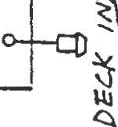' ;. I
I
I
I
ns . el 6
V\

'l ..., I
:li'<>
I
"if_

D._

11
I
":::>
fri I

CL I
<t'

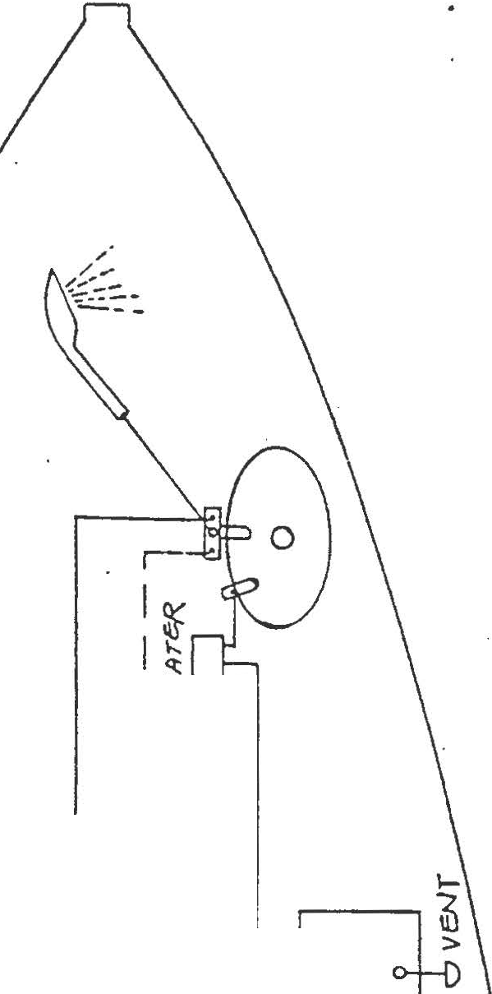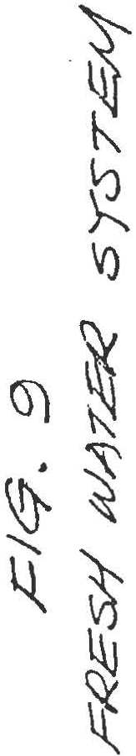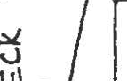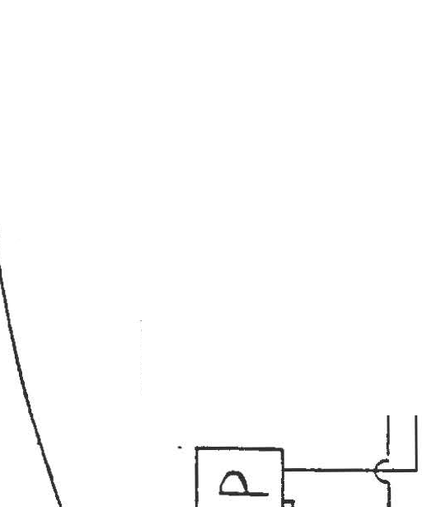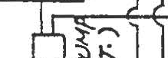l
1

:r.ll"""
::: I-
<(
UJ
cl.
:::> .
\/\
II\ ' \-.
1tl
Q._ \.l

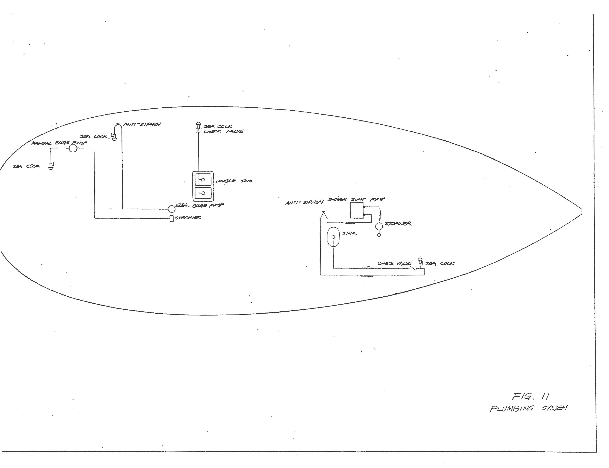

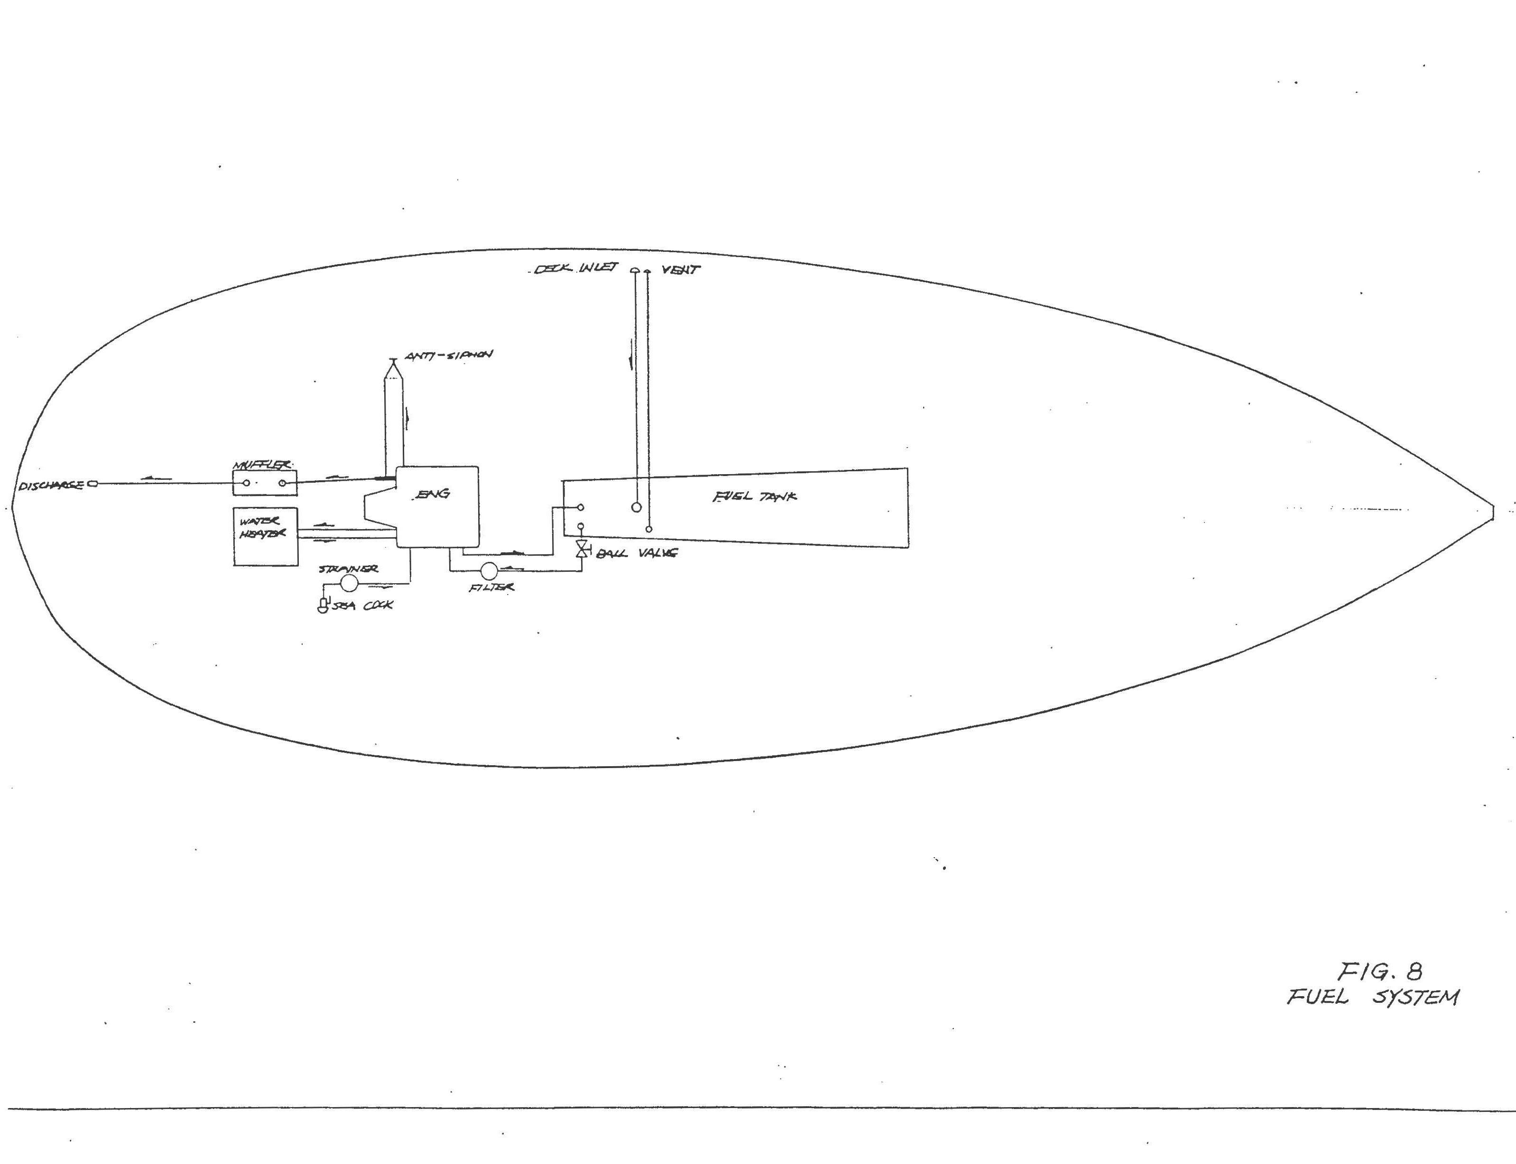

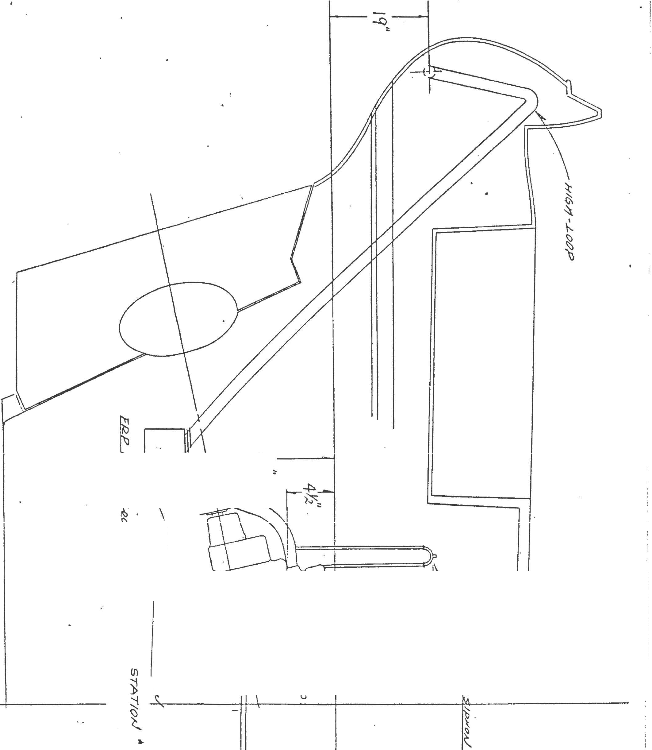

N

t .

-+:>
"
i1l"ltli
I

ltZi

'l

I
({)

t
l \
"i t-
'I

"\

-

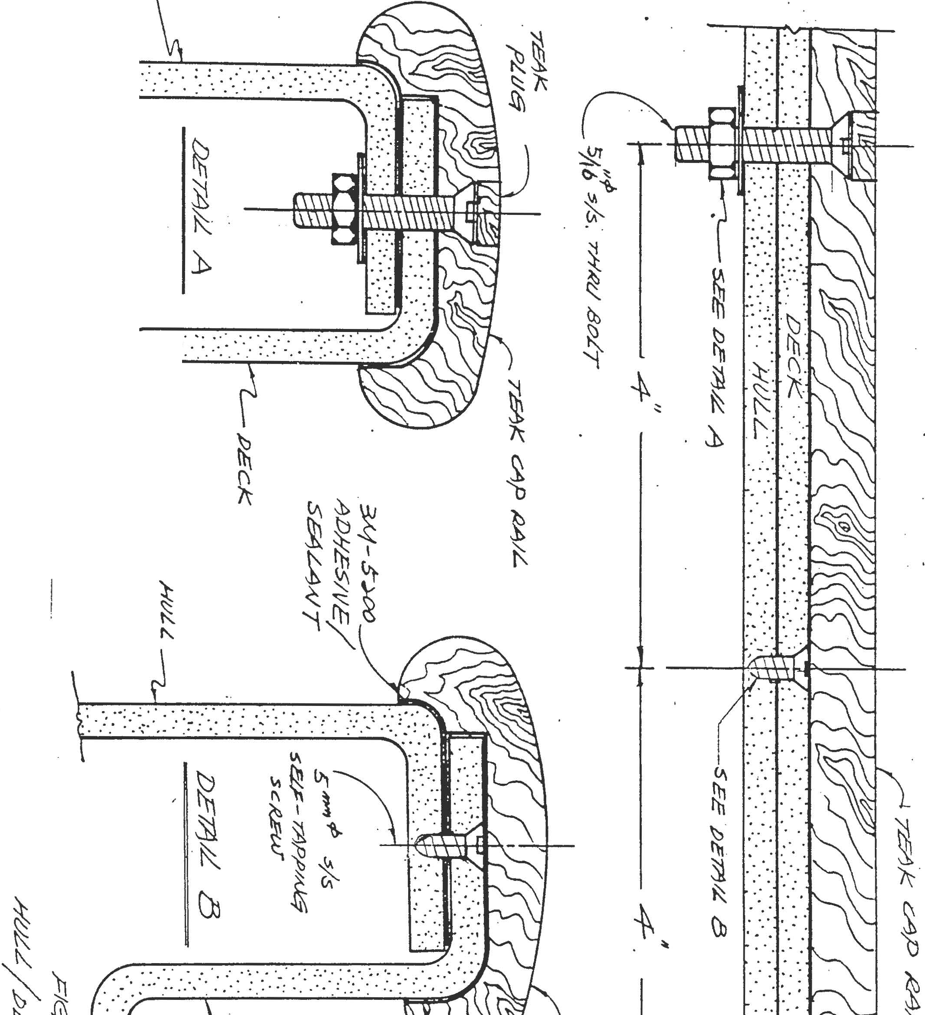
; .
!
!
i

....... ... .. .. . ... .·......... .. .
.......
......

..·.
..
...

DEC:.'<. J/YTAK.E

i)!IE.NT

6

.SAL T llY TAK.£

/

WATER TANK.

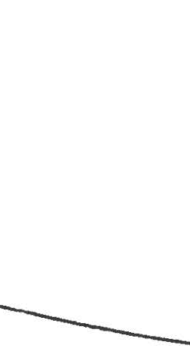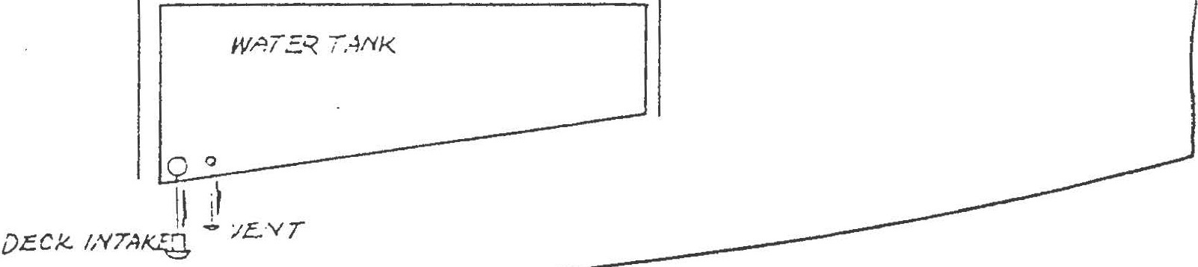SHOWER

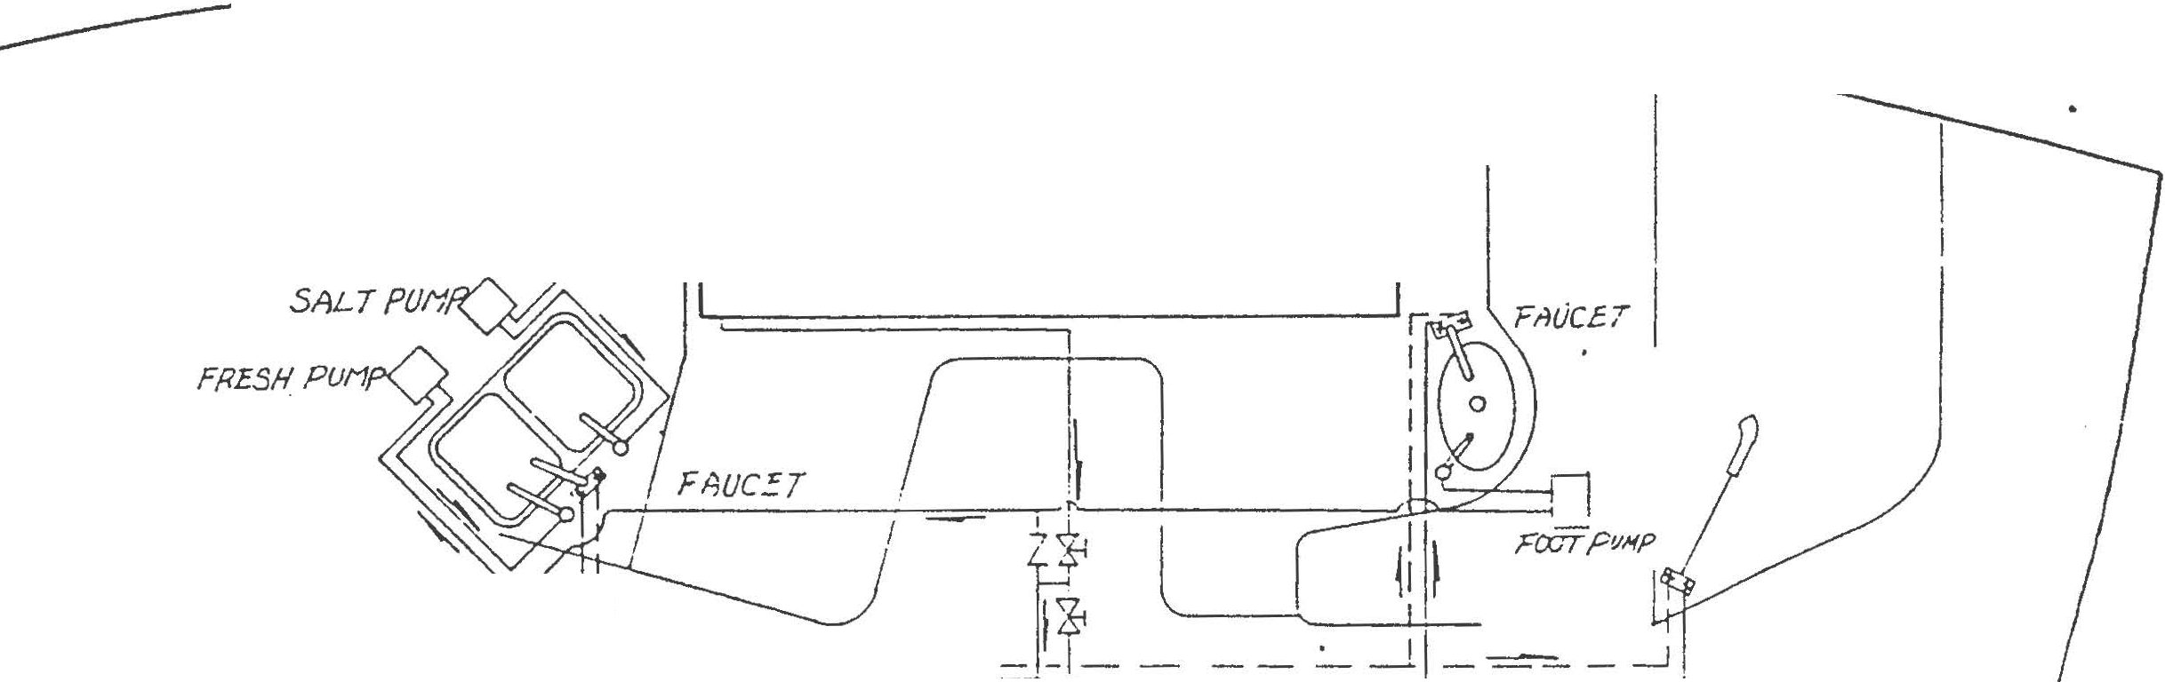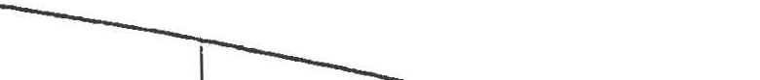

. j 1t
1 1r
-- - -- --,.,}- ------ -

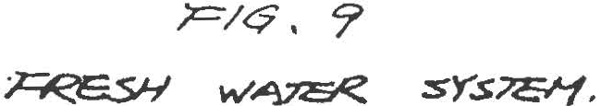

•

I

-
S')

}'1

·

'}
t\)

t"'1 ij\)
\_
·
lli

Vt

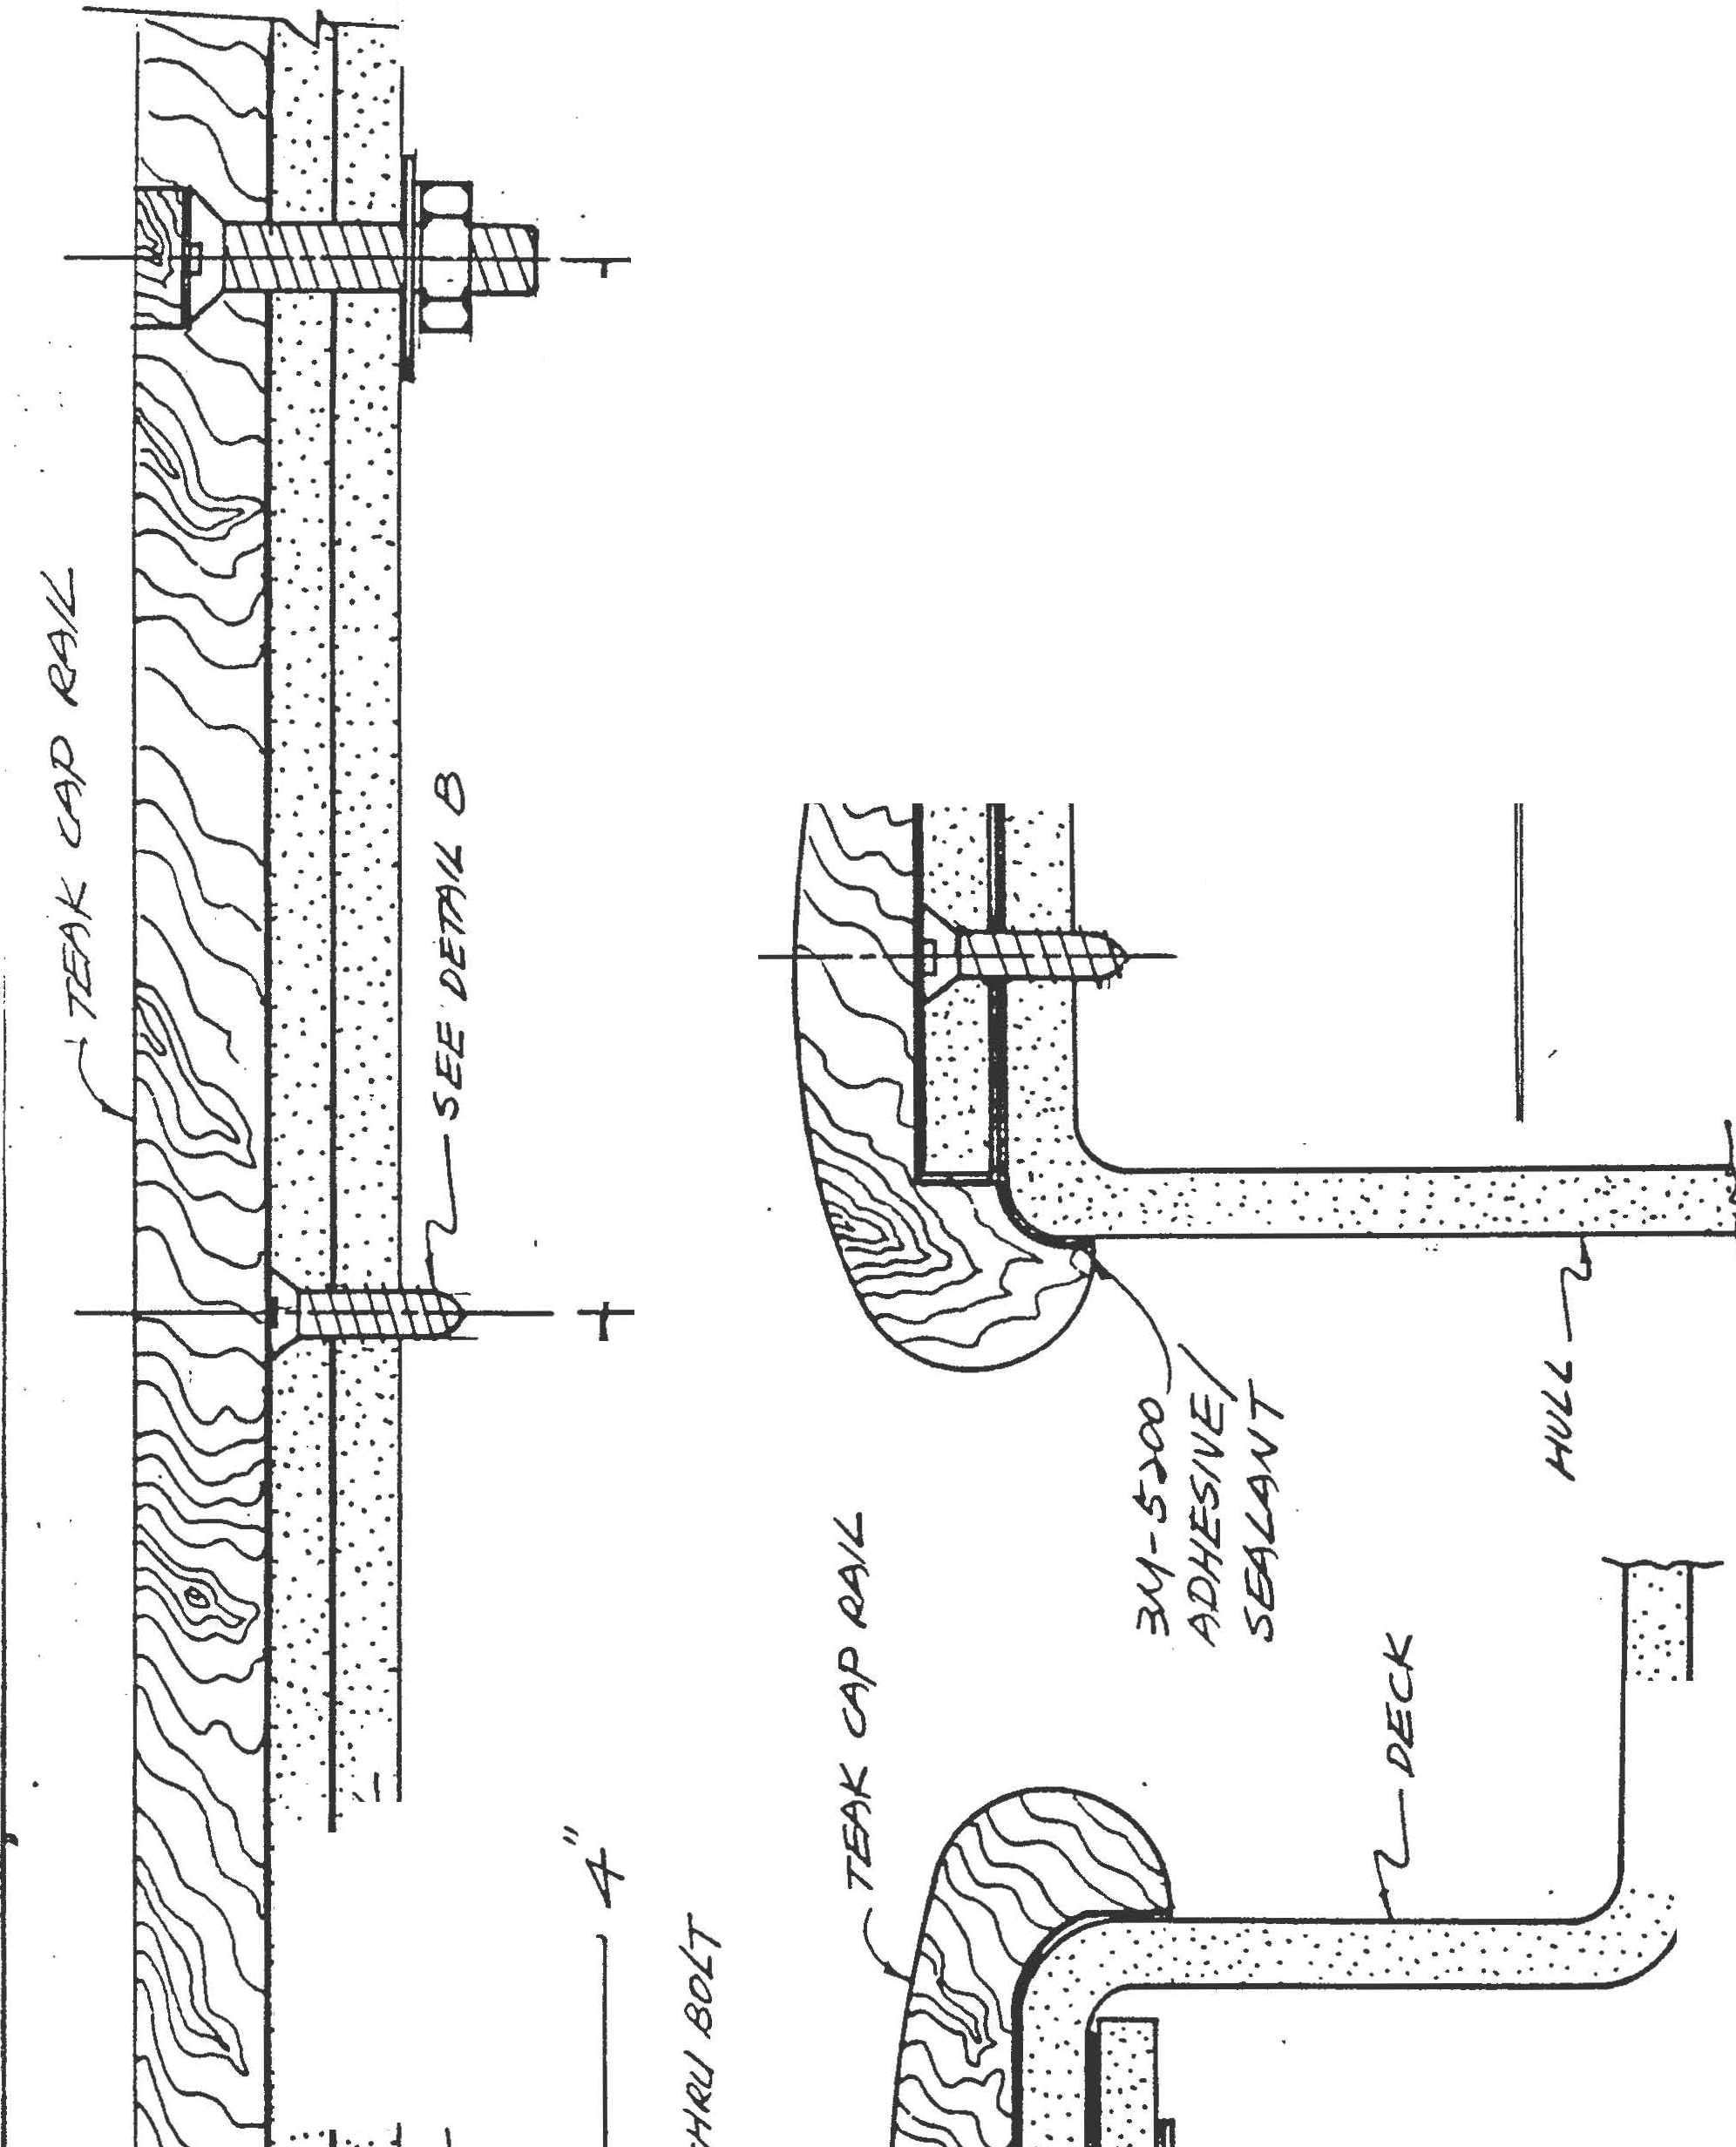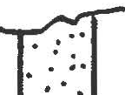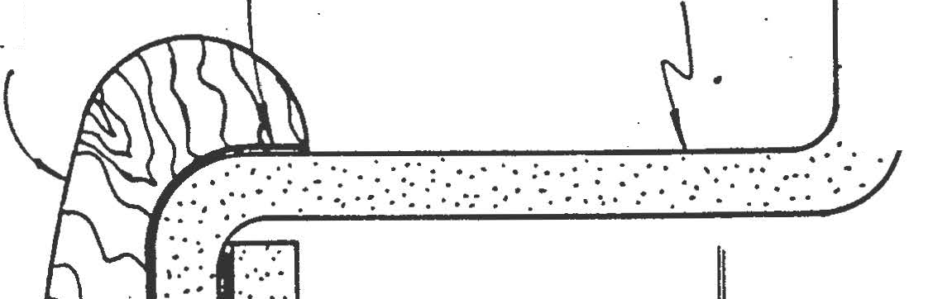­
. -
·
·i I ·
l!J
.v : .
.IJ.J : . . 'S
- · .:.·:.
: : .- :
.:.. :·.·.
....... .........

-- -AA>rt rldl--t -

DECK INTAKE

VACUUM VAL.VE

VE/YT

I

I
6

=NG/NE
rUE!... T1lNk

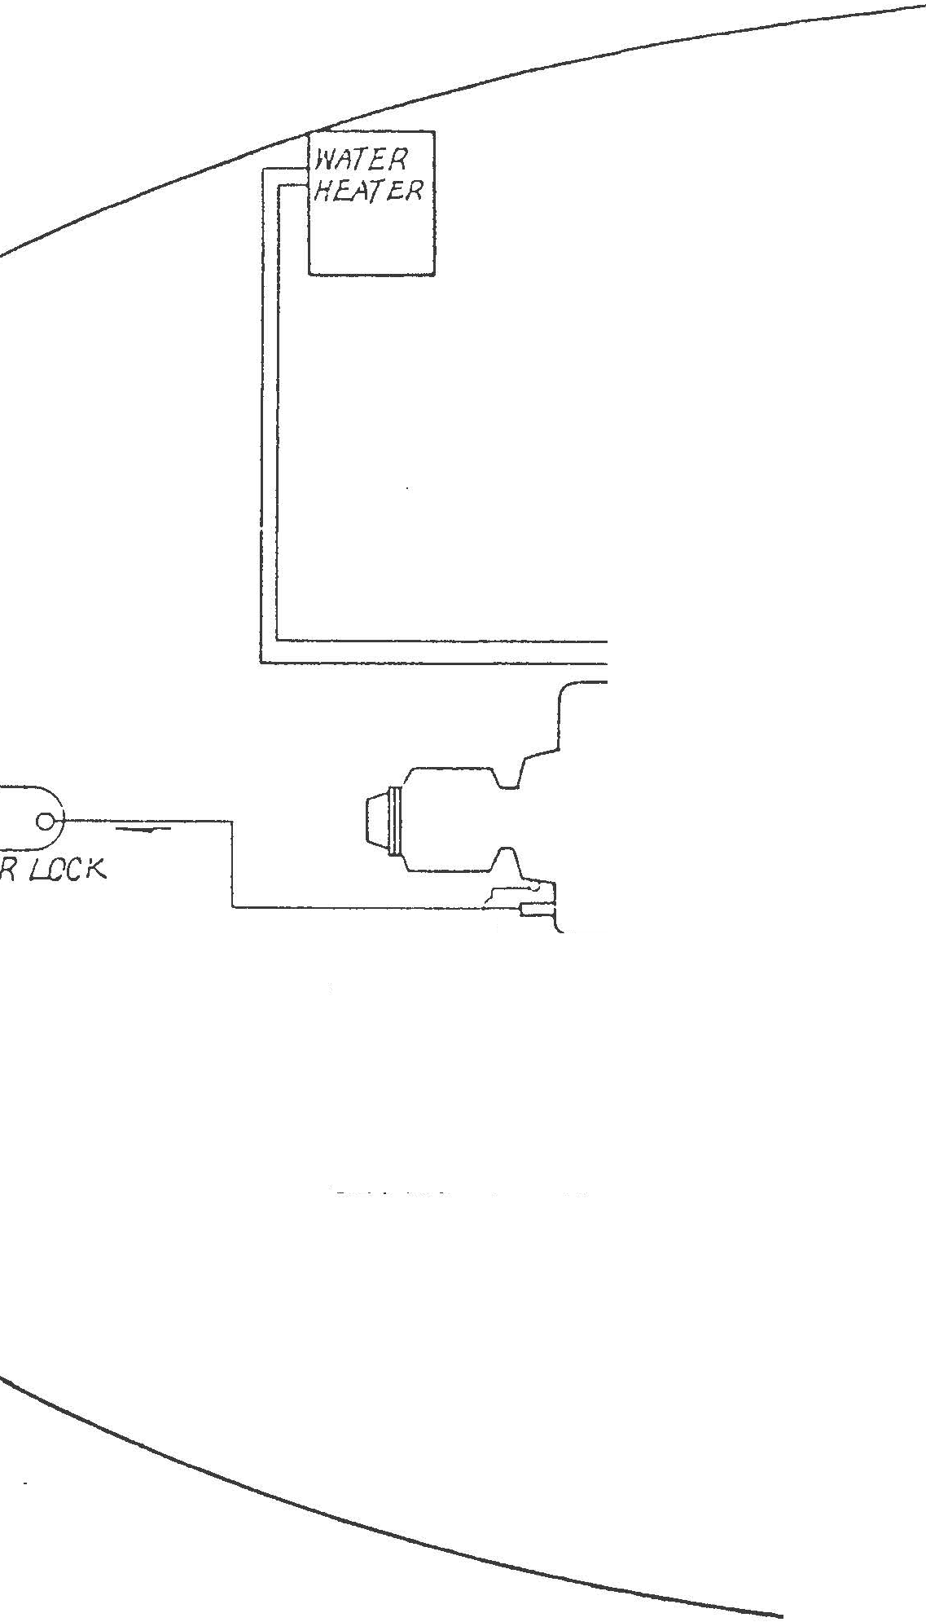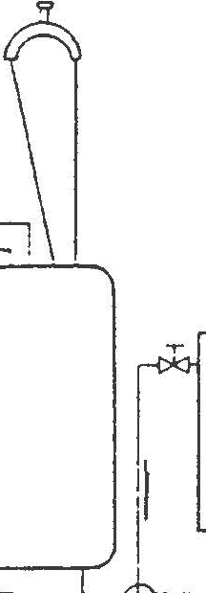

0

rlL7E,:ZU ST

n.t
=
SLA WnTE-'? Jf'l7AJ<E

F/<;. 8

;ct./EL 5YS7Efa/

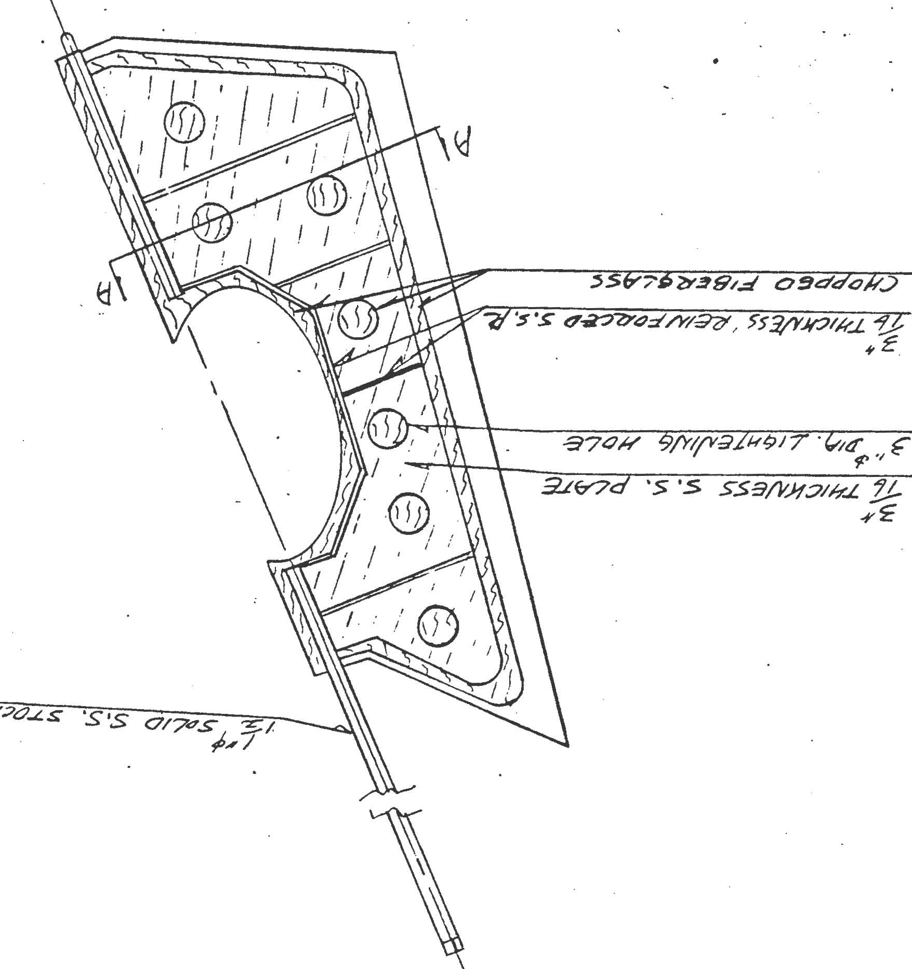//f7-/ o/V tJdJt?2Y.L.:s/V<r.::J ?73<70n2"!
/

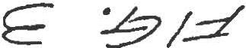

- -·
( - t- , )

-,r-1-' --
I
- r
I
l ......,
_Jt_

l'l-t

(:! I
I
<:::. I

===1 CD[]
I

0 N
<::: 01

I
I
I
:
I
I

I\ \ I
I
.h
<) I
I'\ 'I I

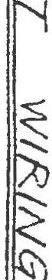\)

(;)
))
>
'-.·..
'v v v
\

"--1I /
If

,

I''

I II
I If I

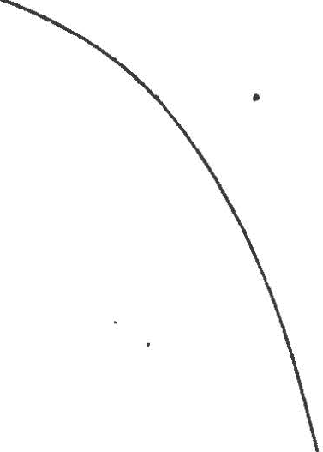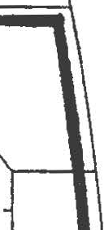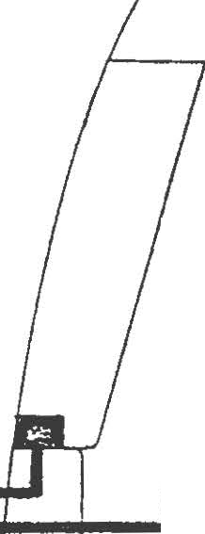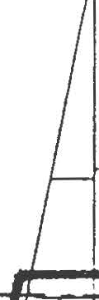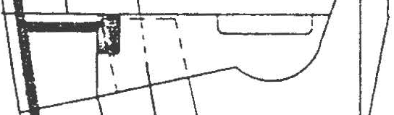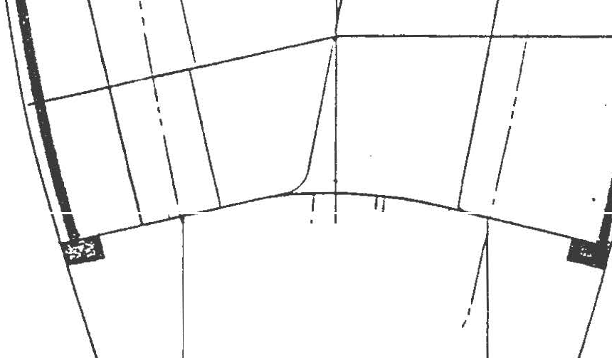\\.
L - .. '
_ _JI I

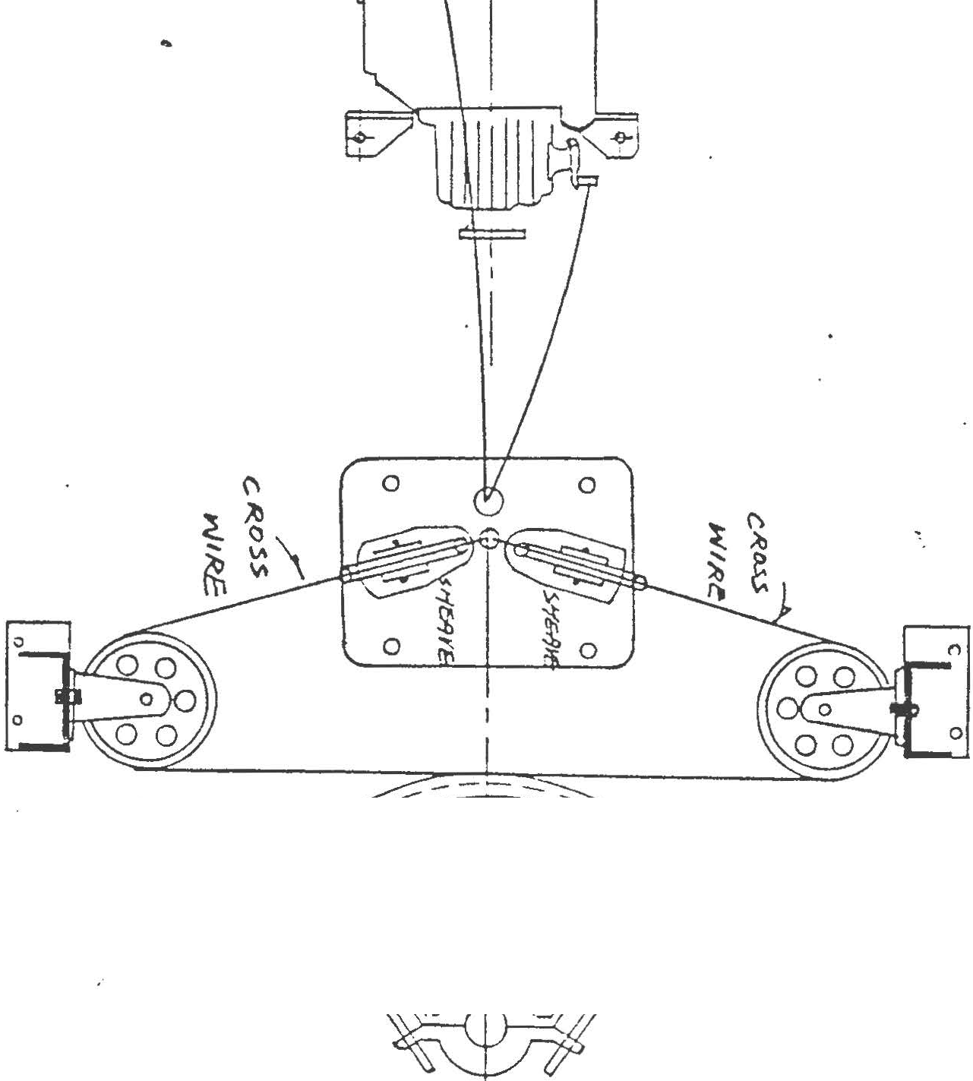>

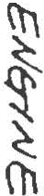

°" 0)
\A VI

-b

Cl\
"t

\j{

i
u
Cl\

'\

60 ,,,....... IC.

;::==+1==+,==41==:;:::::1=!.: ·=Y
I  I | I | I  I | I  I
I | I | I | I
I  I | I  I | I  I | I  I
I | I | I | f
I | I | I | I
I | I | I | I

_,,--c OMHOIV 5ROVND P01,JT

I t It I
t§ r

BR>
s'
J . R. R,sO
.Z"3,

illi

3 W' ' WH17C'

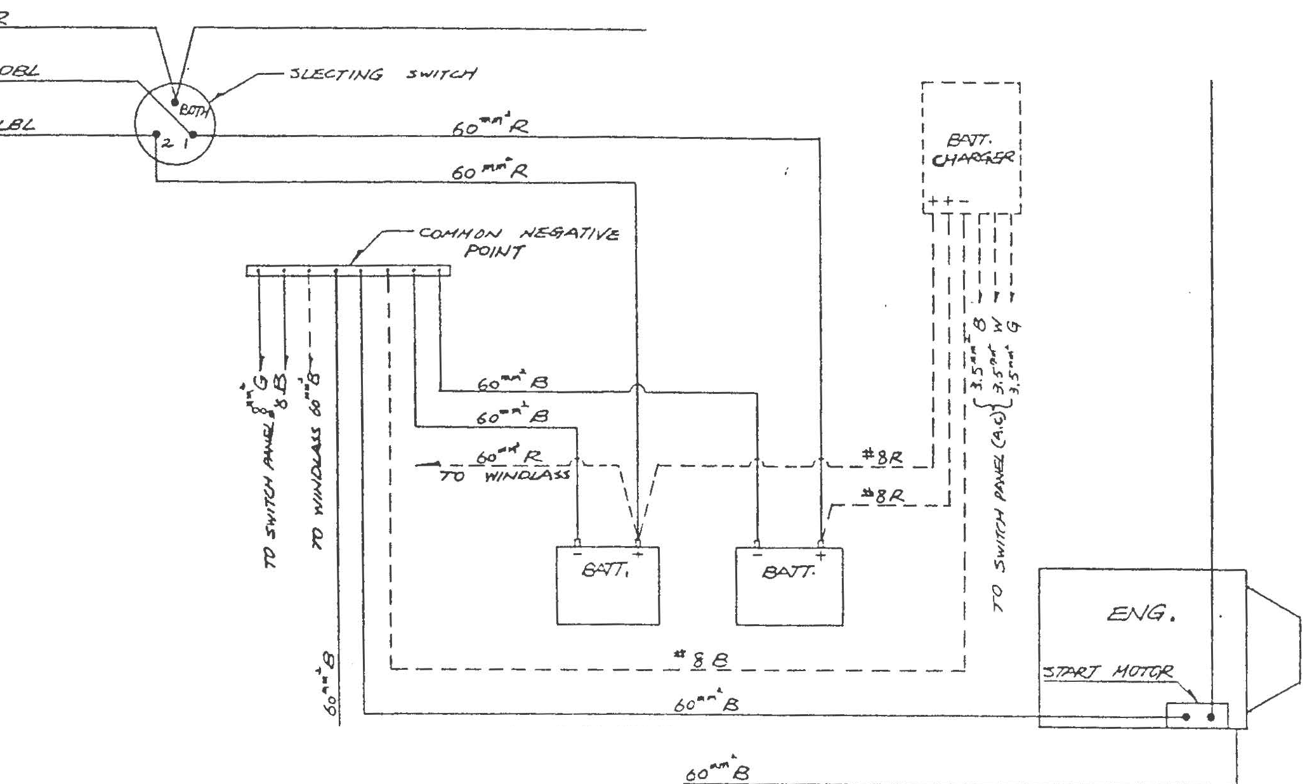+ G , C?REEN
:S DBL ' &.JAE
6 L8L • L./"iHJ' BU/£
7 ----- O/'TTON""JL FT&H

. ;::-/ q, IS.

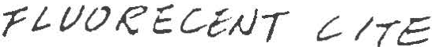!.. !Tc

-ITE:'

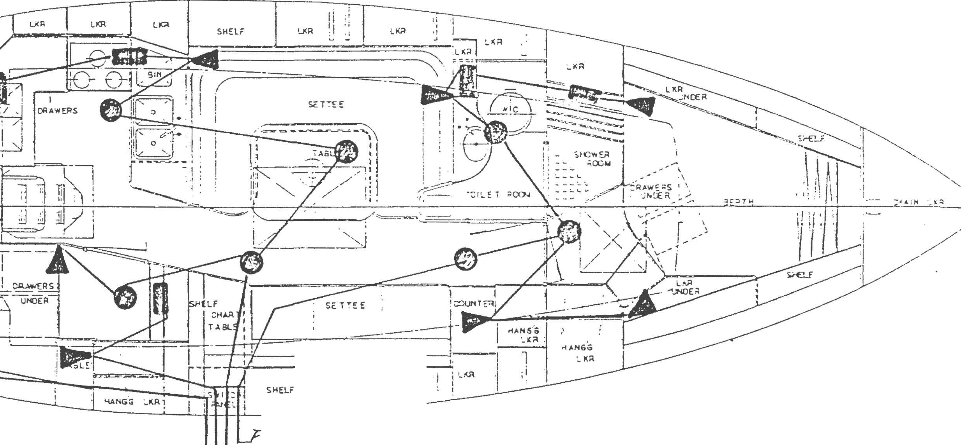

., ;;
ll '-l<R I '_'\j:l
•I

-I>--.--?-1-1- 8/A--/- L- /TC /.ZL?·
- - ·---
::#
./JL.._

_/,)/'./_ _ _ ??}£/- l/Z::--_ _ (z . '-T. 4_._
/Jr.,.. . 4.,-Y . 1717. !.7 .ii t:..f. /.Jc. .

- · k.L'l:'Z::-_ / II- D'<. 'Jc_
'

Fie;, /5.

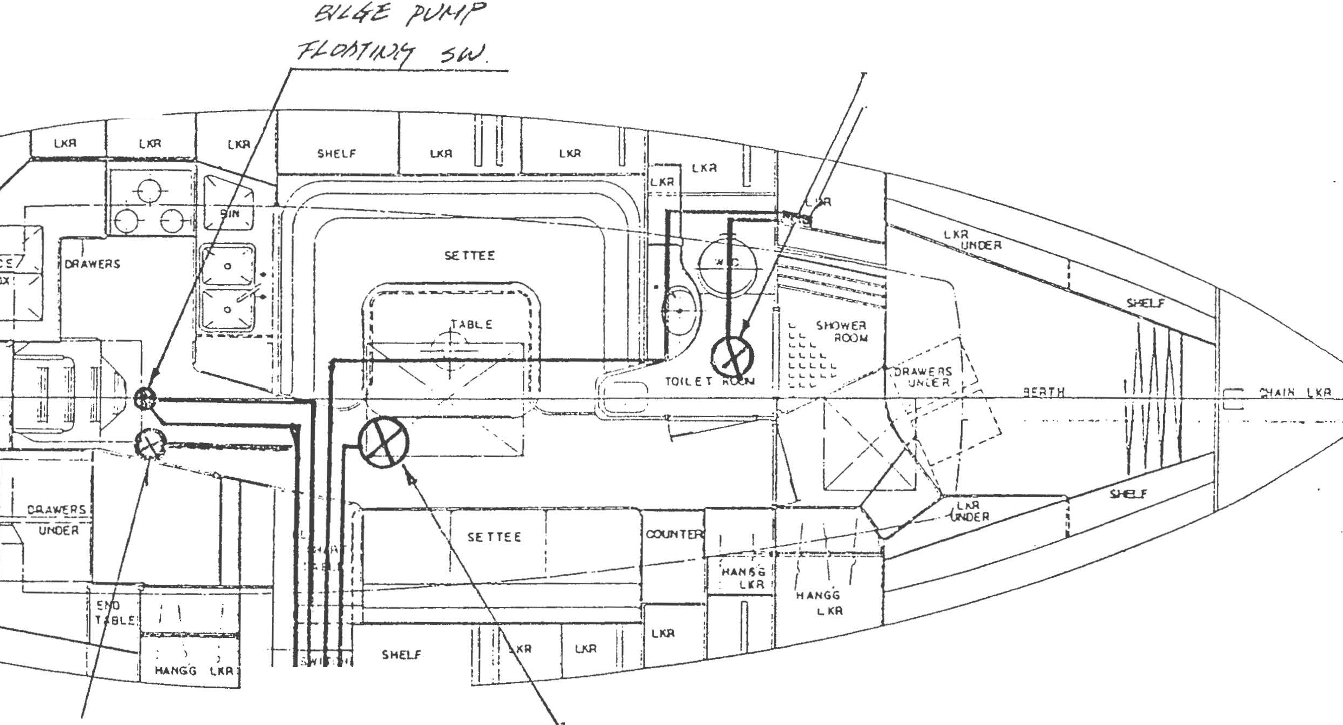

-jf/k? J?t/t!lj/

S</HP PUMP .Sw'!Tql

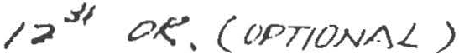

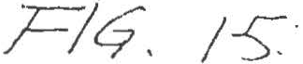..

tv/Jtce ?R-£:55 t/,('Z /V"-7,P

_!1!'/J{ !•t ..e!f.tf_.f.5.V F:___ f' ,y/" _ /..? #ec:-.o ,

_ ?t/_/t'/7 _ /'l/r//' ./..:;? #- ?/N'k

__ 8/Lcrc ,PP'/Y _ _ ,C.ttJ/)f/tt/6- .5­

- r.-?66-.,RvH,.P /2·# 0 $"

/Yc?/...L V?/V_LS(Y/ .:?df?"r* C>'fY/-/ >'..7?c7
9 £;;?/.;:z"

/vc/#.//"''7..L.S:: . :5 '.S -:£ o / 7(.TM ';}CJ;) :i/VO //-"" <73ddf.:7J
' 9/V//]Ow:fcr ...? /rO/.LG/h'fT//J {',.yoz;'::;///C/kJ(YtZl.C'
7rv /J3<YcToI '°"".L.-?1:7.Jo...L. {Y;ac/-:is: ·;..x-v:-P.21m (f::{(l.::f \
.. / P·· t::
9.Lt??d 9rY/;.r f::Y8 ·s·s 8J
"CY:?.-. ¥/"? d's ·..17o8' <7/11_L //>'J </ 3k'/.:/ C/JJ

-----=-=--?"·, $"
,,,; /

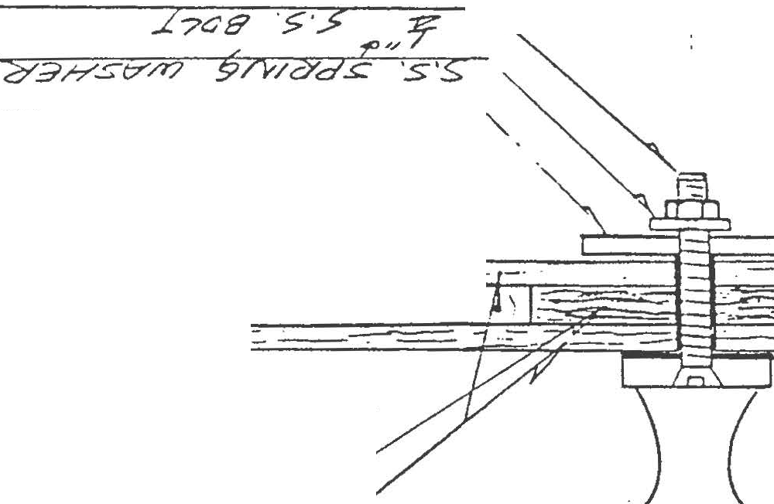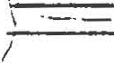9/'V/f>'/l"YCYC? 2Yg <7M "?;/CJ.::;' ::;70/-( " r<f '\\
o
/""--I'· \?

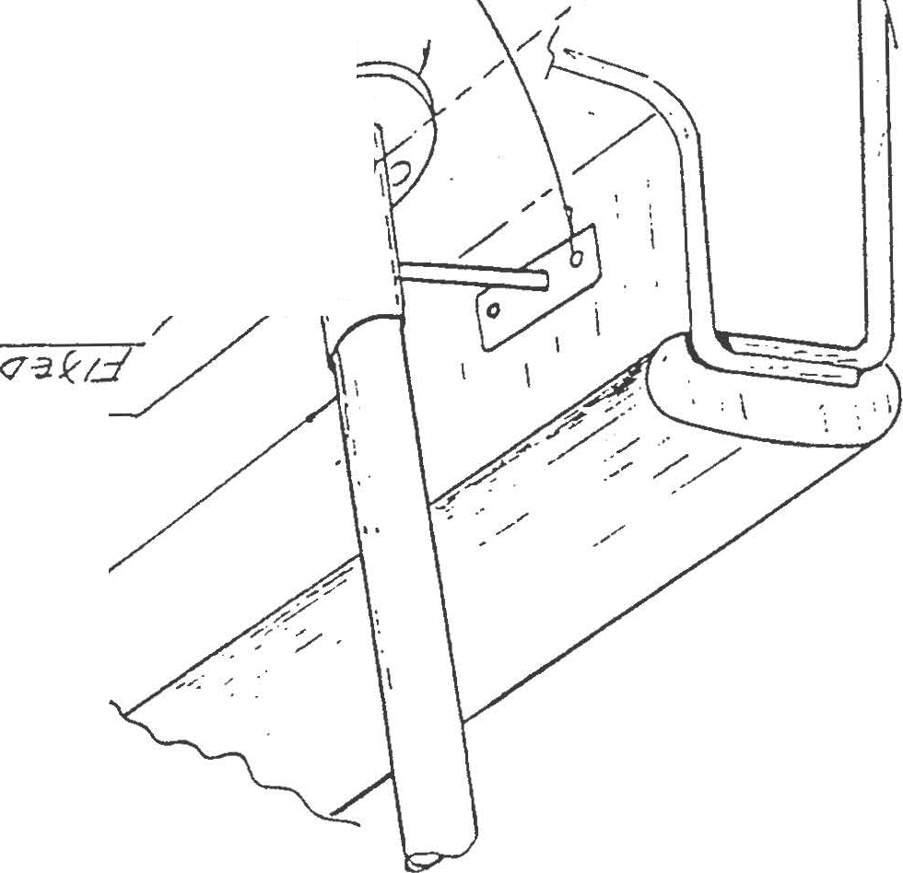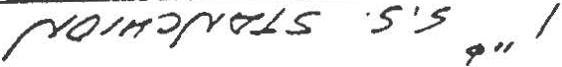3..L--:f77:--o'--:--9-.,.yy,_r:_"H?-=- -==g=--·"s,...,·-s=---5-:s_:._VV_#'_,;;;_1_n-:._:...::_,_q> , \
0/YI'? OC/fh'O:J //h (1:1.7f:T.35
Cy.Jfr".Sfrr7 (Yl'?/ S ../70/? :rz:: //If
'If)'// ..,...
3.sers? /J'Ll/,d::;f"Yo:J.S: ·s·s:

.3.L(;77d 9/'//.J(:Jtr9 .s 'S" $.
.-, I
d' 00 -.LH9t7 7&-.Jo7

,- c.:..-:-\ \ \ i l\ ) I- - -

/Y.:;/S53?7dh'O-:J ?J'o?/
<JOOM 7d <7 E?"JO'CJ::t/Y/371
9..L&/'dh'f/7 d ?f.:1

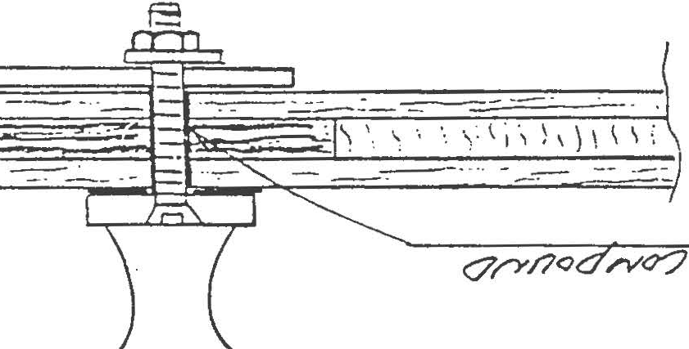

i

h

\( Vj
v._

:. :.......
('(\ t

"-

..,

rfJ

-

... ... .

!
'"'
:. . \j "\' .
·v.·_ . .-::::; 1'l'

":V._

'.\) :
i' t
- .......-:.-.:".

·':lJ
.:..::.. lli

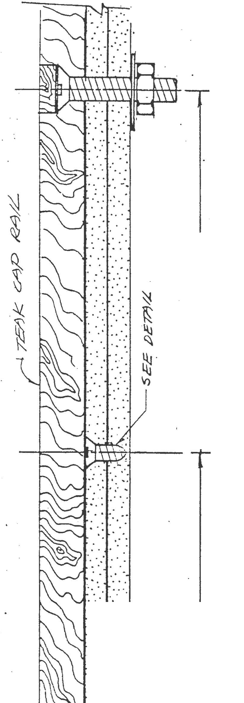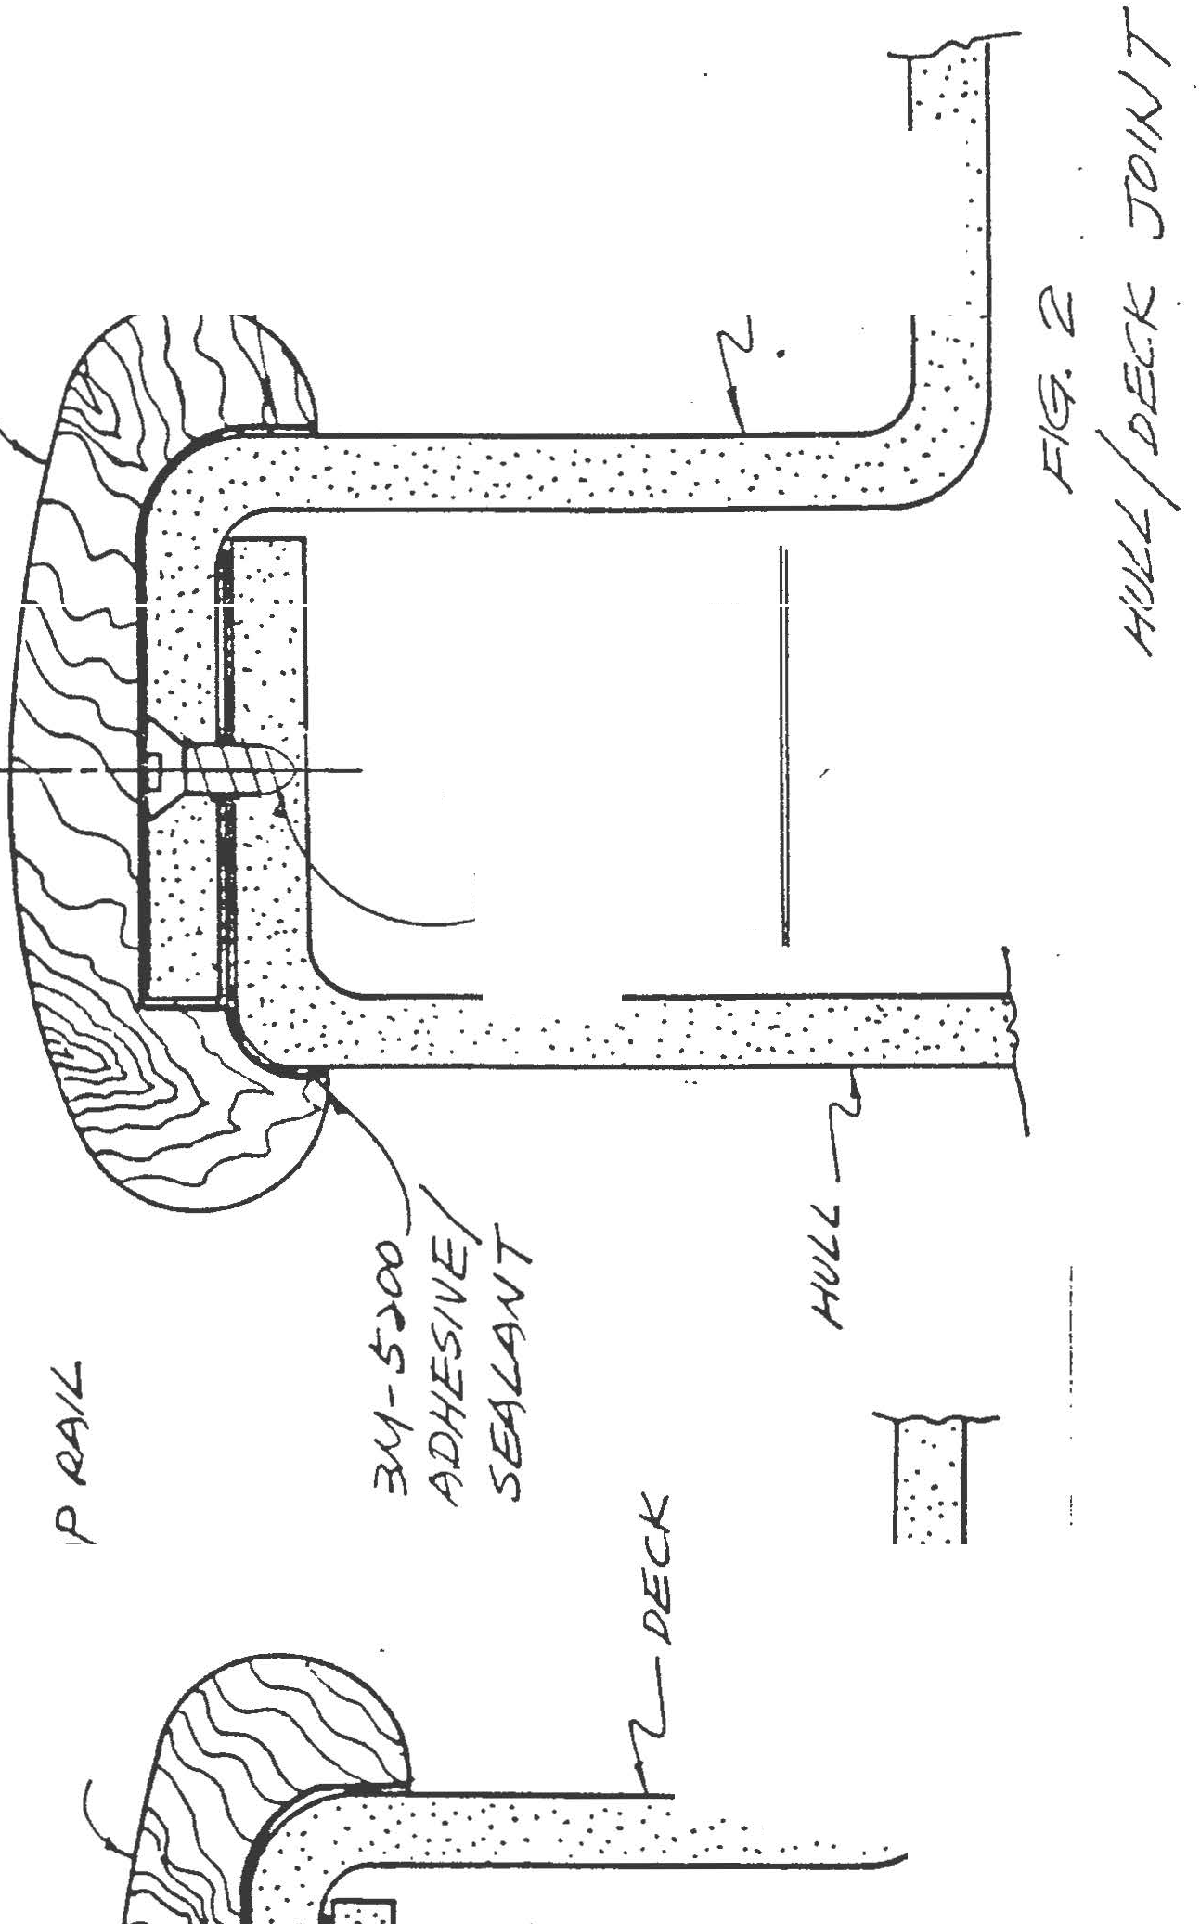: . ::::
....:....:..·...
.... ...

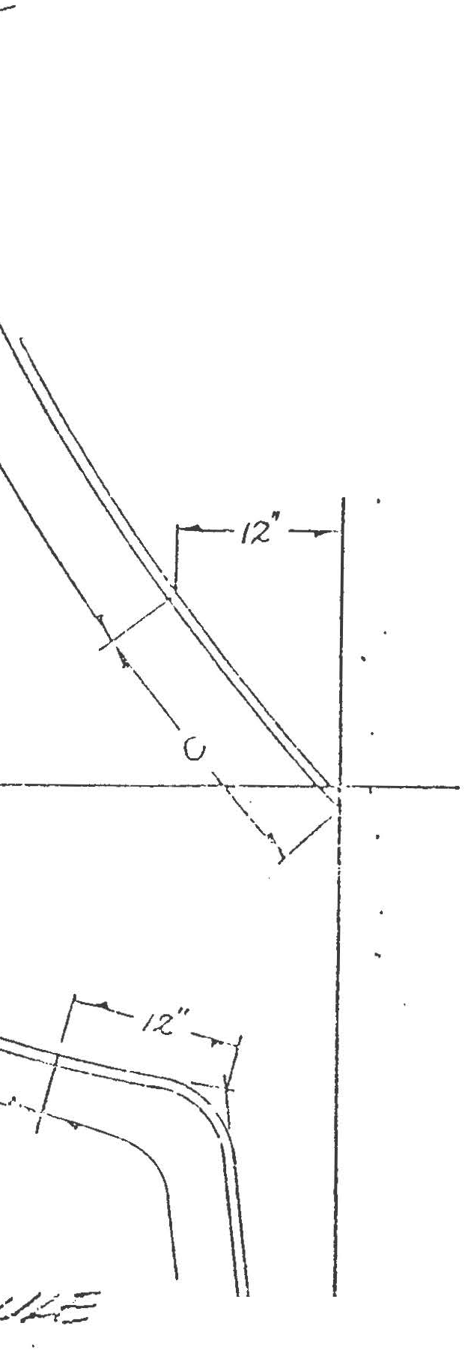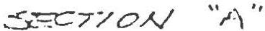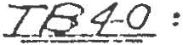-_::::::.:::::::·
- § r;,/E/ l\.l N07£) :
1 --· :..=--=--=-=--
/. C "200 %· CU?lf
2. Af ::: JCO .Y. ;.t' 1vV\T
J A I::: 15D /m, 1\1'\T
1-. /<.' = 600 /"'.. 1i.tCVLN f OV//l/(i
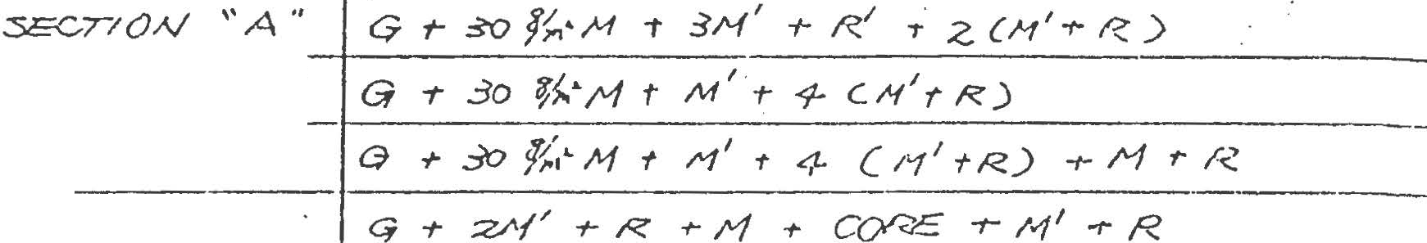5. .R..: 8CO ·Y/fr,.• H '.)!1 :=;.1 r<c1·'/Nc7

7-_73_::}1_ :
w &
---
CRN
SITION

:: ''a''
'- ' c H
'
D!":'ECI< .AND
C/\B/N TOj=>

(:P.8/// S/Dc

'
'".ZJ$ .:5<f_:

--------·
1
- .' "c · '-'1" •

G .,. 3°!;'..· f + .Z/'t' -r 1'1 +- R.1 - :5 ( iLf

1
•' f<.._)

'.... "e"

,

.,·',-,' -/if1-1,''.•f 1 ·rj1' ·,• D, -t 4 C /11 +- ) + I 1 I ·r· /

-
cx=:c ,,r.v.;,r;- ro

1 , . , ,
-·---·-----..

C/-\SIN 7·0,P <-T + ..GM + R t- , -f c..&·, ·r- /vi .,. ,C?

GC\13/}J :5/Cl:3 q t-H
1

1
.,. 1'1 _,. 1'1

+ ,.e.1
1
- 1-1 t' COP.E •" /•{ r i

- ----- -- --------· ---- -----

•.
<>/
c71av UA'' t- _:30 -,.,• M + /I.If I f- .rl + c +- /-1 r R..' +- Z(/\1 1·A _,
.- .

::: ·:e"
G -r .30 jt<'H _,. l"f I .,. s- ( /\1 r- R)

c "c "

G.,.

3'rJ 7(.( /-1
-

t /V/ I .,..

/0 CH'f'R)
-----

DC.L:/'<'.. A'-.·O :::Zl'f
jG .-t
C/\,t:..VIJ 7?:J/7'>

I ..,.
R +- l-1 I t R r M -t CORE
tM+ P. rM

l. CAS, V .:SILC ](-; Ml. Iv(' I ·, f' 11 -1- COPE I' H -f 1'-<. -1 /-'f
-77 r -r /'-'!_!._' _..:!: --:._N 1" /?.
·--

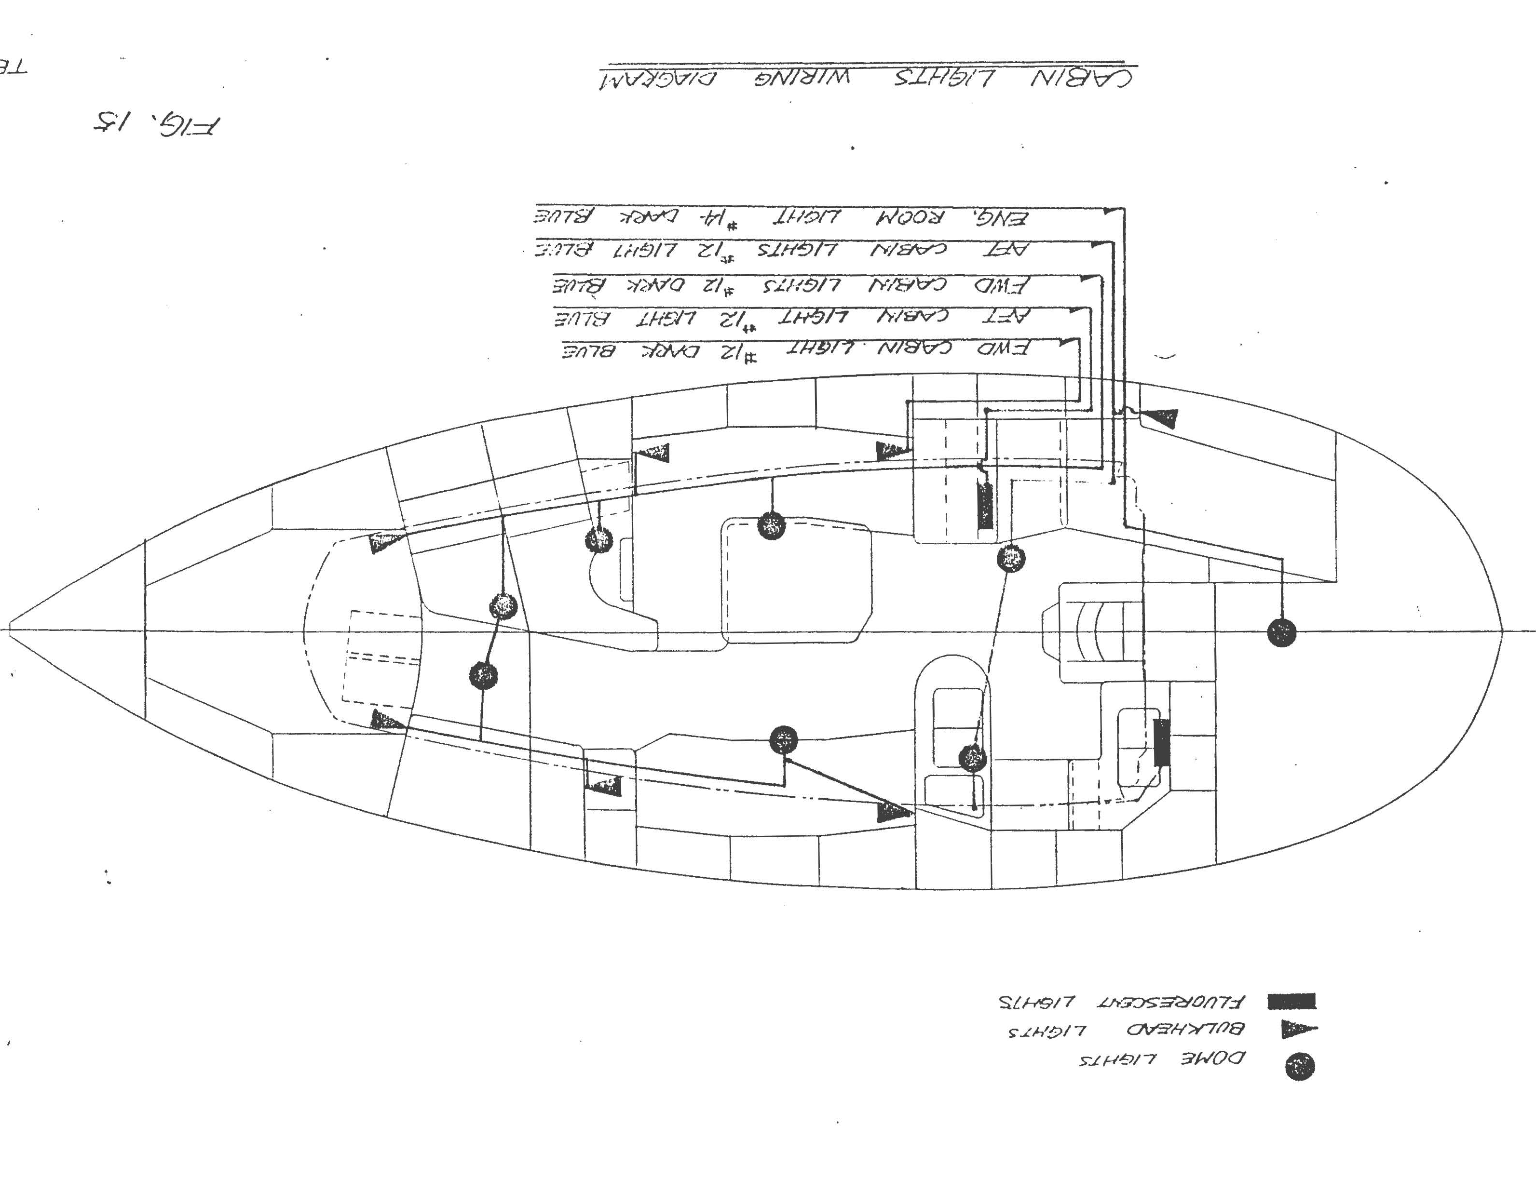

.

-
--..J

:::::;

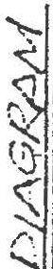\
.I

-- - --'I
II
\
I
I I I
I
\
I
I

LiDJ

l---- ­
- - - - -\- -

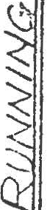I
JI_

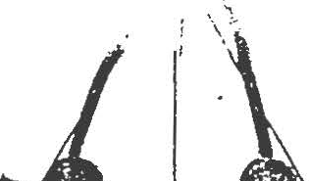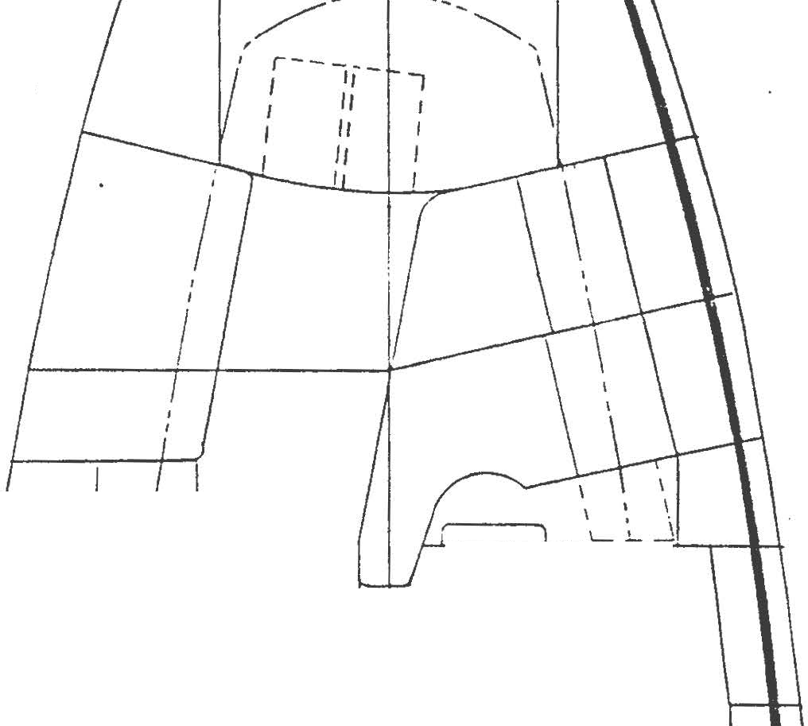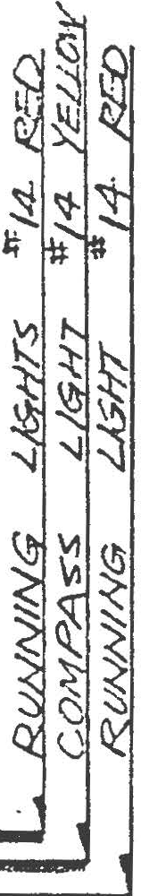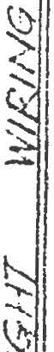

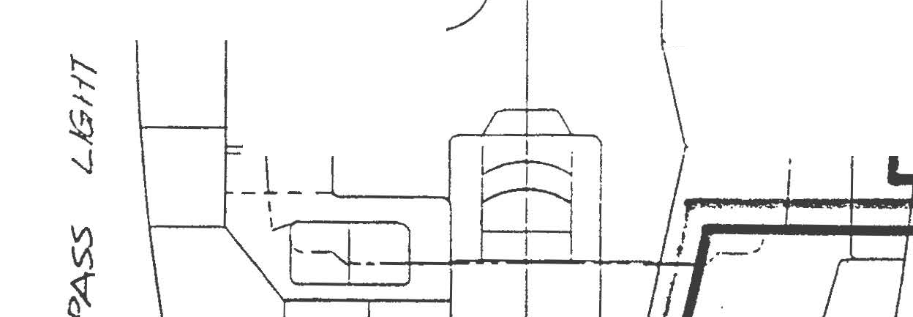

l
i .
i

'

......:,.j '\ .
.· .·
·v.. . rt'

'41.

·(,
t ' " ' :: .::..·.....:" .·.·

..'V.ll:; ...
·..:.·:. ijJ
..·....·· ... .

: .::.. : .·....·..
... ... ..
... ...
4v.si

-- ·

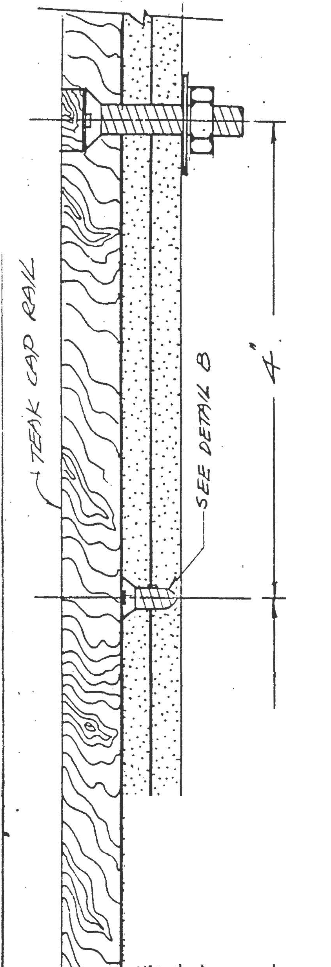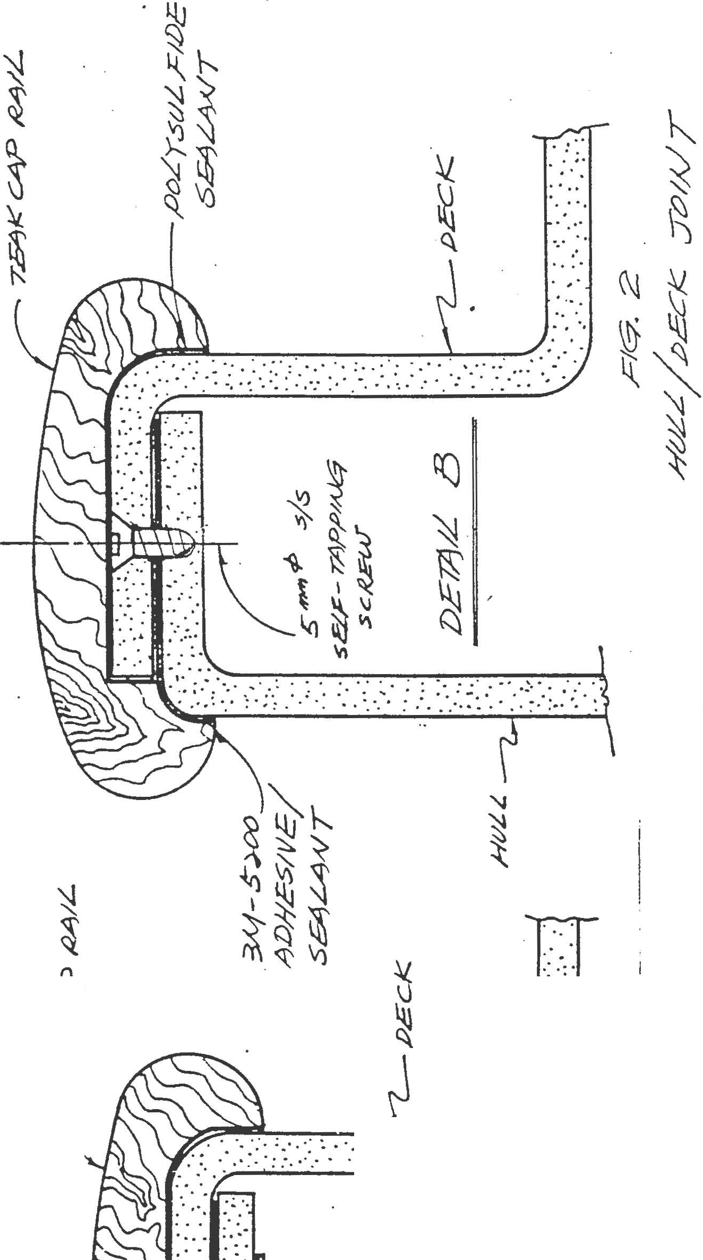

(

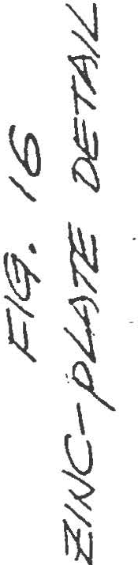:..·.. ·.·...
,, .
'

\---.

'\) :s
i<== \.)
Q
()
"
.N
I
'

I .•,. " .
.. '.
... .
• • ·.1·

.
.,. . . .
·: ...
.. .. . ..
. . ...·.·
-• • I

. :.; .. . .
. .
. : . I . .J..
. .
. . ·. .

.,·.

• ,.: : • ·:
.• -.I .'

' .. . . . .

. ...... ."
...'. .
. . .·: .· " . ....·..

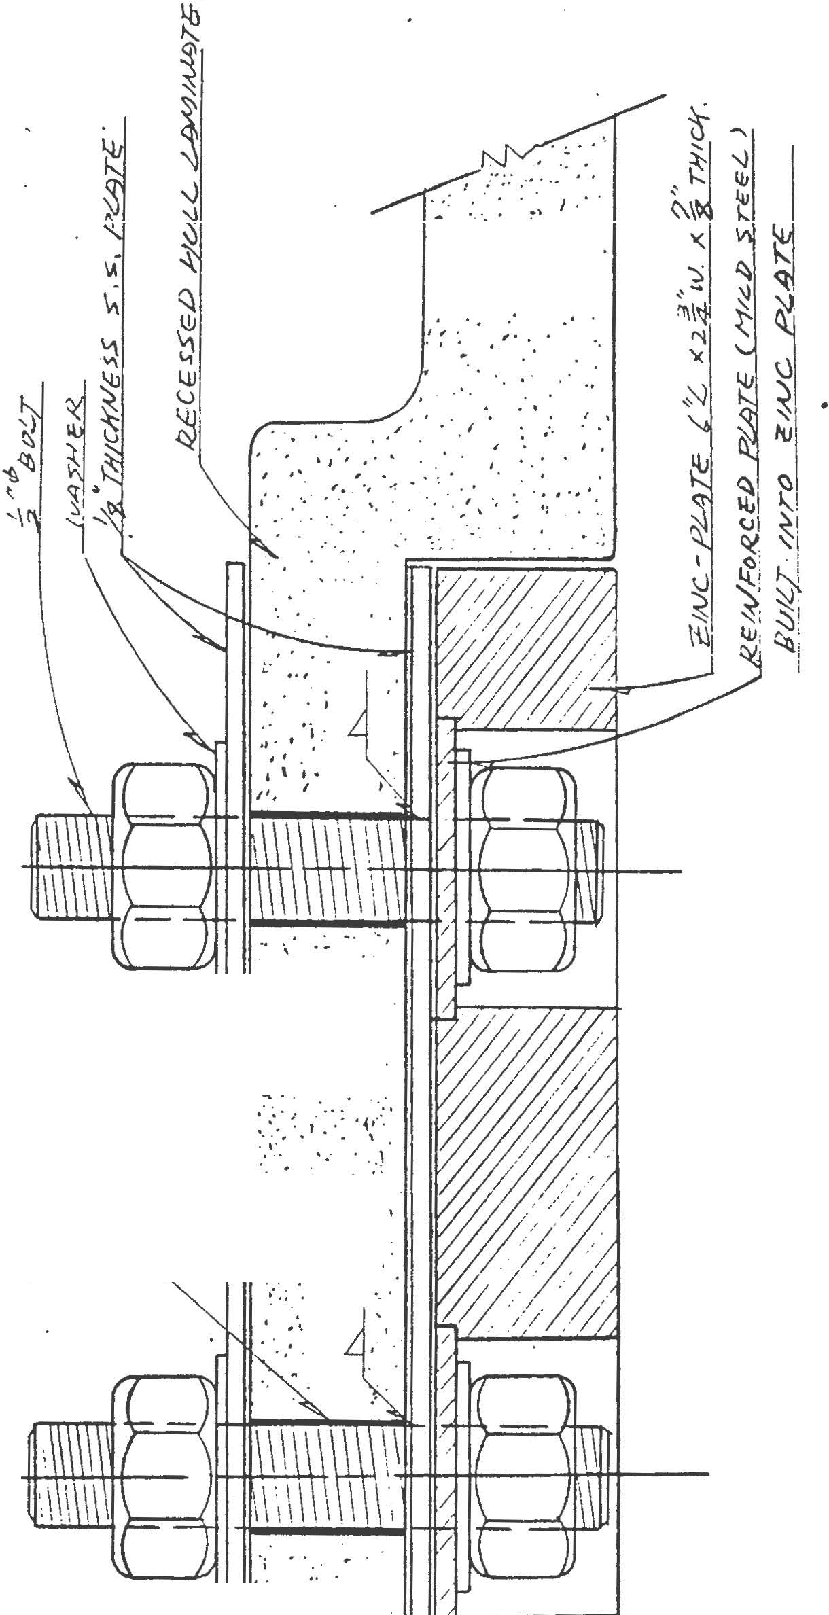..._ _ .. ... ; ..
•, ' :' \ o I
'
. j •• .. '. . •,, ...
. ,, ·'

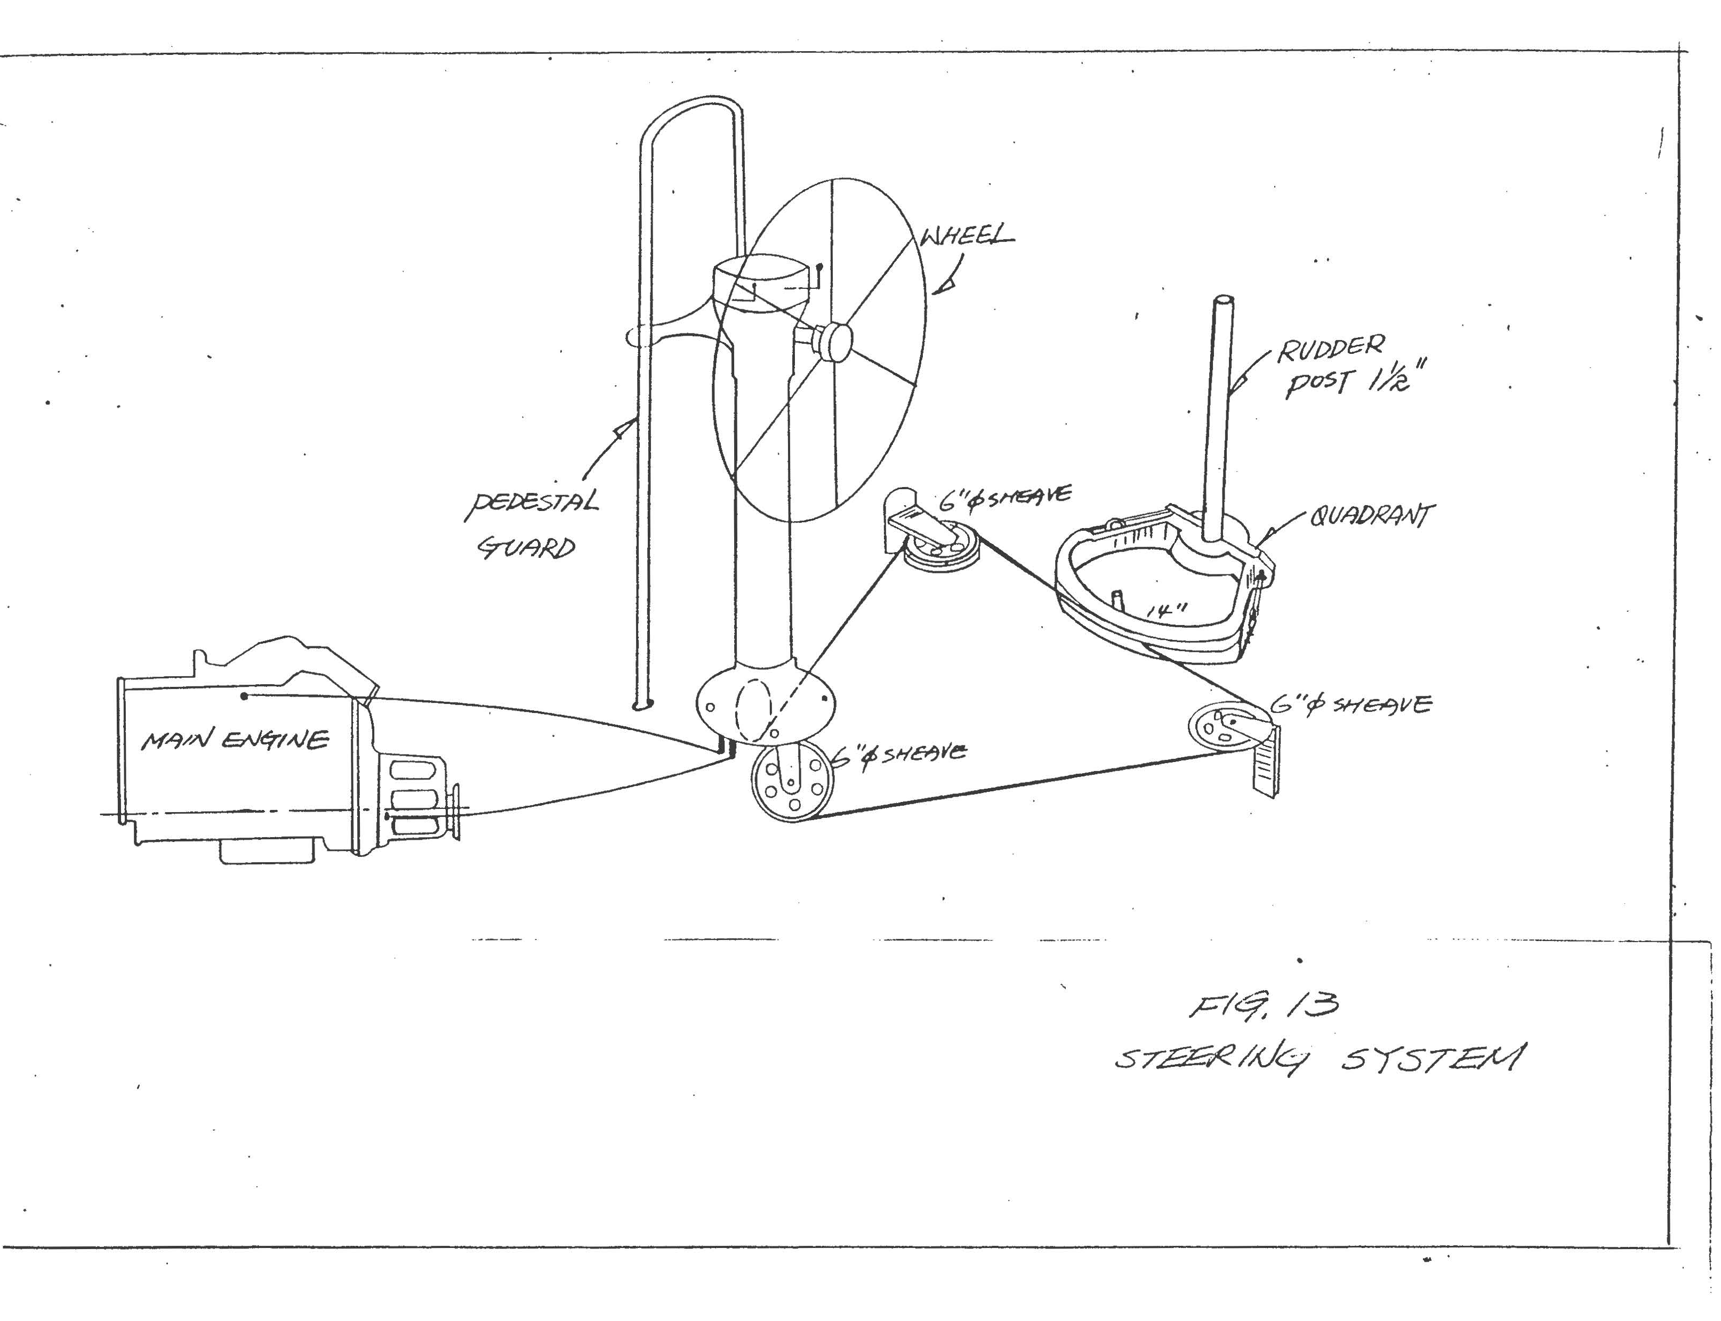

// 3cr ;>f-70-
/ -&;::::/

9/)'/ 7/V/ /Yfi#/VJ )i?ldo F

WO'o-:/ /7. 7t:r/YO/.L (:::7 I
j
- i
I
frO/..t.f:T-?n /V/
j !
I

· OOZ:$-/:YE
<1"/Ync7dh'<?:T/IIIM

C!B((d J./JCT78 §'i/,J/%8 d?:fJ

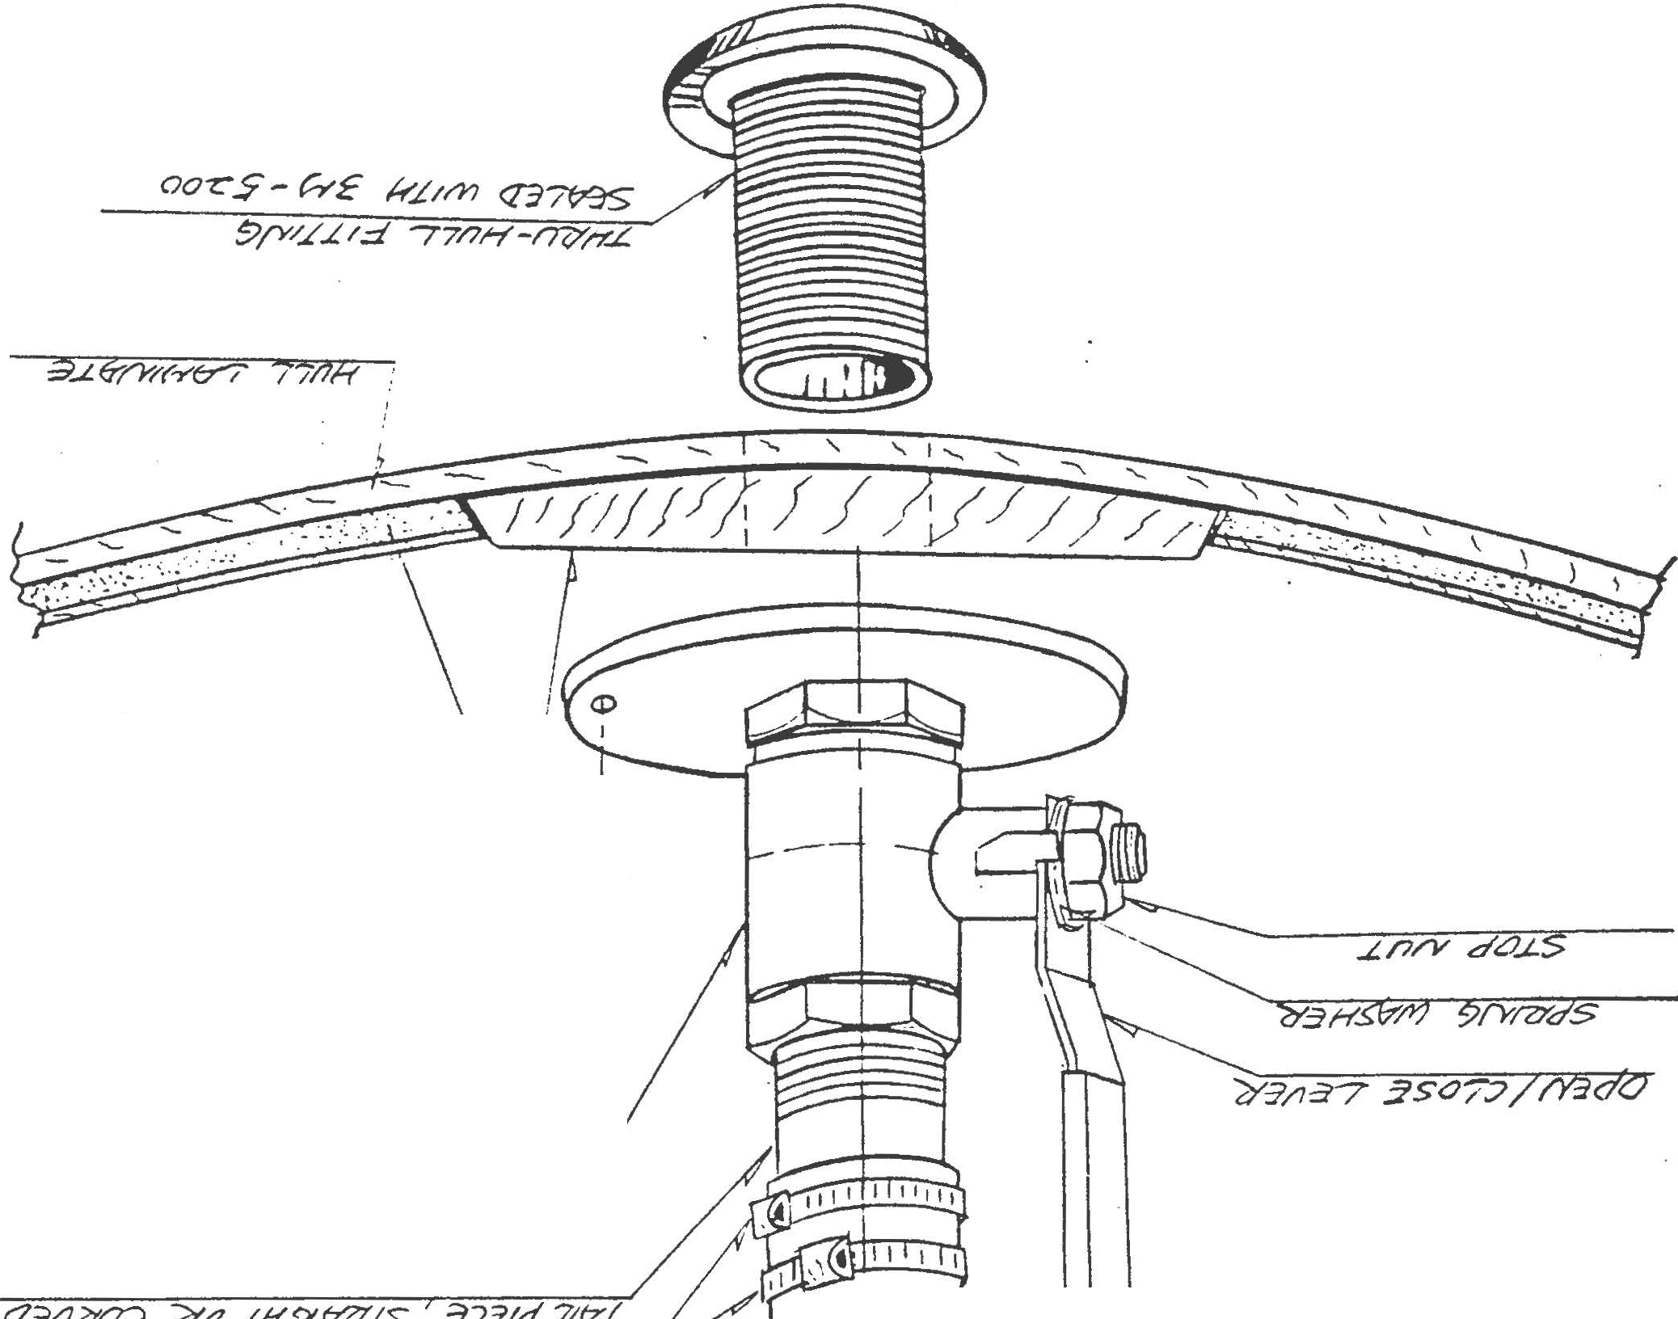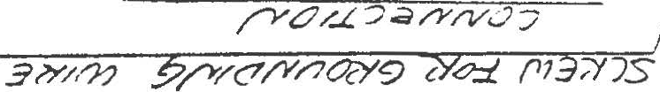1J:J/'Y&'/Y fe/&'(..Y 7&'/7/Y/Yif' O/Y <J .z;/V)
X'? fr3S -3d,,( ..J.. 7if S ;a'<77 3..L

---

I I I
D qi E2J
I 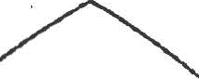
I
I
+:t>
-I
<!:::. 0 c::
'§:  '1 '°1'  ):) | r: |  | -r.  <'=i

.:r

("'l \P
lr:-i
{'\ '\)
('\ \)
l:l
l:l

-,:::.
r "'J\. I'\" (' VI

'<. 4 I/I

§ :P
'<-. t
c:.
'P

t": r- ...... .h tn
I

< '{;\ v
;tj c:.
3:
! --.;:)
I
I
I

I I I
,
I ·:k
r=

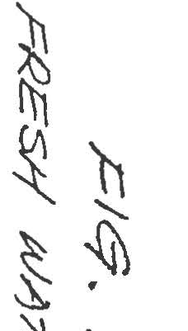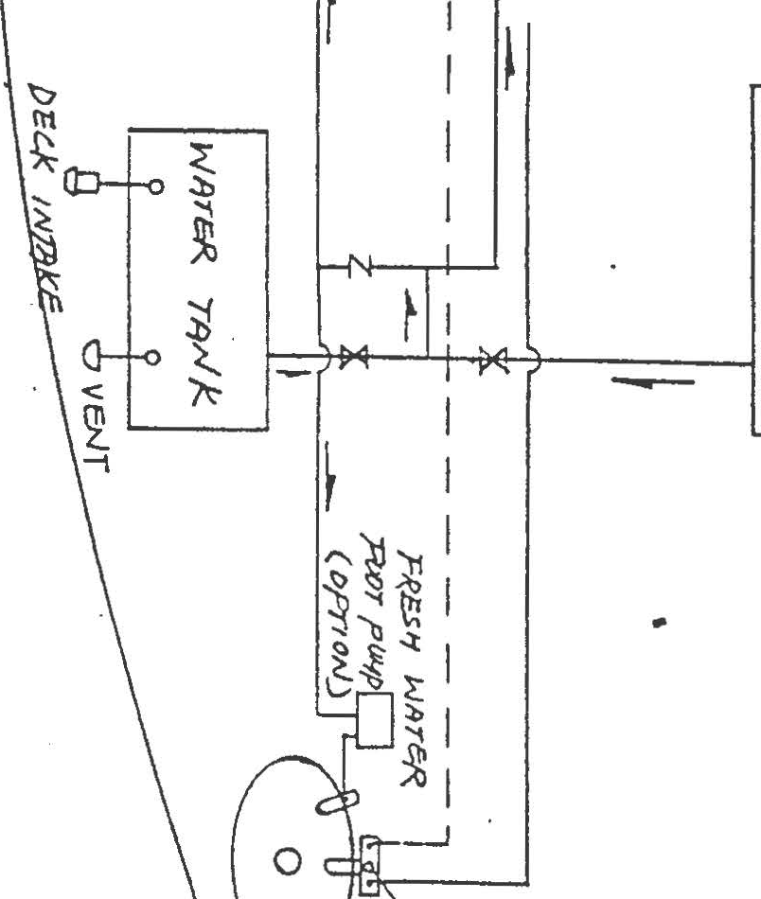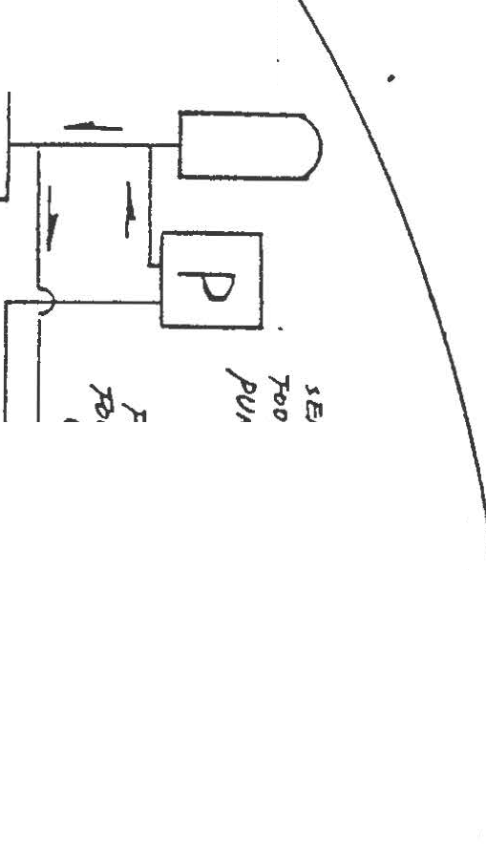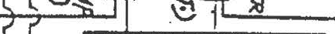

1

i .
-
;

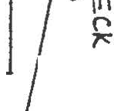

"
I
({)
\.
t
t:
!
'

...,

. .· . .
...
. . .
. .

. .
• • : • • • • • <:,"I • • • • •
.. .
. ... ... -. .

. . . • . • . .
•
•
•
•
. . . •.. . ·
. ..
. "» §. .

.. . .. . .
. •.
. . • '.\.:u" .
. • :-.; f" .

. . ..
. . . .
...!fl
. .-If\"V'\ • •

• . • • . . 1· .
. ..
. .

: . . .
. .
. ..})
'/ .
.
"·.
. v..

r--
"
.

'1
'...
"'





